Programming Project Development and Testing

By Farhan Mirza

Stage 1- Setting up the game screen and player character’s movement

**In this stage, the parts of the success criteria I am going to achieve are:**

* **Fitting one of the sets of controls onto the keyboard**
* **Allowing the player to choose the height and width of their screen.**

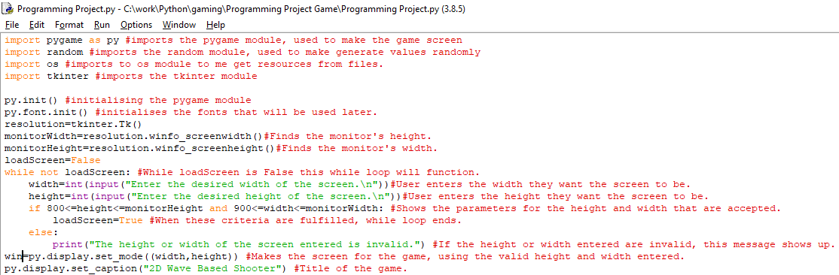

This code contains the importation of all the Python modules I’ll need to make the game. It also takes a height and width entered by the screen and checks that they aren’t bigger than the size of the monitor or too small to be used. The height and width are considered too small if they are beneath 800 and 900 pixels respectively. Once this is validated, the program will make the game screen and give it a title.

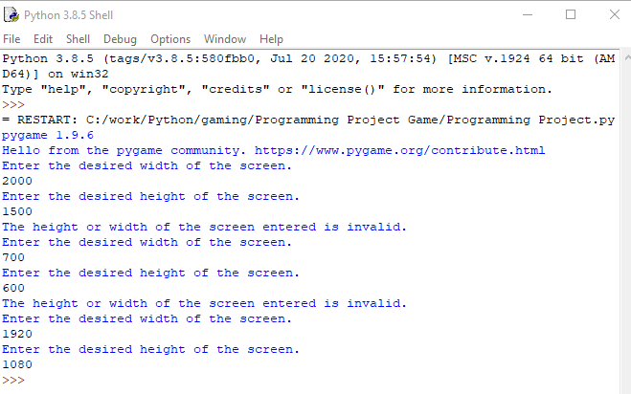

The validation for the height and width of the screen is functioning like it is supposed to. I tested a broad variety of different heights and widths for the screen.

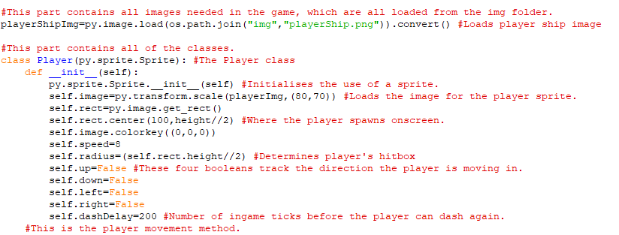This is code for the initialisation of the player class, this class will be used to make a player object when the screen has been properly made, for now, it can’t be properly used in the program. The image used for the player is the image that is loaded into the program before the class. All the attributes are a part of the player class, but their values can be changed outside the class in the main program.

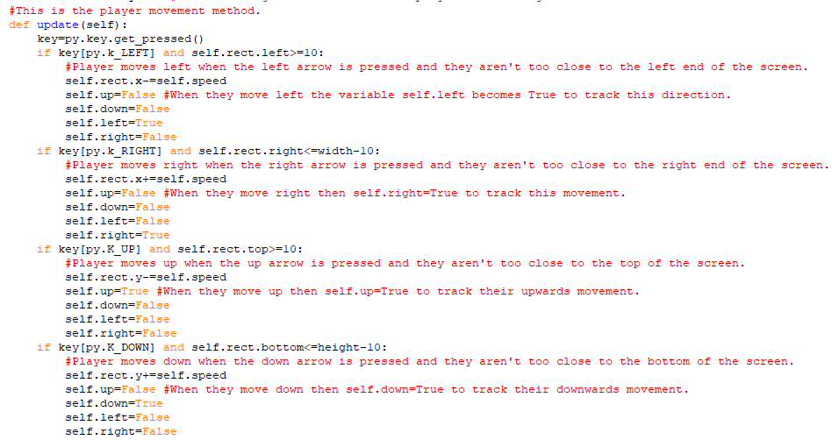This the method for letting a player move in all four directions. Separate if statements were used for each of the moveable directions because if they were all in a singular if, else if, else block then the player wouldn’t be able to move in two directions at once, for example, moving up and left. The program uses the up, down, left and right boolean attributes the track the player's direction so that when the ”dash” move is added the player will always dash in the direction that they are currently moving in. The up, down, left and right keys are used to move in those respective directions.

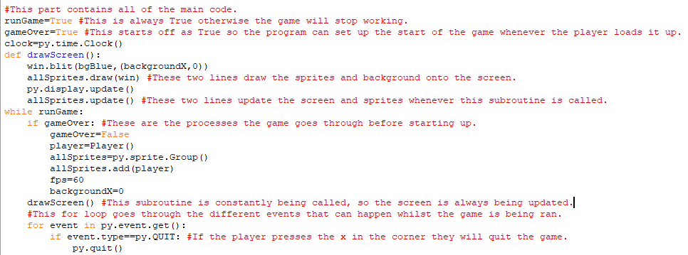

This is the code for the part of the main program that draws the screen and sprites and sets up the game before it starts. This code in the drawScreen function and in the ”if gameOver” statement will be expanded as more features are added. Eventually, the if gameOver statement will call a function triggering the main menu and main game won’t begin until the player chooses to. The allSprites.draw command means that any sprite added to the sprite group allSprites will be drawn onscreen and updated. As the name suggests, all sprites will be added to this sprites groups so they can all be drawn onscreen.

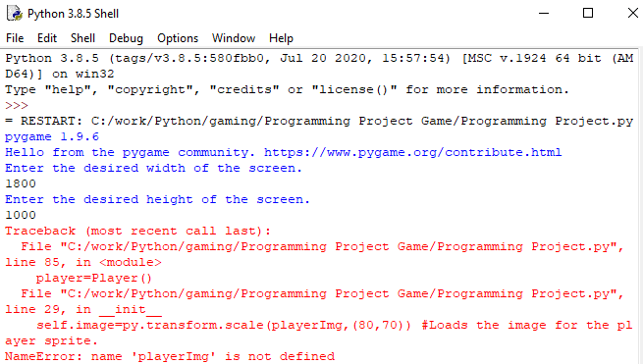

When I tried to load up the game to test player movement, this error popped up, this occurred because I misnamed the variable used to store the player ship image. On line 29, it should be ”playerShipImg”, not ”playerImg”

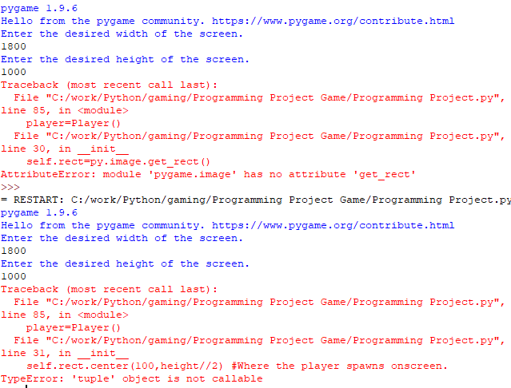

These are two more spelling mistakes as I used ”py” instead of ”self” in the first instance and forgot the equals sign with self.rect.center.

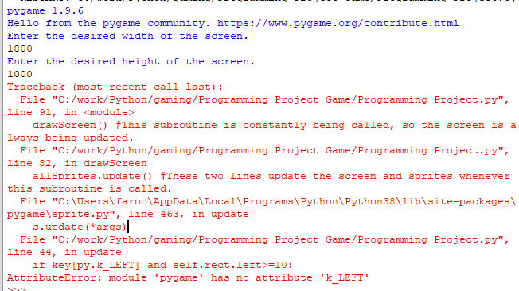

Here I used a lowercase k instead of a capital K for py.K_LEFT and py.K_RIGHT so I replaced them.

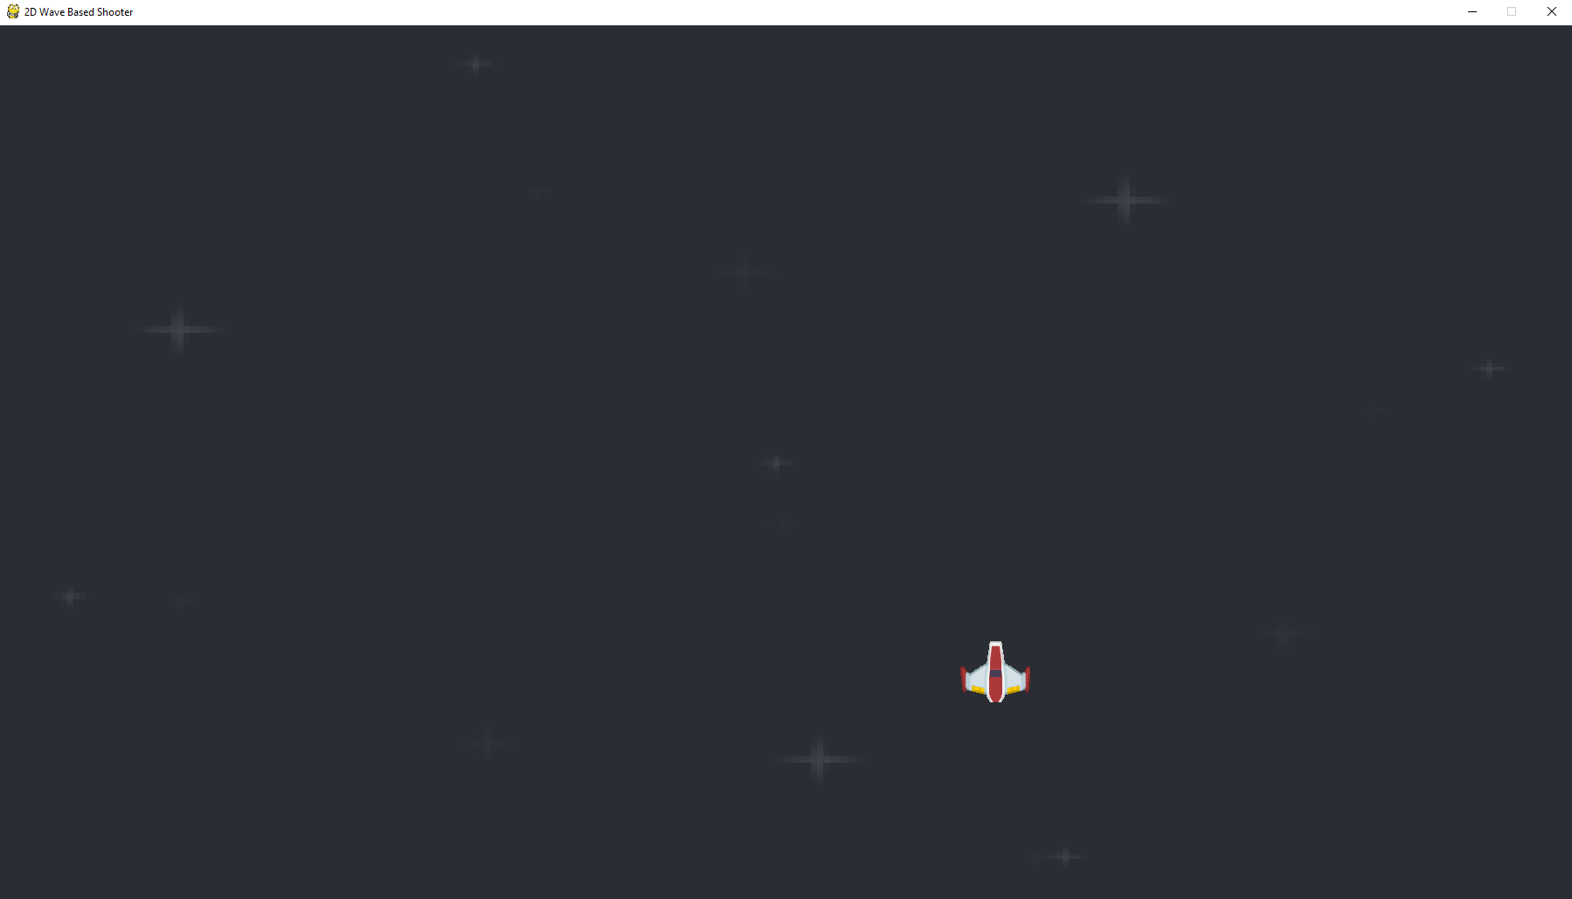

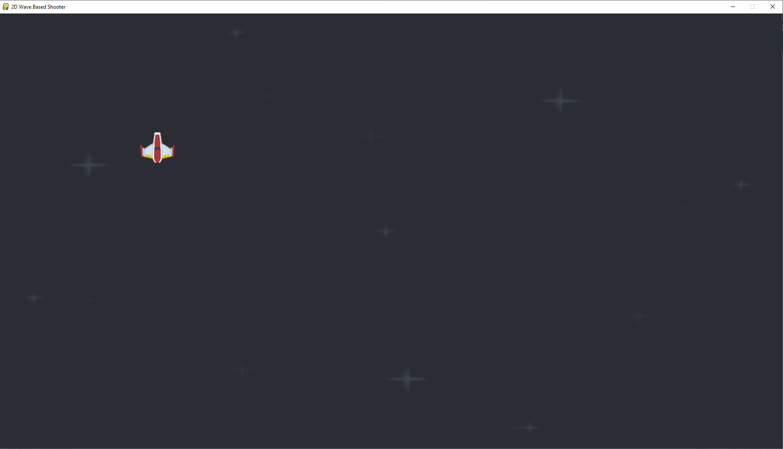  
The spaceship can move across the screen successfully. However, the player moves across the screen too quickly and is facing the wrong direction. I also want the background to be moving as well so the player feels like they are moving through space.

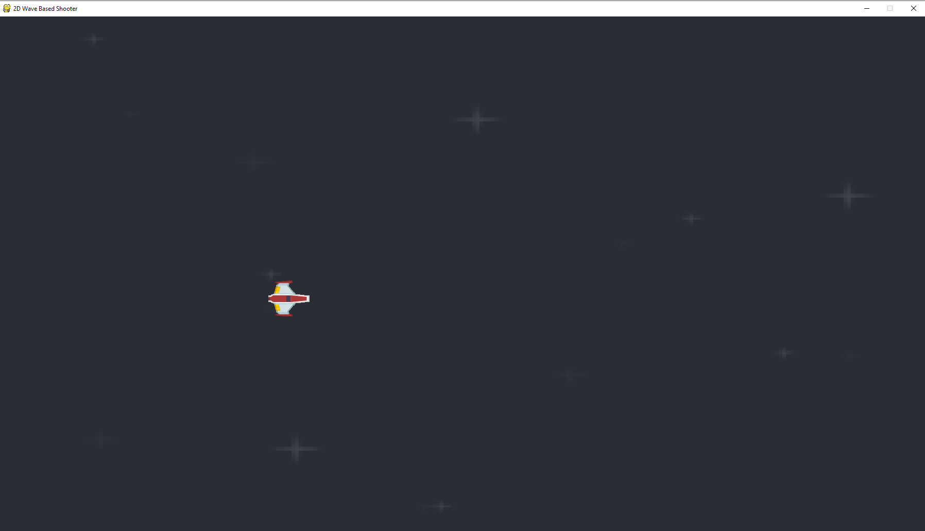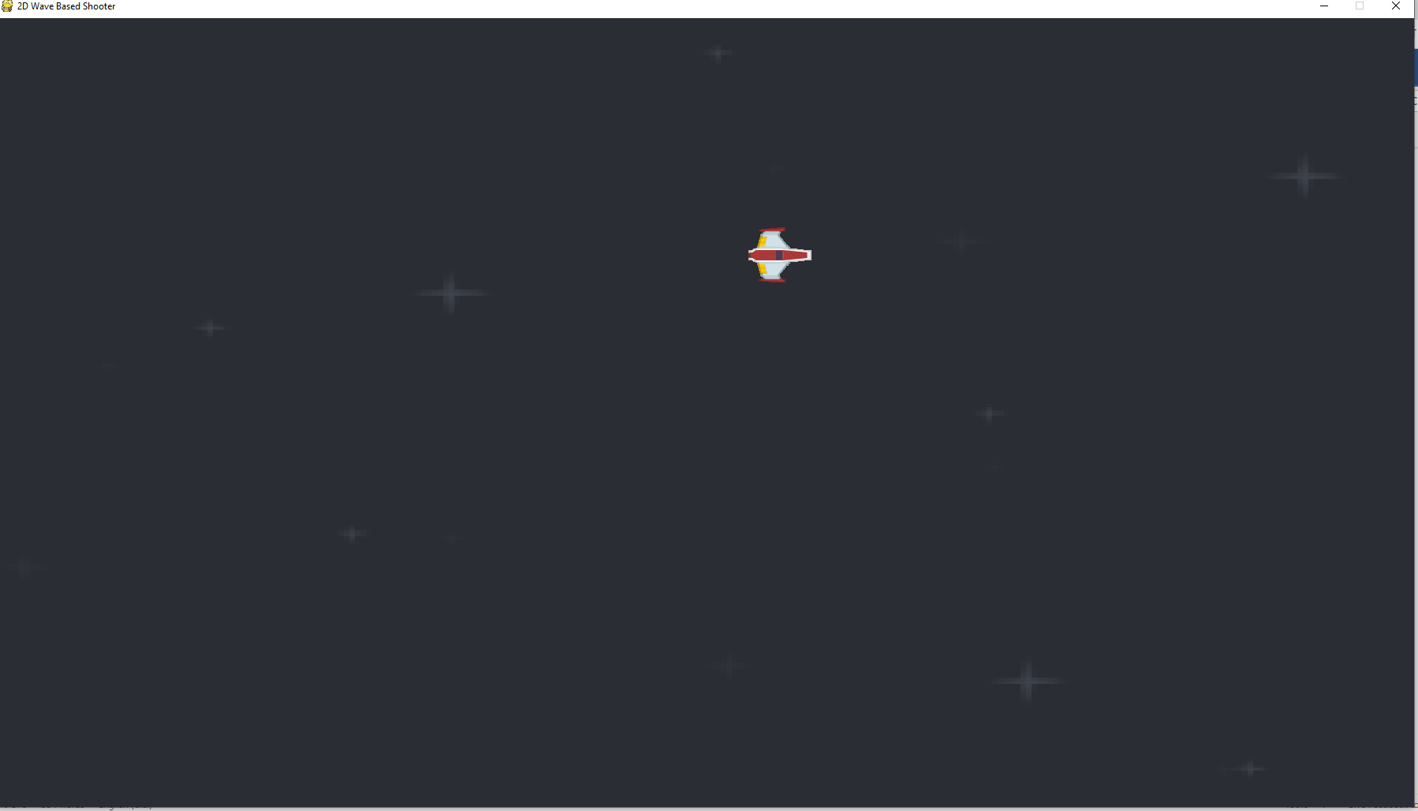  
The game’s background is now moving and the game itself is running at 60 frames per second so the player moves slower. I have also made them face the right direction.

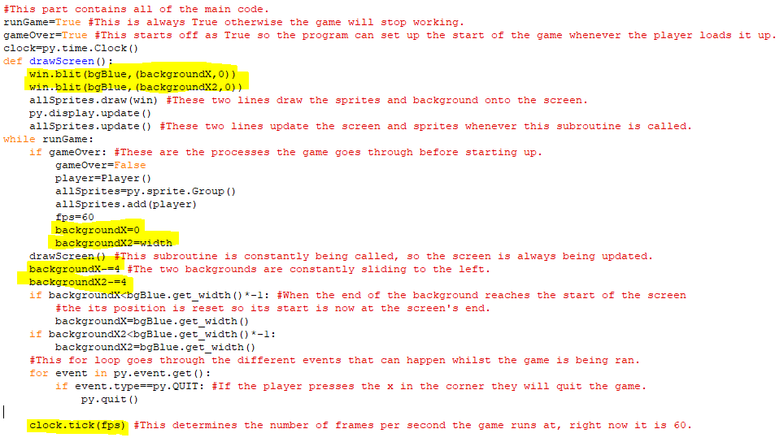The highlighted sections were the parts of the main program that were changed to have a fps limit and to make the background move to the left. There are two backgrounds onscreen now at any given time with one of the background’s start being on at the start of the screen and the other background’s start being at the end of the screen. Both backgrounds are identical and will move leftwards all the time. Once one of the backgrounds have moved fully offscreen, the other background will be fully onscreen and the background that is fully offscreen will be moved to the right end of screen so that it can move leftwards and appear onscreen again. This process occurs for the other screen when it fully moves offscreen and will repeat itself for as long as the player is alive.

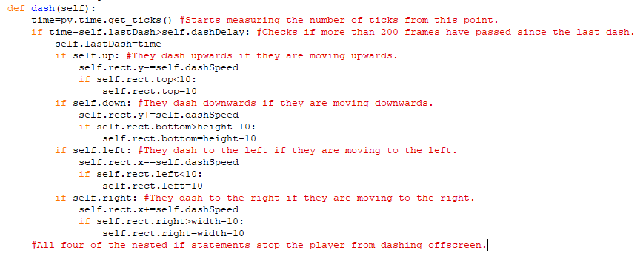This is a method in the player class used to allow the player character to dash in four directions, up, down, left and right. When the player dashes, what they are doing is moving 150 pixels in a single frame as opposed to the usual 10 pixels. The game determines the direction to dash in based on the direction the player is moving in. The up, down, left and right boolean attributes that track the player’s movement are used to find out which direction they are moving in and then the player will dash in that direction when the dash method is called. For example, if self.up is True and the dash methods is called then the player will dash upwards.

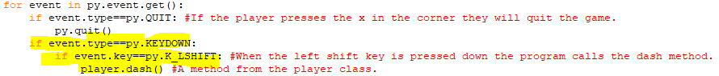

The event for triggering a dash was placed outside the player class and in the main program instead since it is only active when the player presses the relevant key and not when they hold down on it unlike with moving left or right and making sure of this wasn’t possible in a method, so the code wasn’t put there. When the player presses the left shift the dash method will be called and the player will dash in a certain direction.

The dash feature is successfully working in the main program.

Stage 1 Review

So far, I have created a screen for the game to be made on, with the resolution of that screen being determined by the user within limitations of what resolution the game is playable at the resolution of the player’s monitor. In addition, on the screen, there is a moving background mapped to whatever screen size the player chose and there is also a spaceship that the player can control and move around in and dash around in. There are preconditions set to make sure the player can’t move off the map as well.

So far for the success criteria I have let the player choose the height and width of the screen as the screen can’t have a width less than 900 pixels or more than the width of the screen and the width can’t be less than 800 pixels or more than the screen’s width. This means that the screen will be big enough to play on whilst not making it too big to fully see. I have also incorporated basic movement controls which let the player move up, down, left and right and dash which partially fulfills the requirement to fit two sets of controls on the keyboard.

Client Feedback on Stage 1:

The controls are smooth and the dash is a nice feature, it's good you can't fly or dash of screen. However, there is no shooting or enemies yet, it is also tedious to input the window size every time.

Stage 2- Player Weapons and Health and Basic Enemy Waves

**In this stage, the parts of the success criteria I am going to achieve are:**

* **Adding a health system which makes players lose health upon collisions with enemies or hazards.**
* **Introducing an enemy type to fight against in continuous waves.**
* **Introducing a scoring system for when enemies are defeated.**

This is the code for loading in the relevant images for this stage.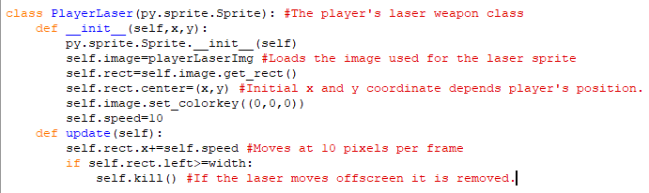

This is the full code for the player laser class, the initial x and y coordinate of the laser will be determined by the position of the player’s spaceship at that point in time. When the laser’s leftmost point becomes larger than the width of the screen then that instance of the laser will basically be deleted and no longer be a part of the program.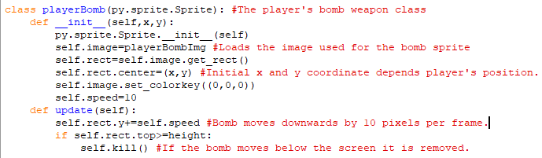

The is the code for the player bomb class, with the bomb’s initial x and y coordinates once again being determined by the position of the player’s spaceship and the time. The bomb, like the laser, has a constant speed and if it moves below the screen it is removed from the game.

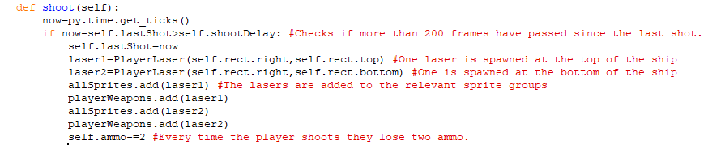This is a method for shooting two lasers from the spaceship. The method creates two instances of the lasers at the top and the bottom of the spaceship and those lasers will then move to the right as that is what is written in the laser class. These lasers are added to a new sprite group called playerWeapons so that weapons sprites can collide with enemy sprites later. The method also reduces the player’s ammo whenever they fire the lasers.

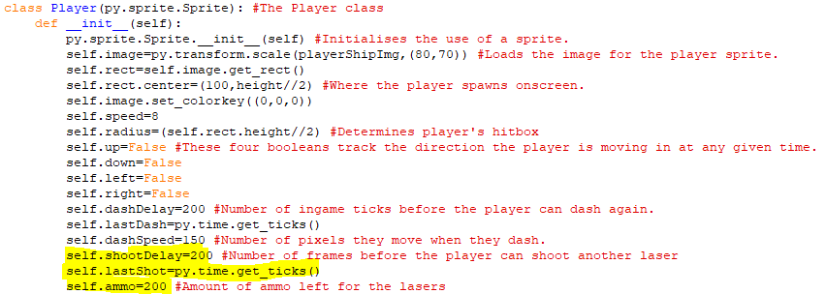The highlighted attributes are the attributes that were added to the shoot method usable.

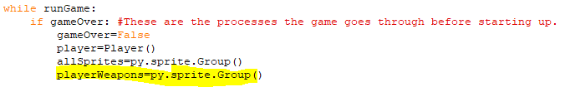The highlighted code is the creation of a new sprite group within the main program.

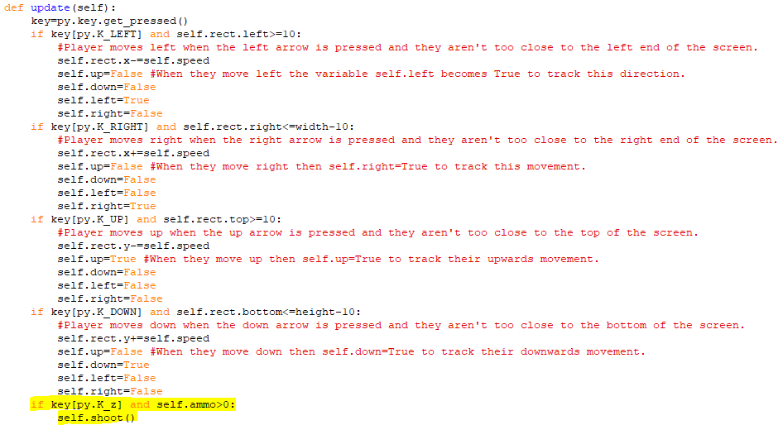

I have added code to the update method in the player class so that when ”z” is pressed the shoot method is called.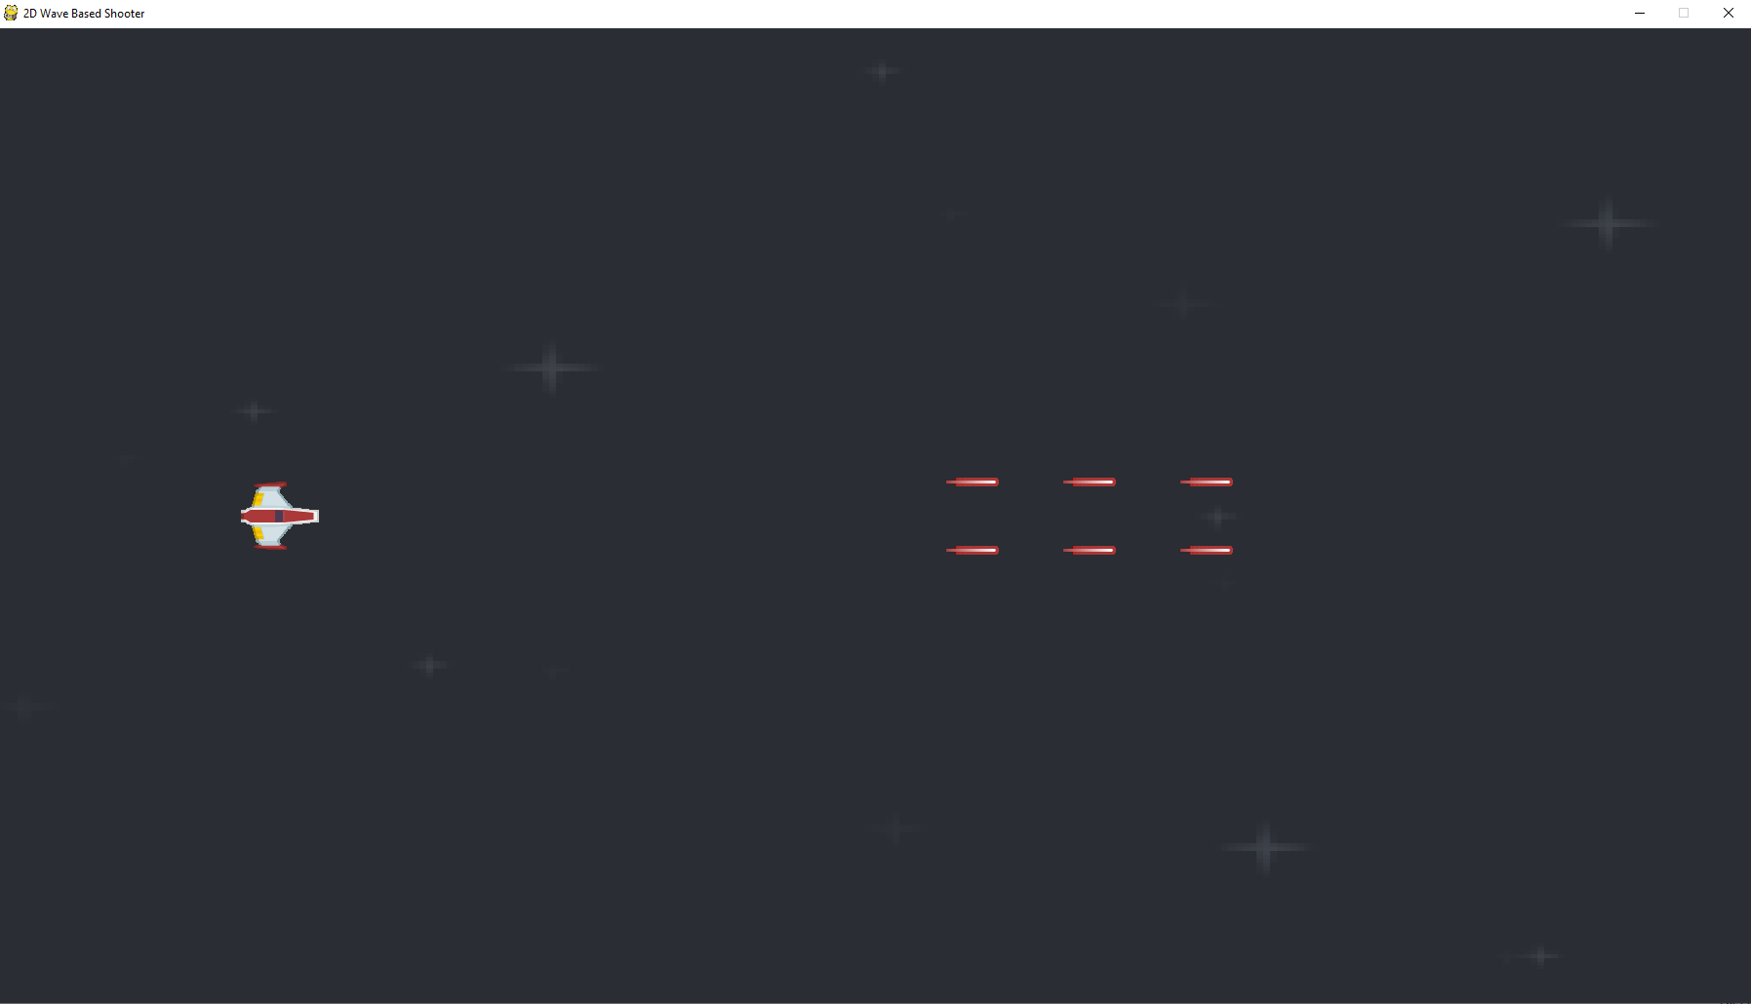  
The two sets of lasers are being shot without a problem in the game.

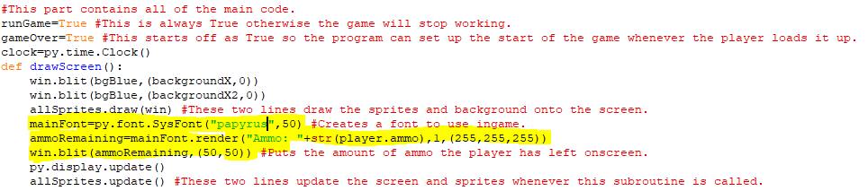The highlighted code creates a font that is 50 pixels big and uses the Papyrus font and makes a message using the font the show the player how much ammo they have left, colour of the message is white which is denoted in RGB form in the code. This message is then displayed onscreen in the top lefthand corner.

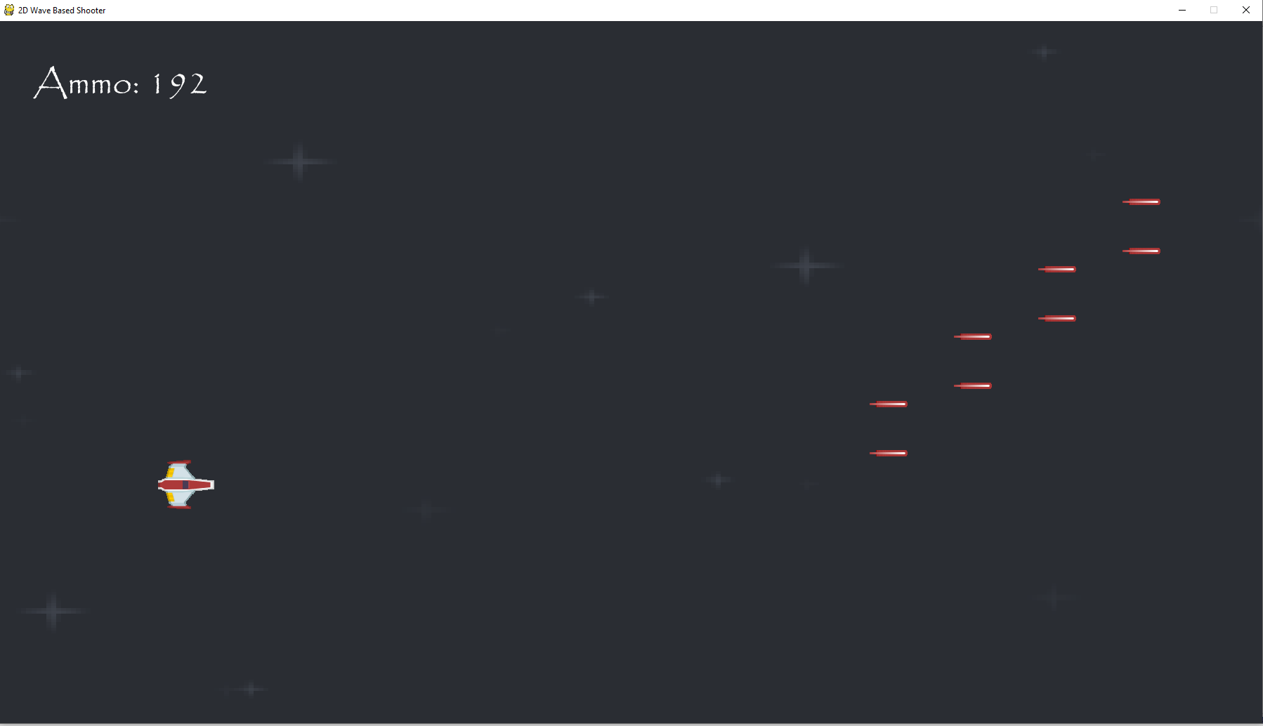

This ammo counter is working in the game itself.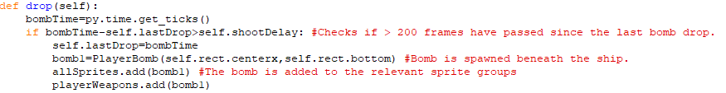This is a method in the player class to create a bomb object from the bomb class, this bomb will then move downwards since that is written in the update method for the bomb class. The bomb will always be created under wherever the player’s spaceship is at that time and the bomb is also added to the playerWeapons sprite group. The bomb doesn’t use any ammo as it would be harder to drop bombs on enemies than shoot them with lasers.

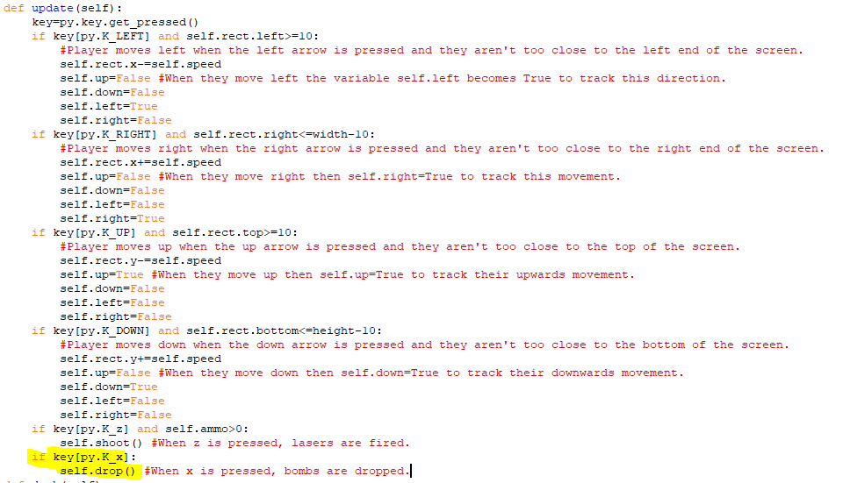The highlighted code in the update method of the player class calls the drop method when x is pressed on the keyboard.

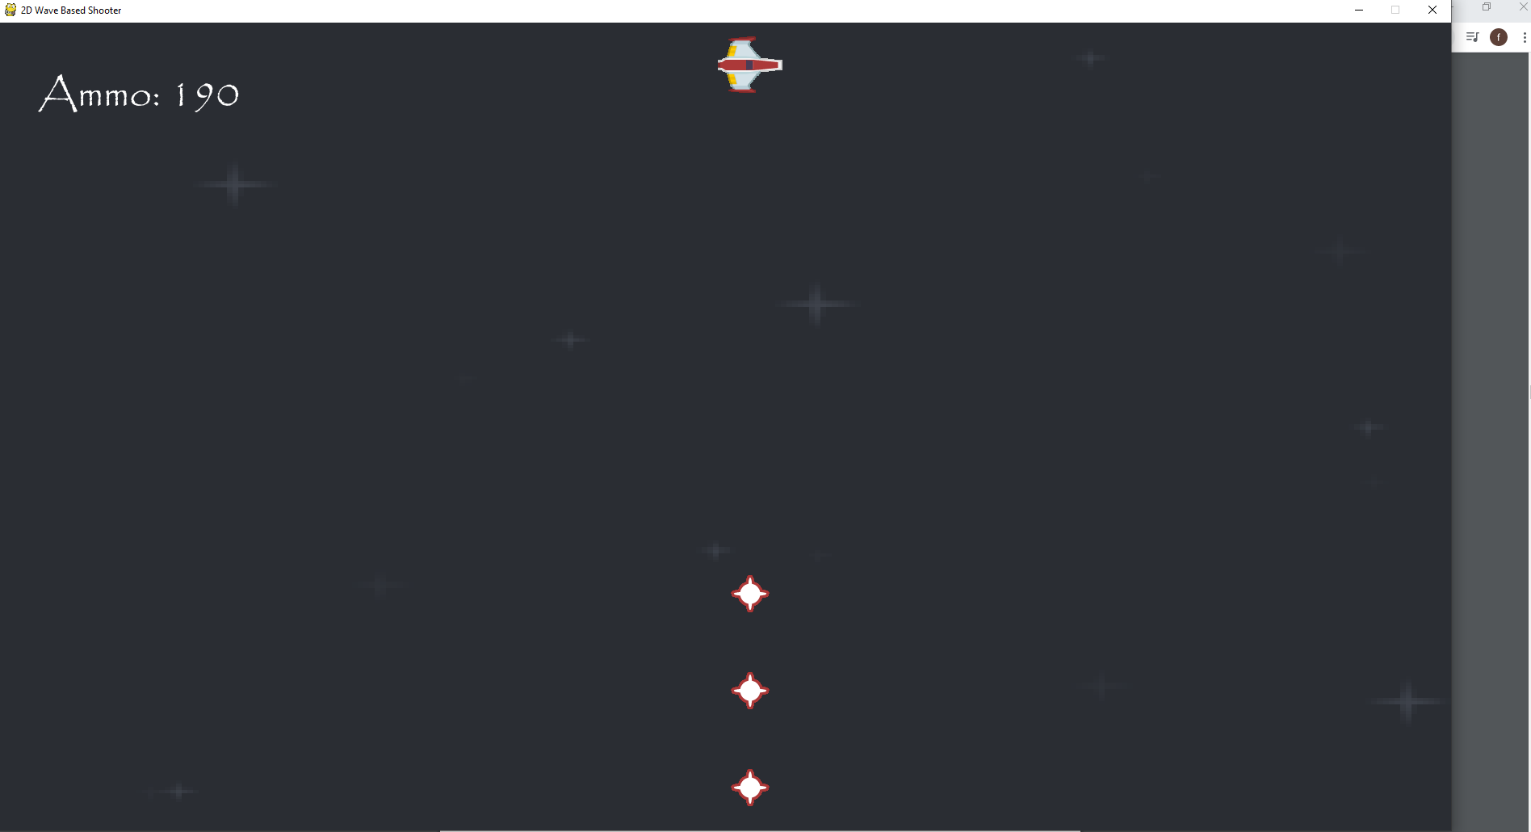

The bombs are being dropped from the player’s spaceship successfully.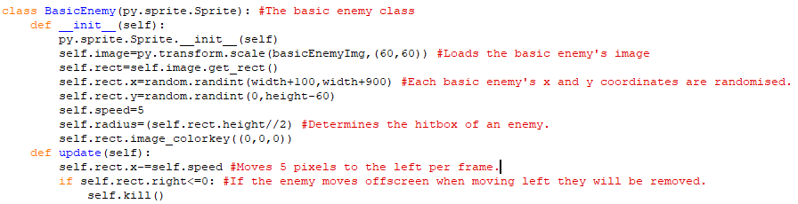This is the class for the basic enemy. The spawn point of each object created from this class will be randomised so that the enemy appears a random number of pixels behind the screen ranging from 100 pixels to 900 pixels behind. The y-coordinate of each basic enemy will also be at any heigh onscreen so that enemies appears at different positions and appear onscreen at different times.

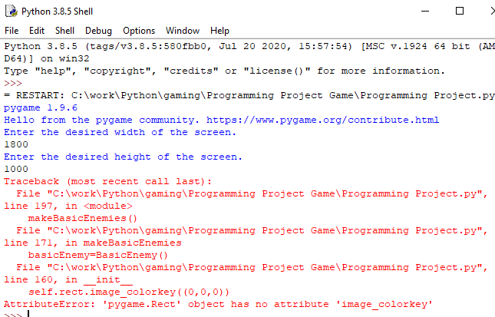

When I tried to run the program, I found that I had wrote self.rect.image instead of self.image.set.

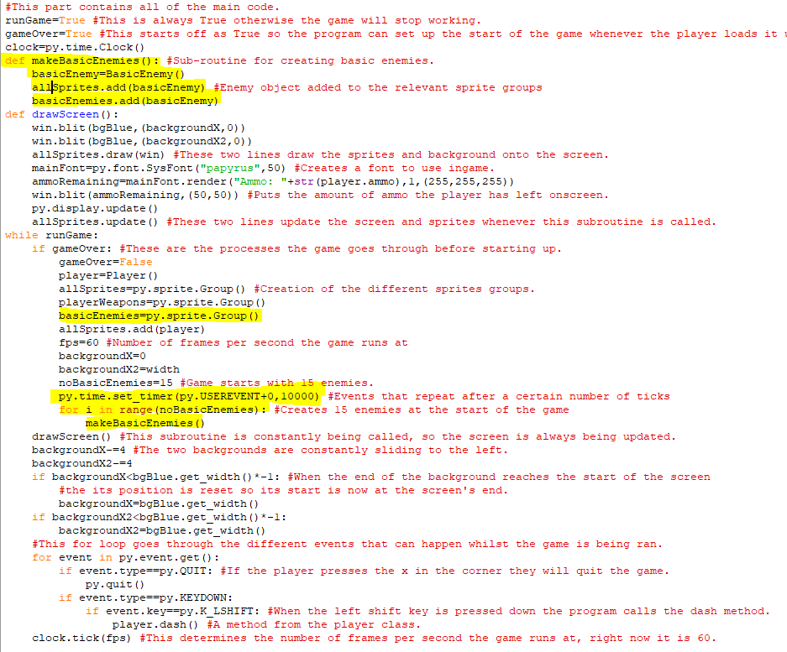The highlighted code is what has been added to the main program. The subroutine at the top creates an enemy object from the BasicEnemy class and then adds it to a newly created sprite group for basic enemies so that collisions between basic enemies and players and player weapons can be handled. The next highlighted line is the creation of that sprite group and after that I have added in a timing event so that later, every 10000 ticks, a new wave of enemies will spawn. Because this is in the if gameOver statement, it will be reset when the player loses all their health once I implement that. Finally there is a for loop used to call the makeBasicEnemies subroutine to make fifteen enemies at the start of the game.

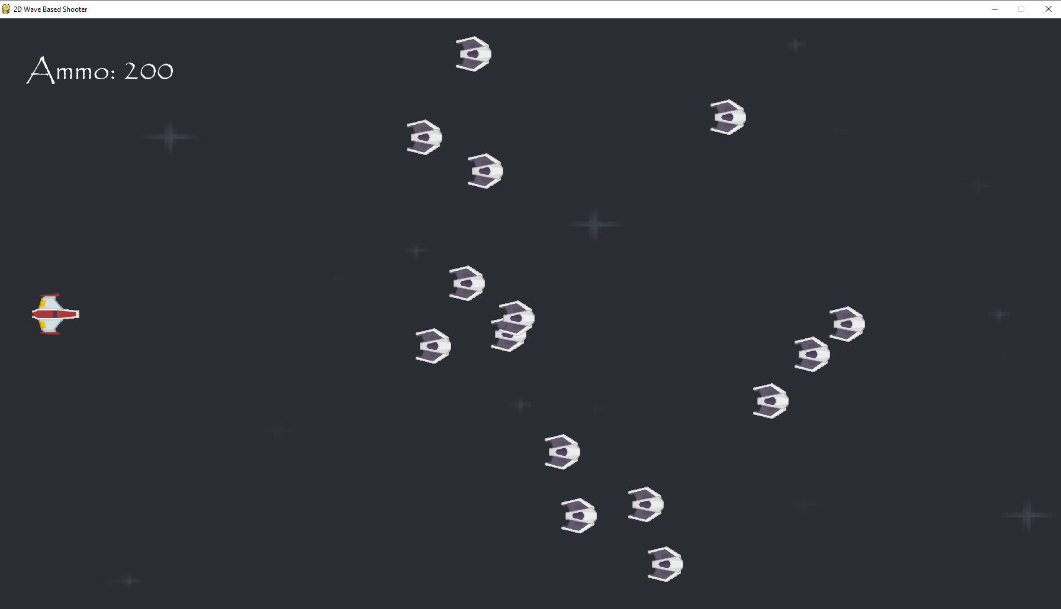  
The initial wave of enemies appears onscreen the game fine. They all have randomised positions with both their width and their height.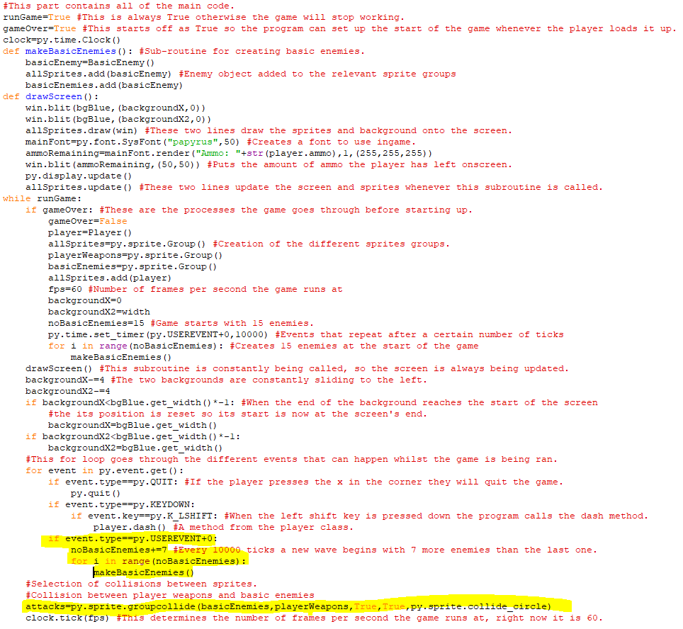The first chunk of highlighted code makes so that every time that event is triggered seven more enemies are added to the number of basic enemies per wave and that that number of enemies are created onscreen each new wave. Since the event fires every 10000 ticks or frames, the waves are 10000 ticks apart. The single highlighted line of code makes it so that when a player’s weapon collides with a basic enemy ship both objects will disappear. The hitbox for the enemy spaceship is the radius that was determined earlier so it has a circular hitbox.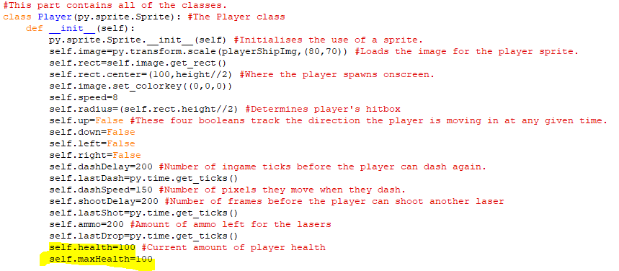The highlighted code is the attributes for the player’s current amount of maximum amount of health.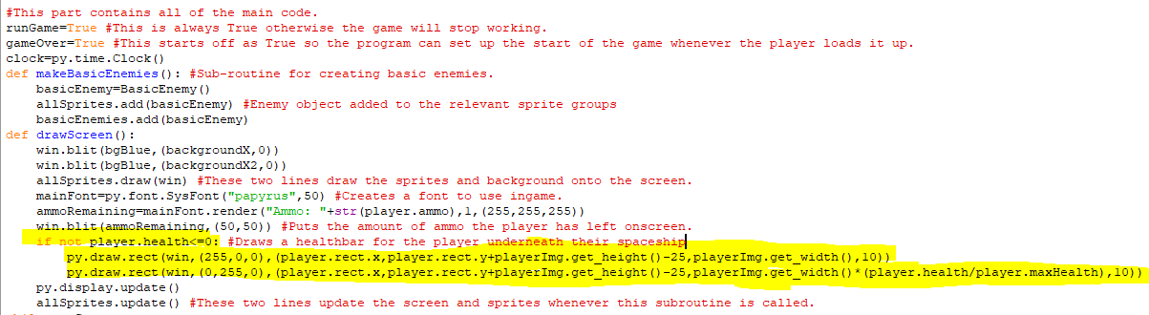The highlighted code creates a healthbar for the player so they can check how much health they have left in game. It places a green rectangle over a red rectangle and whenever the player takes damage, some of the green rectangle is lost and more of the red rectangle will become visible. When it is fully red, the player will have lost all their health and the game will end.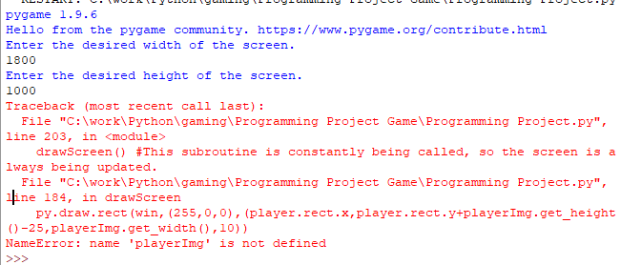When creating the health bar, I used playerImg instead of playerShipImg.

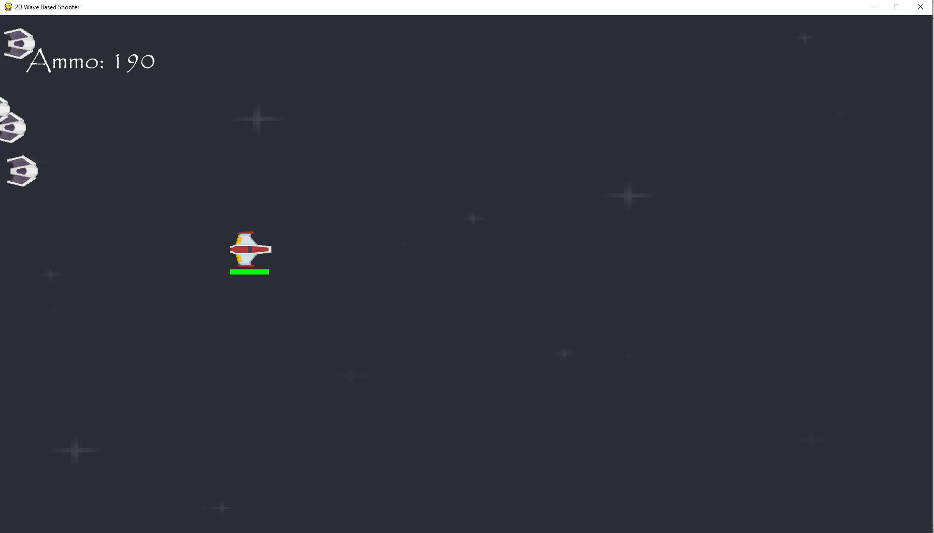  
The health bar is visible beneath the player.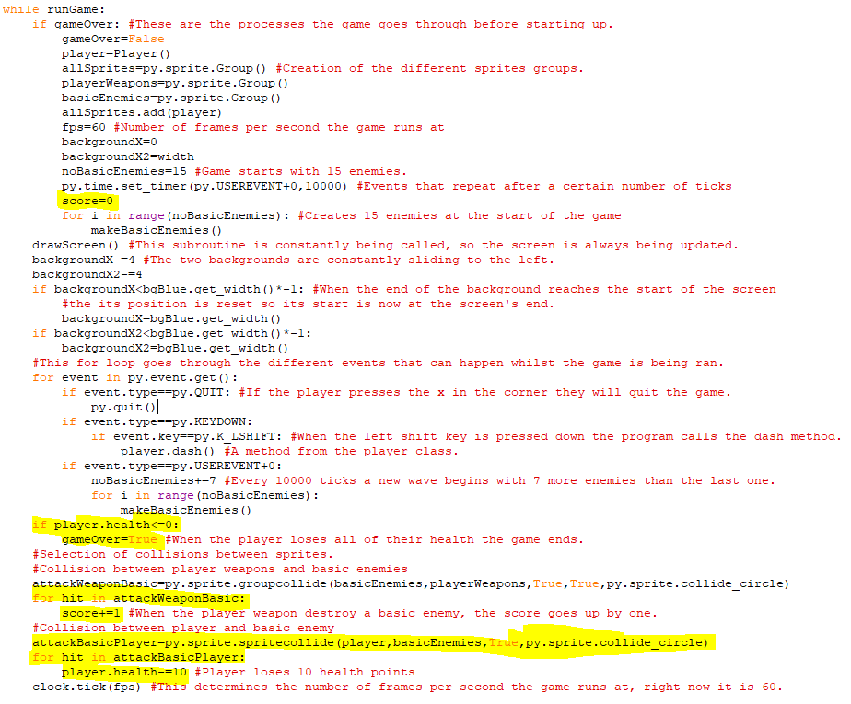The first highlighted line creates a score variable which starts off at zero. The next two highlighted lines make gameOver=True when the player’s health is less than or equal to 0. This means that when the player loses all their health, the game will be reset with the number of enemies being reset back to 15 and the timing events, positions of the backgrounds and the player score is reset as well. The following two lines make the player’s score increase by one every time an enemy ship is destroyed. The final three highlighted lines make it so that when the player spaceship and an enemy spaceship collide, the enemy ship disappears, and the player loses 10 health points.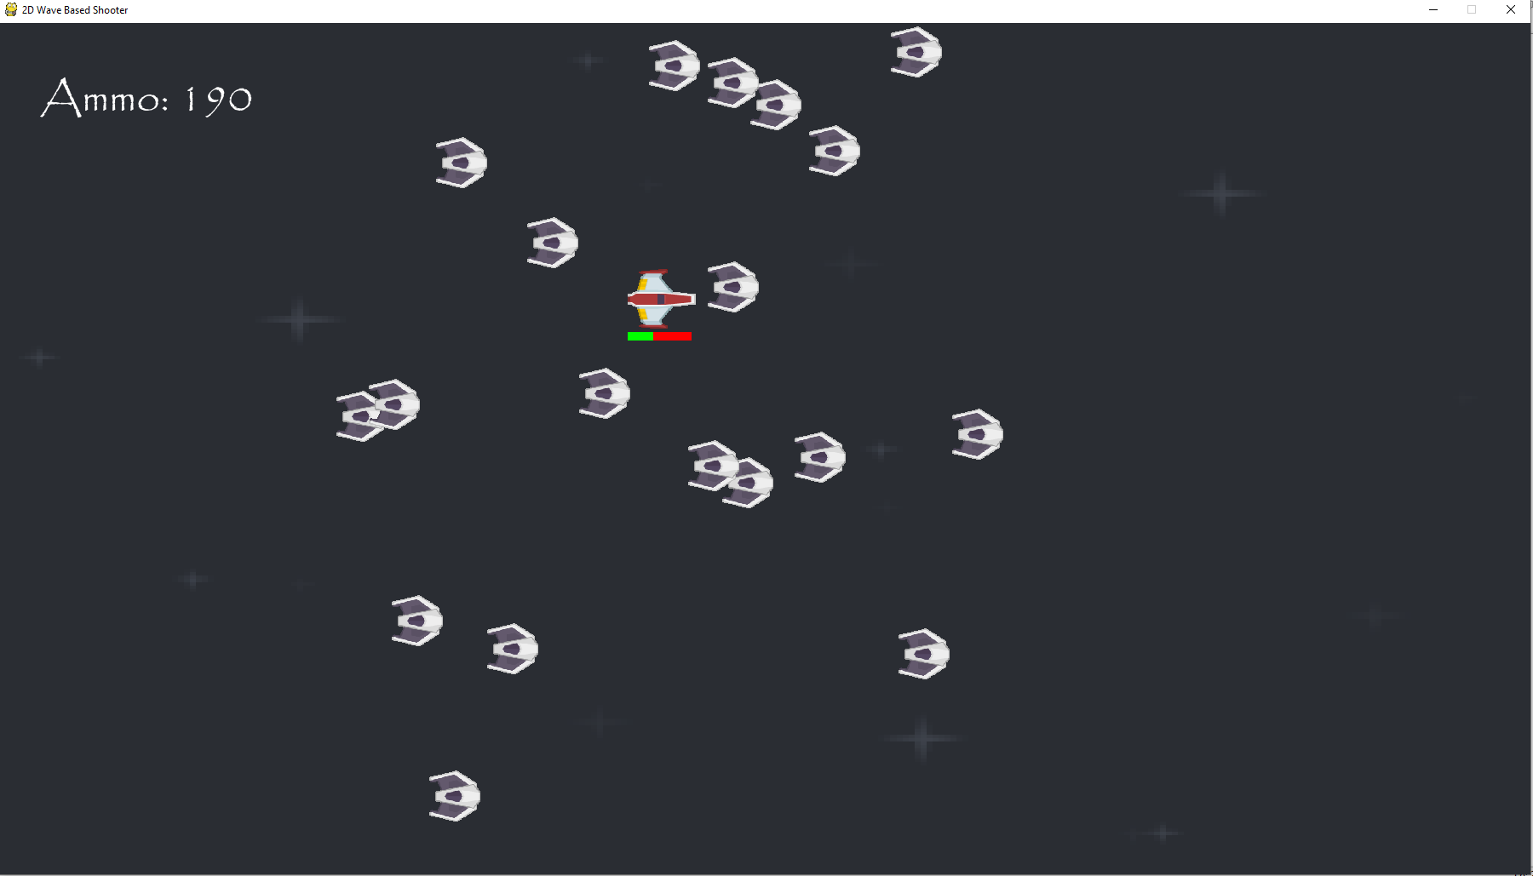  
Colliding into enemies makes the player lose health as seen from the health bar’s status.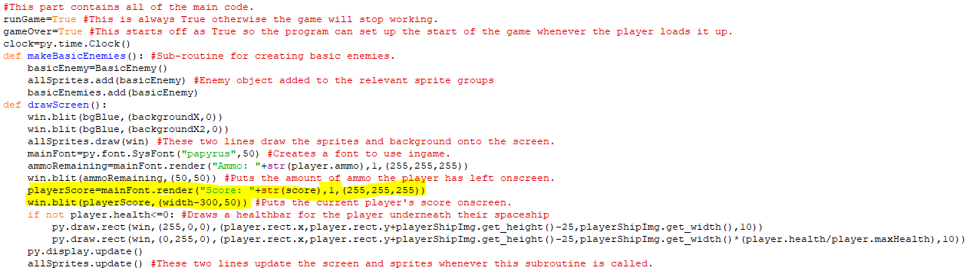This highlighted code displays the player’s current score on the top righthand corner of the screen and it increases when the player destroys enemy spaceships.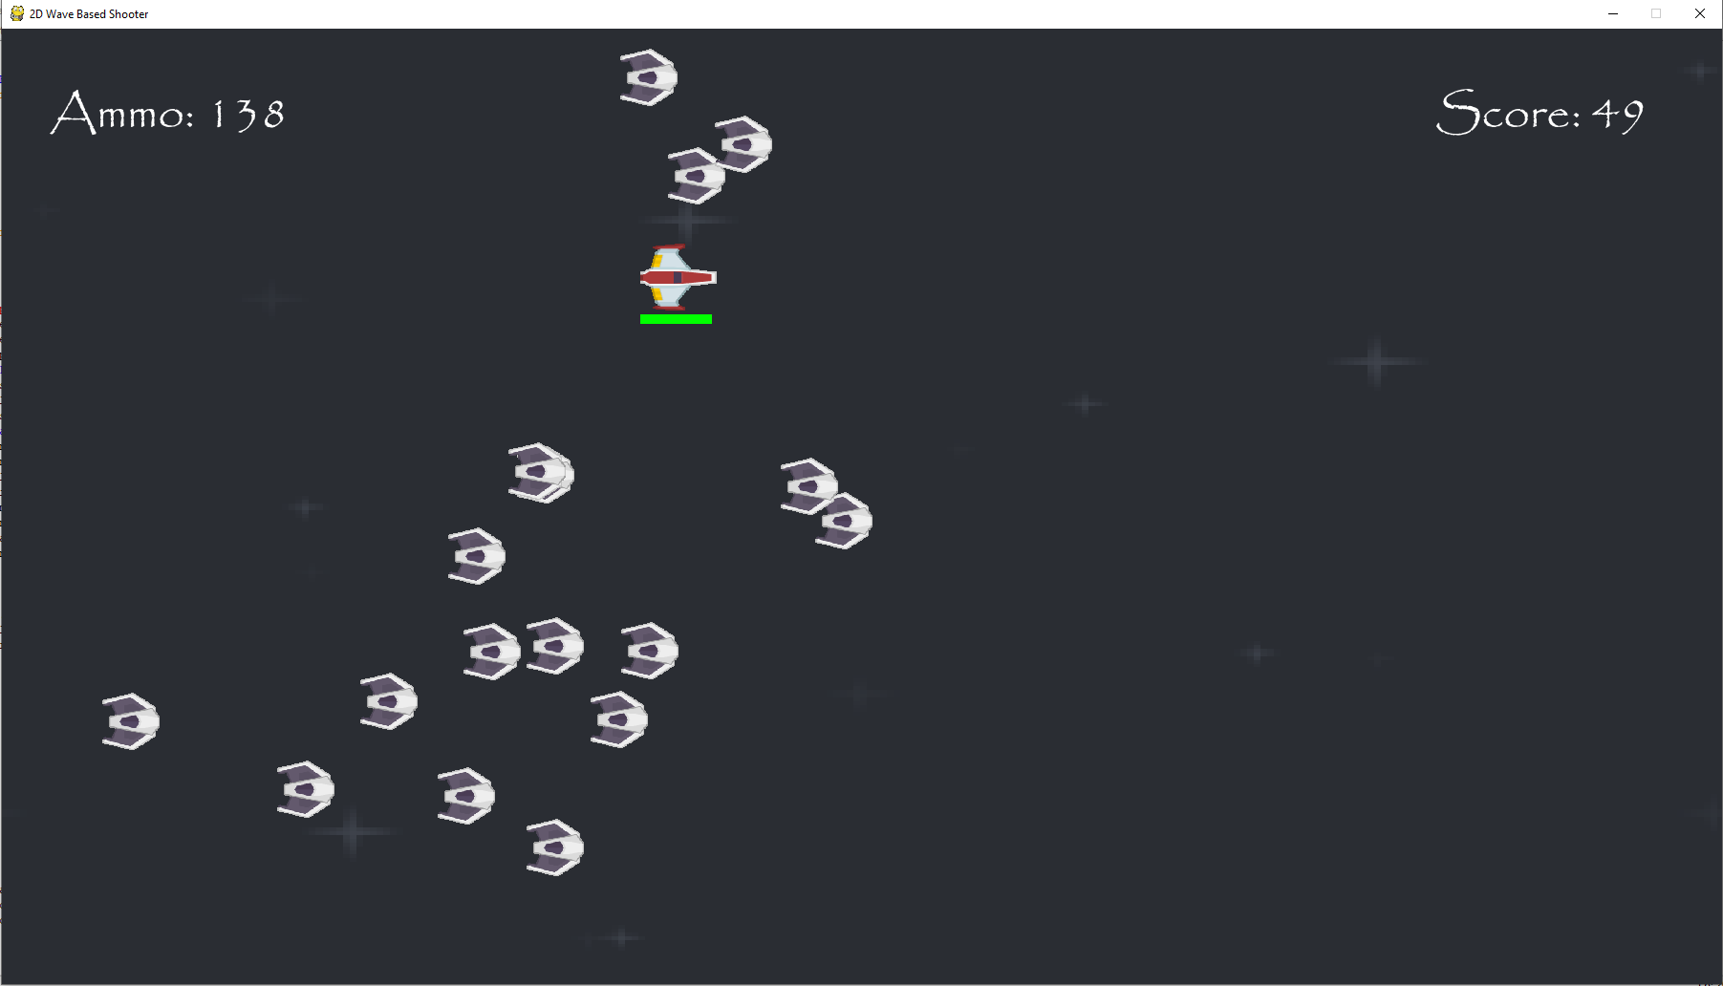  
The score increments whenever an enemy is destroyed, and waves are occurring one after the other regularly. 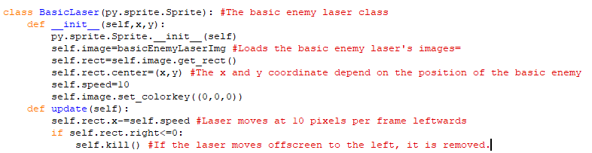This is the class for the laser that the basic enemy shoots out randomly at any given time. It will spawn in right in front of the enemy when its class is called and will then move until it either collides with a player or moves offscreen, in both instances it is then removed from the game. It works similarly to the player laser, but it moves in the opposite direction and harms players, not enemies.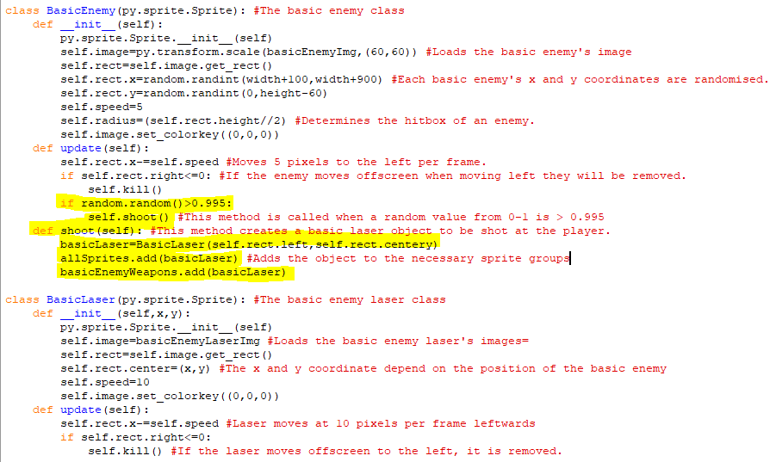The highlighted code adds a new method to the basicEnemy class which creates objects from the basicLaser class to be fired at the player and adds it to a new sprite group called basicEnemyWeapons which contains sprites that will collide with the player and player weapons.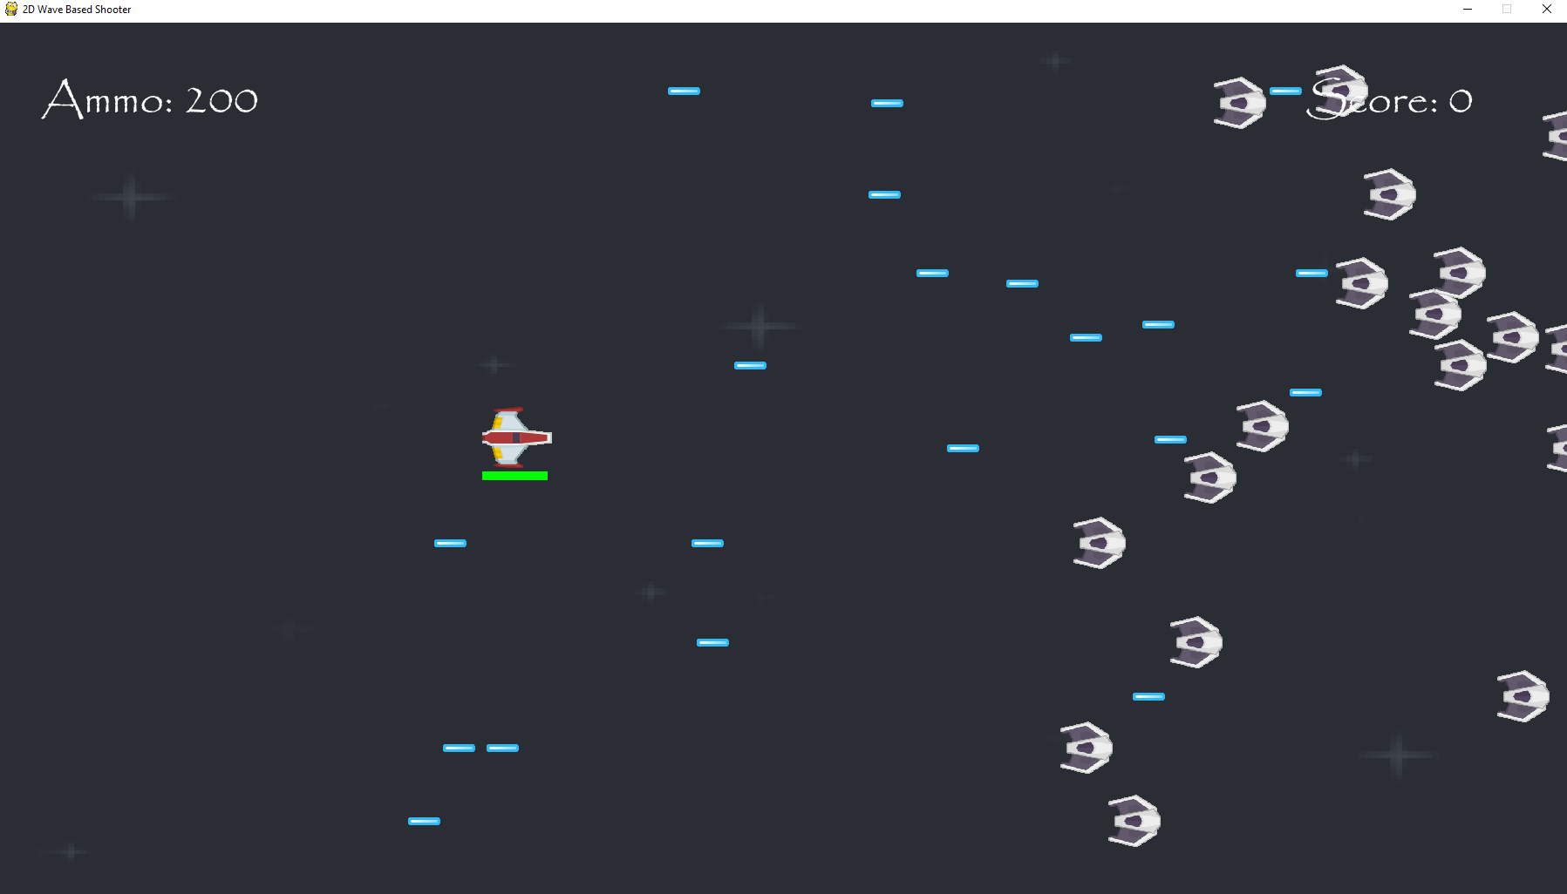  
The enemy lasers are appearing onscreen like they should.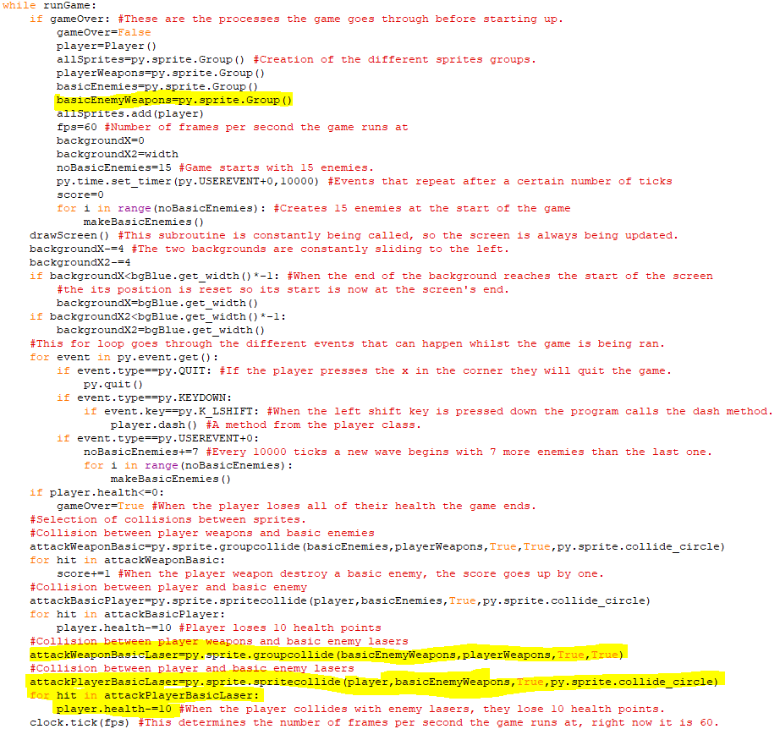The first highlighted line is the creation of the aforementioned basicEnemyWeapons sprite group. The next highlighted lien makes the player and enemy lasers disappear when they collide, and the next chunk of highlighted code makes the player lose ten health points when the enemy lasers collide with the player’s hitbox which is determined by the radius attribute in the player class.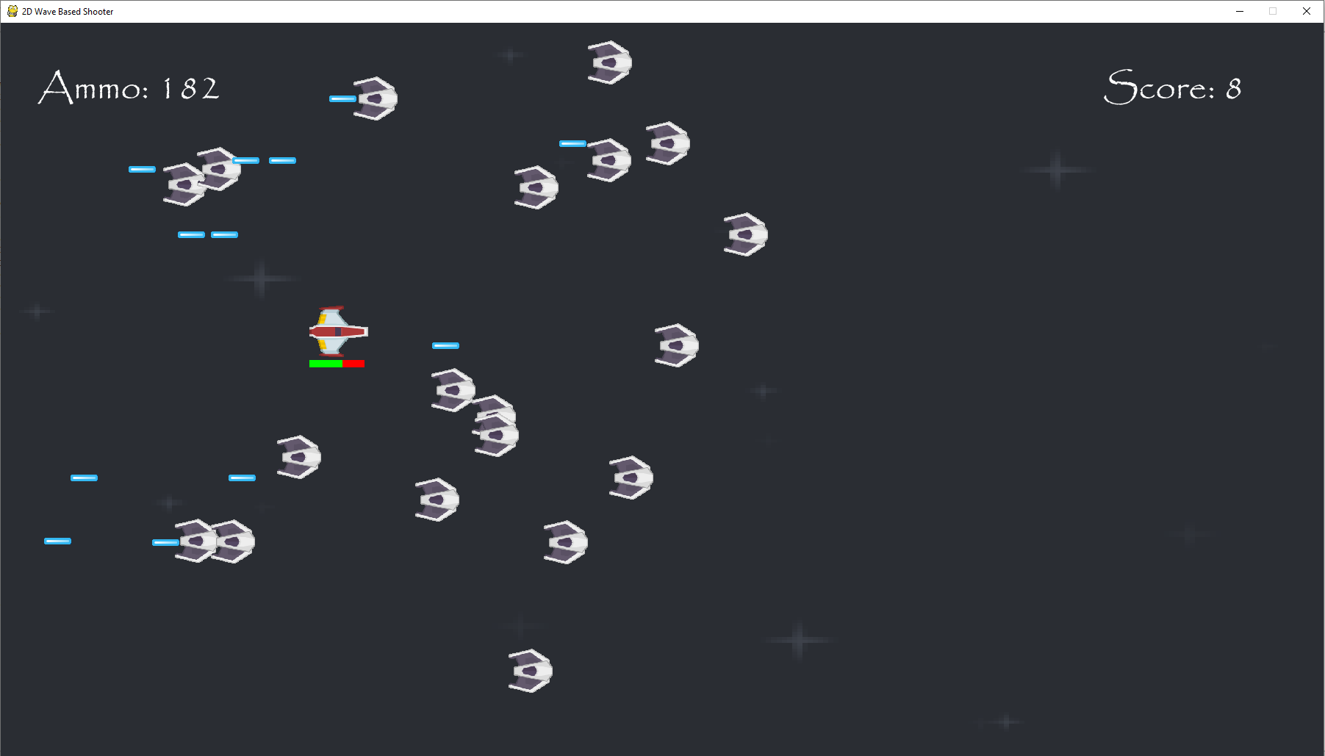  
Enemy lasers are successfully damaging the player spaceship and player lasers are colliding with enemy lasers successfully as well.

Stage 2 Review

In Stage 2, I introduced the two weapons that the player would use with lasers moving horizontally and bombs move vertically and set an ammo limit for the player lasers. There are now also waves of basic enemies that appear, with their numbers increasing each wave. These basic enemies can fire blue lasers at the player which will make the player lose health. Once the player loses all their health the game will restart automatically as I will implement a main menu for the game later. Moreover, a scoring system is now in the game with the player gaining points when they destroy enemy spaceships using their weapons.

For the success criteria, I have introduced the scoring system to be used in the game which is functional as when an enemy is destroyed, it increments by 1, however the scores aren’t currently saved at the end of the game when the player is destroyed. I have also incorporated a health system which makes the player lose health when they collide with the enemy weapons or other hazards as mentioned before and these basic enemies are fought in continuous waves. Eventually, I am going to add more types of enemies that will be fought later as well as some bosses.

Client Feedback:

You have two weapons (bomb and laser) which means you can use a variety of strategies and the score and health work well so you lose health when collide with enemies and projectiles and gain score points by shooting enemies. But as there is currently only one enemy type it can get quite repetitive

Stage 3- Hazards and Powerups

**In this stage, the part of the success criteria I am going to achieve is:**

* **Adding powerups to the game.**

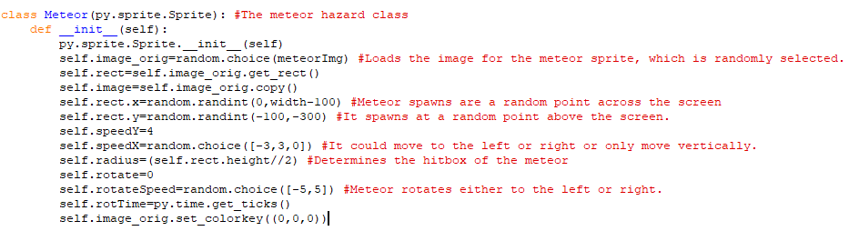This is the class for the meteor hazard and so far, I have initialised its attributes. The class has two image attributes because I am going to write methods which make the meteors rotate whilst falling and second image is needed to change the first one. The image that it uses is randomised from either a small meteor, two medium ones or a large one. The meteor will be placed at any point across the screen so they could fall and across the screen at any point and they will begin a random number of pixels above the screen, so their falling looks natural. the speedX attribute will also randomly make the meteor move either to the left, the right or vertically so that they are more challenging to dodge.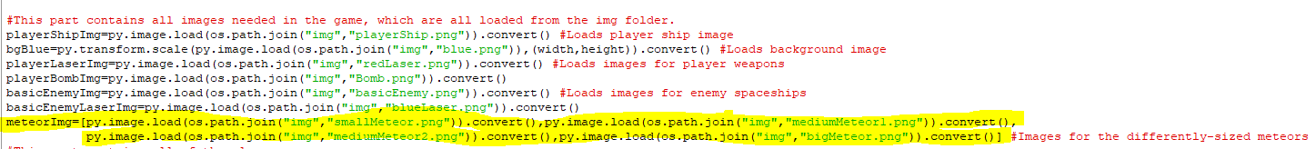Code for the meteor images used.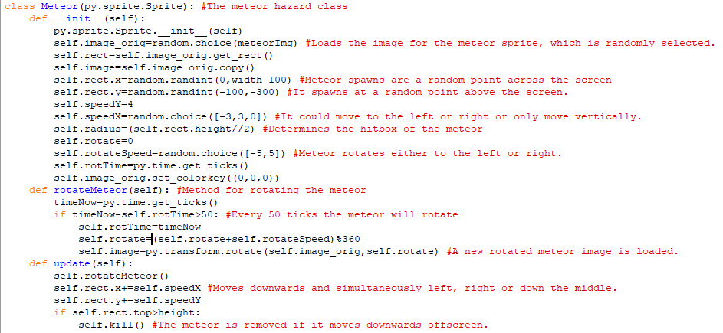The first method added to the meteor class allows the meteor to rotate by rotating the meteor by 5 pixels to the left or the right every 50 frames. The rotation itself changes the preexisting image to a new rotated one. Whilst this happens, the second method is making the meteor move downwards whilst also moving either to the right, left or down the middle and if the meteor moves below the screen, then it is removed from the game.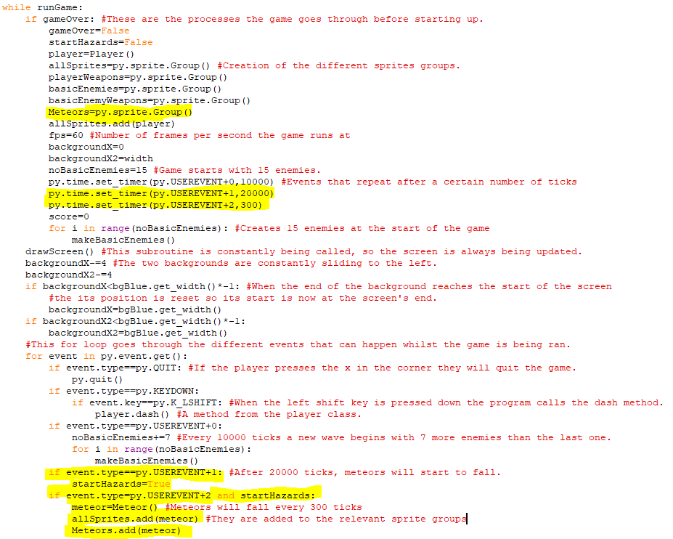The first highlighted line creates a new sprite group for meteors. The next two lines of code are two timing events. The first timing event means that meteors will only start falling after 20000 ticks since at that point the startHazard variable becomes True and once the startHazard variable is True then every 300 ticks a new meteor will fall from the sky which is shown in the second timing event and its corresponding code in the final chunk of highlighted code.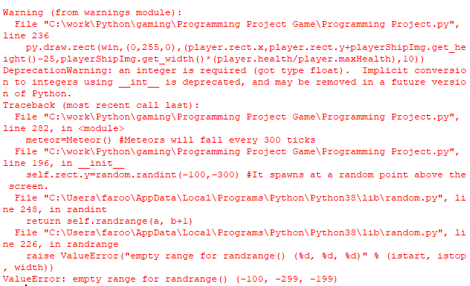When writing the initial y coordinate, I wrote player.rect.y=(-100,-300) instead of player.rect.y=(-300,-100) which meant that it wasn’t in the accepted range.

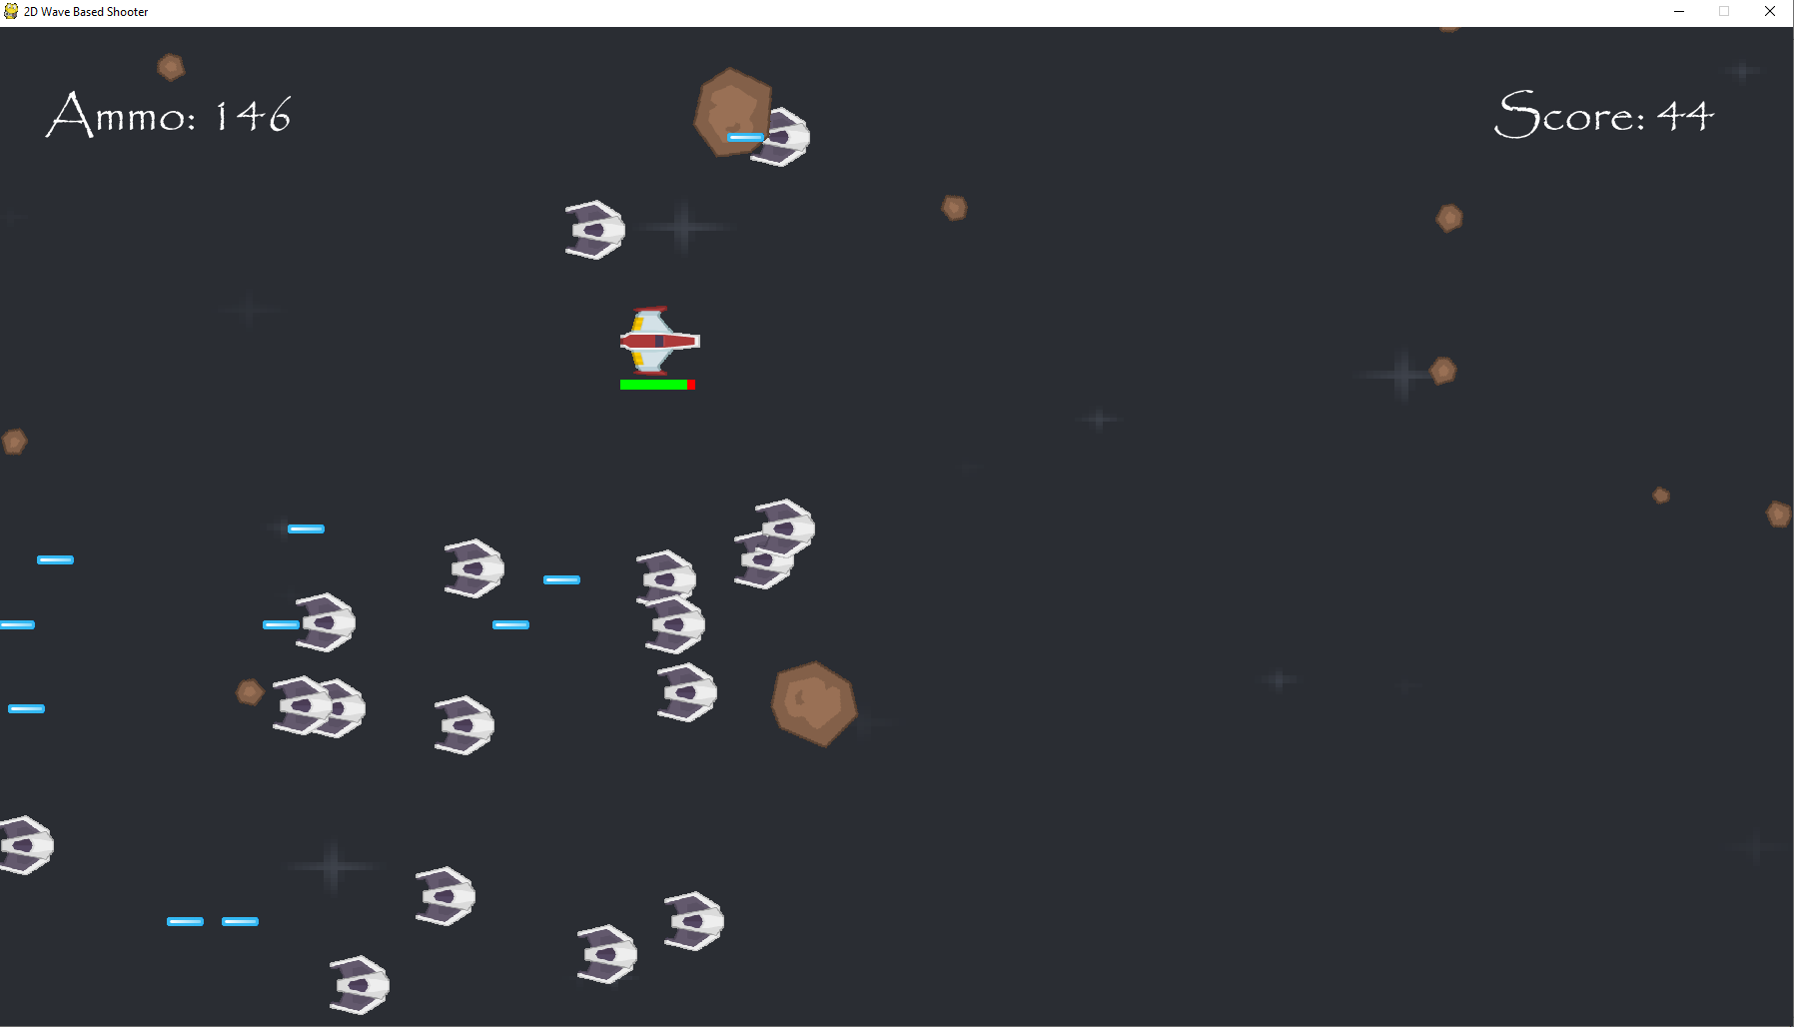  
Meteors of multiple sizes and directions are now falling from the sky.

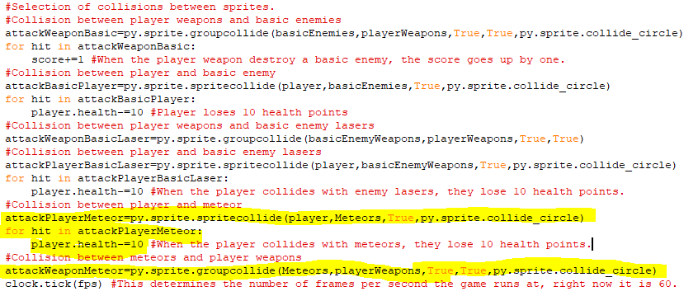The first chunk of highlighted code determines what happens when a player spaceship collides with the meteor. When this occurs, the meteor will disappear, and the player will lose ten health points. Currently, when the meteor is hit by the lasers, the meteor and laser will disappear, but later meteors will have a certain chance of dropping a powerup.

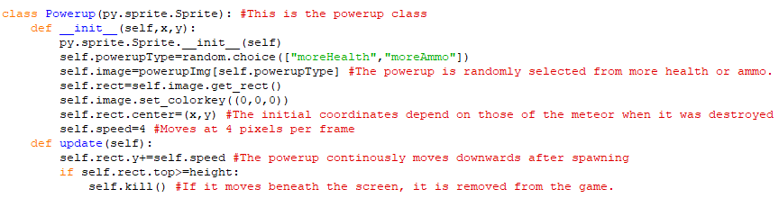This is the class for the powerups that have a chance of spawning from meteors. When an object is created from this class, the image used is randomly selected from a shield for more health and a star for more ammo as those are the powerups that are currently in the game. The powerup will also spawn in at the position of the meteor when it is destroyed and moves at a speed of 4 pixels. The method for the powerup makes it move downwards and then removes it from the game if it moves below the screen.

A dictionary has been used to store the images for the powerups, which makes it very easy it add in more powerups later if I want to.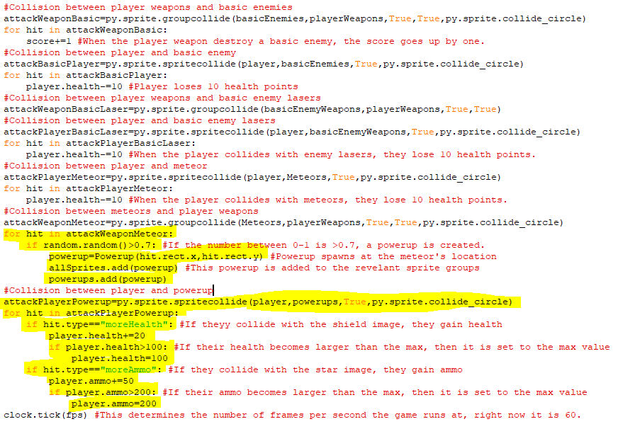The first chunk of added highlighted code states that when a meteor is destroyed by a player weapon then if a randomly generated number between 0 and 1 is more than 0.7 then a powerup object is created which will randomly either be for additional health or ammo. The object is added to the powerup sprite group so that it can interact separately with the player sprite. The next chunk of code is for a collision between the player and the powerup. If the player collides with a health powerup, then they will gain 20 more health points but if that gives them more than 100 health points then their health is set to 100. Similarly, picking up ammo powerups makes a player gain 50 more lasers but if they have more than 200 pieces of ammo then their amount of ammo is set to 200.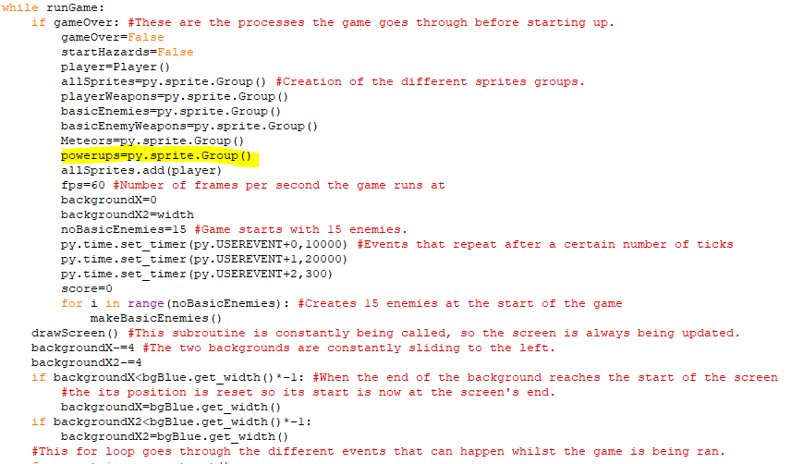

Here is where I added the new sprite group.

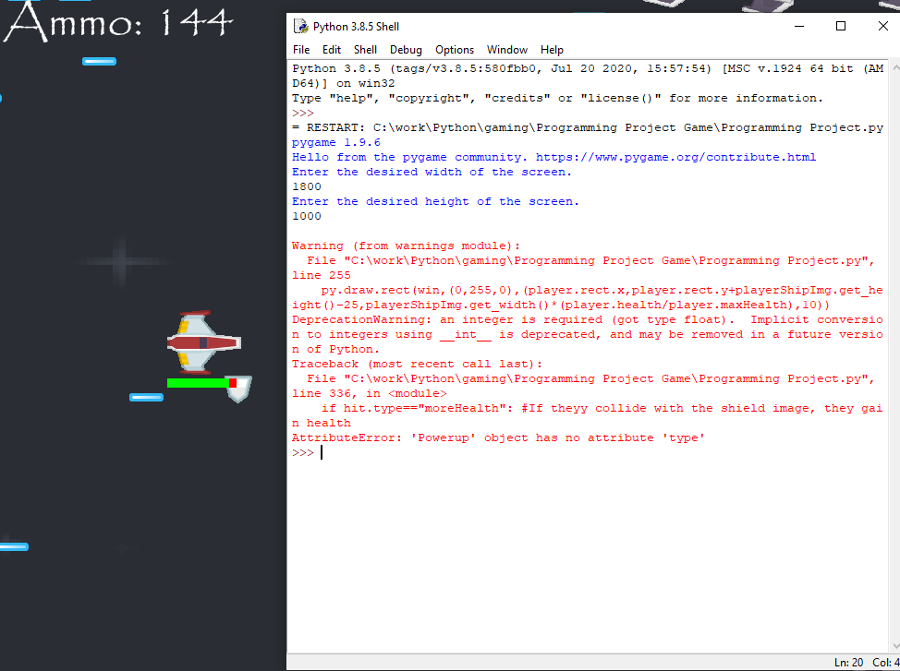This message popped up when the player spaceship collided with the powerup. The problem is that I wrote "hit.type" in the collision between player and powerup when the powerup class doesn’t have a” type” atttribute, it has a ”powerupType” attribute. So, I need to change what I wrote in the collision section.

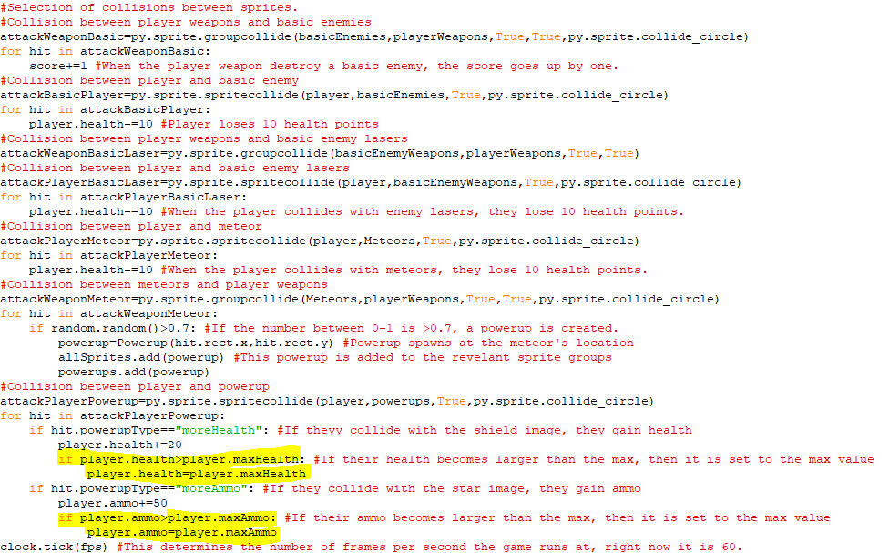I changed those attributes and made the player’s health and ammo reset to a maximum health and ammo (which are currently 100 and 200 respectively) so that in the future, the player will be able have upgrades that increase their maximum health and ammo and this part of the code will follow that when powerups are gained. A maxAmmo attribute was created in the player class for the second highlighted chunk of code.

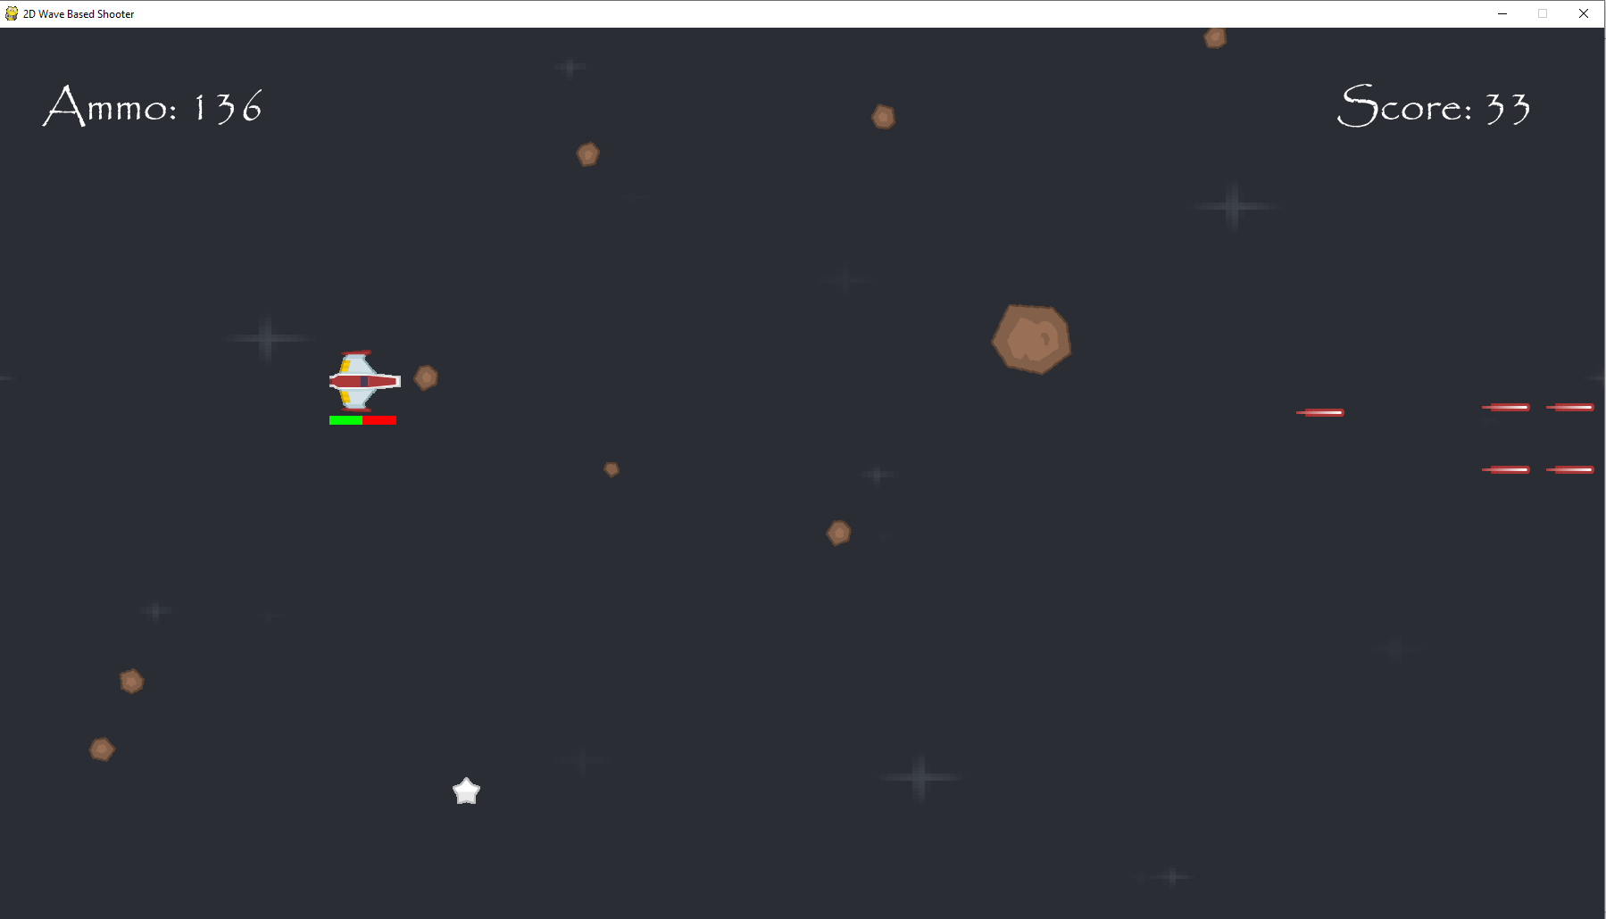Collisions with the powerups are now functioning properly. You gain health when you hit the shield and you gain ammo back when you hit the star unless you have maximum levels of them.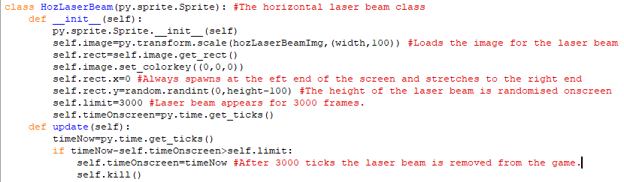This is the class for the horizontal laser beam. It will appear onscreen for 3000 frames has been stretched across the whole screen. Its height is randomly selected at a point onscreen. This laser beam is different from the one in the design section as it appears after a warning and stays in one place across that portion of the screen, rather than the laser moving across a smaller section of the screen. That laser beam might be used with the boss fight later.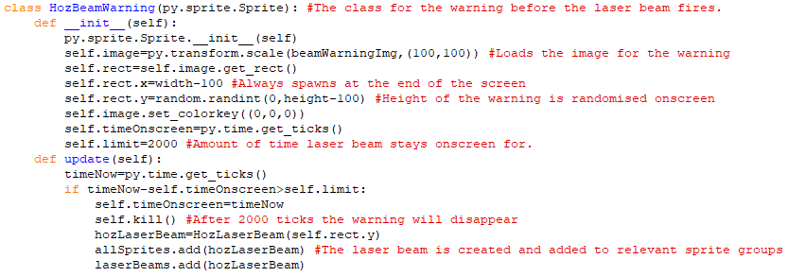The is the class for the warning that appears before the horizontal laser beam appears. It has the same height as the laser beam itself but isn't stretched as far. Its y-coordinate is randomised on some position on the screen, but its x-coordinate is always on the right end of the screen. The update method means that once an object is created from the warning, it will stay onscreen for 2000 ticks before the laser beam is created at its y-coordinate and stretches across the screen. The laser beam is added to the laser beams sprite group so that it can deal its own amount of damage to the player. 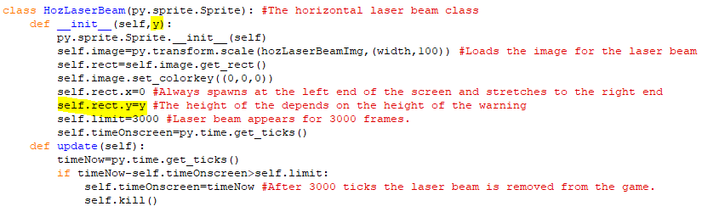I changed the initial y coordinate of the laser beam so that it is equal to the y coordinate of the warning when it disappears instead of being randomised as it spawns where the warning symbol was.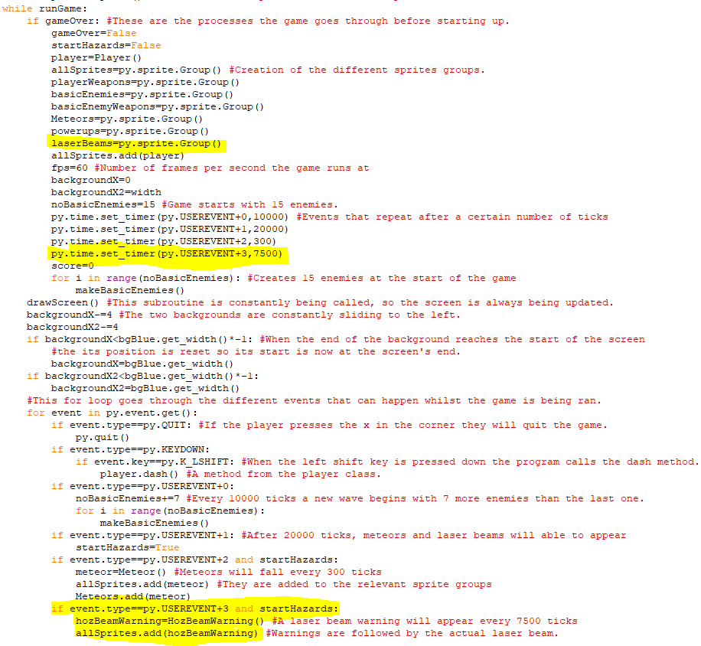The first highlighted line is the creation of the laser beams sprite group. The second highlighted line creates a timed event that triggers every 7500 ticks. The chunk of highlighted code at the bottom is for the timed event for the laser beams. When startHazards becomes True after 20000 ticks, the warning and every 7500 ticks afterwards, the class for the warning will be called and after the warning the laser beam will appear.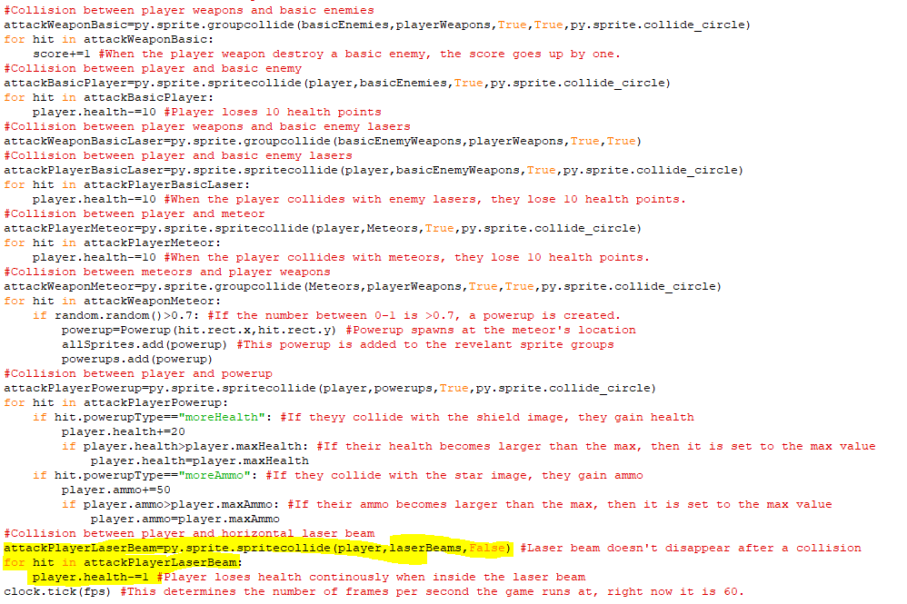The highlighted code is code for the collision between the laser beam and the player. When the laser beam and player collide, the laser beam won’t disappear. Instead, for each tick that the player is in the laser beam, the player will lose 1 health point. This means that laser beams will drain players’ health bars very quickly.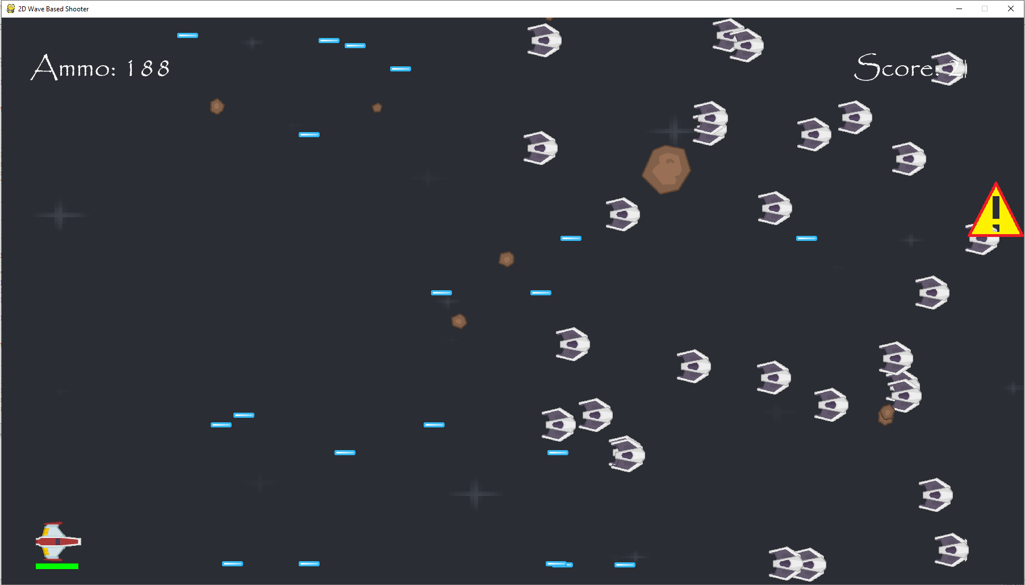The laser beam warning is showing up onscreen properly.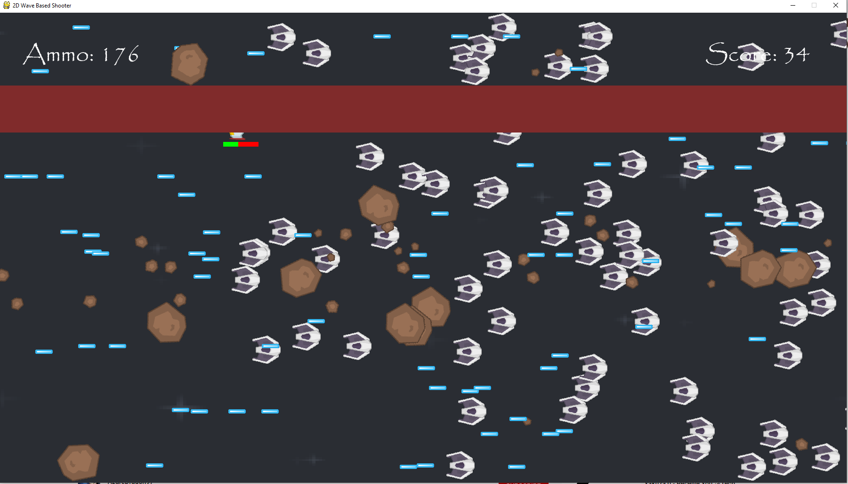

The laser beam does show up after the image and does continuously damage the player.

Stage 3 Review

In Stage 3, I introduced two additional hazards into the game: meteors and laser beams. The meteors fall from the sky and can damage the player and the laser beams will stretch across the entire screen from a point where the warning sign previously was. The frequency of both is controlled by some timing events that allow these hazards to trigger after a certain number of ticks and after that point they will trigger every either 300 or 7500 ticks. I have also given the meteors a 30% chance of dropping a powerup when they are destroyed and these powerups will either increase the player’s health or ammo but not more than their maximum levels.

For the success criteria, the health system has been expanded as it now must respond to more factors which increase and decrease its health, like the meteor and laser beams. In addition, powerups have been added with extra health and ammo powerups currently available which will increase the player’s health and ammo.

Client Feedback:

Adding big lasers and meteors adds more variety to the game as there are more things to dodge along with the risk-reward aspect of them as they drop health and ammo but it can be risky to try and get them.

Stage 4- Harder Enemies and the Boss

**In this stage, the parts of the success criteria I am going to achieve are:**

* **Introducing new enemy types over time.**
* **Expanding the health system for different kinds of attacks.**

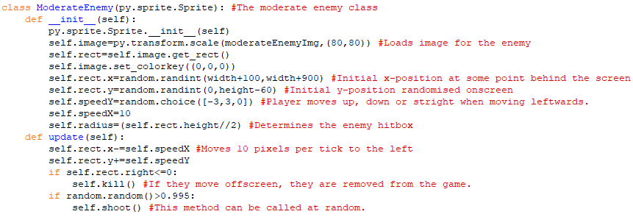This is the class for the more difficult enemies called moderate enemies. The size of these enemies is a little bigger than the basic enemies and they will fire two lasers at the player instead of one. The initial x and y coordinates are randomised in the same way as for the basic enemy, but now the moderate enemy moves faster across the screen and can also move up and down whilst moving across. The update method controls the movement of the enemy and they are still removed from the game when they move offscreen. The calling of a shoot method at the bottom won’t work until one has been implemented.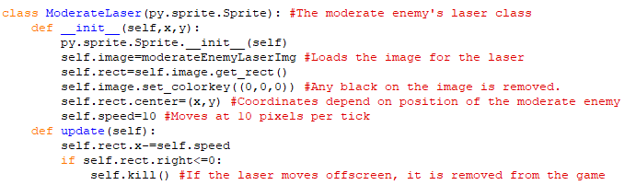This is the class for the lasers that the moderate enemy will shoot. It is functionally identical to the basic enemy laser, but it uses a different image and moves faster. I will later try to simplify the laser classes with the use of inheritance.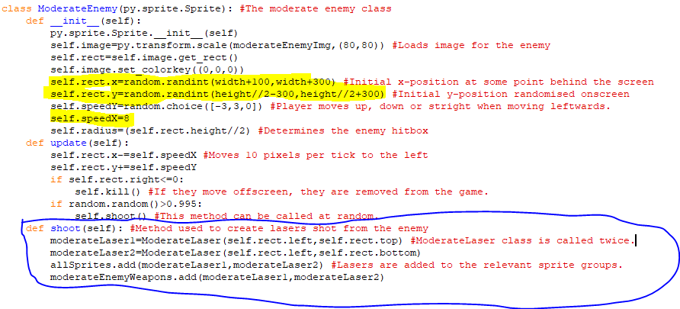The highlighted code is attributes that have been altered. I reduced the range of heights the enemy can be at and pushed them closer to the centre so that they won’t end up moving offscreen too early as they can move up or down as well. I also made their x-coordinate much closer to the right-hand side of the screen so that they won’t move above or below the screen before they appear onscreen. I also reduced their speed so that they don’t move across the screen too quickly. The circled method is the shoot method for this enemy. It is like the other enemy’s shoot method, but two lasers are shot from the enemy instead of one. A new sprite group was also created to allow for separate collisions between the player and these lasers as they will do more damage.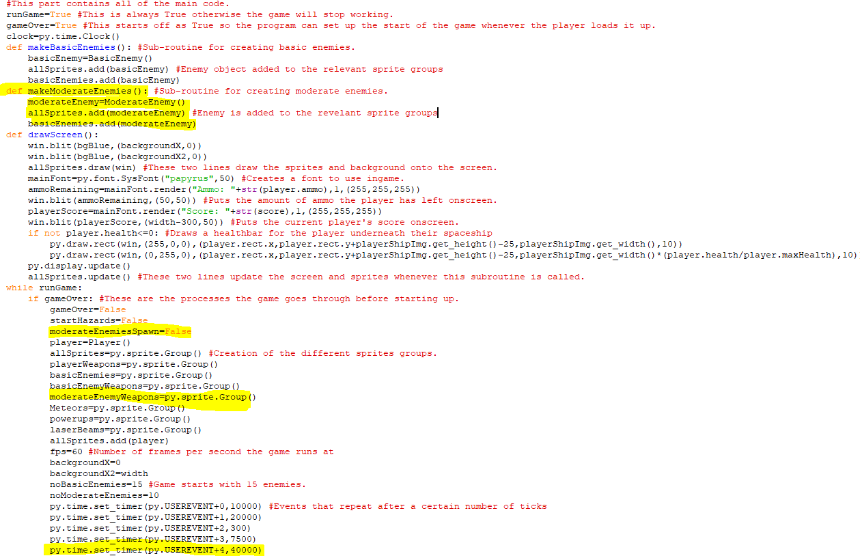The first chunk of highlighted code is a subroutine for creating a moderate enemy. An object of it is created using the relevant class and then it is added to the basicEnemies sprite group since there is no need for another sprite group to store these enemies in. The second highlighted line is the creation of the moderateEnemyWeapons sprite group and the line at the bottom is the timing event for when moderate enemies start appearing in waves, with them currently appearing after 40000 ticks so after 4 waves. The variable moderateEnemiesSpawn has also been created and is currently set to False, when it is set to True then moderate enemies will start spawning. 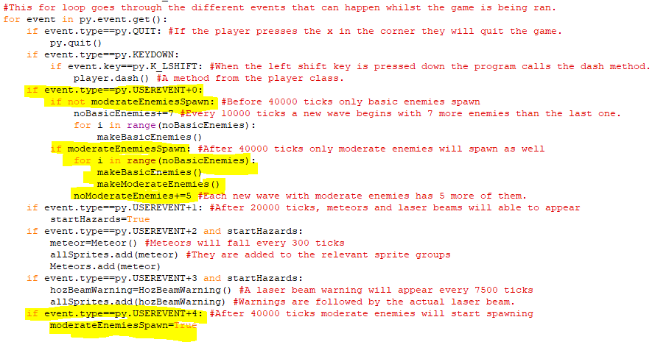The events of the first timing event (which is effectively each wave) have been altered so that when the moderateEnemiesSpawn is False only basic enemies spawn and there number increases by 7 each wave. But when moderateEnemiesSpawn is True then moderate enemies will spawn, and their numbers will increase by 5 each wave with the number of basic enemies in each wave now remaining constant. The last two lines at the bottom say that when 40000 ticks have passed and that event occurs, then moderateEnemiesSpawn is set to True.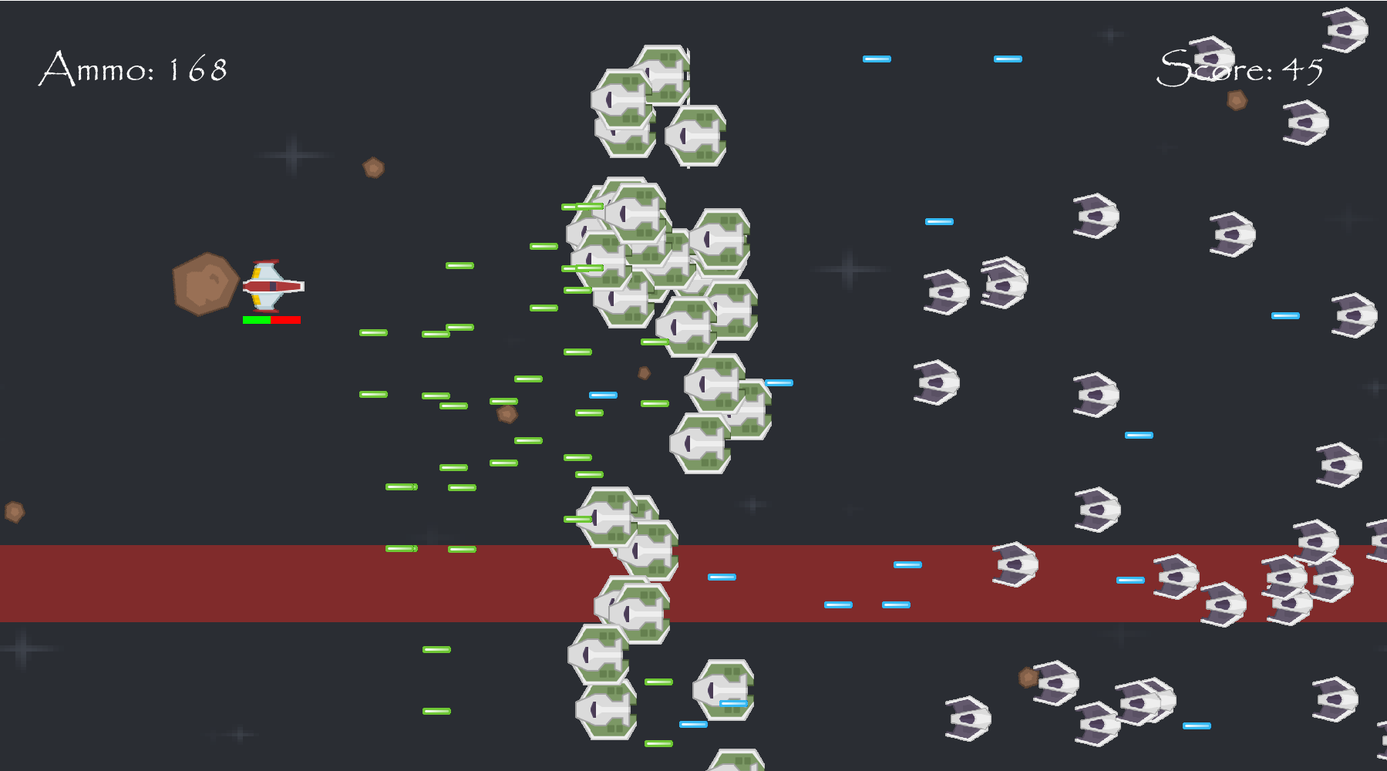The moderate enemies are successfully appearing but there are far too many lasers onscreen at once so I will cut down that down to one laser instead of two.I changed the method to only have one laser coming out of the moderate enemy at a time.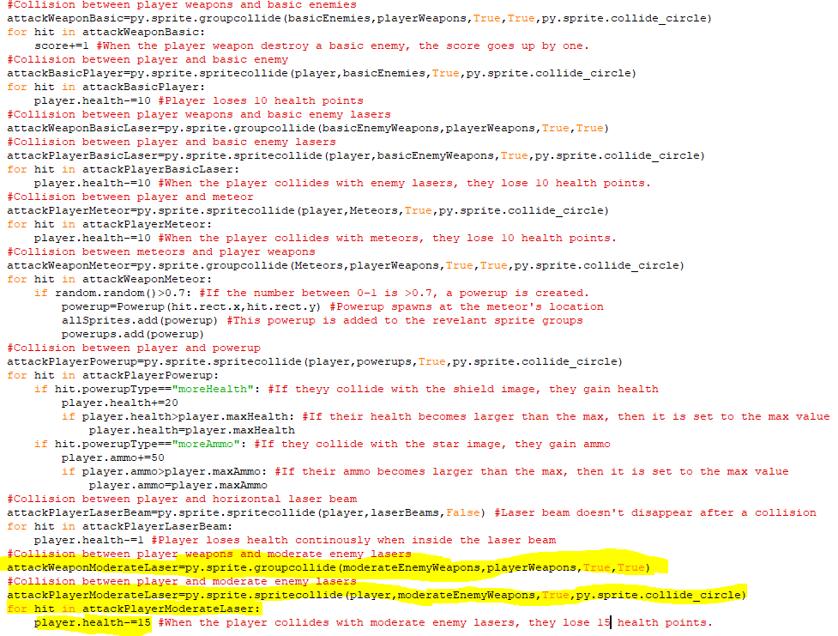The highlighted code is the collisions between player and moderate enemy lasers and between player weapons and those lasers. When player weapons and moderate lasers collide, they are both removed from the game. But when the player spaceship and moderate lasers collide the player loses 15 health points, which makes them more dangerous than basic enemy lasers which only make the player lose 10 health points.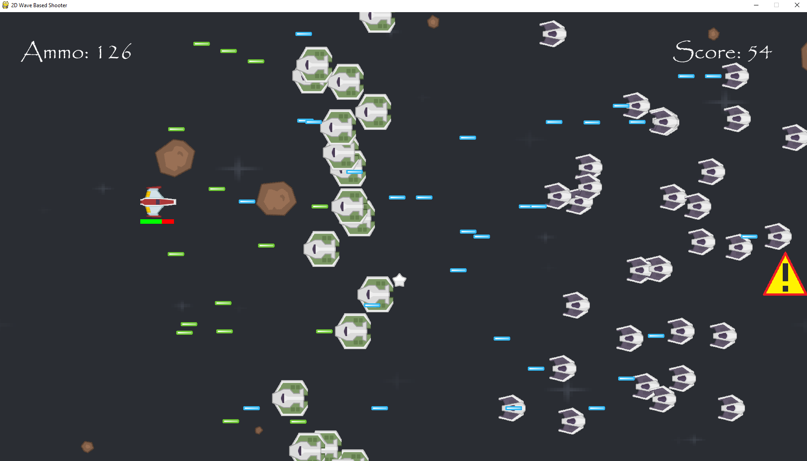The moderate enemies and moderate enemy lasers appear to be working properly, with the lasers deal 15 health points of damage upon collision and the enemies dealing 10. Player weapons can be used to destroyed moderate lasers before they collide with the player as well.

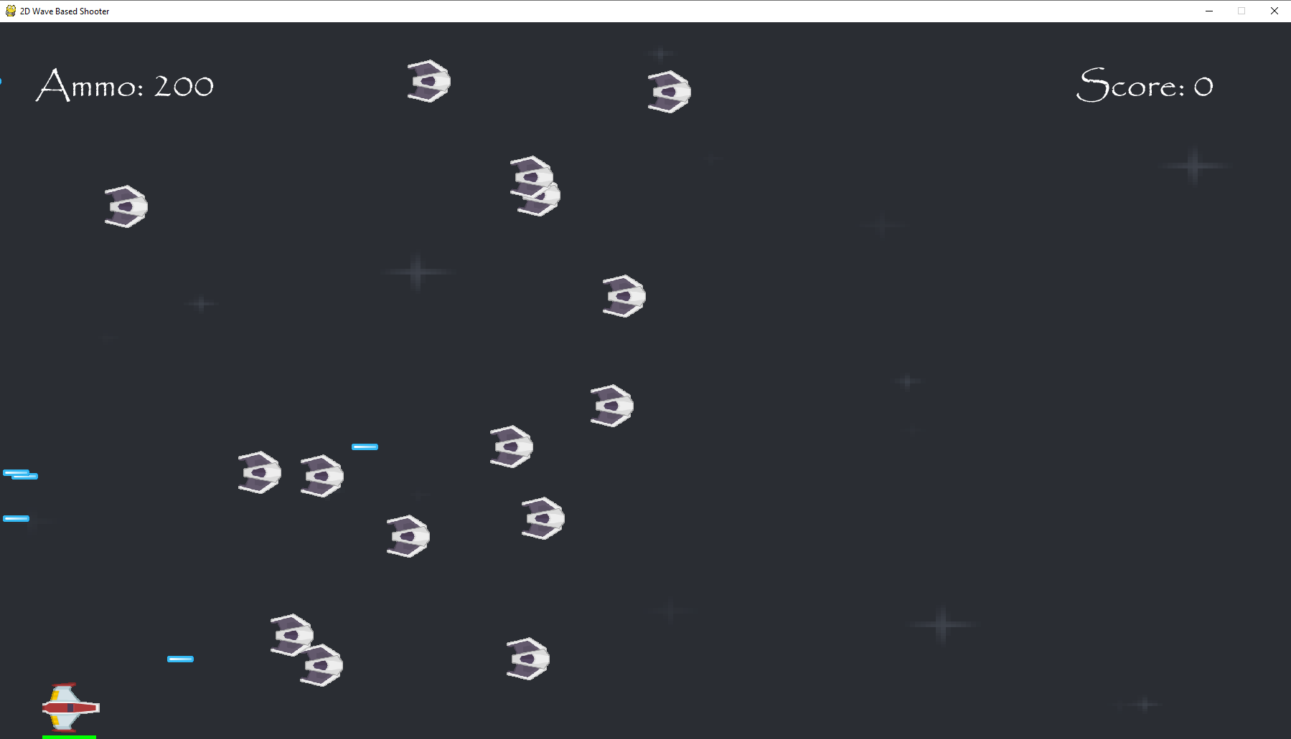When moving downwards I realised that bottom of the healthbar was beneath the screen when it should always be fully visible.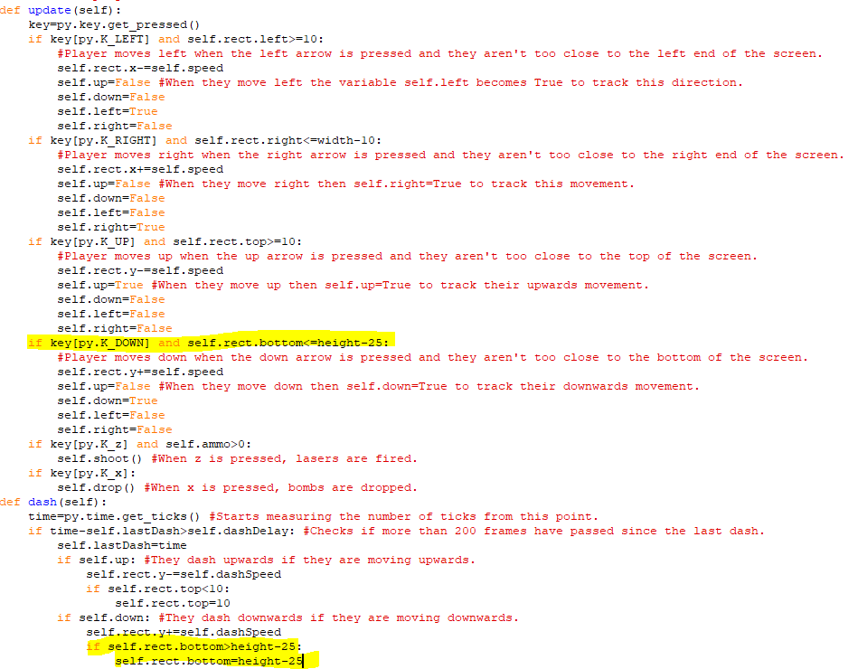In the player dash and update methods, I changed the lowest height you can go down to so that it is a little higher, so the health bar won’t go under the screen.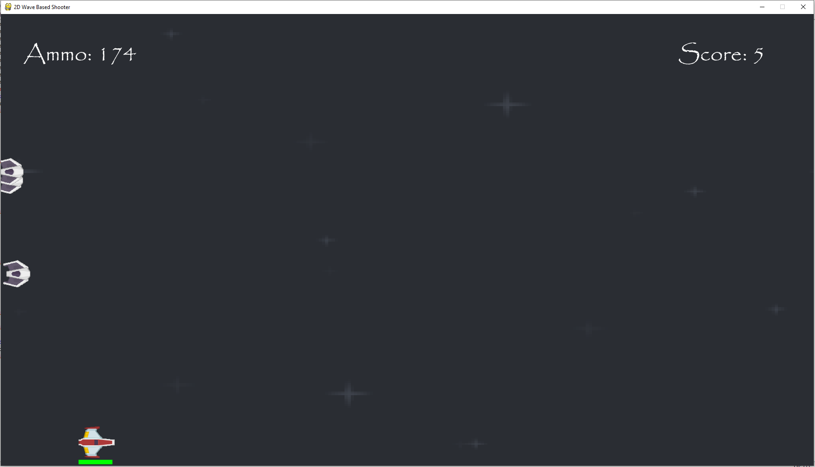You can no longer go so far down that the health bar goes under the screen.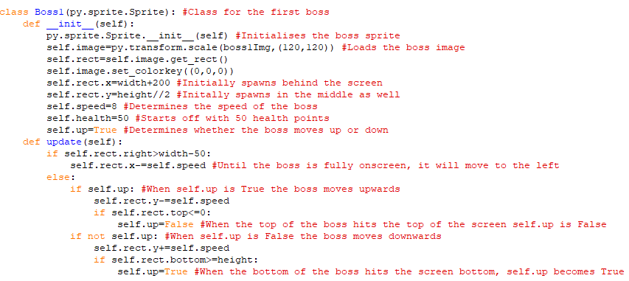The is the class for the first boss in the game. Its image is 120 pixels by 120 pixels, so it is bigger than the player and it starts off behind the screen. The boss also initially spawns a little bit behind the screen and close to the middle of it. Their speed is the same as the player’s and they start off with 50 health points and player deals one health point of damage when they land a hit. In the update method, the boss will move to the left until the right end of the boss is fully onscreen. After that, the self.up attribute determines whether the boss moves up or down and it starts off as True, so the boss moves up but when they reach the top of the screen self.up becomes False and they move downwards instead. Then when they reach the bottom of the screen self.up becomes True again and they move upwards, this continues until either the player or boss is destroyed.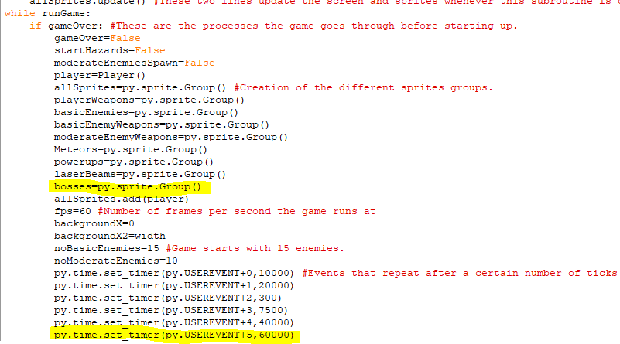I have created a sprite group for bosses and made a timing event for a boss to spawn in after 60000 ticks.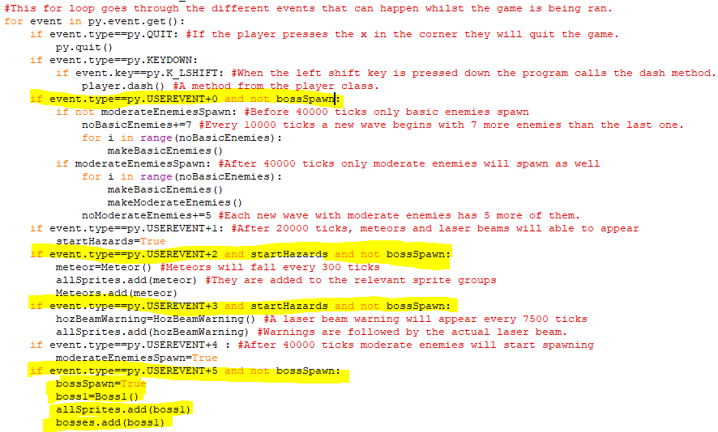The highlighted code at the bottom creates an instance of the boss class that is spawned into the game and is added to a new sprite group for bosses but once this has occurred the variable bossSpawn becomes True, so waves of enemies and other hazards won’t spawn until the boss is defeated.

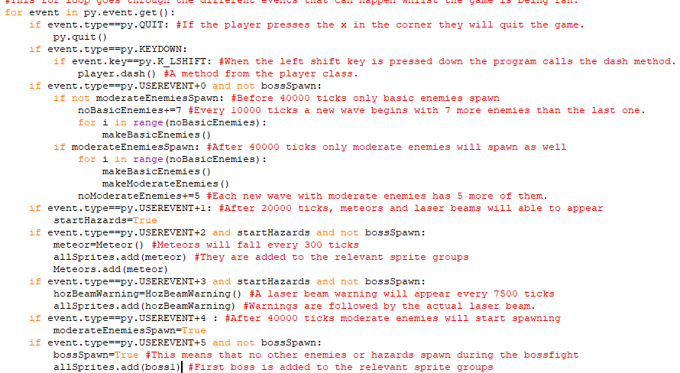I removed the bosses sprite group I felt it would be better for the interactions be with the individual boss sprites themselves, like with the player sprite. This meant that creation of the boss 1 object was moved to the start of the while loop.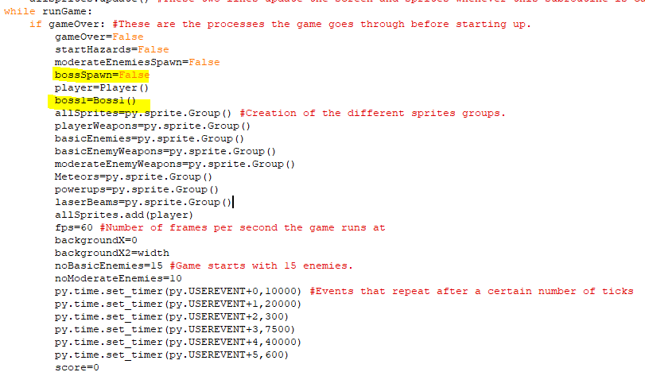This is where the creation of the boss 1 object was moved to, the bossSpawn variable is also declared here as False when the game starts.

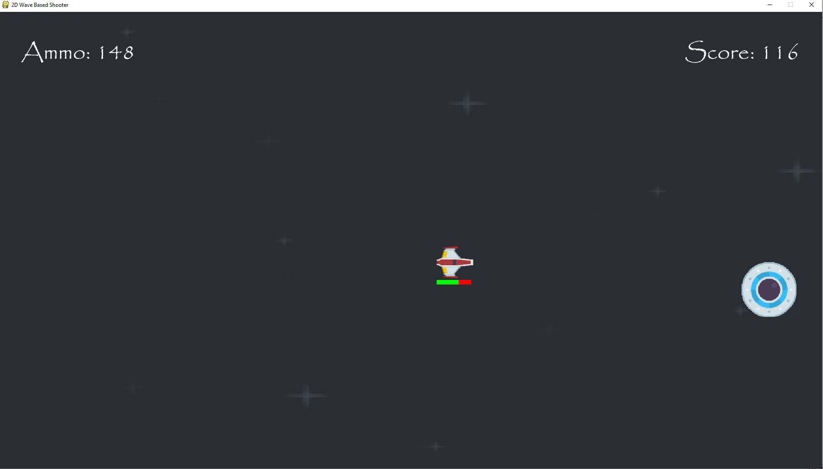The boss successfully spawns in the game and there are no other hazards onscreen at the same time.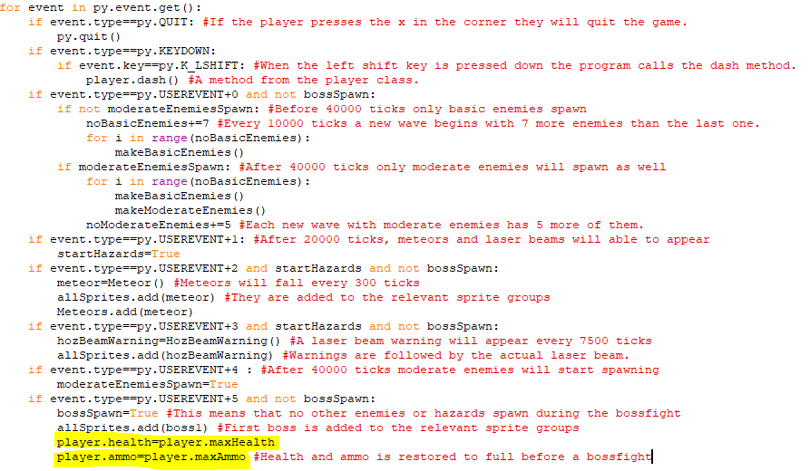The player’s health and ammo are restored to 100 and 200 respectively when boss fight is triggered.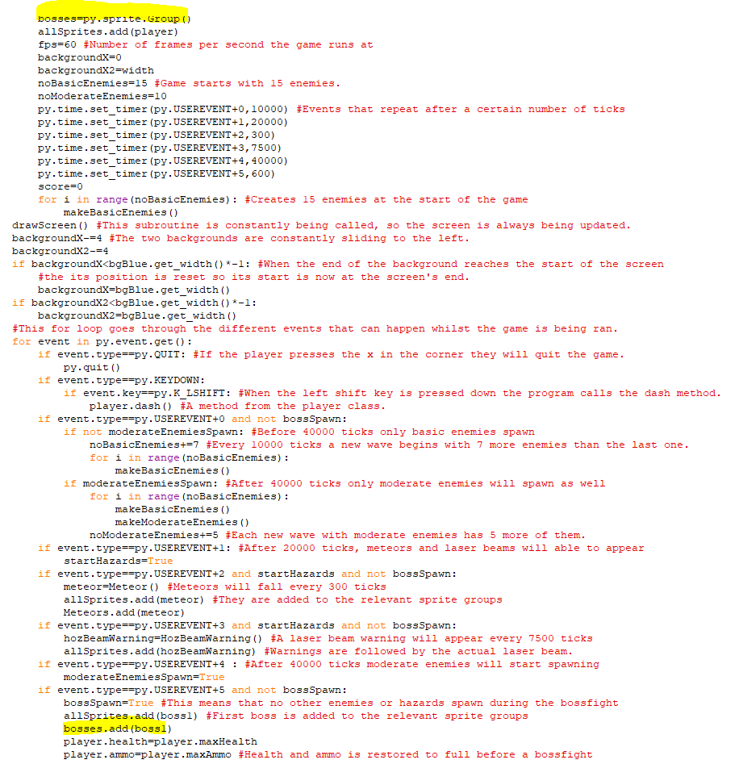I reintroduced the sprite group for bosses to allow for collisions between the player and boss as otherwise they would both only be in the same sprite group.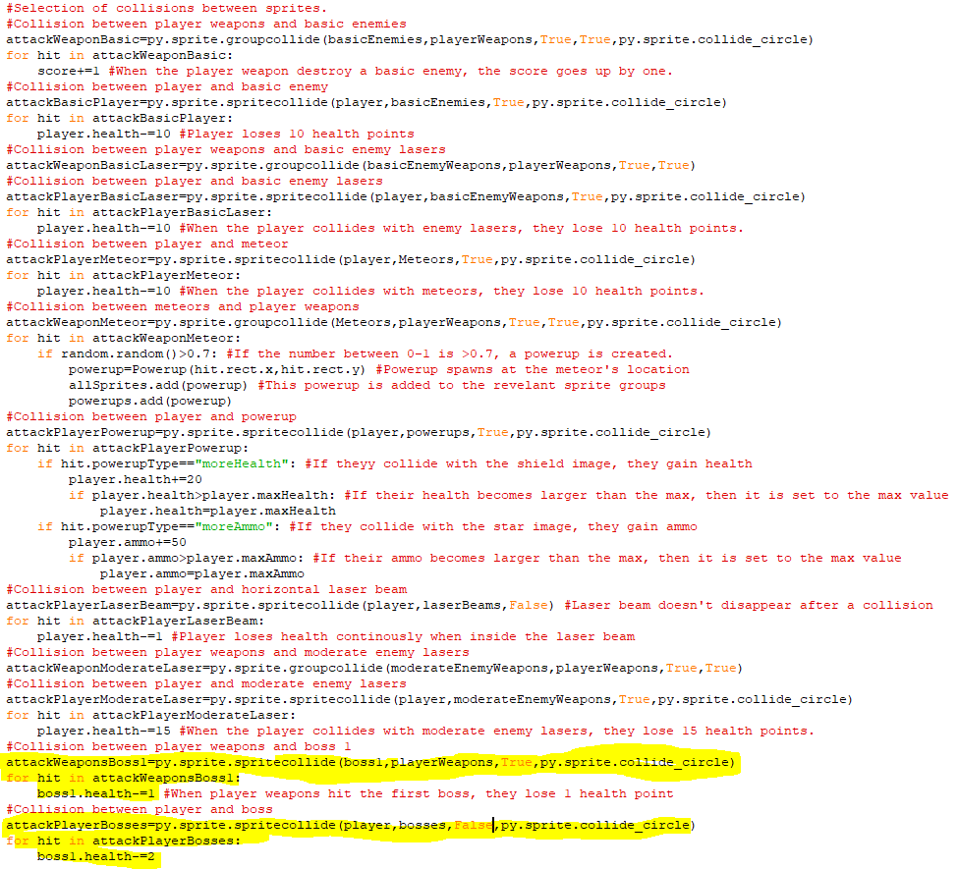The first chunk of highlighted code is the collision between the boss 1 sprite and player weapons. When they collide, the first boss will lose one health point. The second chunk is for the collision between the player and any boss, even later ones, that is added to the bosses sprite group. For each tick that the player and boss are colliding, the player will lose two health points.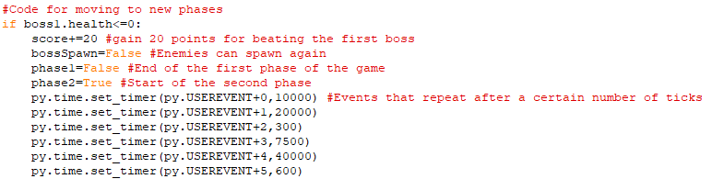When the first boss loses all their health, the game moves onto the second phase and enemies can spawn again since bossSpawn is now False. All the timing events have also been reset and they will lead to different events and have different timings in phase 2 of the game when I code that later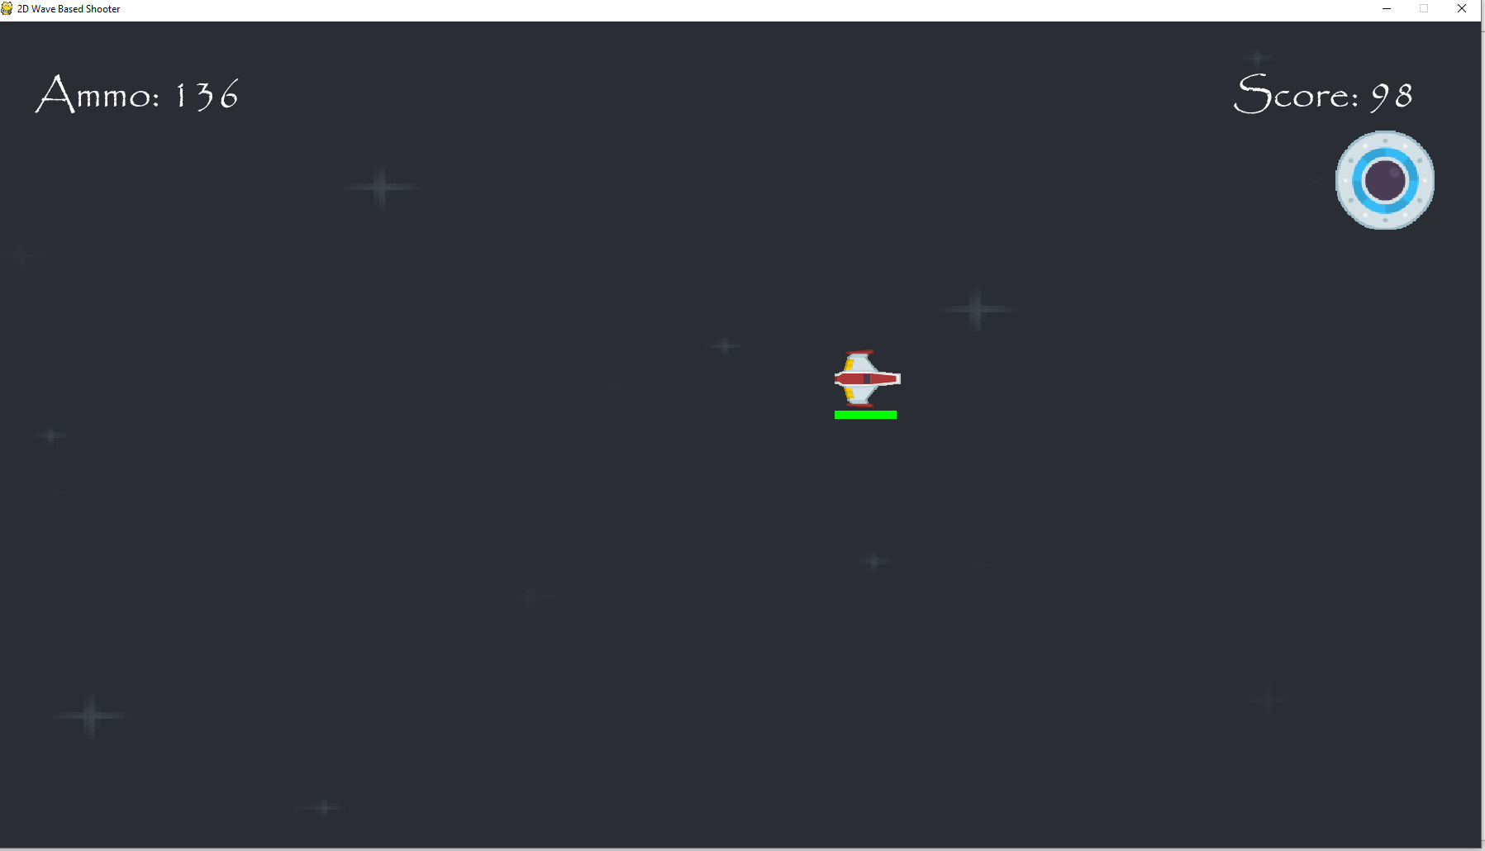The boss is taking damage and my health and ammo were set back to full when the boss spawned in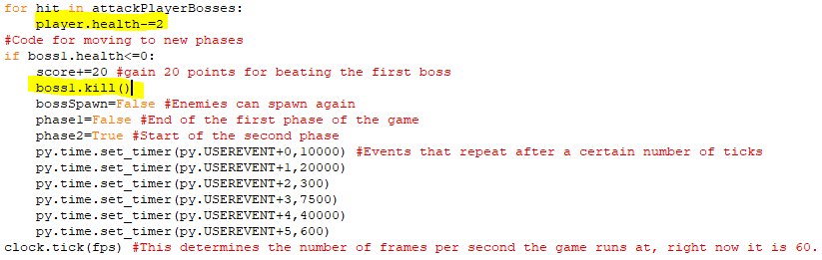I changed the first highlighted line since before it was dealing two health points of damage to the boss when we collided instead of dealing it to me. I have also added in a line to remove the first boss from the game when it is defeated. Since before when they lost all their health they weren’t removed, and I kept getting 20 points added onto my score each tick.

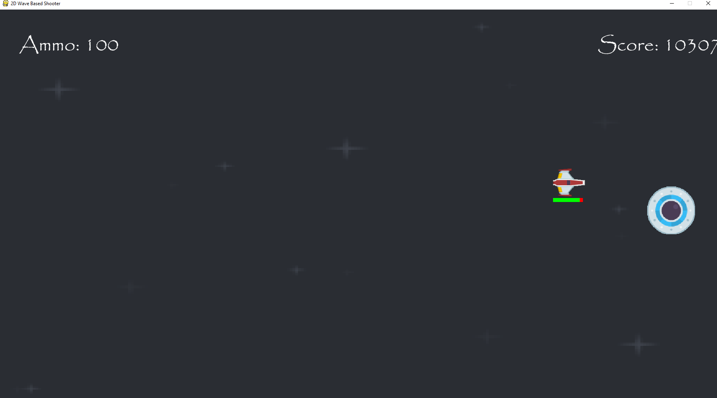This is what happened to the score when boss1.kill() wasn’t in the code.

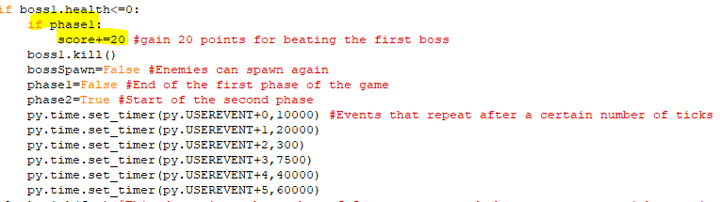The score will only increase by 20 once after a boss is killed as phase becomes False after that line of code.

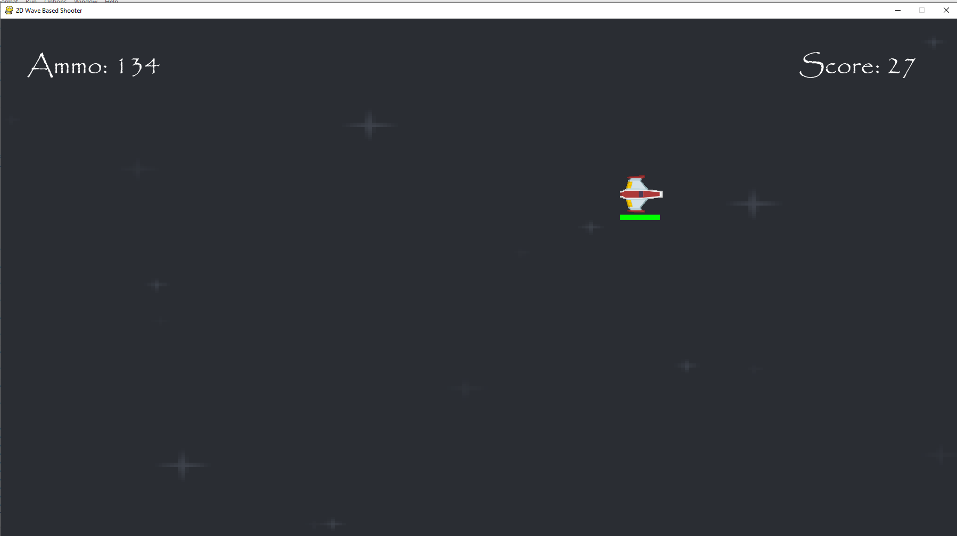The boss is removed after taking enough damage and only 20 points are given as a reward.

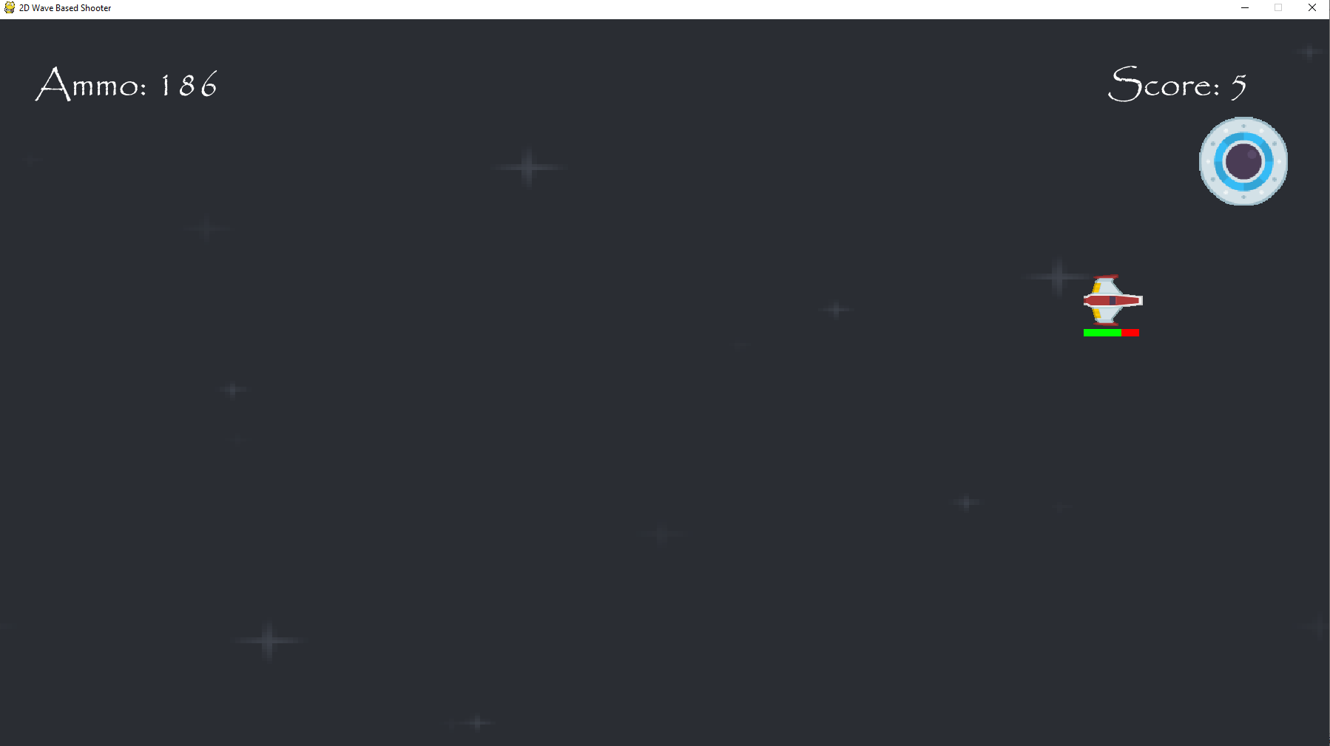Colliding with the first boss does make the player use health.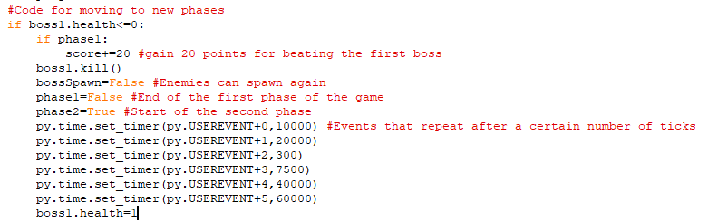The first boss’s health is set to 1 after all the timing events have been reset so that is if statement doesn’t keep repeating itself and the 2nd phase can be reached.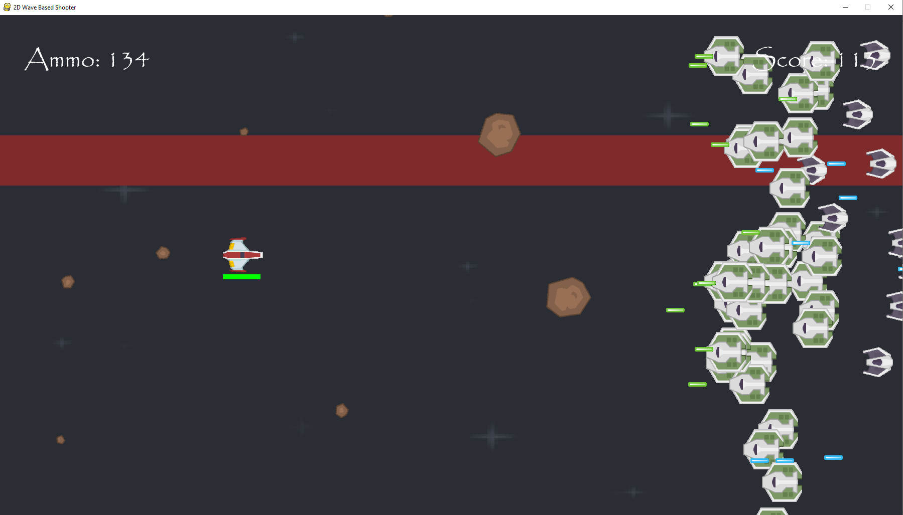The game continues as normal after the first boss fight.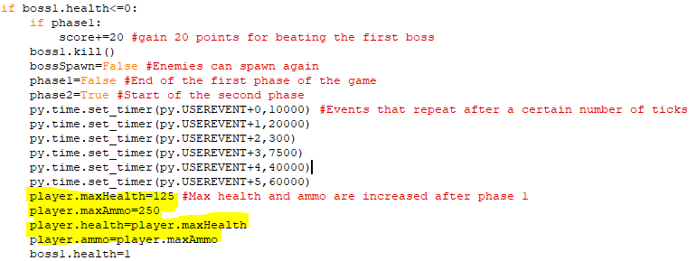I have increased the maximum amount of health and ammo after the first phase and player’s current amount of each value is set to the maximum amount after the boss fight.

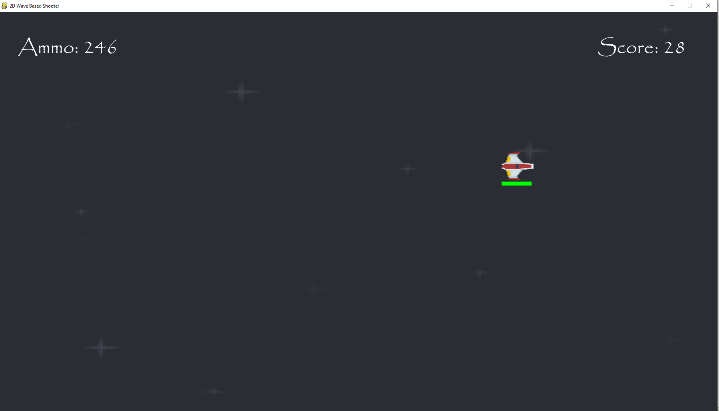Maximum health and ammo are successfully increased after the first boss fight.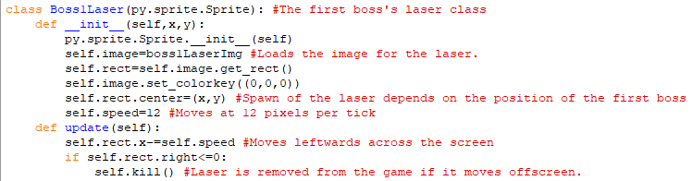I am now writing code for the boss’s different attacks and this is the class for the boss’s laser attack. It is identical to the classes for basic and moderate enemy lasers except it moves at 12 pixels per tick so it is faster than them and where they spawn depends on the position of the boss at that time.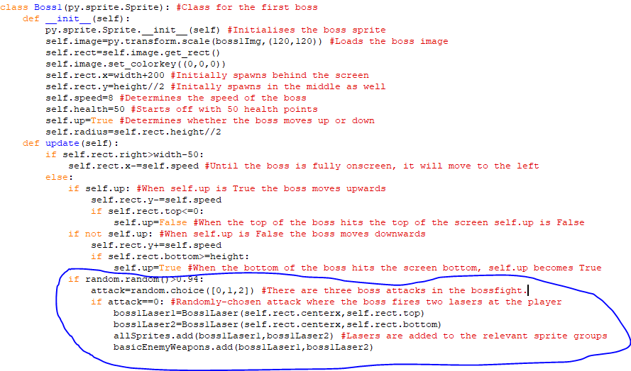I have expanded on the update method in the first boss’s class. Now if a randomly selected value between 0 and 1 is more than 0.94, the method randomly chooses between three attacks based on another random number selected from 0, 1 or 2. So far, there is code for if the number selected is 0 and if that happens then two laser objects are created from the Boss 1 laser class and those lasers are spawned at the top and bottom of the boss. The two lasers were also added to the basic enemy weapons class so they will deal 10 health points of damage to the player.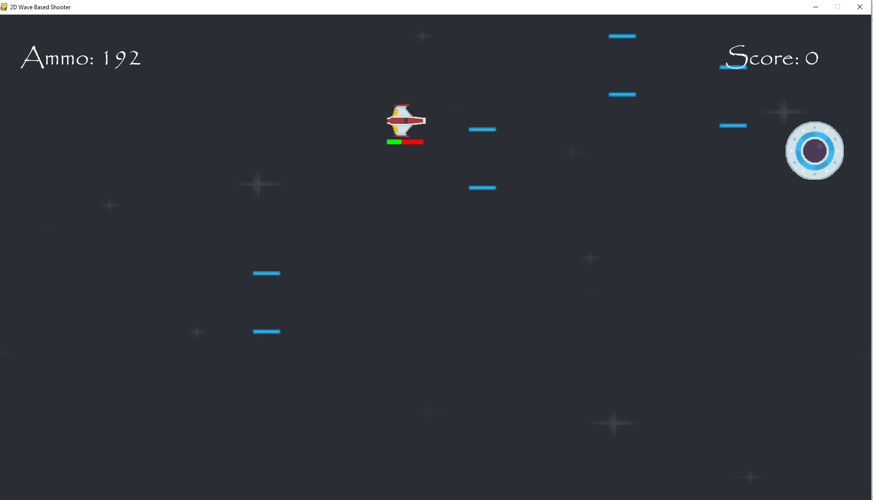The pairs of lasers are spawning onscreen and are dealing ten health points of damage to the player.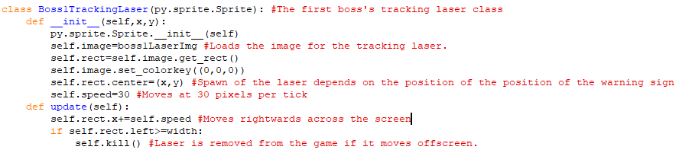The class for the boss’s second attack, which is a laser that spawns based on the position of a warning sign that tracks the player’s location. It is like the code for the other laser attack for the boss, but it moves across the screen much faster. It will spawn on the left end of the screen with its y coordinate being determined by the position of the warning sign tracking the player and will then move across the screen very quickly to act as another hazard for the player and if it moves offscreen then it is removed from the game.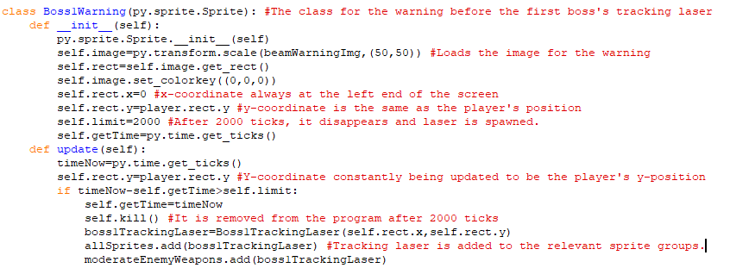The class for the warning symbol that appears before the tracking laser. It uses the same image as the warning symbol used for the laser beams but is a lot smaller. Also, it is always at the left end of the screen but its y-coordinate will always be the same as the player’s y-coordinate. In the update method, the y-coordinate of the warning is constantly being set to the player’s y-coordinate and after 2000 ticks, the warning is taken offscreen and the laser is put in its place and is shot across the screen at 20 pixels per ticks. Since the laser is added to the moderate enemy weapons class, it deals 15 health points of damage to the player.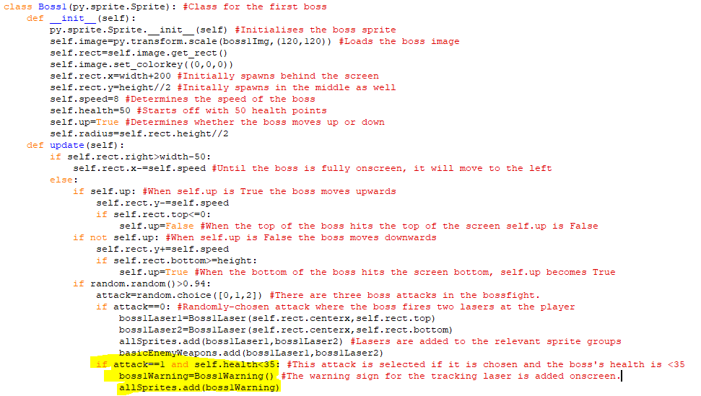The highlighted code states that when the value 1 is randomly selected from 0,1 and 2 and the boss’s health is less than 35, then the warning for the tracking laser is drawn onscreen. This will track the player’s y-position until it is removed and the laser spawns at its final position and moves rightwards across the screen very quickly.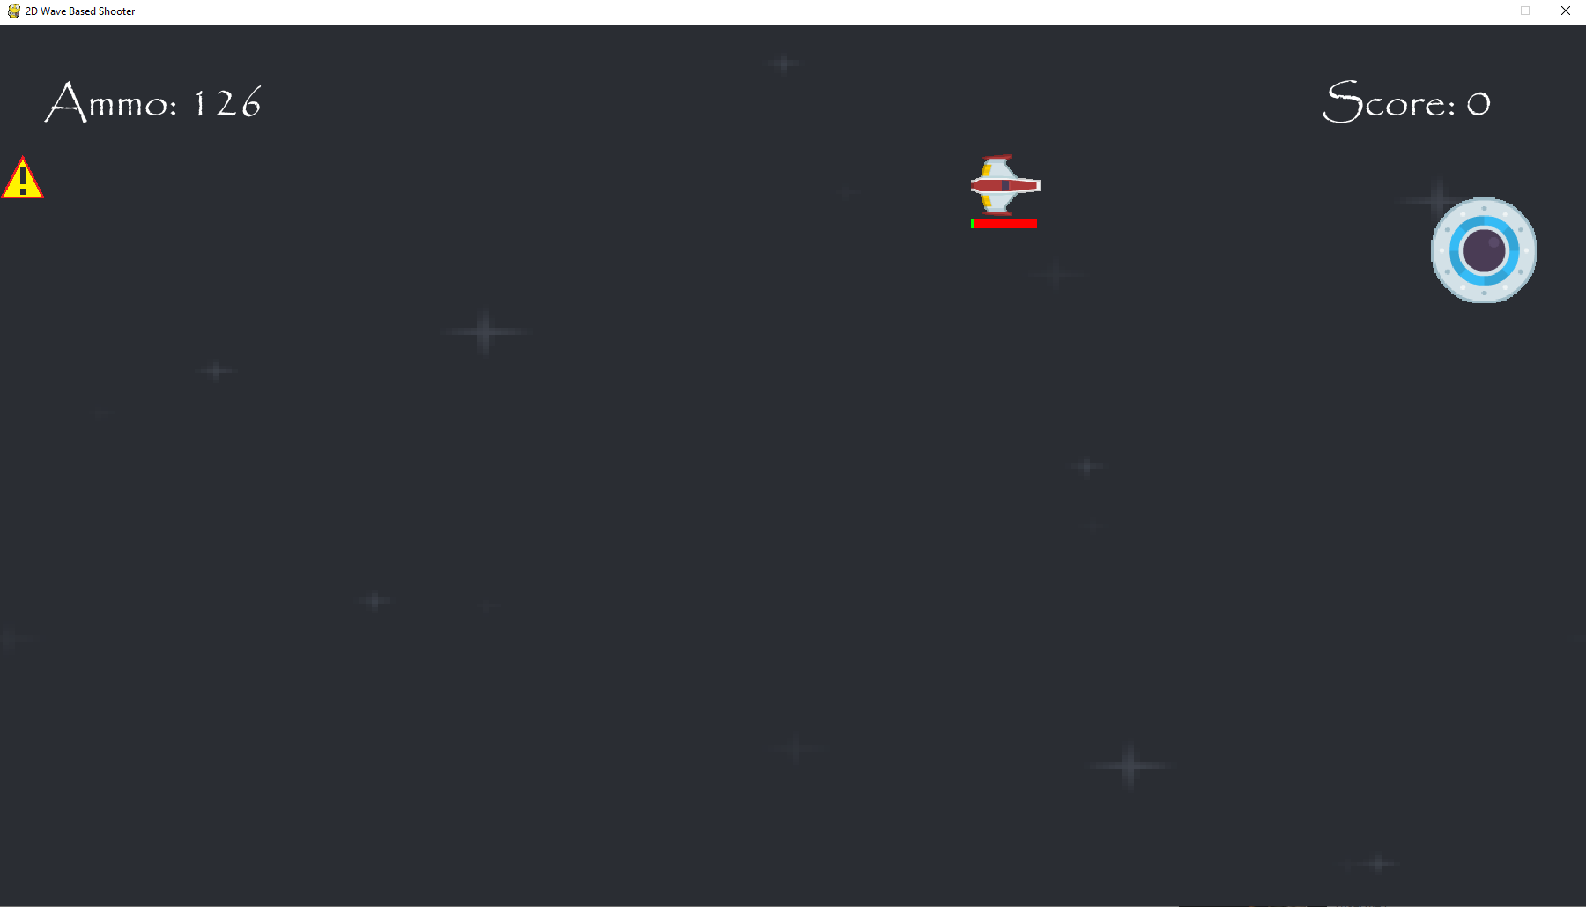There is an issue with the next warning symbol spawning before the previous one has been removed, so multiple tracking lasers are fired at the player very close together. However, the warning symbols are tracking the player’s position and the lasers are spawning where the warning symbol was. But they are spawning at the top of the symbol when they should spawn in the middle.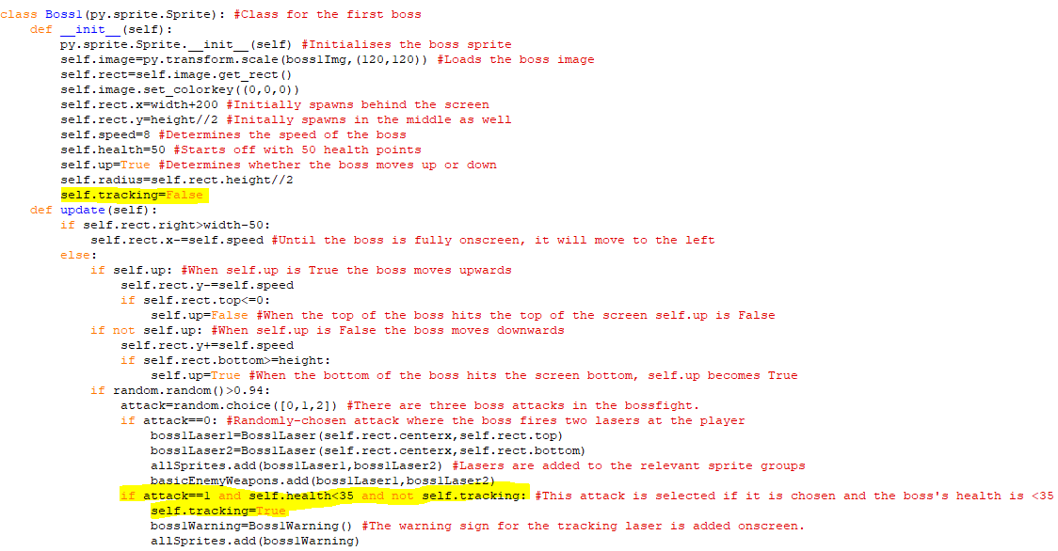There is now an attribute when if a tracking laser is going to fired. It starts off as being False and when it is False the tracking laser warning can be created onscreen but when this happens, self.tracking is set to True so that more warning signs can’t spawn whilst one is already in the game. When the laser has been fired then tracking will be set to False so that another tracking laser can be fired.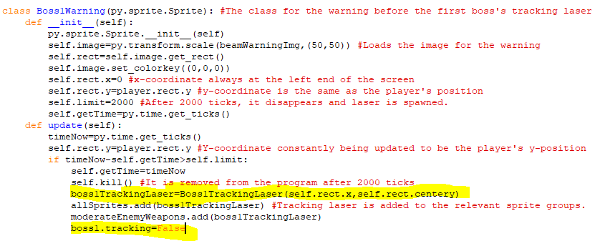The y-position of the boss’s tracking laser has been set to the middle of warning sign instead of the top and when the laser is fired and added to sprite groups, then tracking becomes False so that another warning sign can appear for another tracking laser.

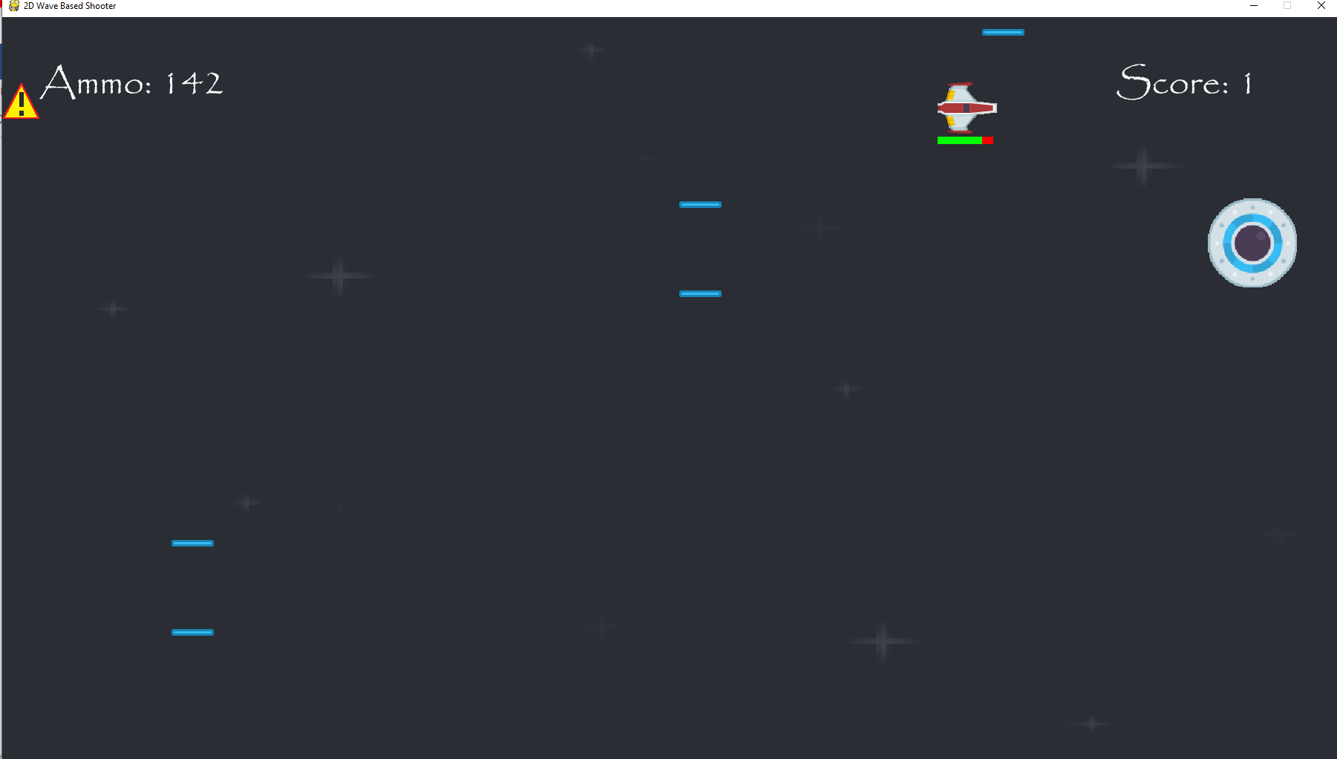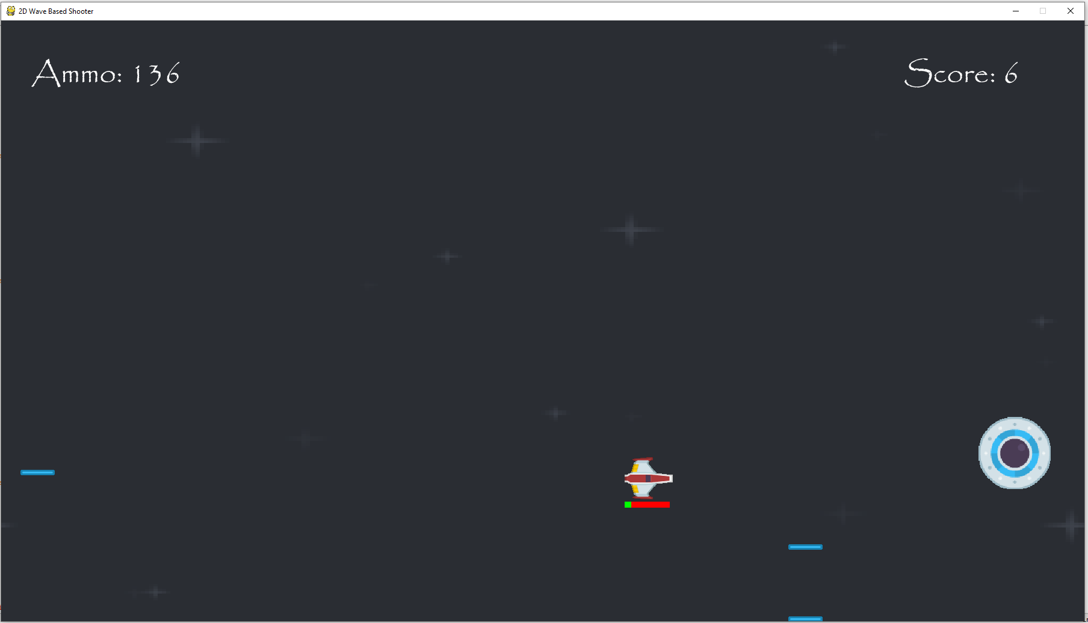Warning signs now appear onscreen one-at-a-time and lasers will spawn from their final location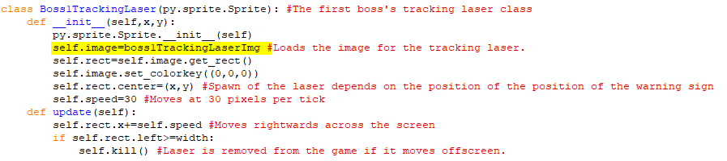I have used a new laser image for the tracking laser.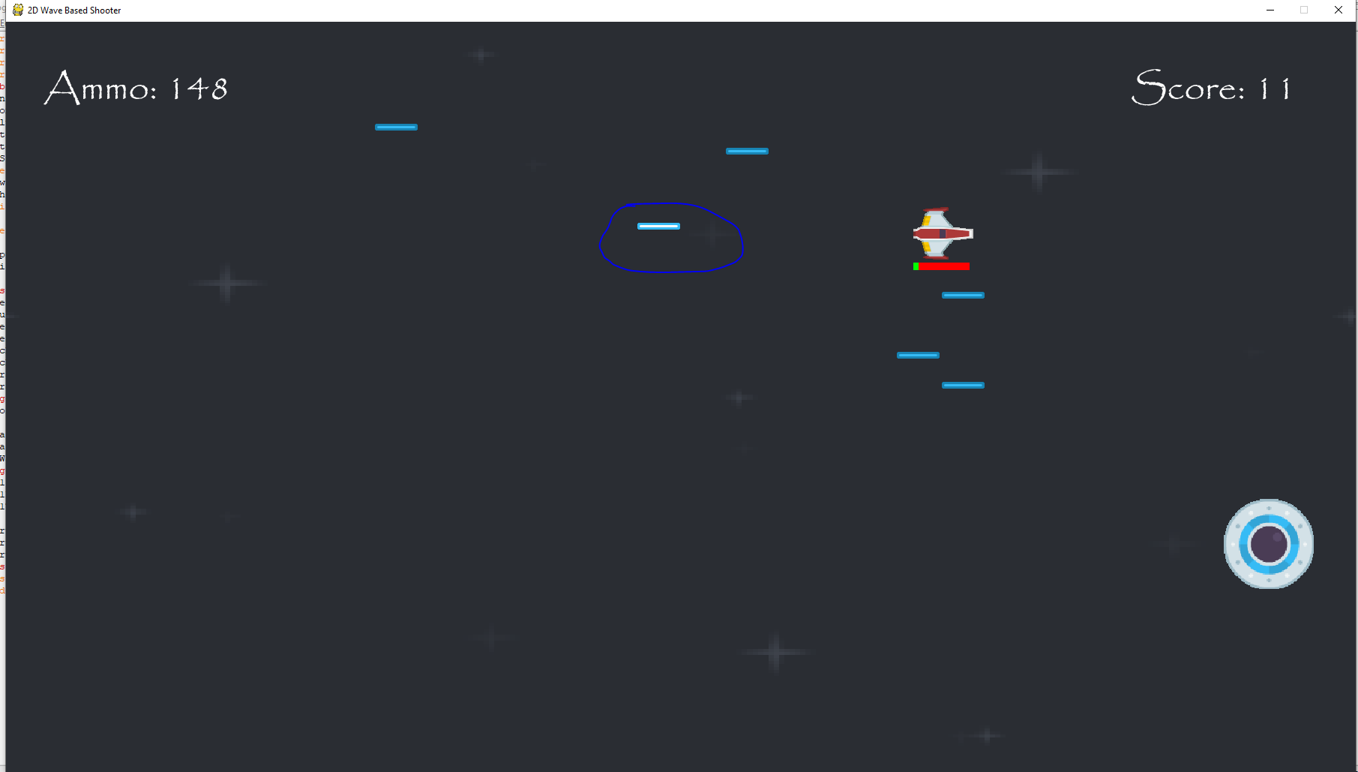The circled laser is the tracking laser, fired from the left.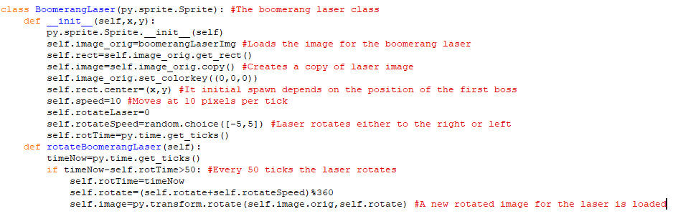This is the class for the boomerang laser. When the first boss fires this laser, it will move to the right but once it reaches the end of the screen it will move back to the left. The laser will also be rotating either to left or right whilst moving and moves at 10 pixels per tick. The rotation method makes the laser rotate every 50 ticks like the meteors and the rotation once again change a preexisting image and changes it to a new rotated image.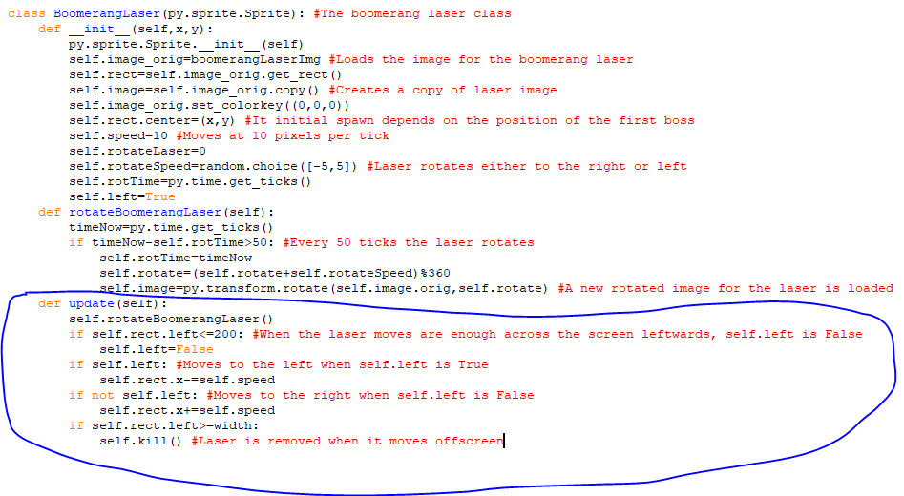The update method will cause the rotate method to be called constantly, so the laser is constantly rotating. There is also a new attribute called self.left and when starts off as True. When it is True the laser moves to the left but once the left-hand side of the laser reaches 200 pixels from the left end of the screen, self.left becomes False so the laser now moves to the right and once it moves off the right end of the screen, it is removed.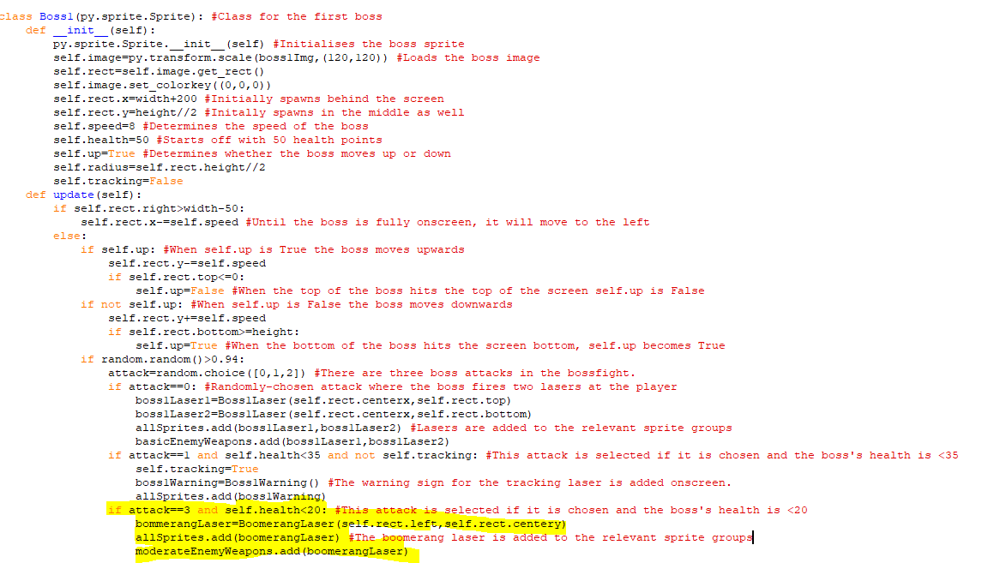The highlighted code at the shows that an object from the boomerang laser class can be made when the attack is randomly assigned the value of 2 and the boss’s health is less than 20. Since it is added to the moderate enemy weapons class, it deals 15 health points of damage to a player upon a collision.

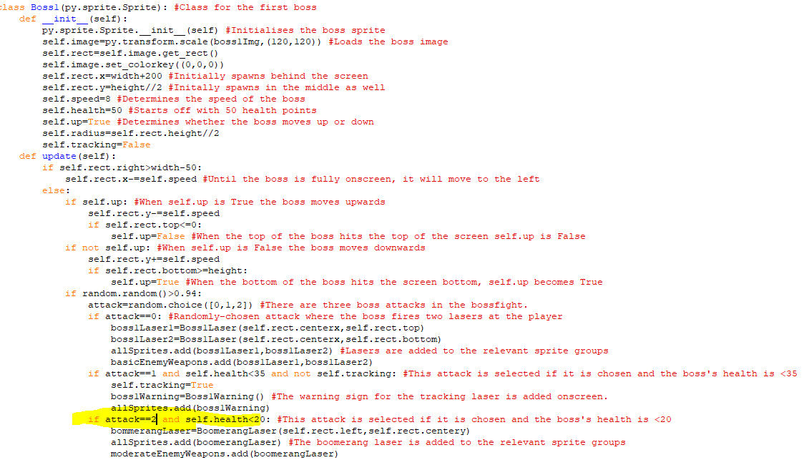  
The third if statement should have been if attack==2 not 3 since attack can’t take the value of 3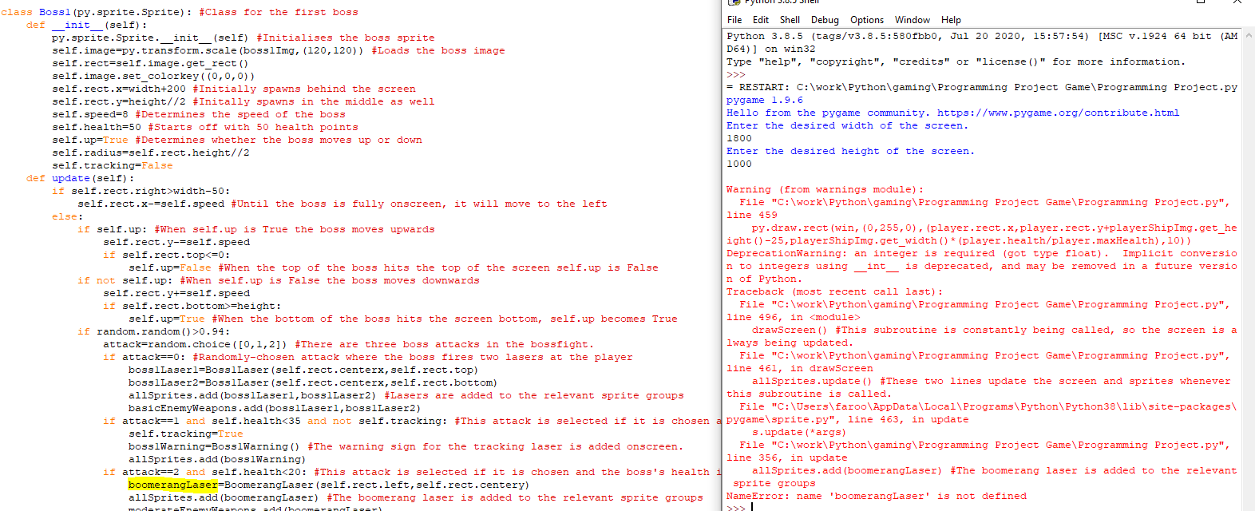I accidently spelt boomerangLaser as bommerangLaser at the highlight code.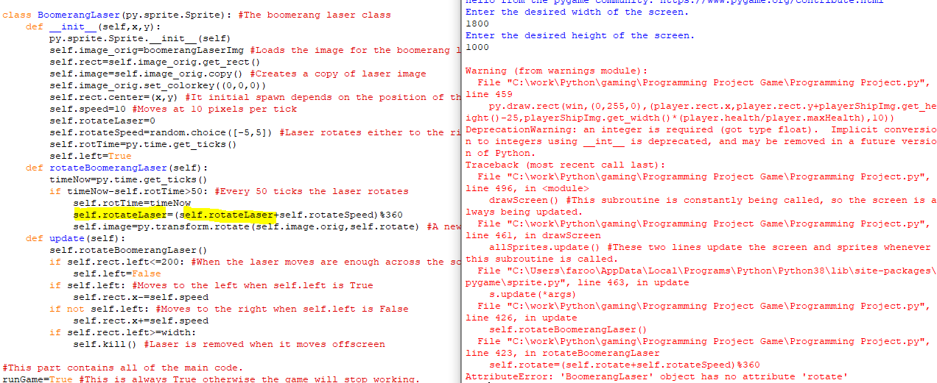I wrote self.rotate where I should have written self.rotateLaser at the highlighted code.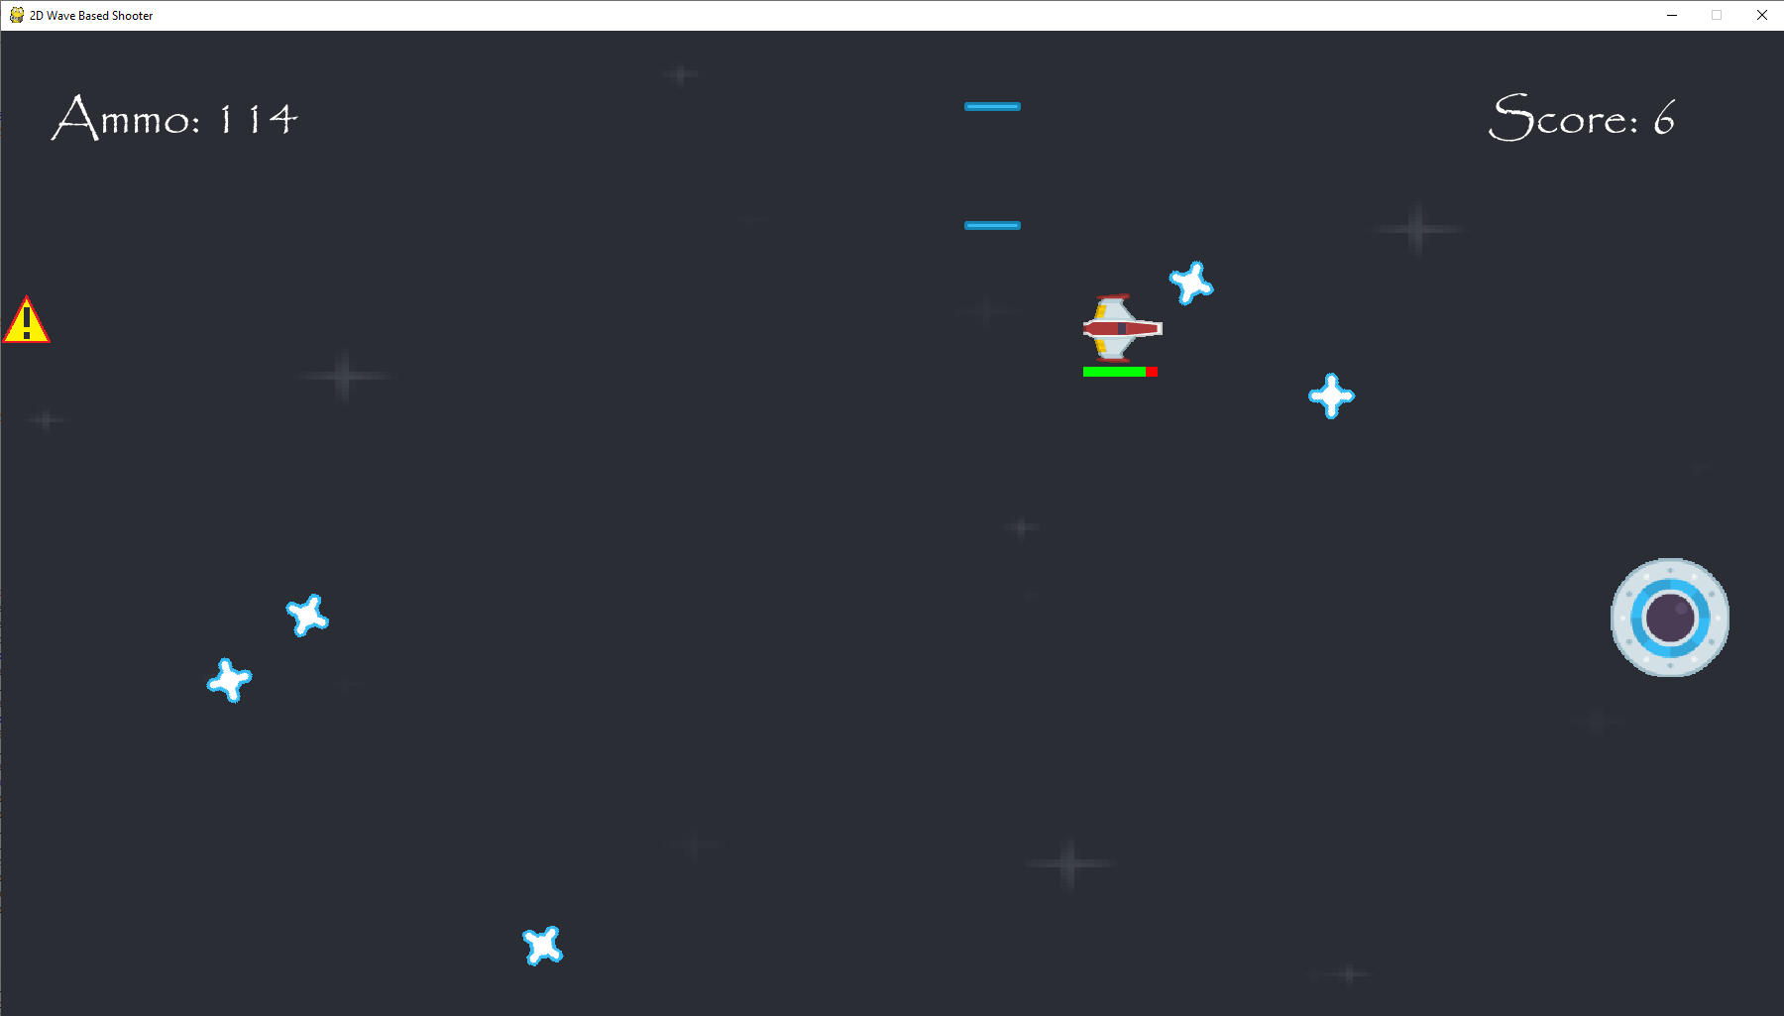  
The boomerang lasers are succesfully moving back and forth across the screen and damage the player upon collision. They also don’t appear until the boss has lost 31 health points.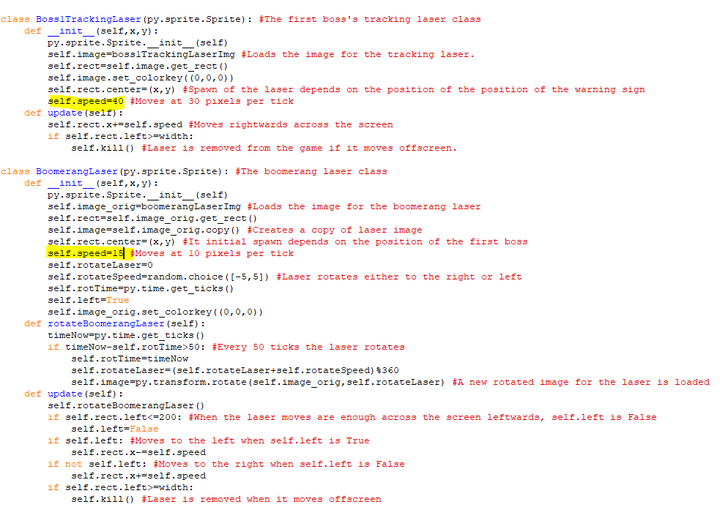  
I increased the speeds of the tracking and boomerang lasers from 30 and 10 to 40 and 15 respectively. This was to make the boss fight more challenging.

Stage 4 Review

In Stage 4, I have introduced harder enemies in later waves that move faster, in more directions and fire lasers that move faster and deal more damage. When they enter the game, the number of basic enemies stops increasing and their number increases between waves instead in order to make the game more challenging over time. After 6 waves of enemies, a boss fight occurs where the boss starts off by attacking the player with pairs of lasers, but as the boss loses health, they will unlock new attacks to use against the player. Once the boss fight ends, the game then returns to its wave-based structure.

For the success criteria, I have started to accomplish the fourth point about introducing enemy types and bosses over the course of the game, but there are still more enemies and bosses to add. In addition, the scoring system has been expanded as bosses will give more points than regular enemies when killed. I have also expanded the health system since the new enemies and attacks do different amounts of damage than previous ones so the health bar will have to change by a different amount depending on the attack and the enemy.

Client Feedback:

Adding new enemies adds greater variety to the game and bosses are a pretty good addition to the and as they unlock new moves as they lose health, they can be rather tough.

Stage 5- Creating a Main Menu

**In this stage, the parts of the success criteria I am going to achieve are:**

* **Having an interactive UI that lets me start the game and check controls.**
* **Having a consistent layout and design.**

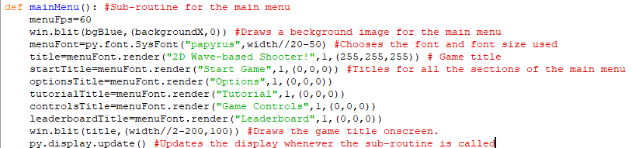I am now making a main menu for the game. It is a separate sub-routine that is called before the game begins. It uses the same background as the background for the game as well as the same font. There is then text for the different sections of the main menu like starting the game, going to options, looking at a tutorial or controls and viewing the leaderboard. There is also text for the title of the game and that is written onscreen. The size of the font is determined by the width of the screen.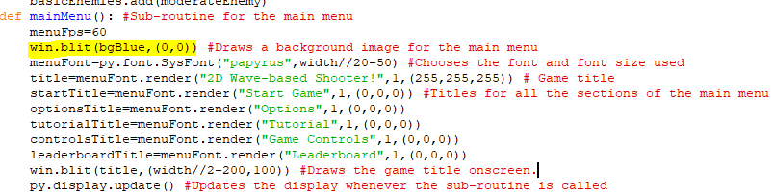I realised the variable backgroundX would be in the game yet so I replaced it with 0 so the background is drawn properly.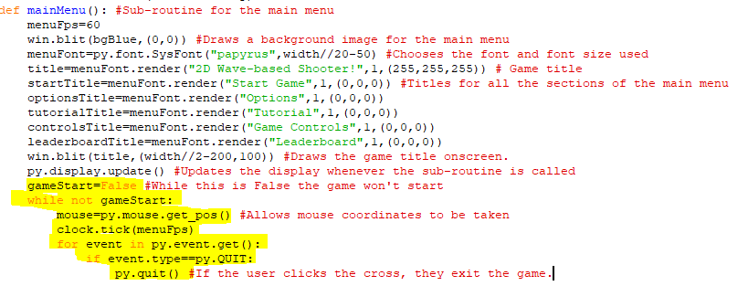The highlighted code creates a variable called gameStart and sets it to False. While it is False the game will be stuck on the main menu for now but in the while loop I have also created the ”mouse” variable that is used to store the coordinates of the mouse onscreen and that will be used to determine how a player can click on the different sections of the game. If the player clicks on the cross in the top right hand side of the window the game will close.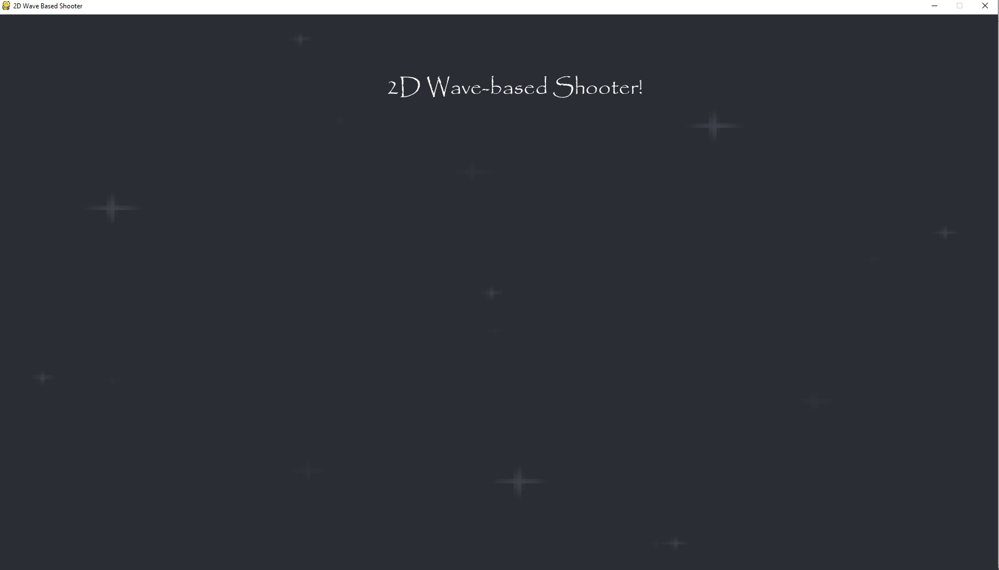  
This is how big the title is when the width of the screen is 1800 pixels.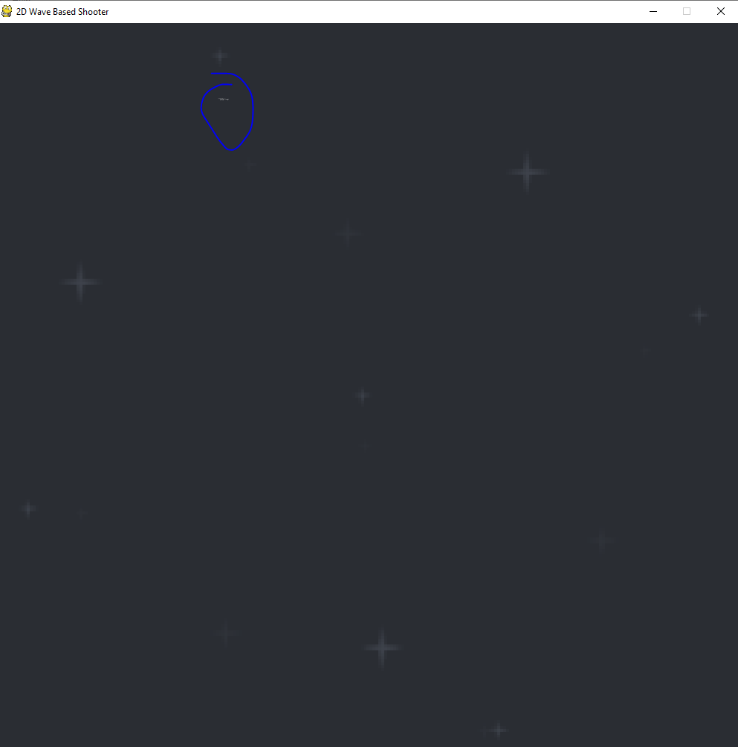  
The title is hardly noticeable when the width is 1000 pixels

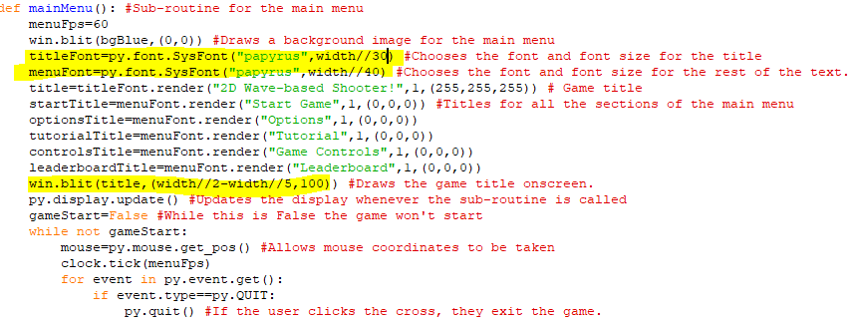I changed the fonts as there are now two separate fonts for the title and the other text. The title’s font size is now the width DIV 30 and the x-coordinate of the start of the title is width DIV 2-width DIV 5 to try and make sure the title stays in the centre, no matter the width chosen for the screen.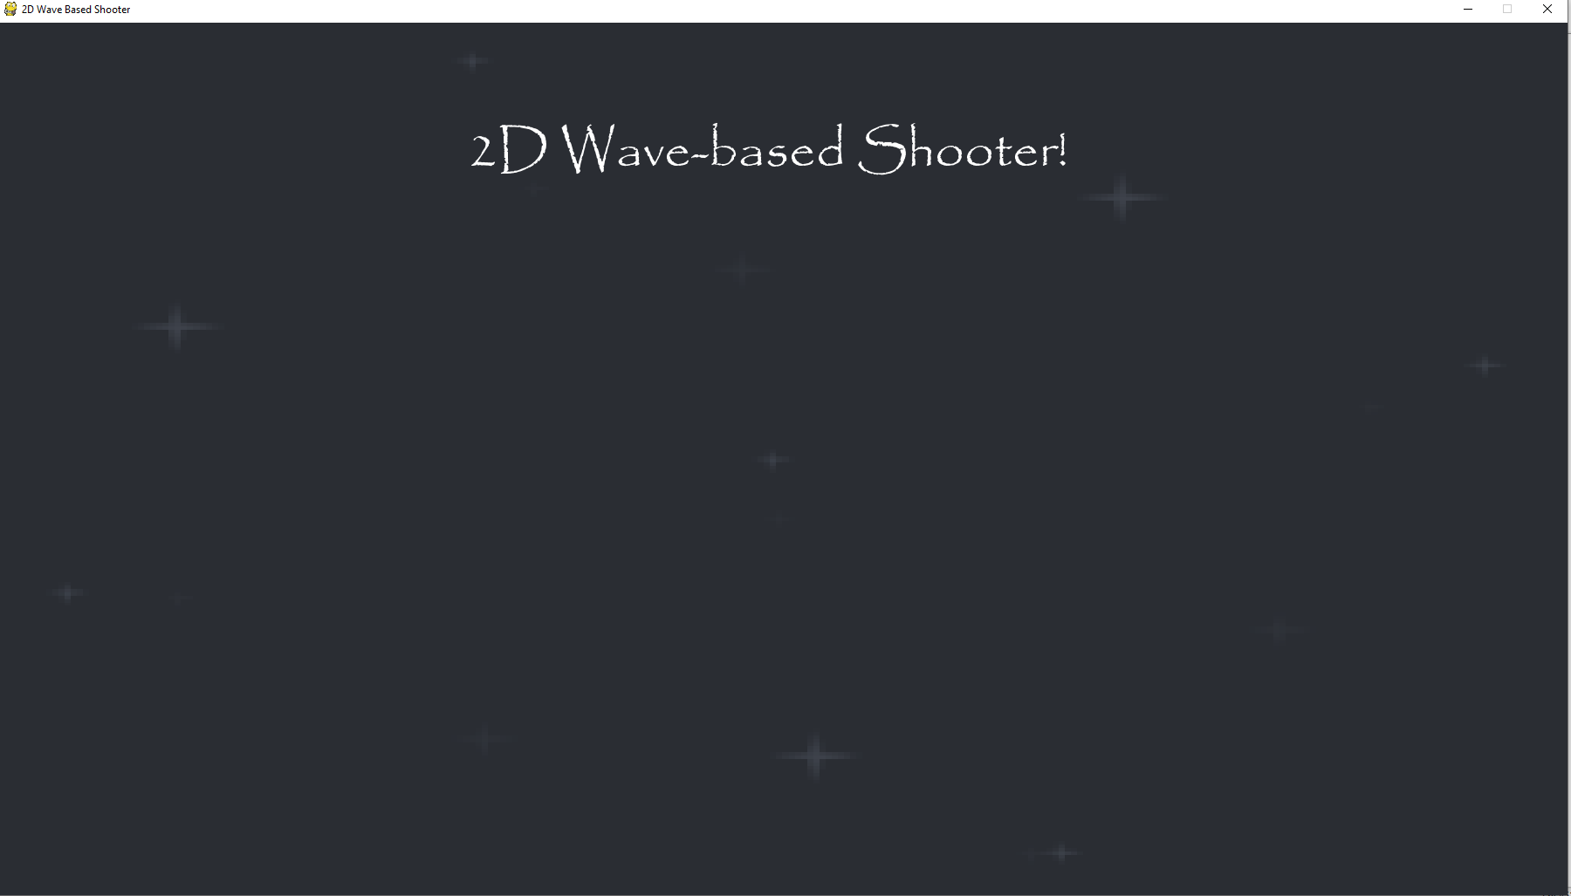  
Here is the title when the width is 1800 pixels. It is quite close to the centre.

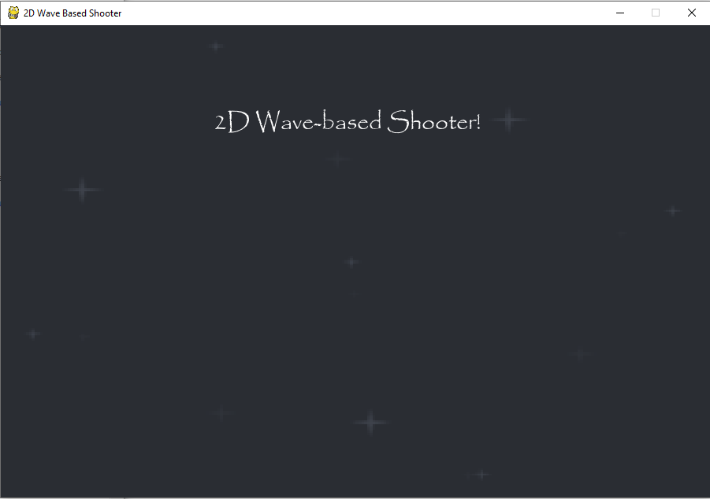  
Here is the title when the width is 900 pixels. It is still quite close to the centre.

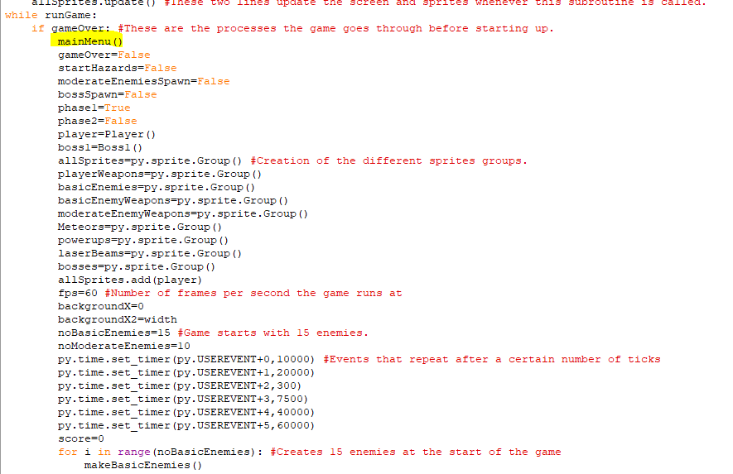Here is where the mainMenu subroutine is called in the main program, before the game loads up, or when it ends, the player is taken to the main menu. But at this point they are stuck on the main menu until I implement a section to start the game.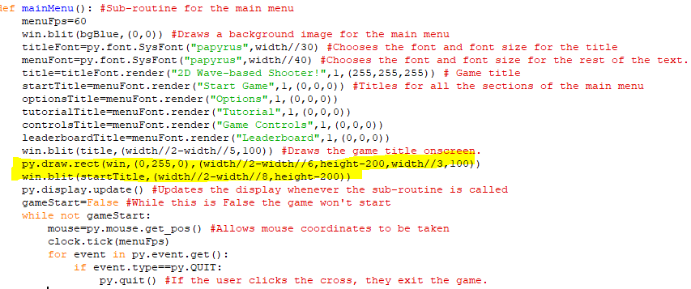The highlighted code is code for drawing the icon for starting the game, as well as the text inside it.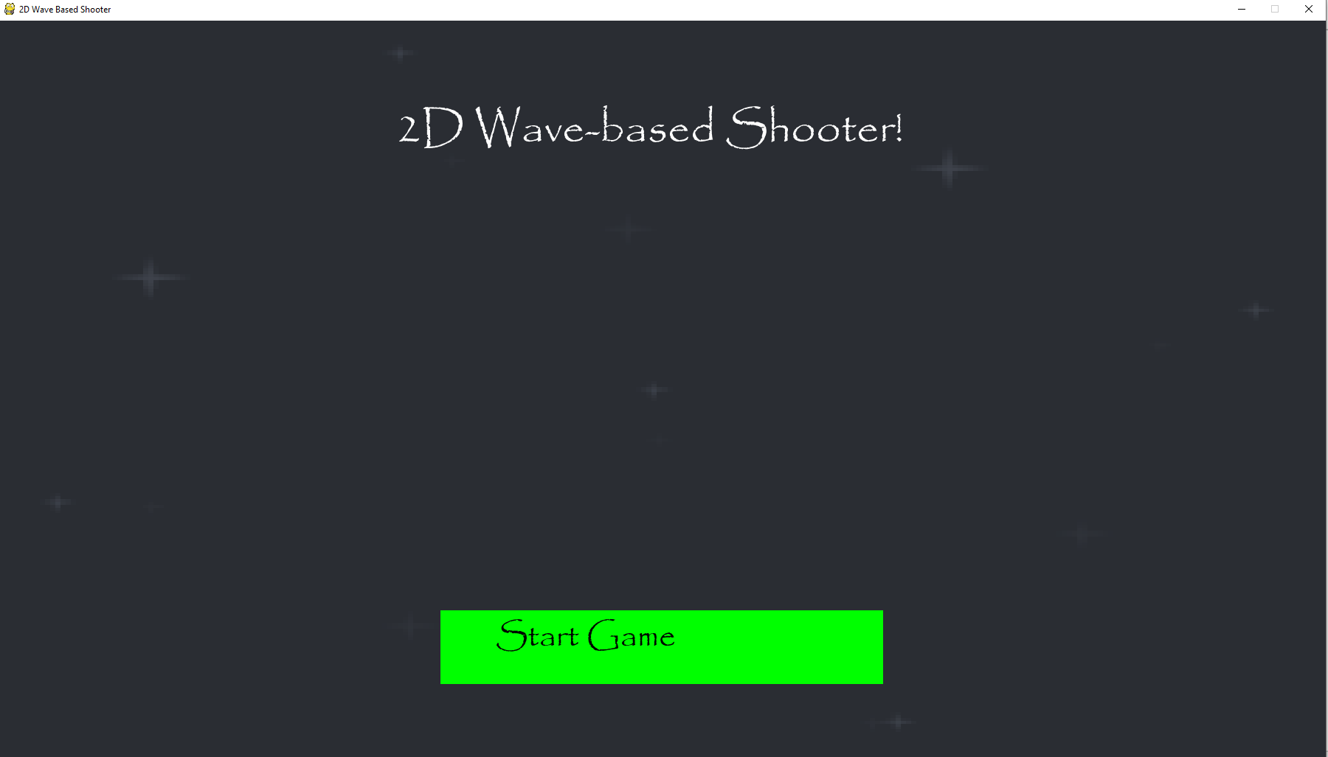  
At a width of 1800 pixels, the clickable green icon is in the centre but the text inside it isn’t in the centre of the box.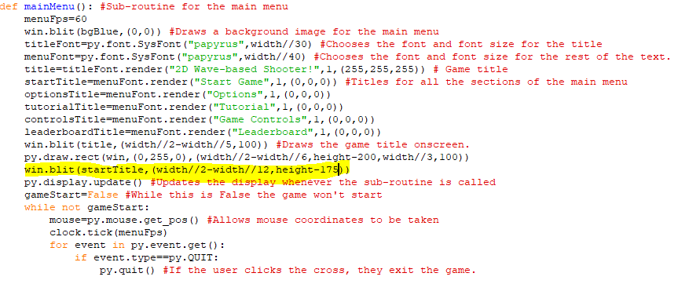I changed the position of the text in the box so it shouldn’t be as far left and as high up now.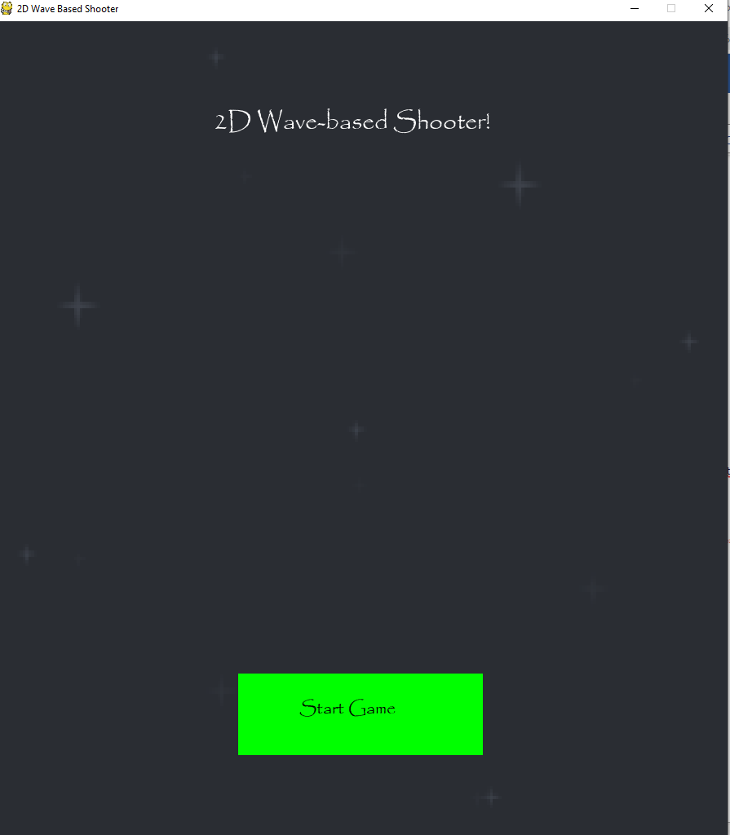  
At a width of 1000 pixels the placement of the box and the text ”Start Game” are both quite close to the centre.

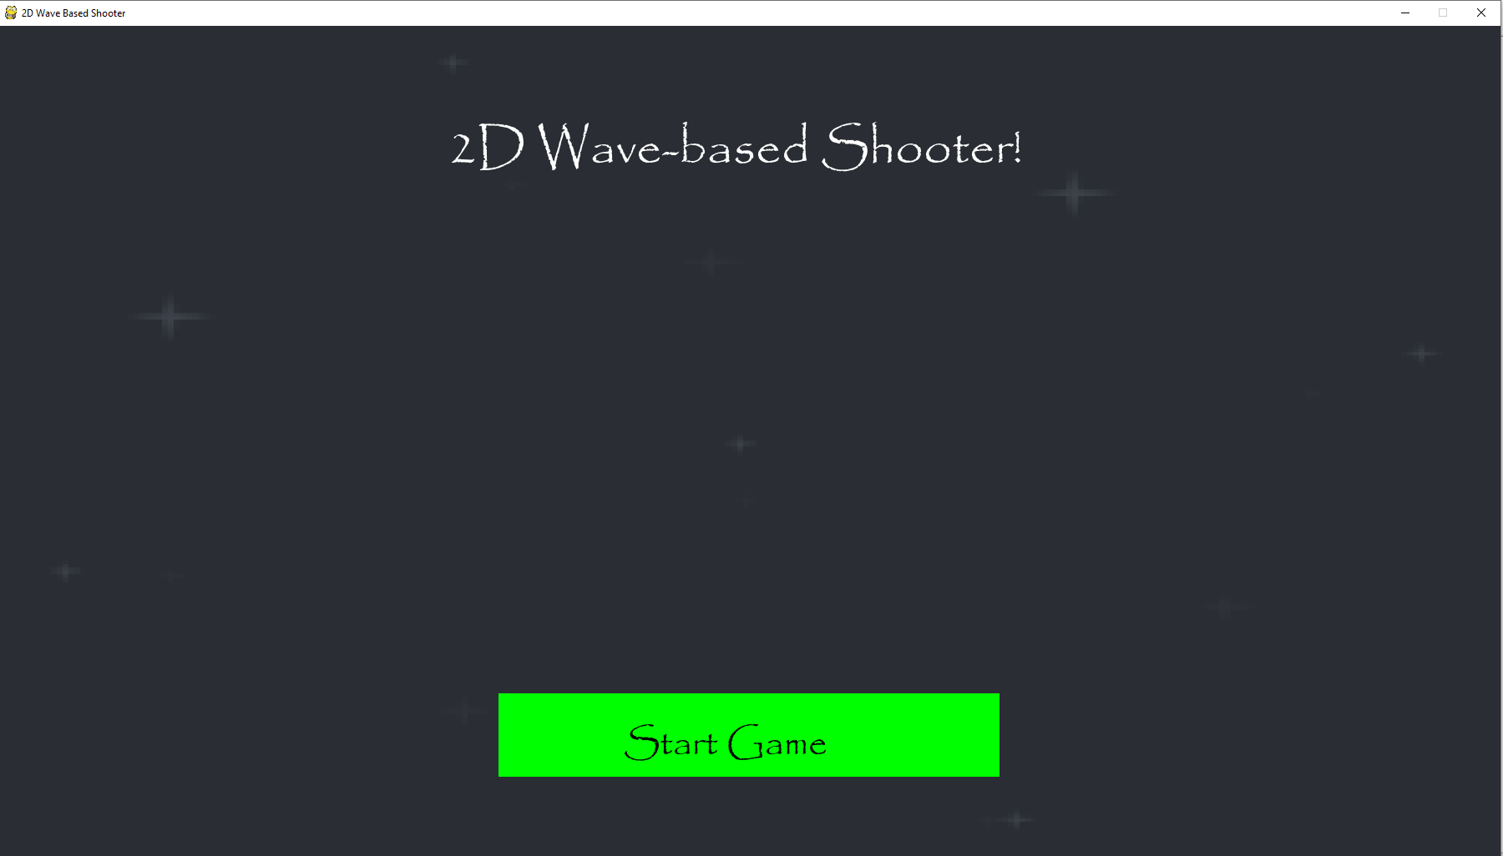  
At a width of 1800 pixels, the placement of the box and text are still both quite close to the centre.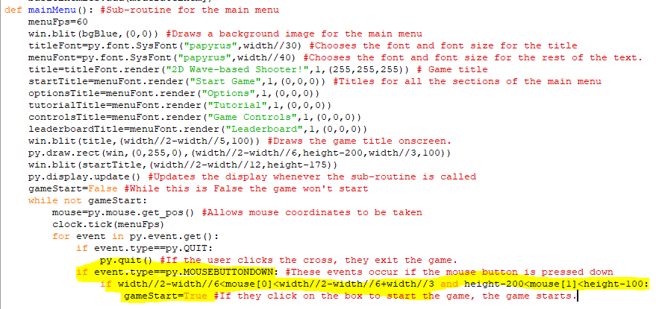  
This code says that if the mouse is within the coordinates of the Start Game box, then the gameStart variable becomes True. This means that the while loop ends, and the game begins.

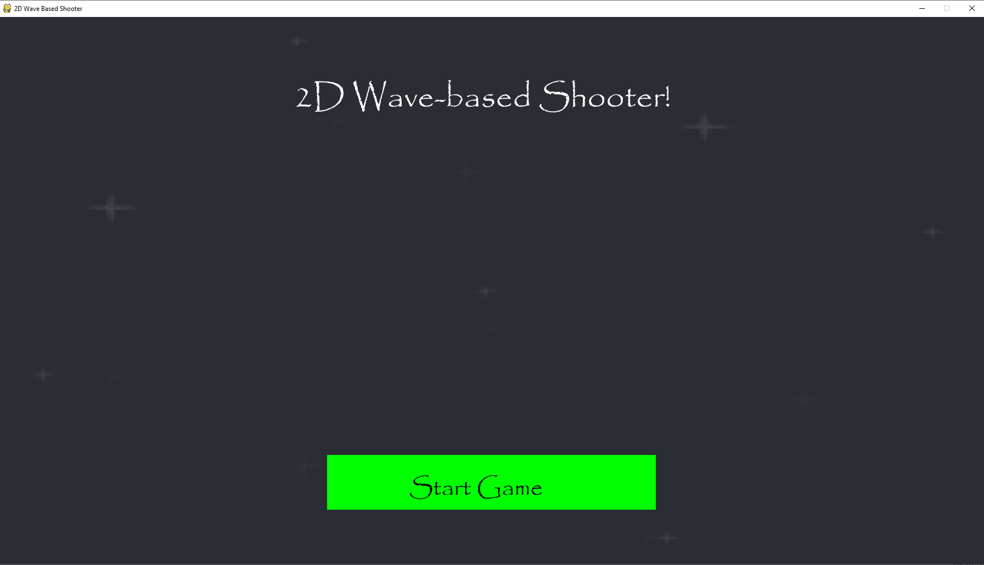  
When I click all around the green box, the game doesn’t start.

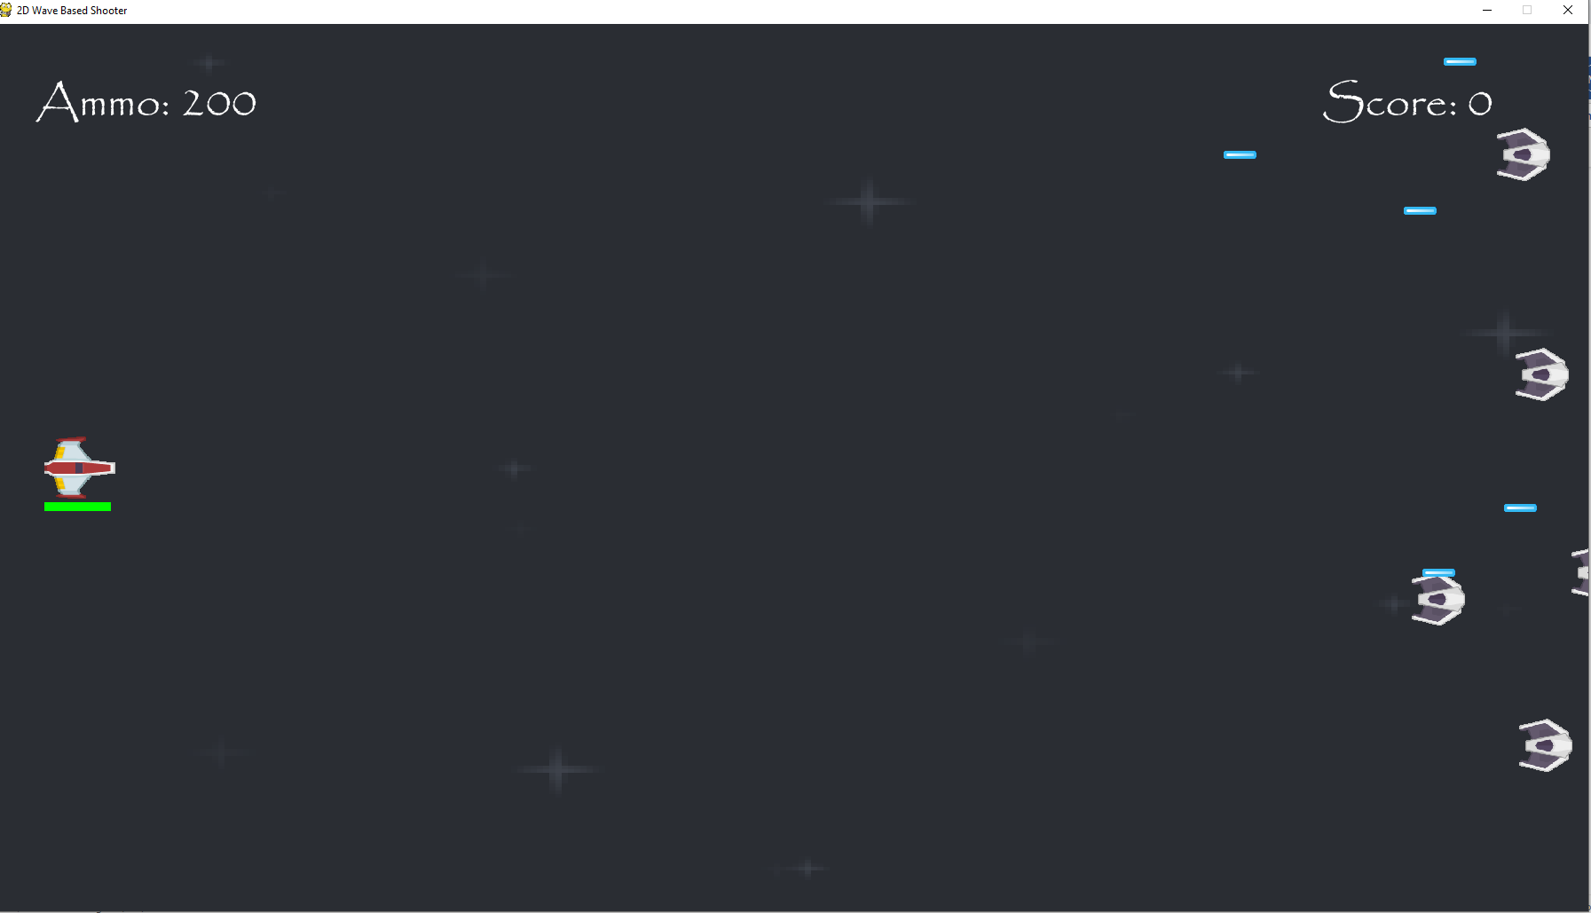  
When I click on the green box the game begins as normal.

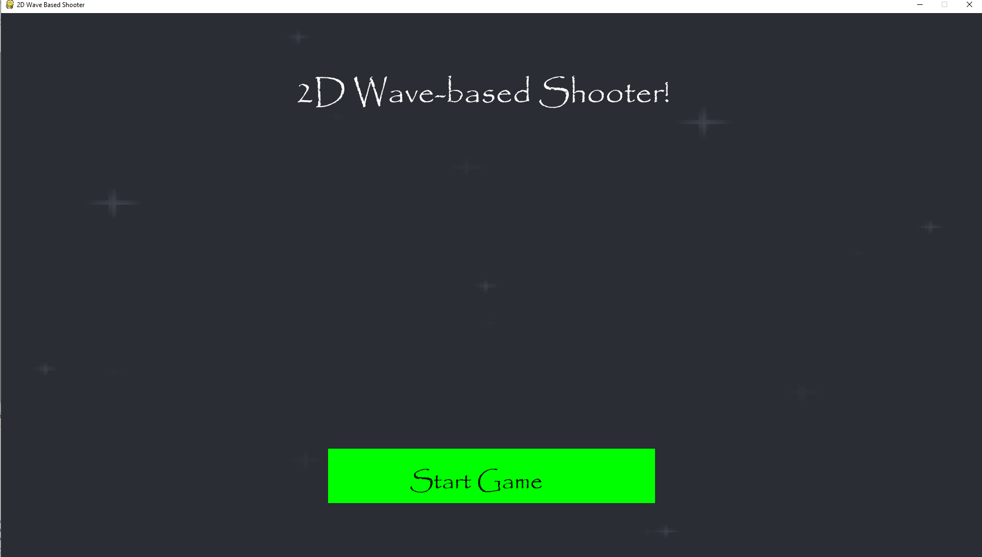  
When you die in game, you are taken back to the main menu.

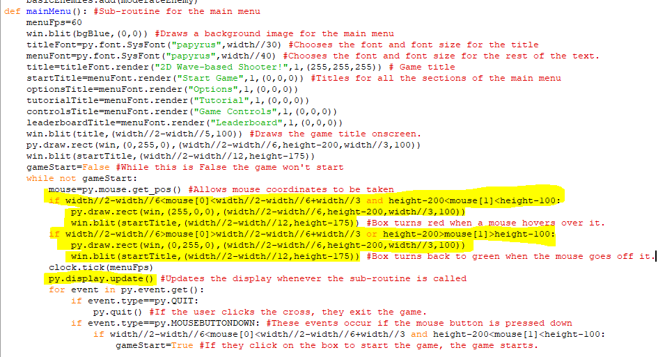This the code for the changing the colour of the icon when a mouse hovers over it. When the mouse’s and y coordinate are within the green box it will change colours to red to signify that it can be clicked and when the mouse moves out of the coordinates within the box it should change back to green again. The display update command was also moved down so that the colour of the box will be able to change. The colours are determined using RGB so 255,0,0 is red and 0,255,0 is green.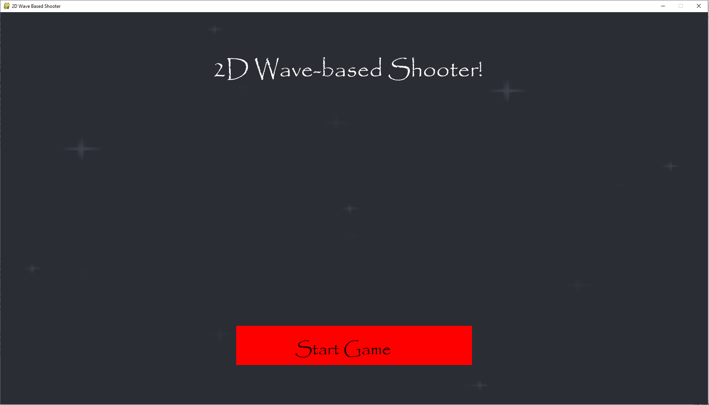  
The box changes to red when I hover over it, but it doesn’t change back to green when I go off that section.

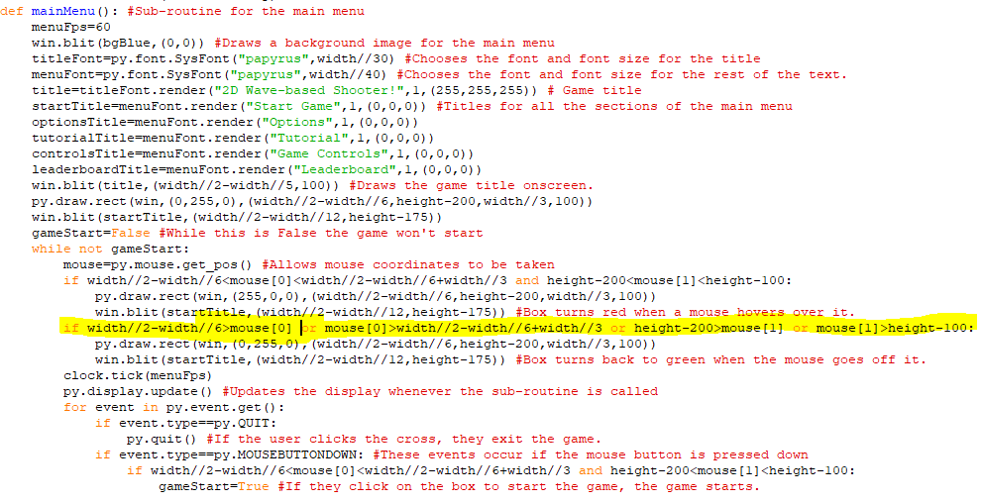  
I changed the line of code determining the coordinates the mouse to need to be in to change the box colour back to green. So now it makes individual comparisons between the mouse’s x and y coordinates and whether they are bigger or smaller than other coordinates that determine the edges of the box.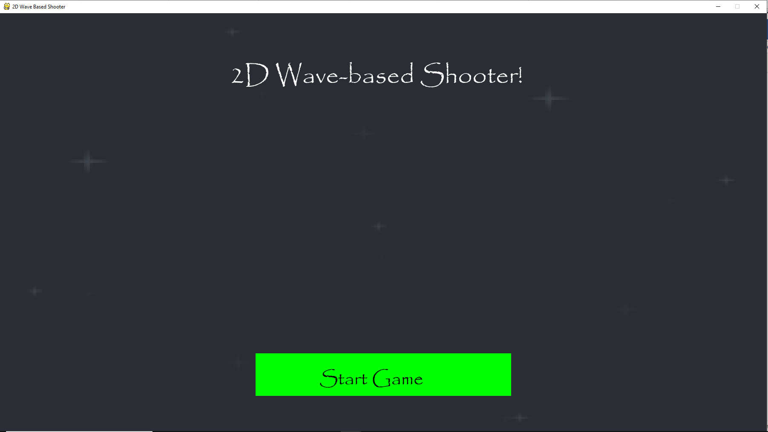  
Now when I go off the icon, the colour of the box changes back to green.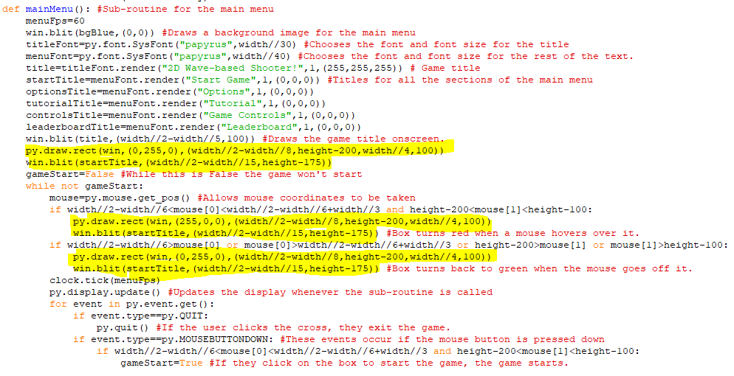I made the size of the box smaller so it would take up less of the screen and then changed the position of the box and text inside so that they would still be close to the centre.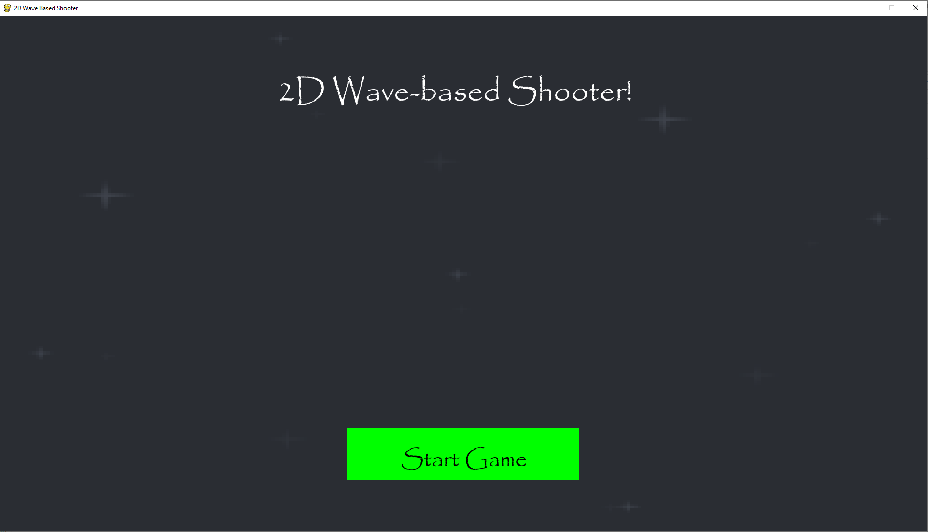  
The box and text are still fairly centred at a width 1800 pixels.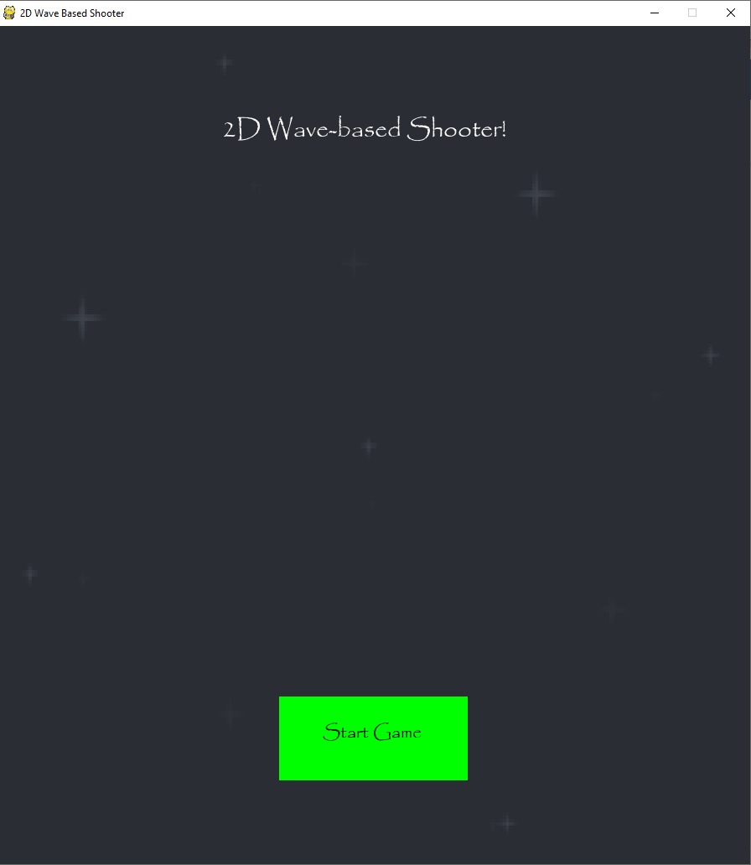  
The box and text are fairly centred at a width of 900 pixels as well.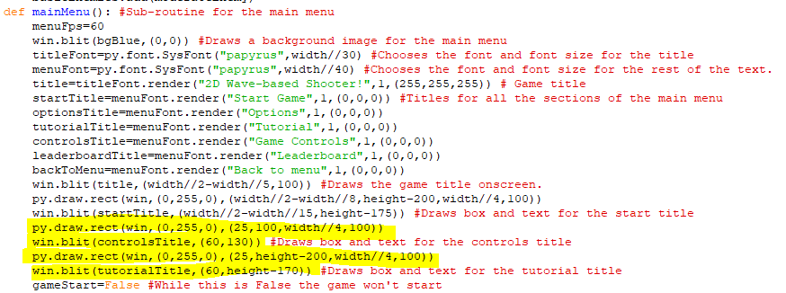  
This code draws more boxes for the controls and tutorial section of the game. They are in the top left and bottom left of the screen. The size of the boxes will also decrease the smaller the width of the screen becomes; it is always 4 times smaller than the width. I have also created some back to menu text to be used in each of the other sections. 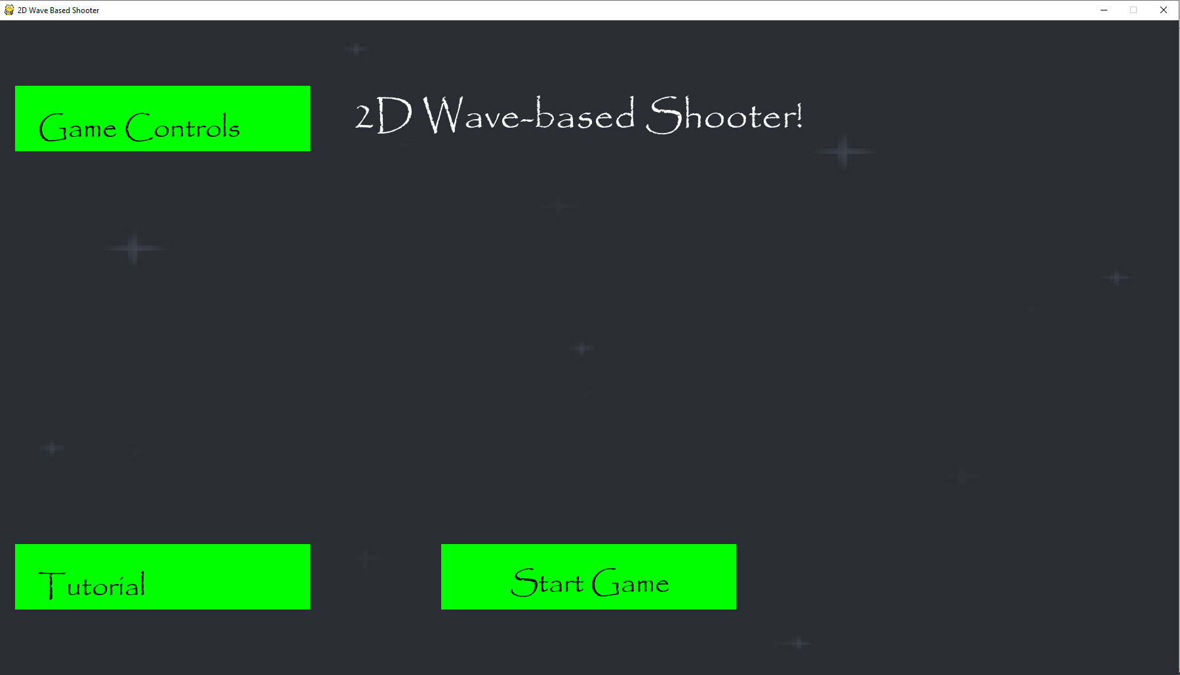  
The new sections appear onscreen like they should at a width of 1800 pixels.

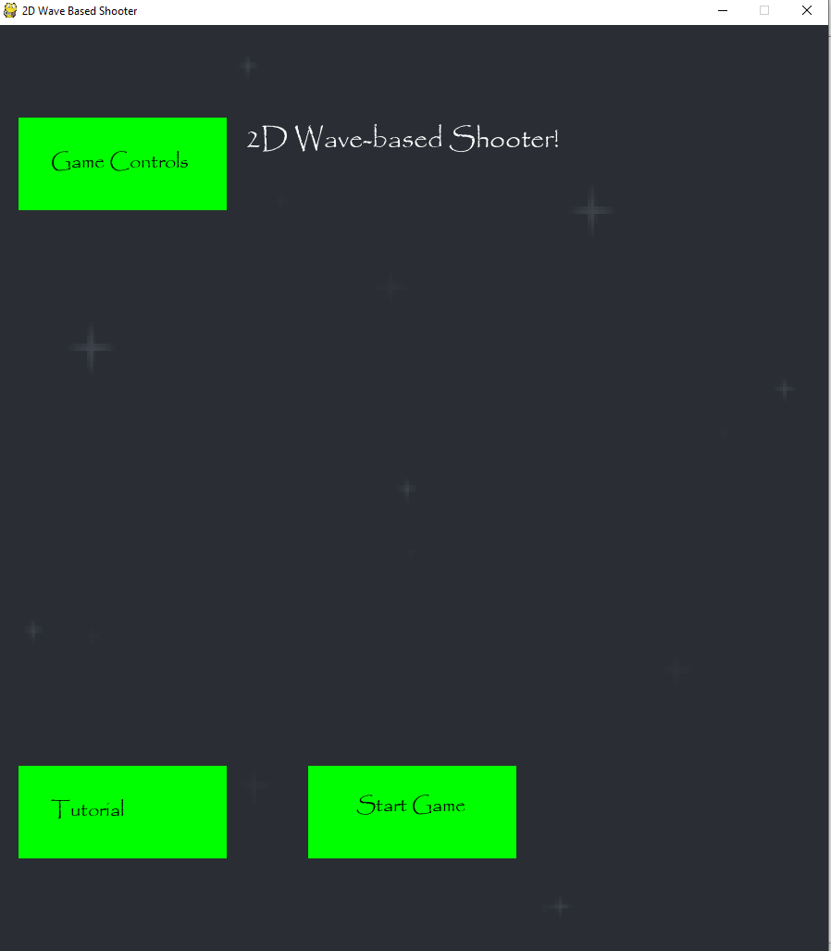  
The new sections also appear onscreen on the left when the smallest width of 900 pixels is used.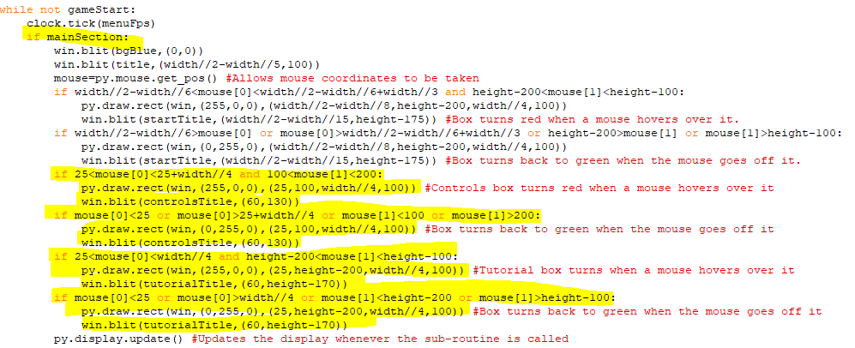The highlighted code at the bottom is the code added to make the new sections change colour to red when a mouse hovers over them and change back to green when a mouse goes off them. The code itself works in the same way as the code for the start game section. The highlighted if statement is being used to signal when different sections of the main menu are displayed. When this current section needs to be displayed, mainSection will be True but when they click on another section, mainSection will become False and another boolean will become True so that that section is displayed instead.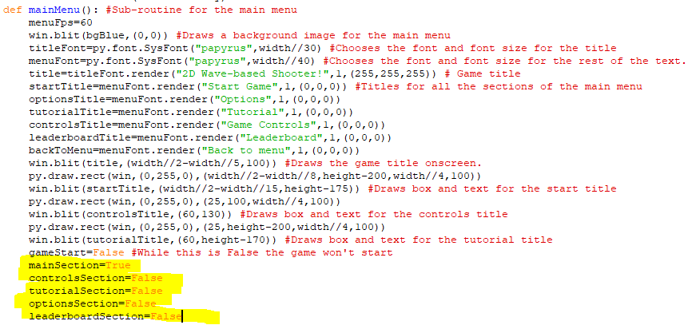The highlighted lines are the boolean variables for the different sections. When the game is started, only mainSection is True so the main start-up menu is all that is seen now.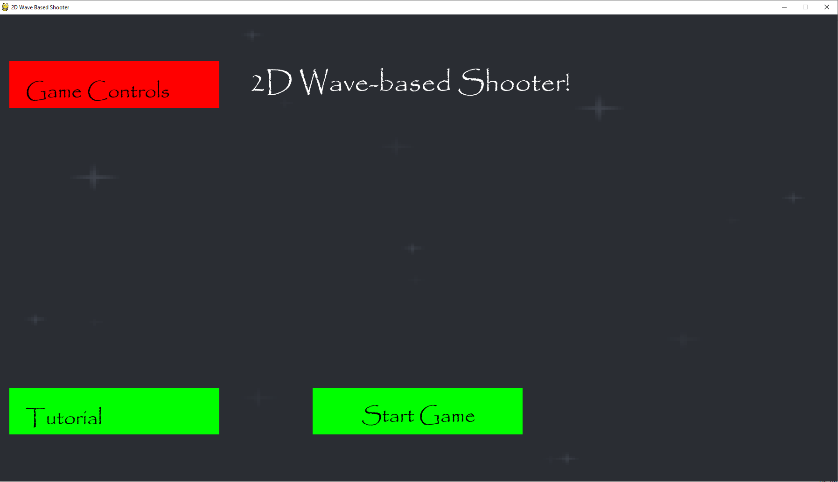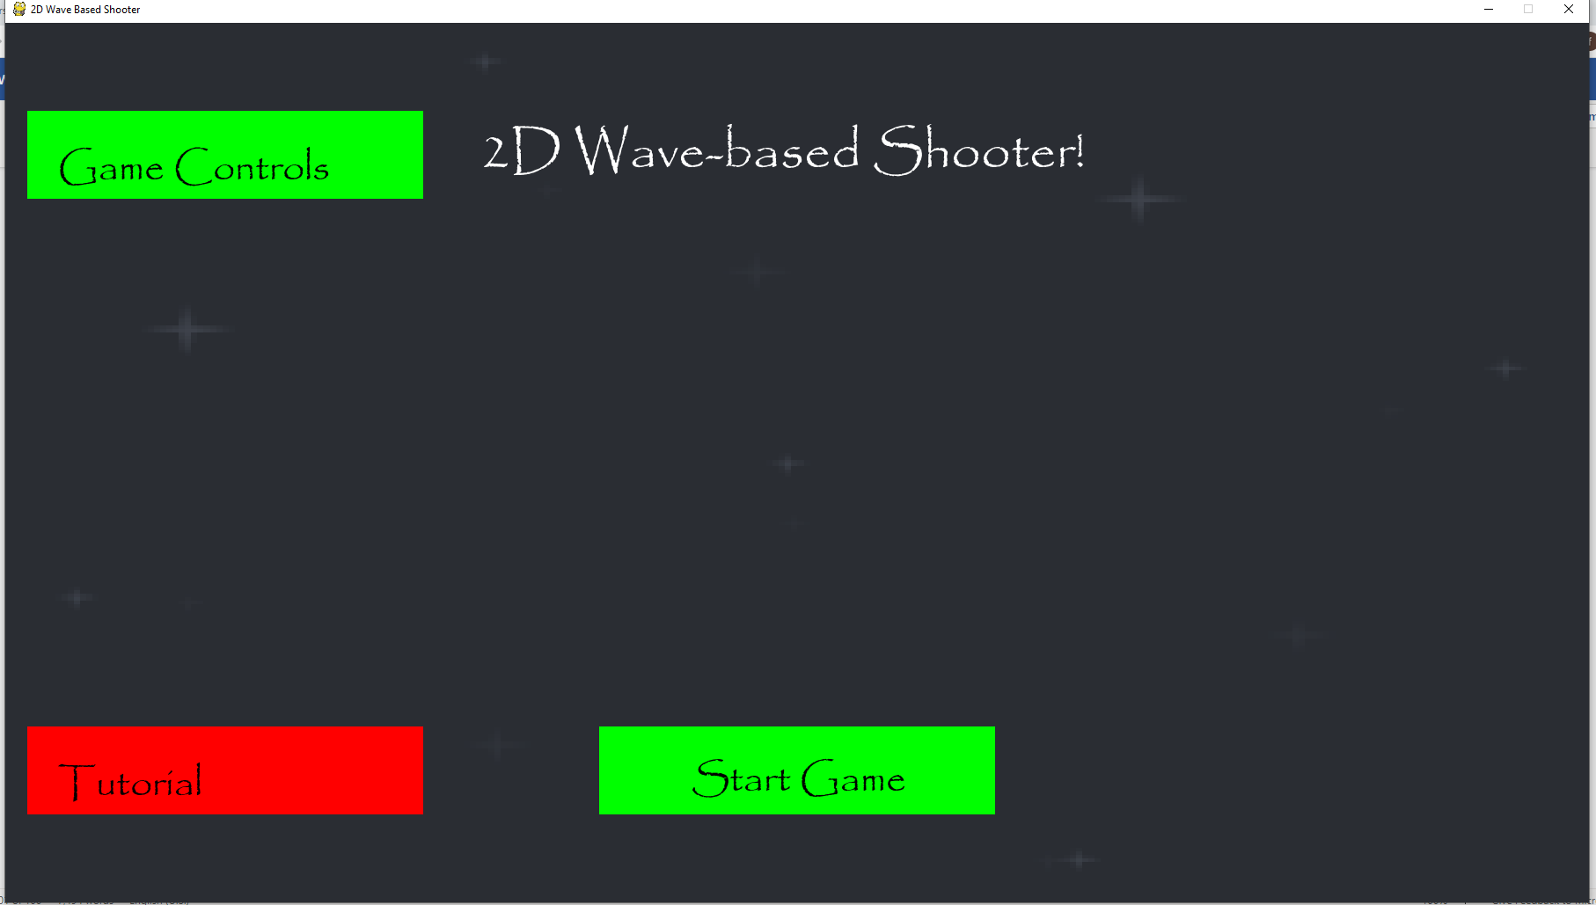  
The sections change colour to red when the mouse hovers over them but then change back to green when the mouse goes off them.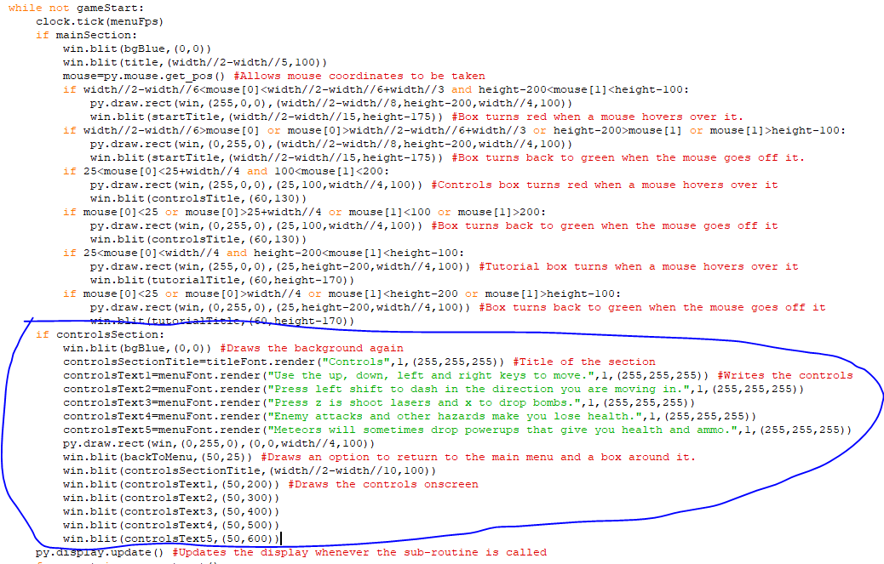The circled code is the code for control section being displayed onscreen. When controlsSection is True the game will draw a new background over the existing screen and the code writes the text for the different controls. This is done using the menuFont so it is 40 times smaller than the width. These instructions are then drawn onscreen one after the other but a back to menu box is also drawn onscreen in the top lefthand corner to let the player go back to the main menu.

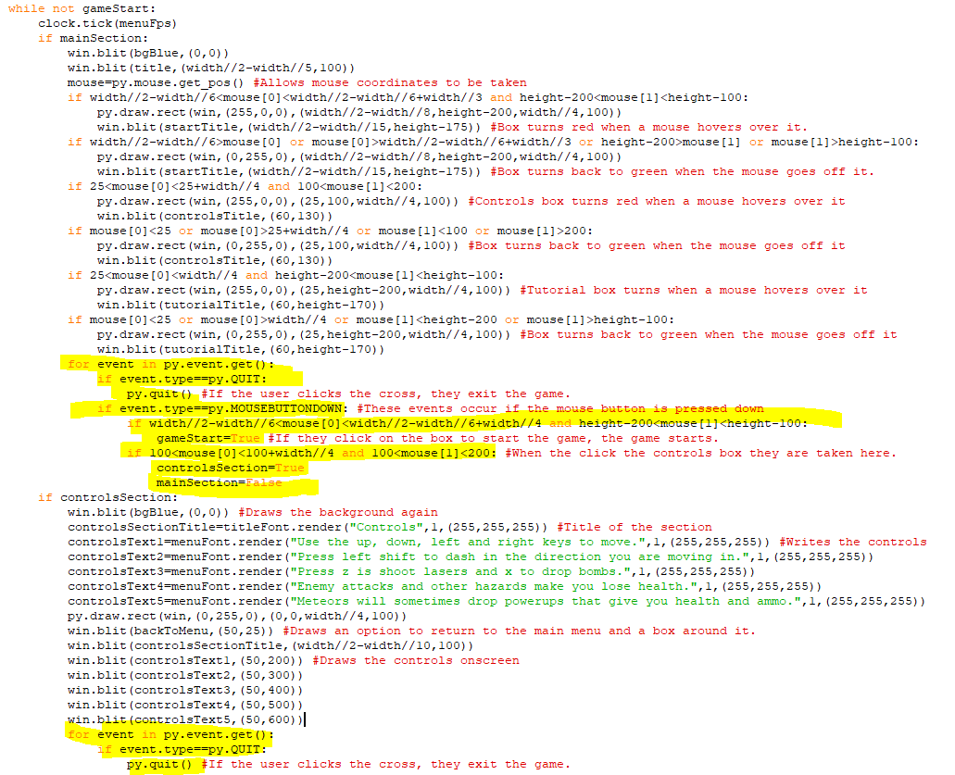I have split the events for loop into two separate ”for loops” for each section. This allows me to break down the events more easily. In the first block of highlighted code, I have added a section in the last three lines that makes controlsSection True and mainSection False when it is clicked on. This means that the instructions should now be displayed onscreen. The highlighted code at the bottom lets the player close the game when they are in the controls screen.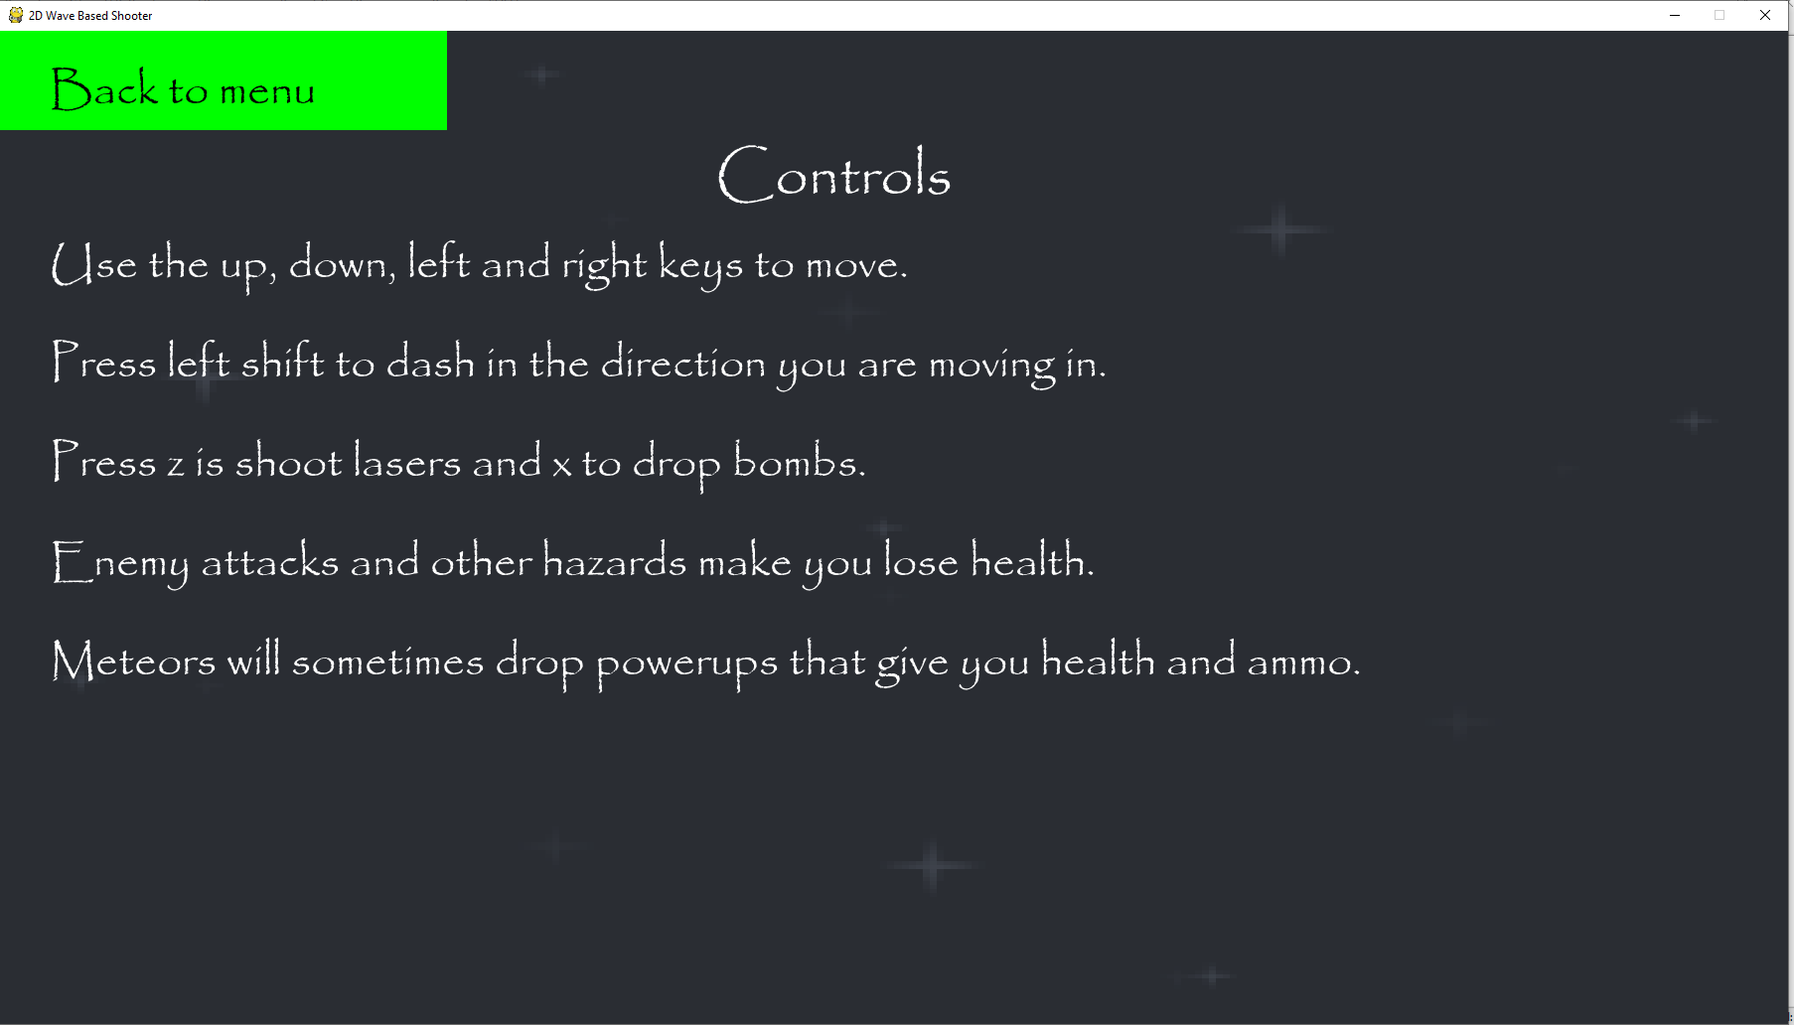  
When I clicked on the controls options it took me to this screen. All the instructions are being displayed.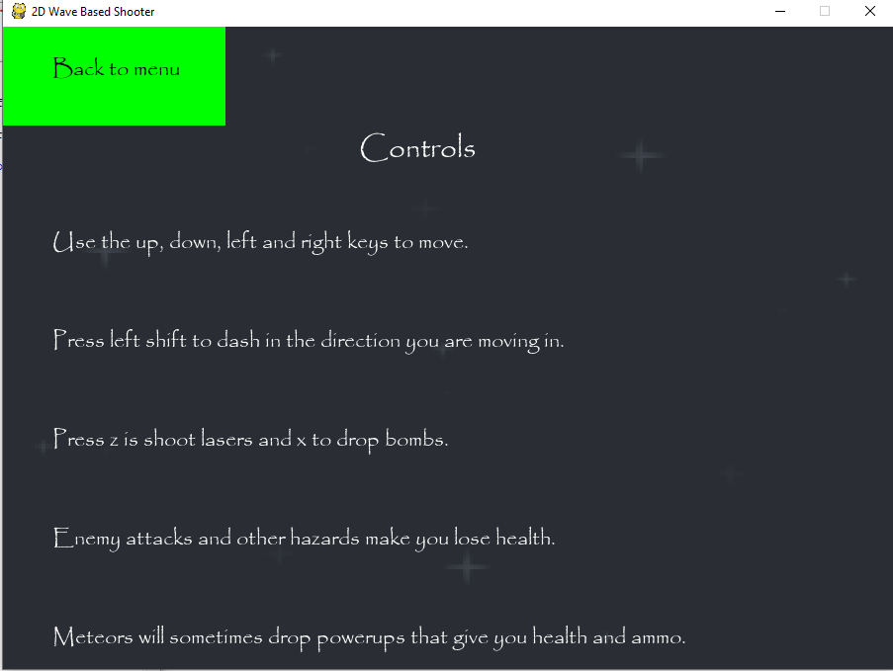  
The instructions still fit when the height of the screen is at its smallest, 650 pixels.

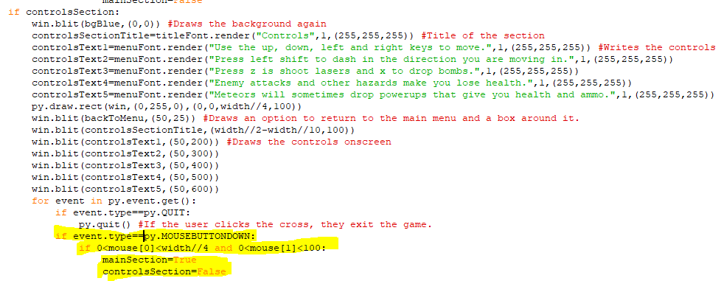I have written some code that should make the game return to the starting menu when the mouse is clicked at any point in the coordinates of the box, as mainSection will become True and controlsSection will become False.

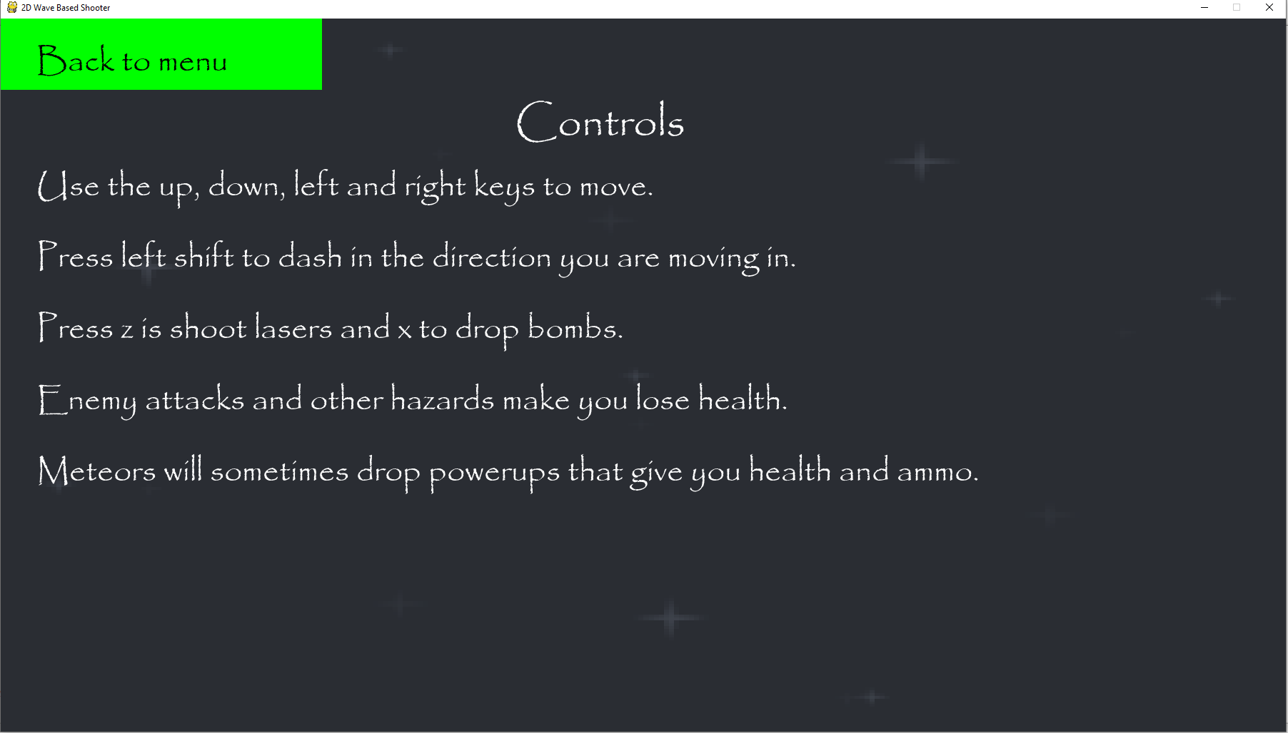  
For some reason, the program won’t return to the starting menu when I click on the box, even though the coordinates it can be clicked in are identical to that of the box.

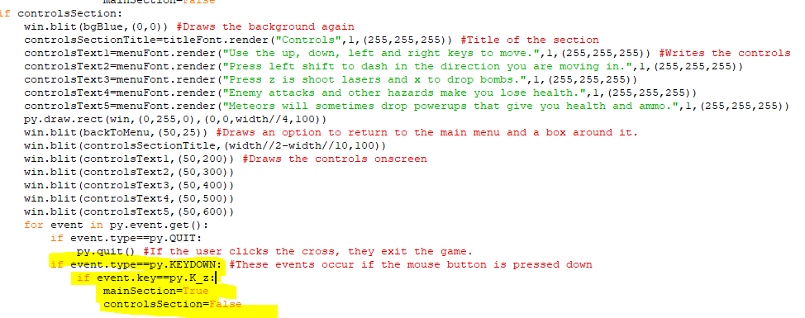I replaced clicking on the box with pressing the letter z when in the control section to return to the starting menu.

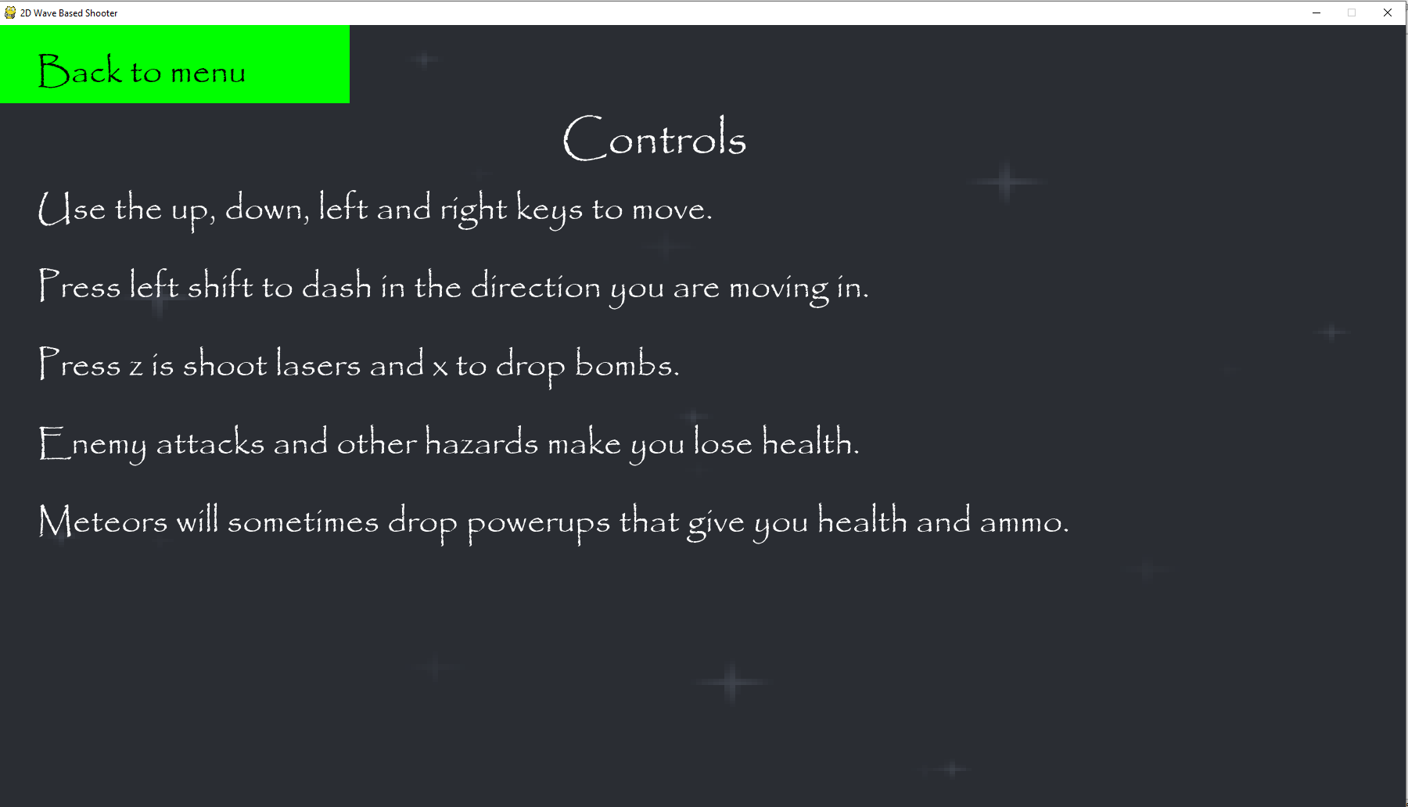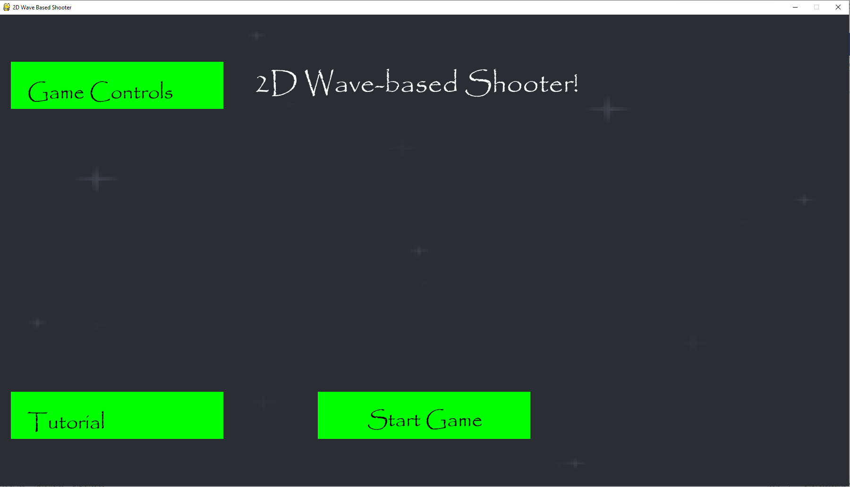  
It works, when I pressed z when in the controls section, it returned me to the starting section.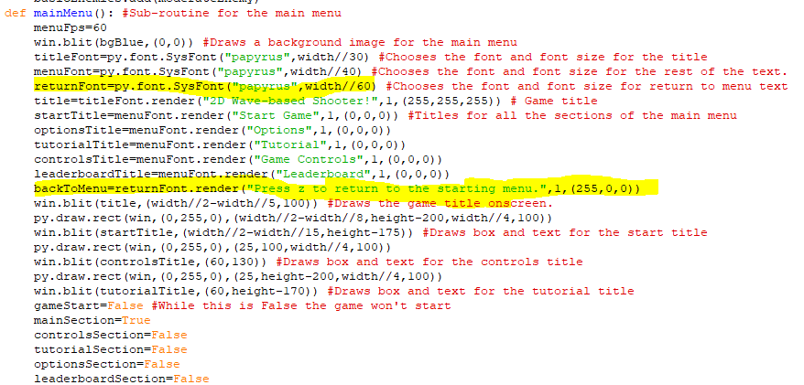I replaced the text for the backToMenu title, decreased its font size and changed its colour to red to make it visually distinctive onscreen.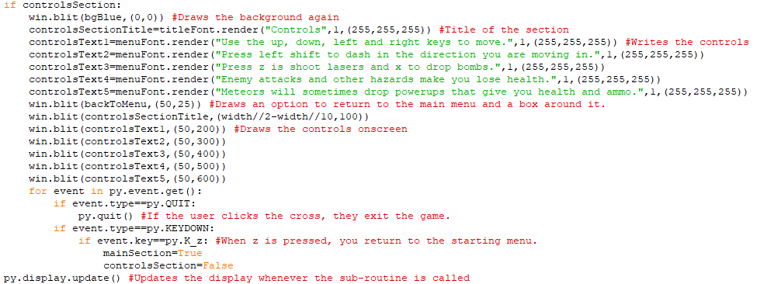I have removed the green box so only the back to menu text, now in red, is left.

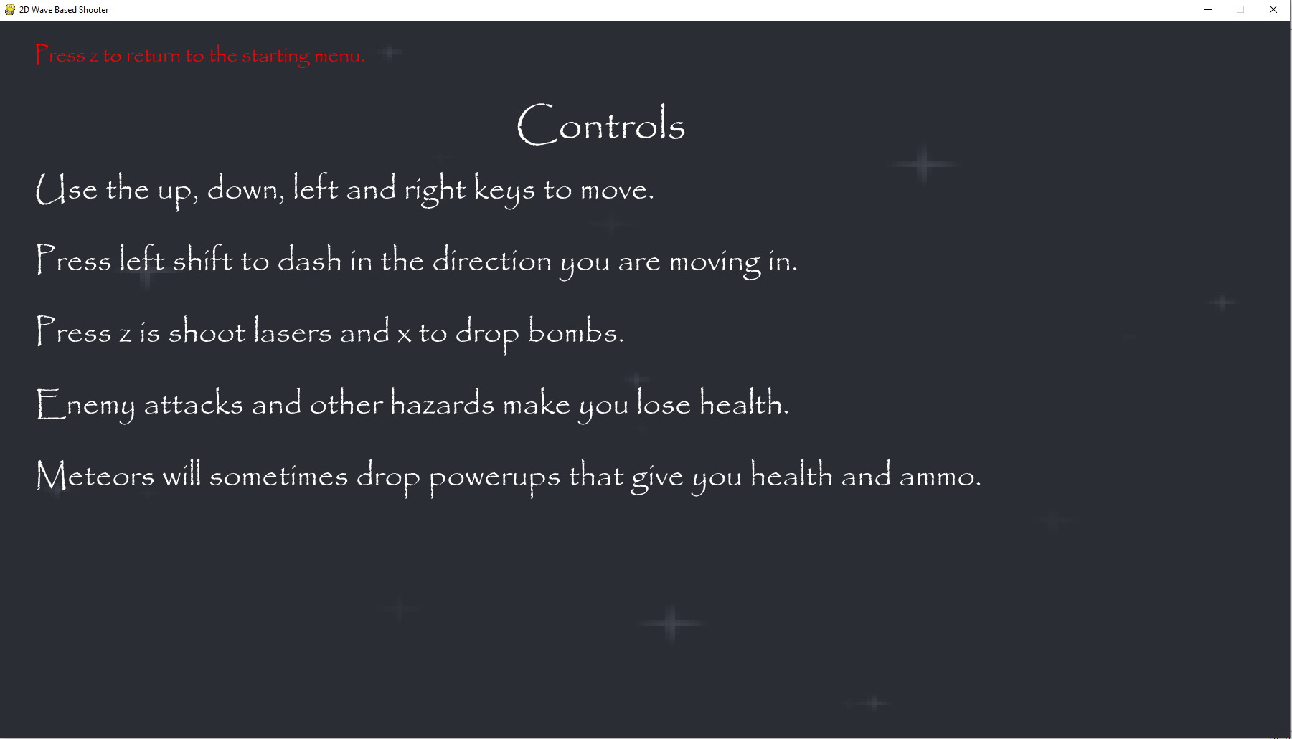The red back to menu text appears onscreen just fine.

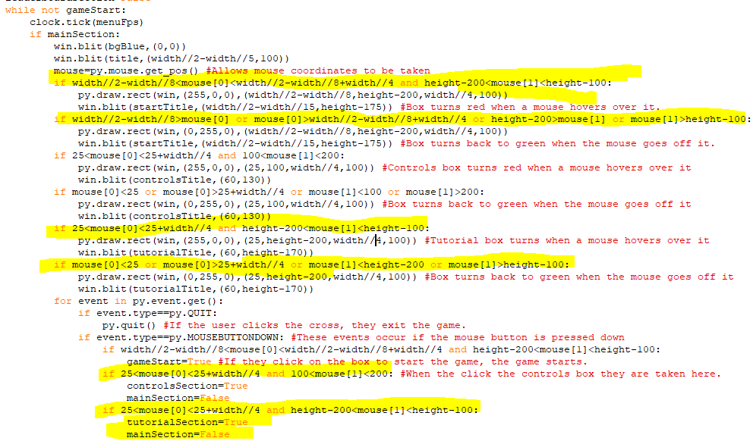With the single line of code at the bottom, I noticed that if the mouse coordinate only made the control section trigger if it was click when it was more than 100 pixels across from the left, even though the box stretches back to 25 pixels across from the left, so I changed that. In addition, I change the coordinates needed to change the colour of boxes and to click on them so that they directly fitted the boxes. I also made the same code for triggering the tutorial section, when the player clicks on the tutorial box, tutorialSection becomes True and mainSection section becomes False.

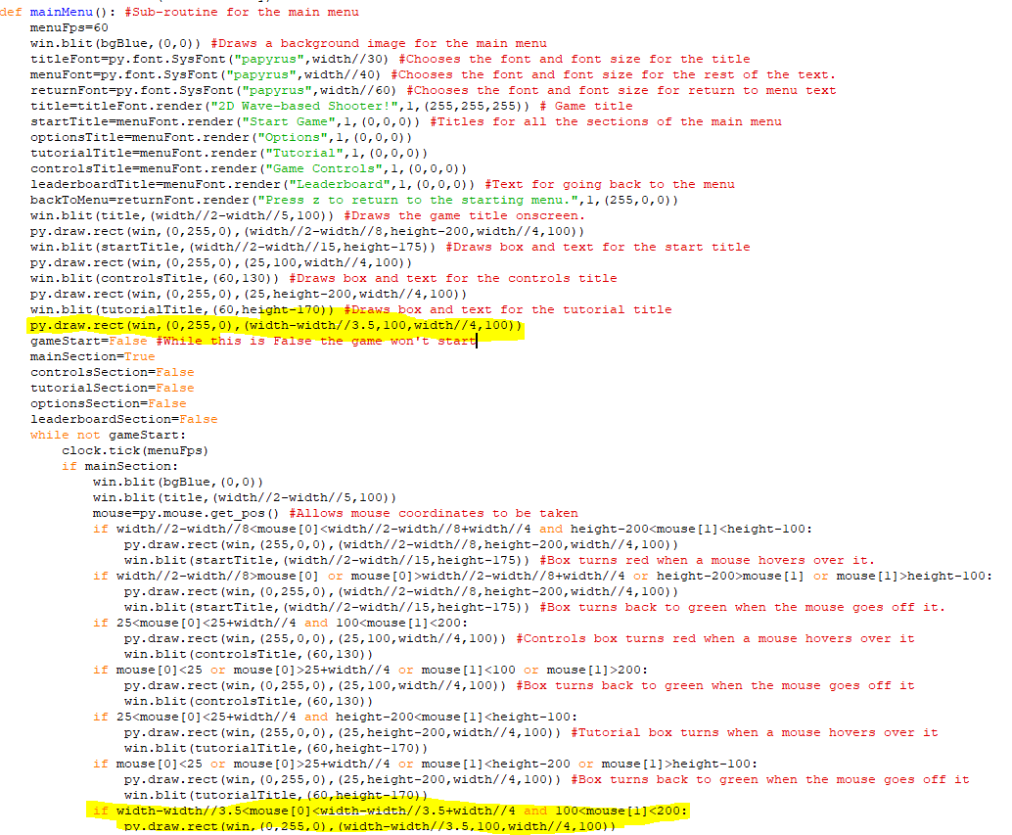The highlighted code draws a green box in the top right of the screen. This box will be parallel to the y coordinate of the Game Controls box. Its size also depends on the width of the screen like with the other boxes, with it getting smaller as the width decreases.

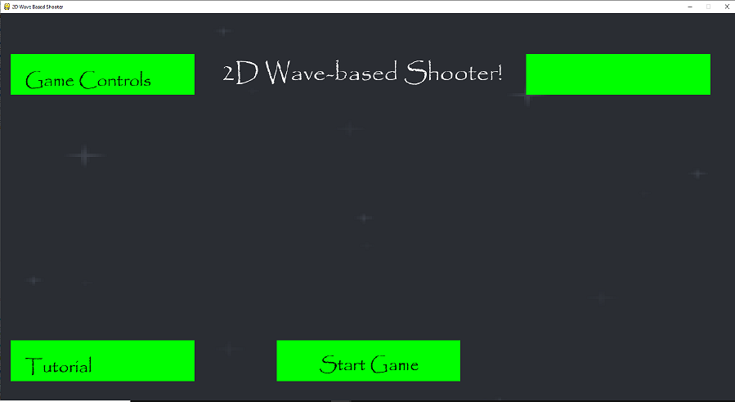  
The box appears onscreen in a suitable position at a width of 1800 pixels.

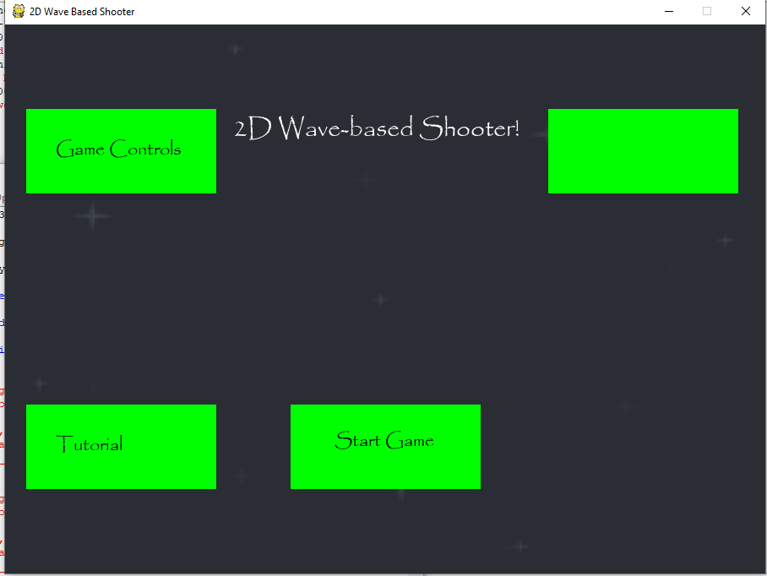  
The box appears onscreen in a suitable position when the width is only 900 pixels.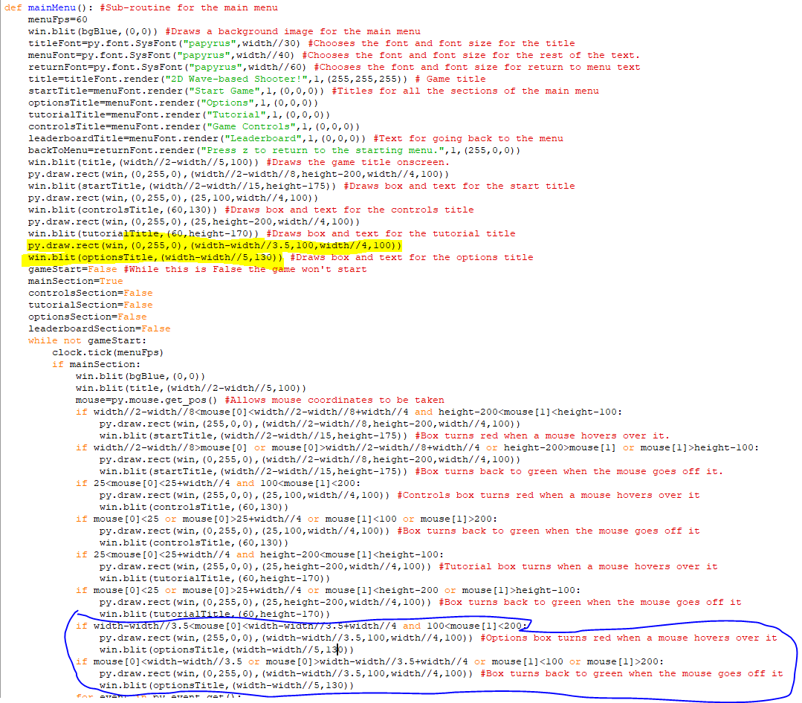 This is the box for the options menu so I added the options text in the highlighted code as well as the circled code. In the circled code I changed the existing code so that it turns red when a mouse hovers over it and it goes back to green when a mouse goes off it.

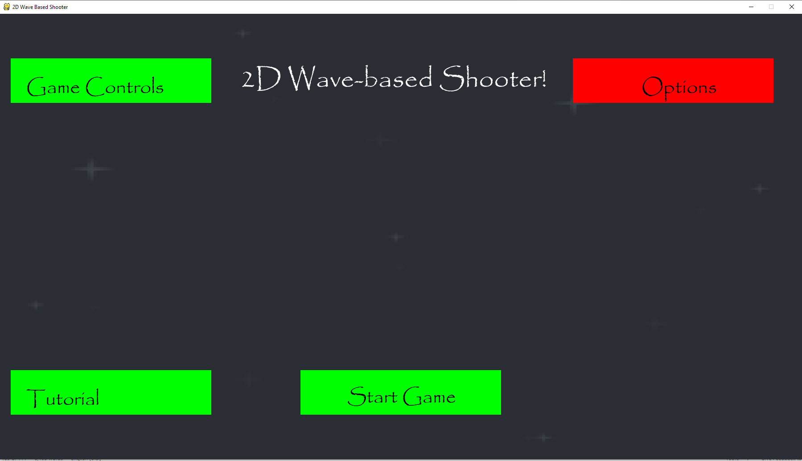The options text is now onscreen and the box turns red when a mouse hovers over it.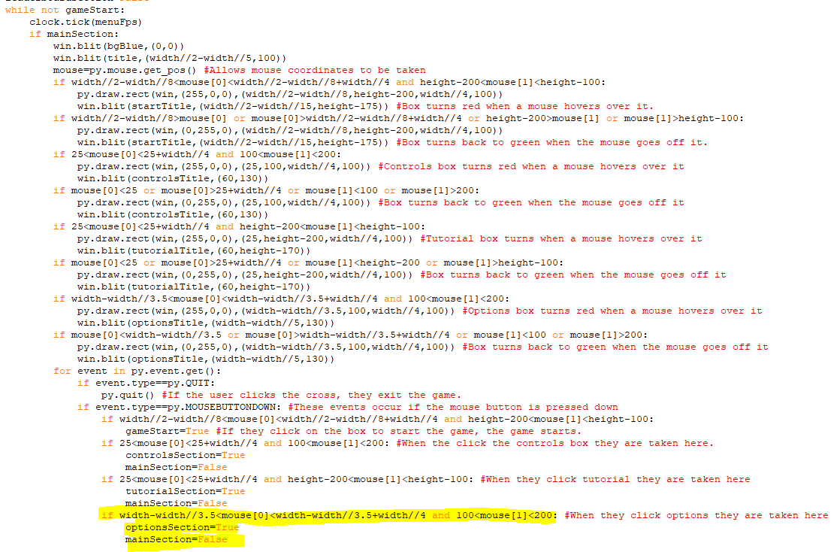The highlighted code makes the boolean optionsSection True when the options box is clicked and also makes the mainSection False so that the user is taken to the options menu.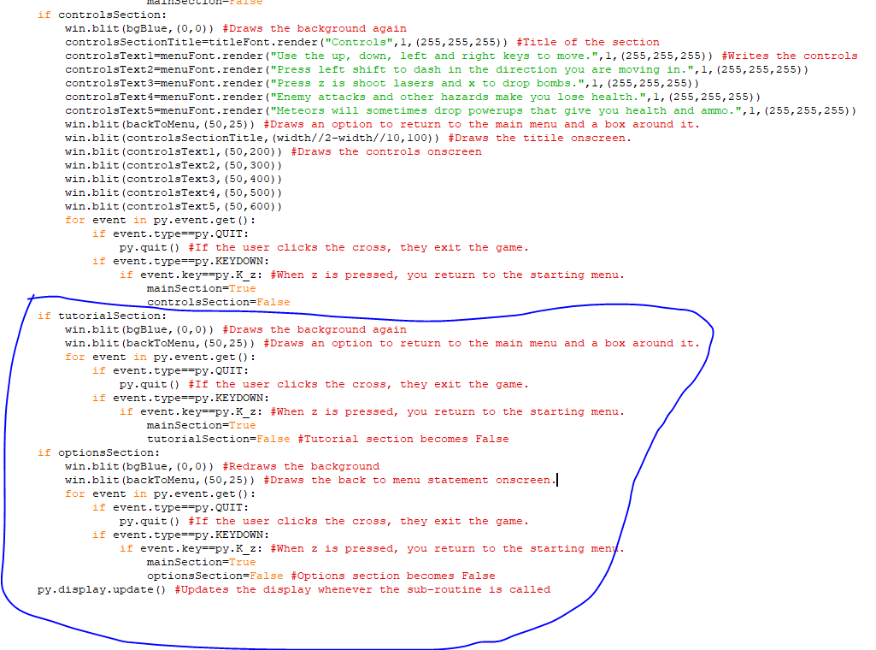The circles code is what happens when either the options or tutorial sections is clicked. Currently, they are almost identical, with both sections telling you how to return to the main menu using z and both having nothing else onscreen other than the background. When z is pressed in the tutorial section, then tutorialSection becomes False but if it is pressed in the options menu, then optionsSection becomes False.

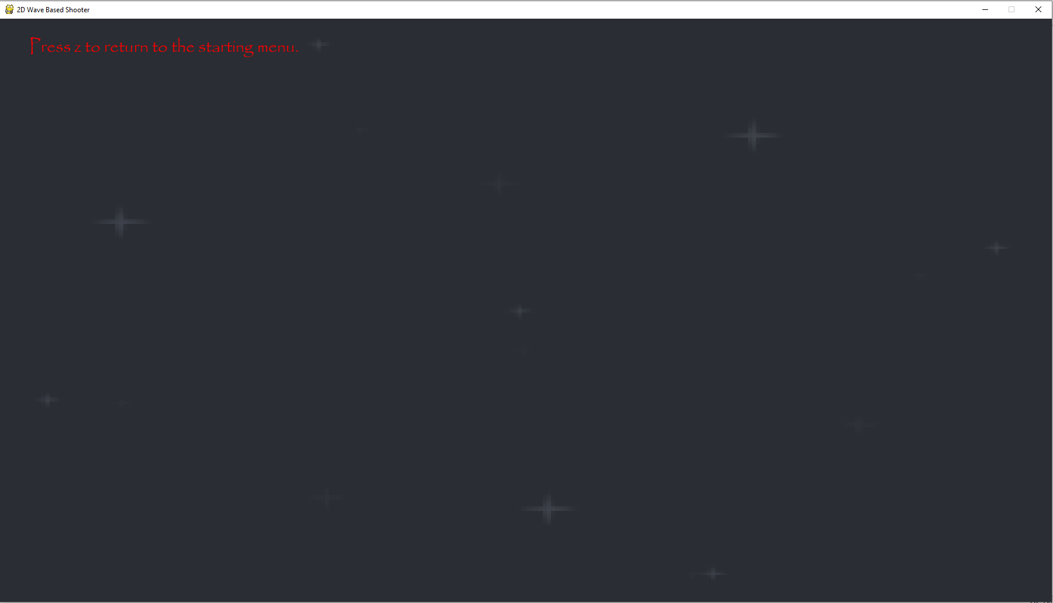  
This image is what currently show up when you click on the tutorial or options section.

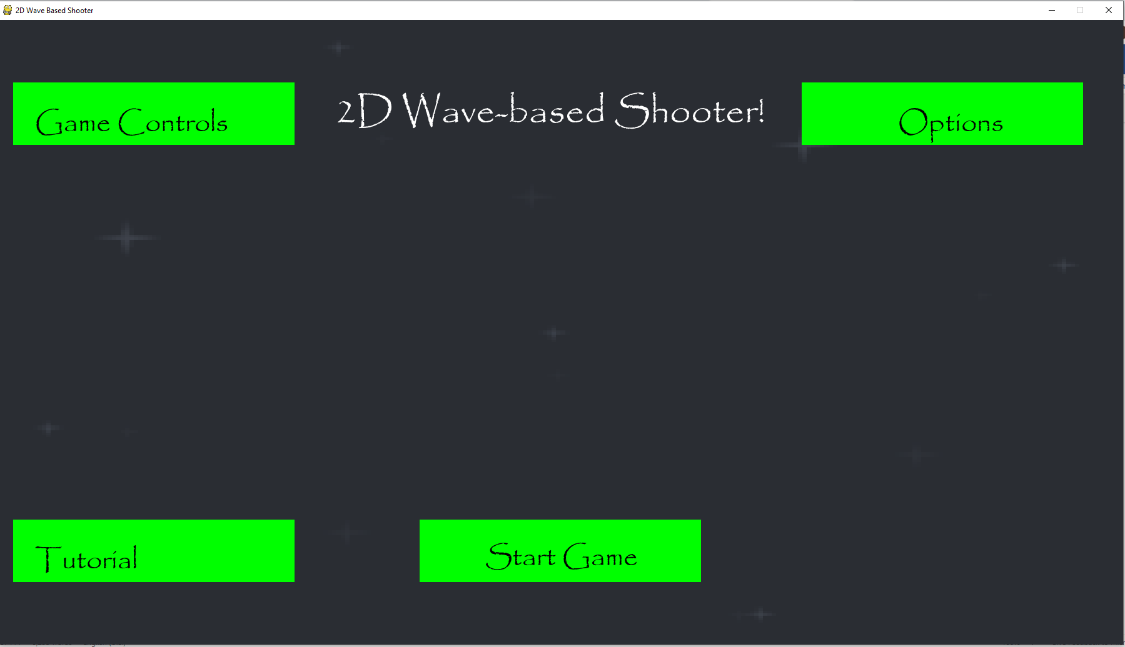  
Pressing z on either of the sections causes you to return to the main menu.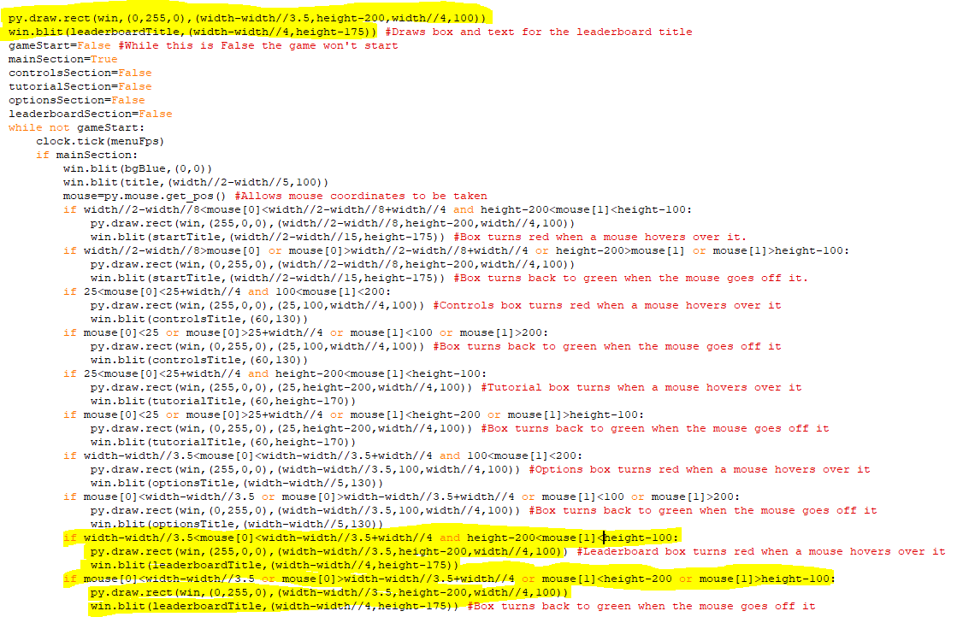I have added in code to draw a box for the leaderboard section and put the text ”leaderboard” inside the box. This box is redrawn as red when a mouse hovers over it and turns back to green when the mouse goes off it. It is also vertically parallel to the options box and horizontally parallel to the tutorial and start game boxes.

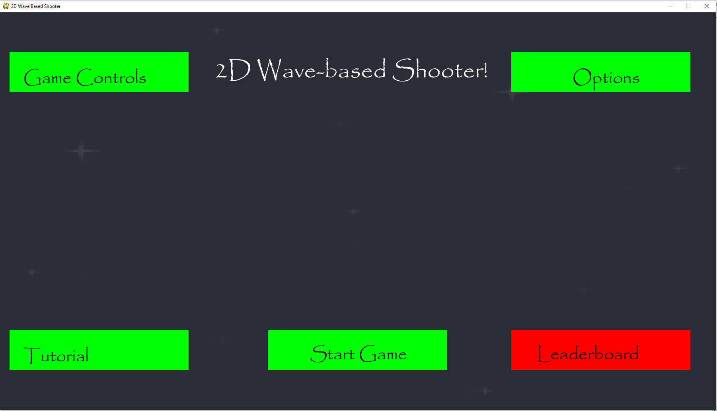  
The leaderboard box appears onscreen and changes to red when a mouse goes over it.

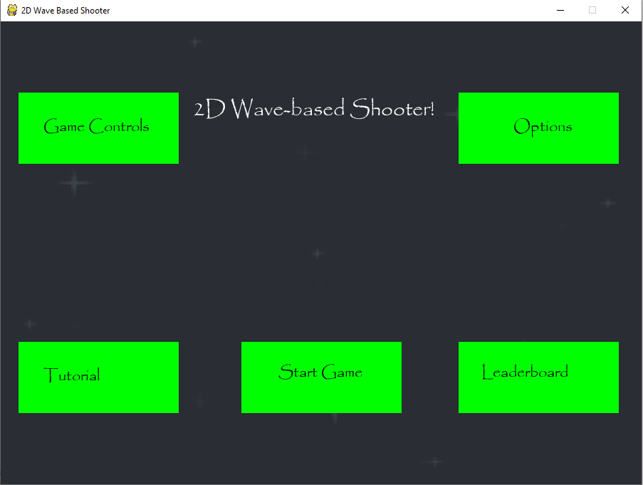  
This is how of the sections fit on when the game is at its smallest width of 900 pixels.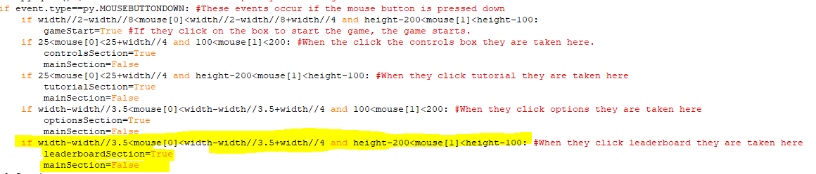The highlighted code at the bottom makes the game go to the leaderboard section when the mouse is clicked on the leaderboard box as leaderboardSection becomes True and mainSection becomes False.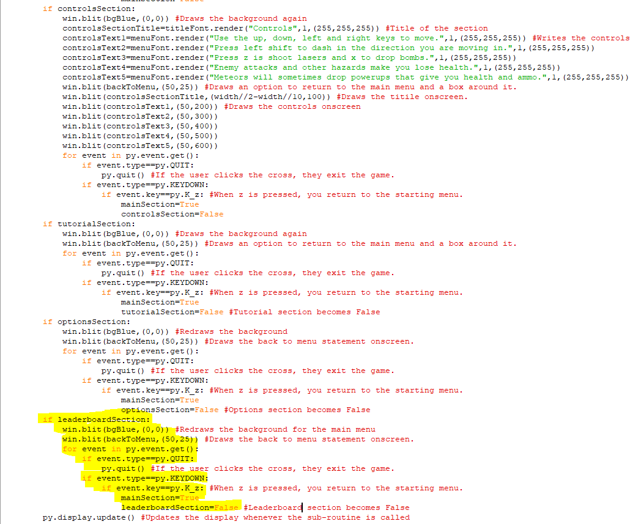Currently, the leaderboard section is functionally identical to the tutorial and options sections since when leaderboardSection is True you can click on the cross in the pygame window is exit the game and you can press z to go back to the starting menu, as that makes mainSection True and leaderboardSection False.

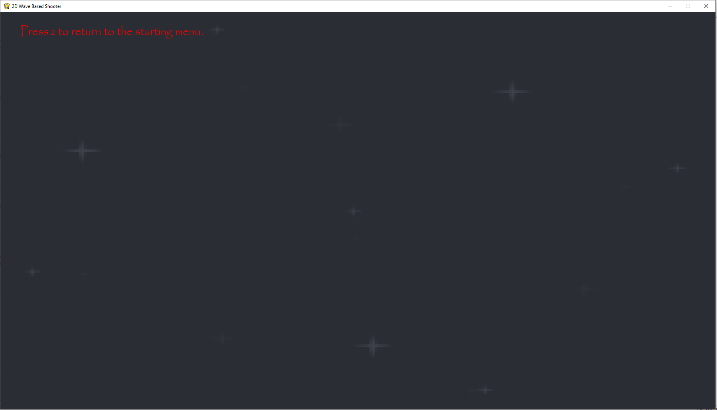This is what is shown when you click on leaderboard currently, pressing z will return you to the starting menu. I have tested that. The leaderboard will be expanded upon later when I record the user’s score once they lose all their health ingame.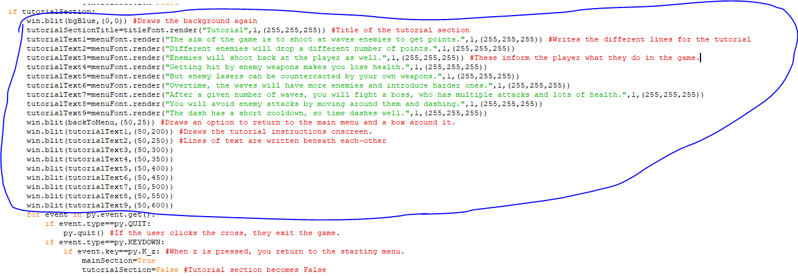The circled code is the text that has been added onscreen in the tutorial section to allow the player to understand how to play the game. They tell the player things like the aim of the game, avoiding enemy damage and how waves get harder over time. This text is first written in the game when it is rendered and is then drawn onscreen afterwards. I have also added in the title for the tutorial section, which is at the top when that section is clicked.

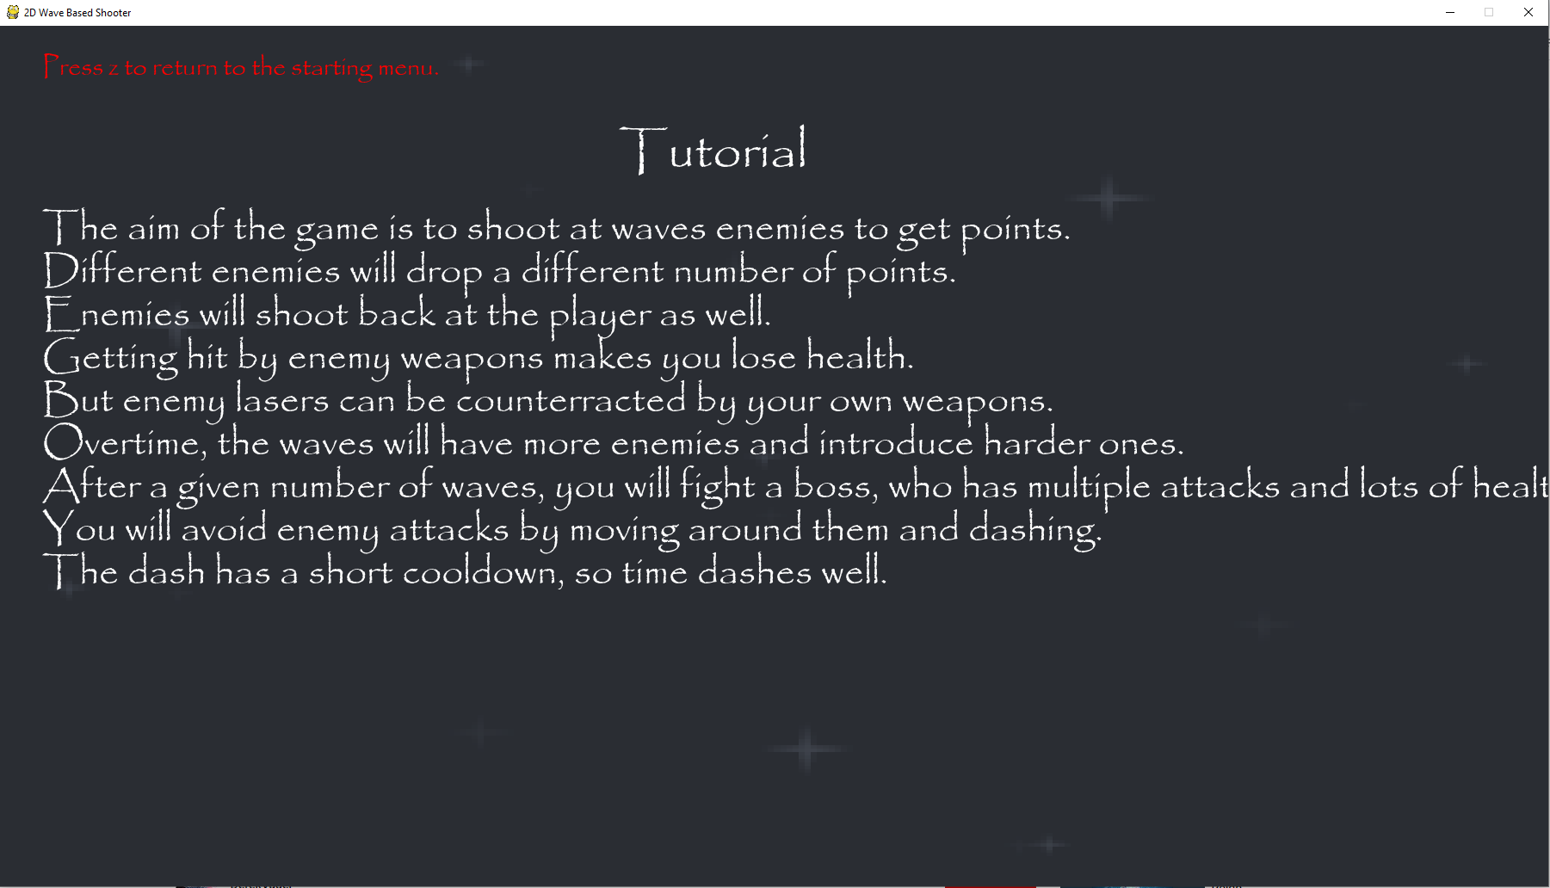  
The lines of text aren’t overlapping but they are very close together. One of the lines also goes offscreen so the word ”health” isn’t fully visible.

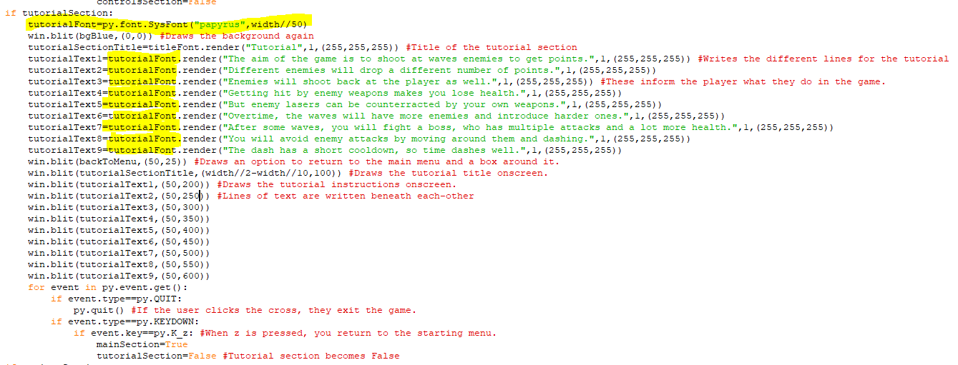I created a new font for the tutorial section that is smaller than the font used for the other sections as its size is the width//50 rather than the width//40 or the width//30. I then replaced the fonts used for the text with that font.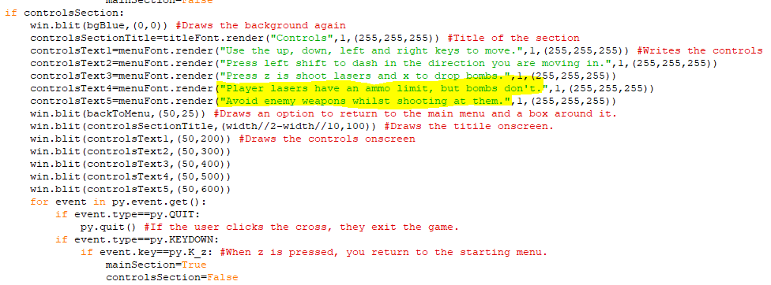I also changed the last two lines of the controls section so that they don’t overlap with the content of the tutorial section.

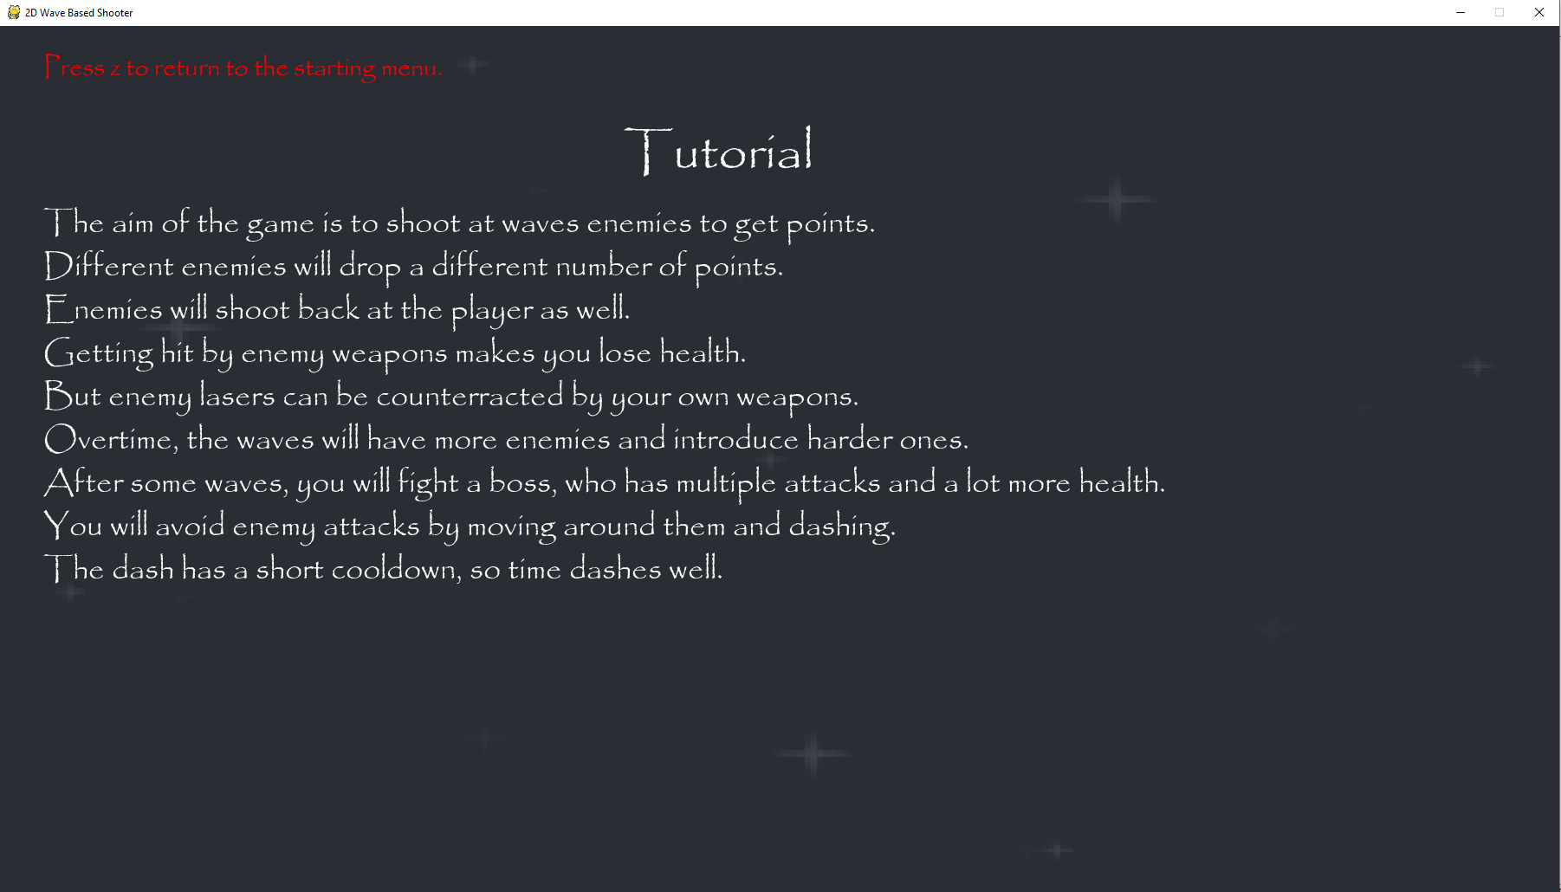  
The lines of text are now further apart from each-other and all the text is onscreen. This makes the tutorial section easier to read.

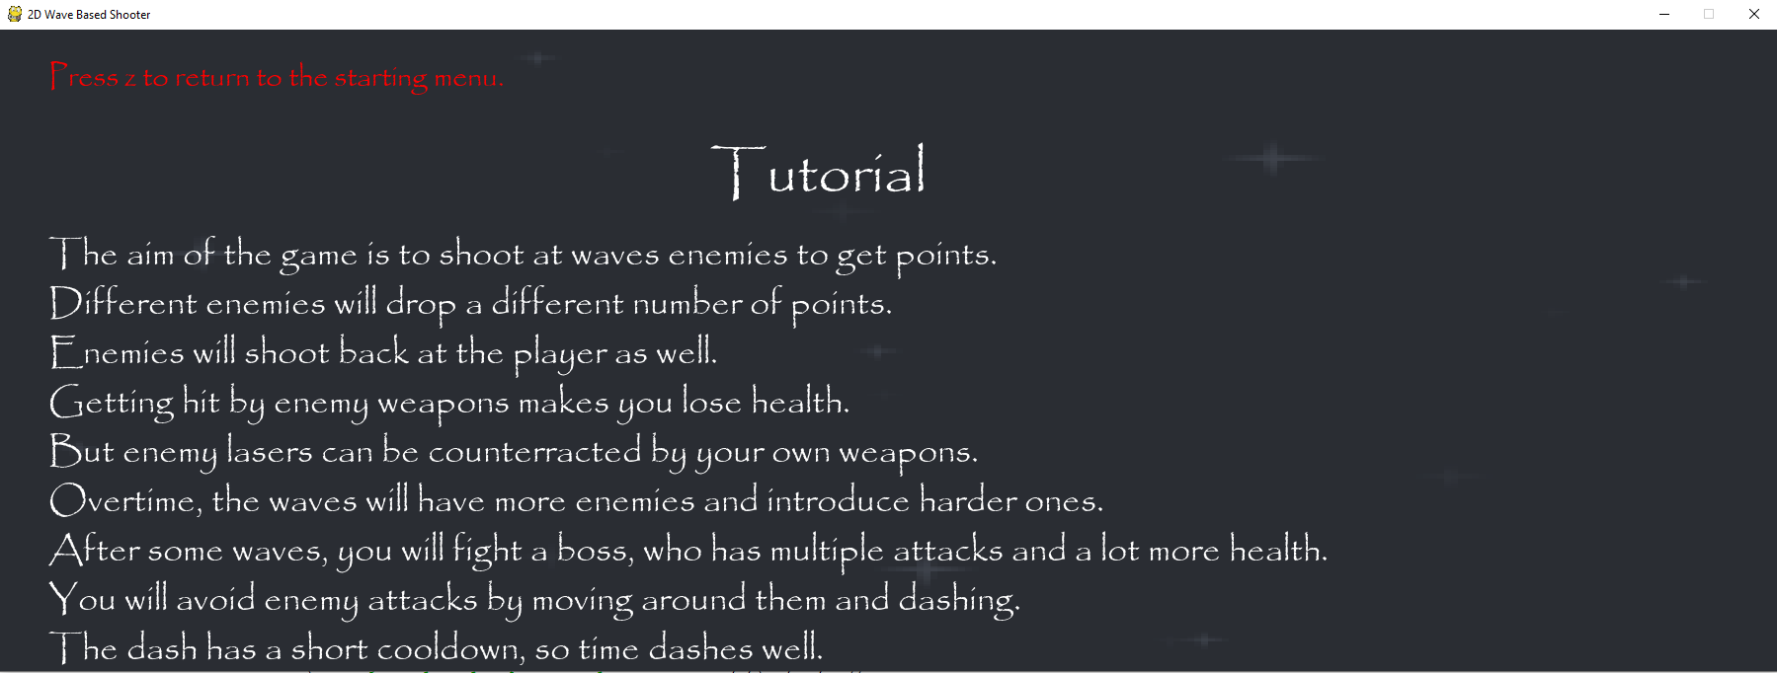This is what the tutorial section looks like when the width is 1800 pixels, but the height is only 650 pixels, as you can see, the text still fits onscreen even at the smallest height.

Stage 5 Review

In this stage, I have created a functional main menu for the game and have created all five sections of the main menu, with two of them being fully finished right now. The tutorial section and controls section both display all the information that they must to the player as they tell how player what to do in the in the game and how to control their spaceship in the game. It is easy to navigate between menus and you can always go back to the starting menu by pressing z. It is also visually clear when you can and cannot click on different sections due to the use of colour so the menu is easily navigable.

For the success criteria, I have created an interactive User Interface that currently allows me to start the game and also check its controls. The controls are presented in a clear manner and it is clear and obvious onscreen how to access each of these sections. The design of the main menu is also quite consistent, with the same font being used as well as the same kind of boxes that are all the same size. In addition, the boxes will always change colour from green to red when a cursor is on them so it is always clear when something can be clicked which fulfill the requirement for having a consistent layout and design.

Client Feedback:

The menu is well labelled and easy to navigate, and the buttons will change colour when a cursor hovers over them. But the leader board button does not yet work.

Stage 6- Implementing a Leaderboard and a Second Phase

**In this stage, the parts of the success criteria I am going to achieve are:**

* **Recording the score of the player**
* **Having an interactive UI that lets the player see the highest scores**
* **Introducing more enemies and another boss**

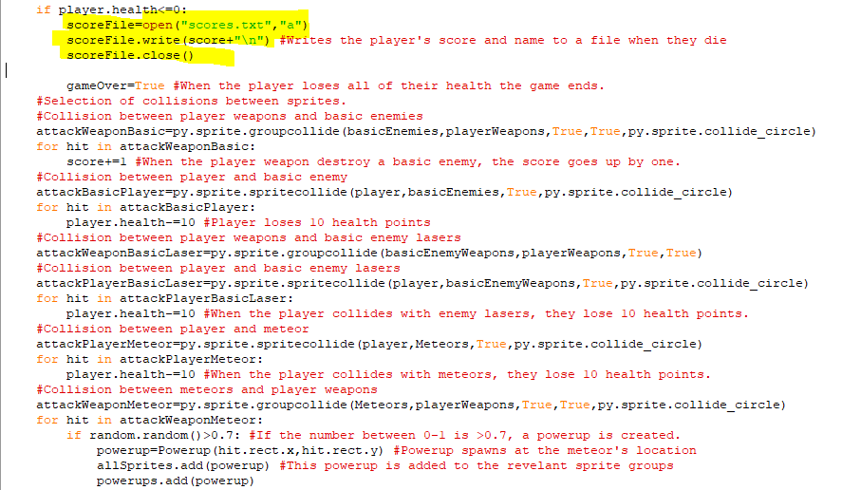The highlighted code takes the player’s score when they die and stores it in a text file called scores. The \n in the second line means that when another score is taken it will be written on another line.

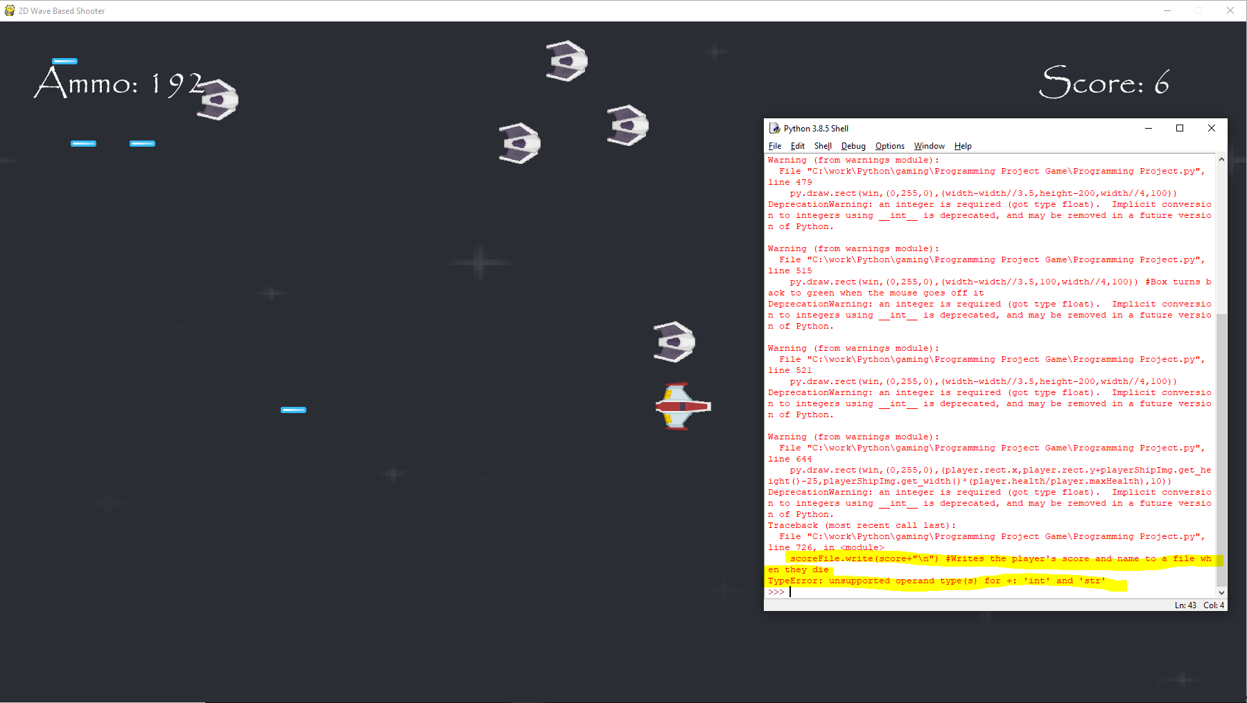When I died it came up with this highlighted error message because I hadn’t converted the integer value of the score into a string before adding it to a file.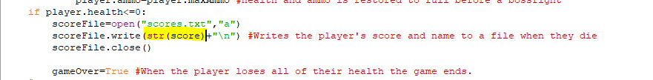I have now converted the score into a string before adding it to the file.

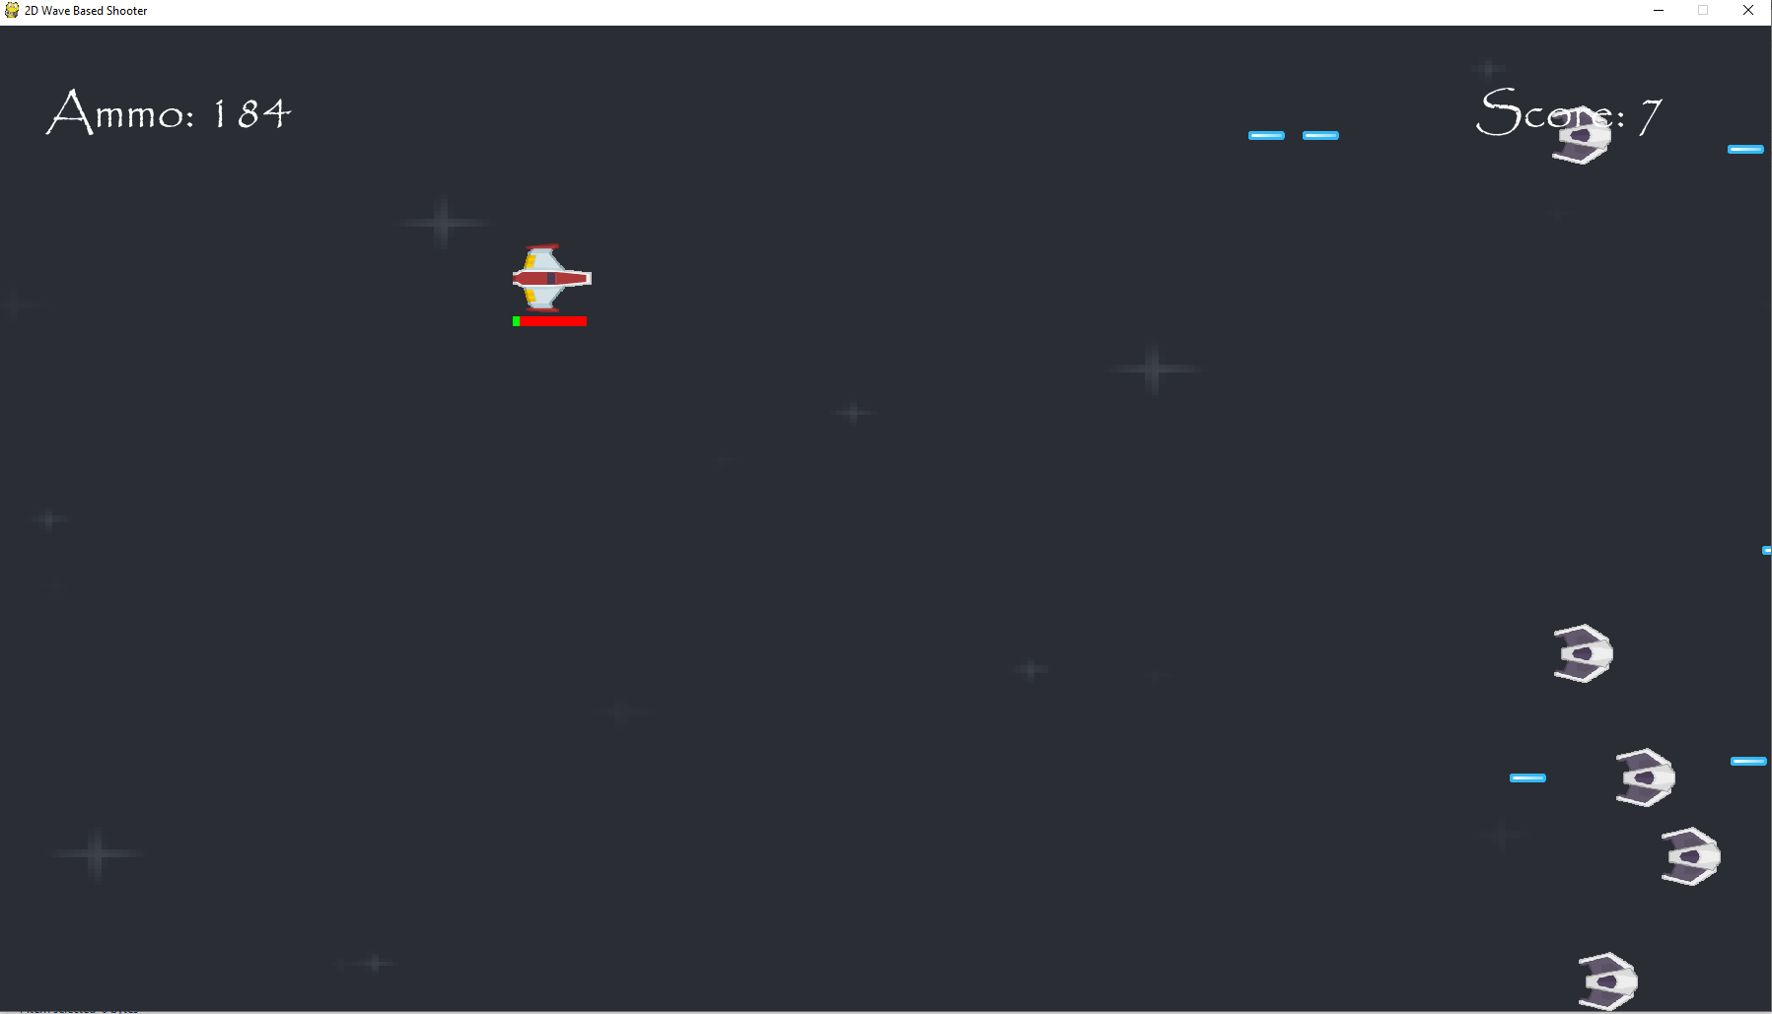  
This is my score of 7 before I die.

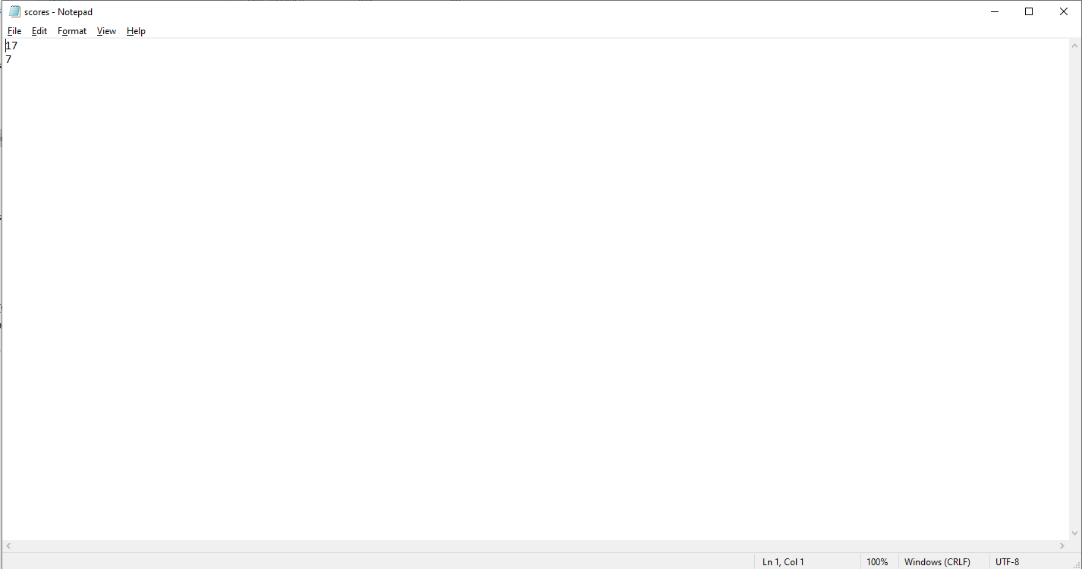  
The scores are being saved to a text file and they do appear on separate lines of the text file.

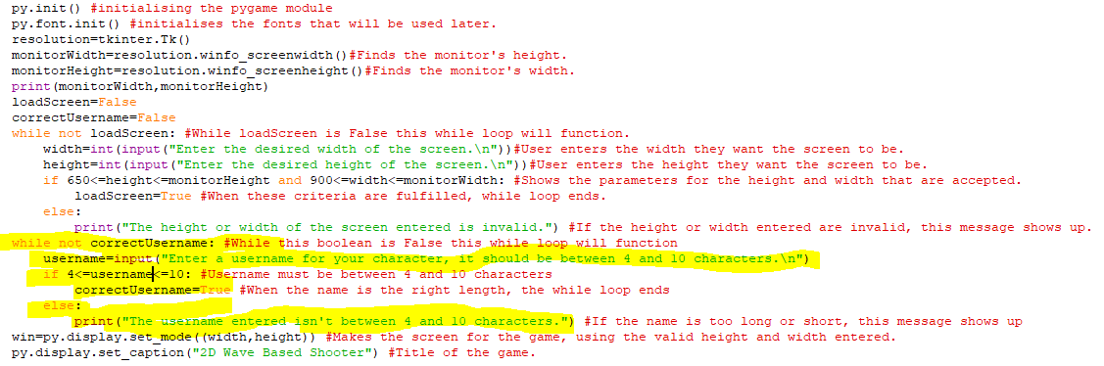At the start of the program, after the height and width of the screen are entered, the program will ask for a player name from the shell which has to be between 4 and 10 characters. There is a while loop making the program run through this text repeatedly until a username between those parameters is entered. After that, the game screen will be drawn.

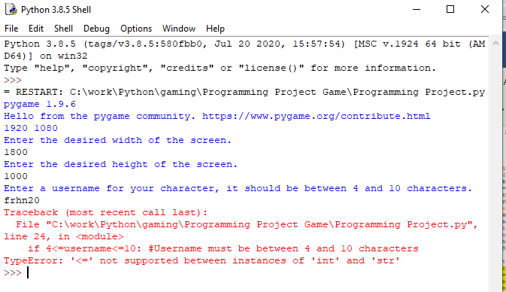  
When I tried to enter a username, this error message showed up because I hadn’t compared the length of username to 4 and 10, instead I had compared the variable itself which doesn’t work because it is a string.

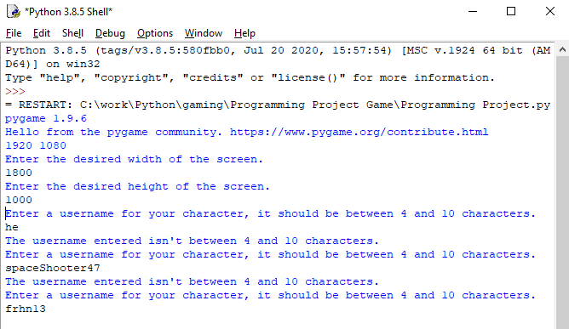  
I entered usernames that were more than 10 characters and less than 4 characters, and the program didn’t accept them, but when I entered a name with 6 characters, the program did accept it.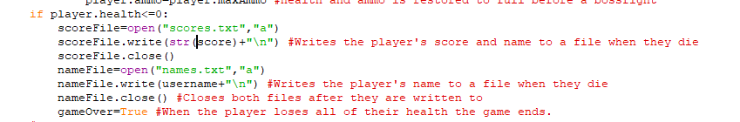I have added in code that takes the player name entered and stores it in a file for player name when the user dies in the game. This code also makes sure that the names are on different lines in the text file. Since the names and scores are stored simultaneously in the files, it means that corresponding scores and player names will be stored in the same line for each text file.

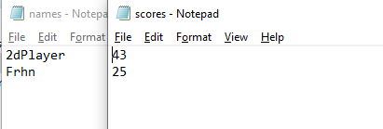  
I removed the previous scores from the file and the new scores and corresponding player names are stored in the same line number in the files when the player dies in game.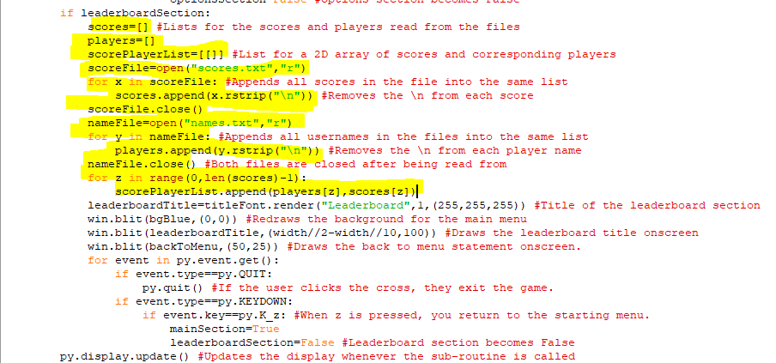When the player clicks on the leaderboard section the game will take all the player names stored in the player names file and append them to a list called scores. This is done using a for loop to through all the names in the file and the rstrip \n command removes all the \ns from each line of text when it is added to a list. Another for loop is used to loop through the scores file and add all the scores in the file to an array called scores. It also removes the \ns from the scores. Since the corresponding scores and players were on identical lines in their text files, they will also have identical indexes in the lists, so these lists are combined to put corresponding scores and players in a 2D array.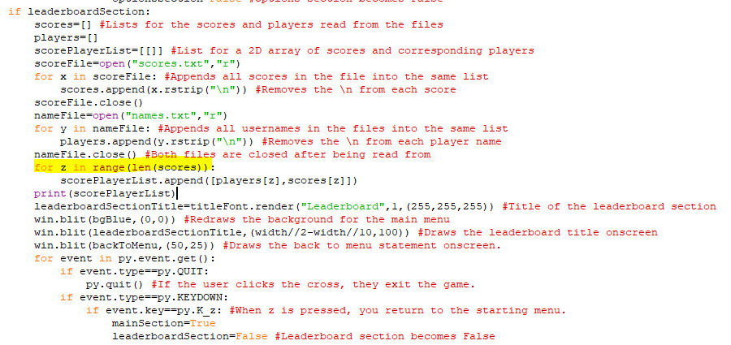I realised that range should be to the length of either of the lists, rather than one less than that os that all items from both lists are appended.

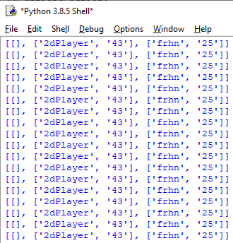  
I added a line of code to print contents of the scorePlayerList to check if the corresponding player names and scores were being printed. This is happening but an empty element is also being created at the start of the list which will need to be removed.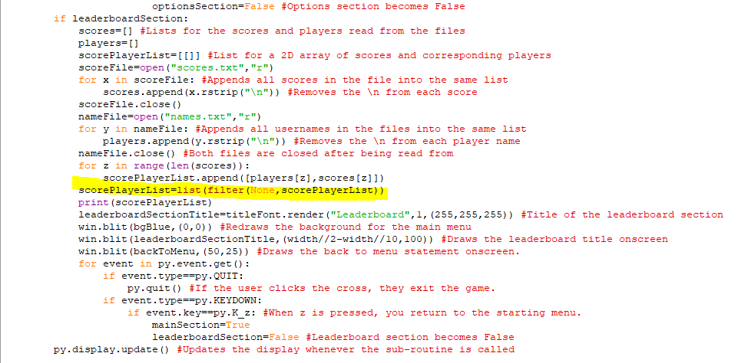The highlighted code checks where there an element is empty in a data structure and then removes that element from the data structure.

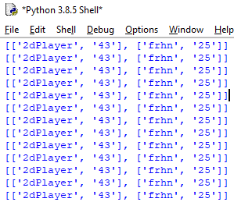  
The empty element no longer shows up the 2D array is printed.

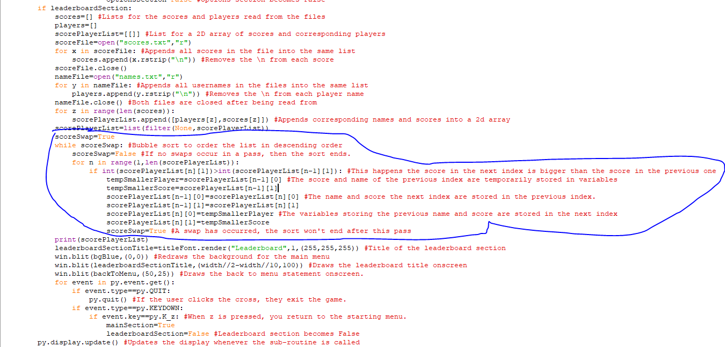The circled code is a bubble sort I added to the leaderboard section once the items have been added to the same 2D array to sort them in descending order of score. A for loop is used to go through each item in the list and compare it with the item before it which would be a single pass in a bubble sort. But this only occurs while scoreSwap is True so when a pass finishes, if scoreSwap is still False then the bubble sort ends as the list is sorted. If the item before is smaller than the current item then their positions are swapped by temporarily storing the score and player name of the previous element in two separate variables, whilst storing the score and name of the current element in the index of the previous one. Finally, the variables storing the name and score of the previous element are stored in the current element’s old index. This means that a swap has occurred and if a swap occurs in any given pass then scoreSwap becomes True so another pass will occur afterwards. At the start of each pass scoreSwap is set to False, so if a pass occurs without a swap then the array is fully sorted.

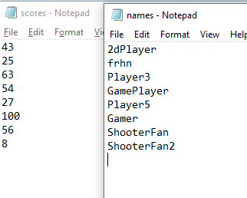  
I played the game several more times with more player names and scores and this is how the scores and corresponding player names are laid out in the list, importantly, they aren’t in descending order.

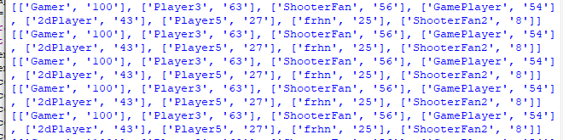I added a line of code to print the 2D array of the players and scores after it is sorted by the bubble sort when I click on the leaderboard section and the player names and scores and presented in decreasing order of score.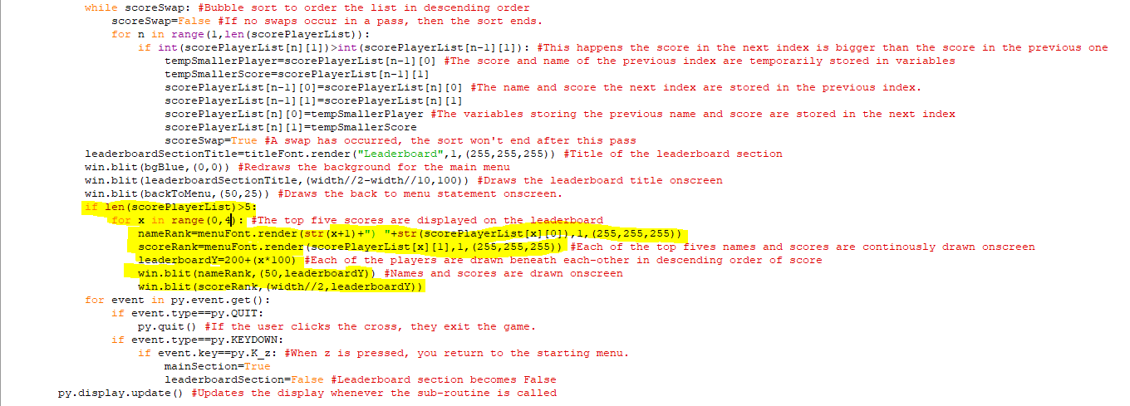The highlighted code is code for displaying the top five scores and corresponding player names onscreen in the leaderboard section when there are more than five scores. There is a for loop which loops through each of the first five elements in the scorePlayerList array. It then renders text for each of the players and corresponding scores in white font. The leaderboardY variable makes the y-coordinate of each name and corresponding score 200 pixels below the one above it, so that when the names and scores and drawn onscreen, they aren’t all in the same place.

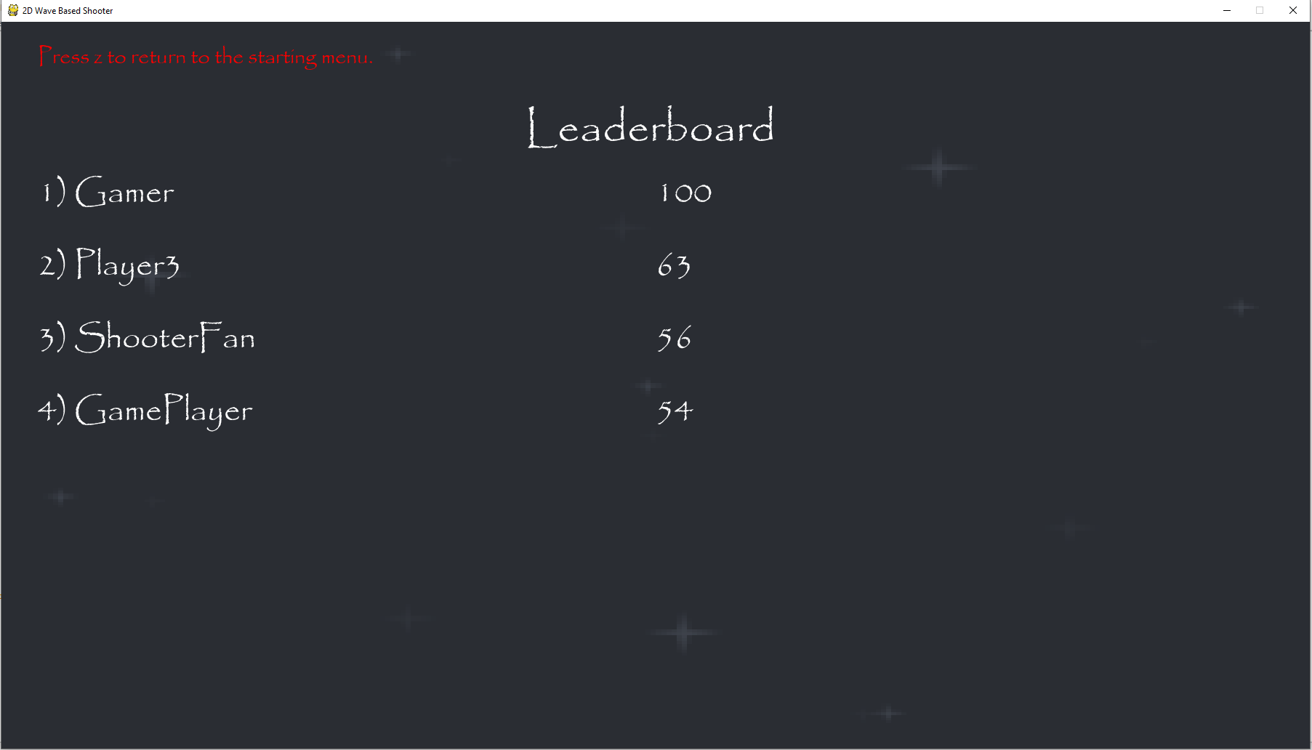  
This is what is displayed when I go into the leaderboard. This is because I made the range between 0 and 4 rather than 0 and 5 so the last element outputted is the one in the 3rd index, rather than the one in the fourth index like it should be.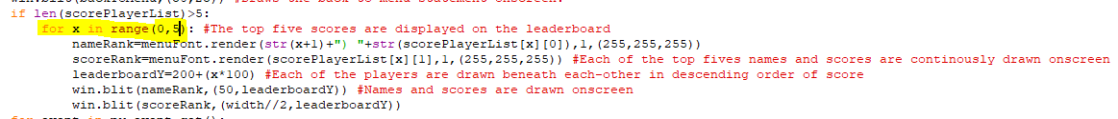The range now goes from 0 to 5.

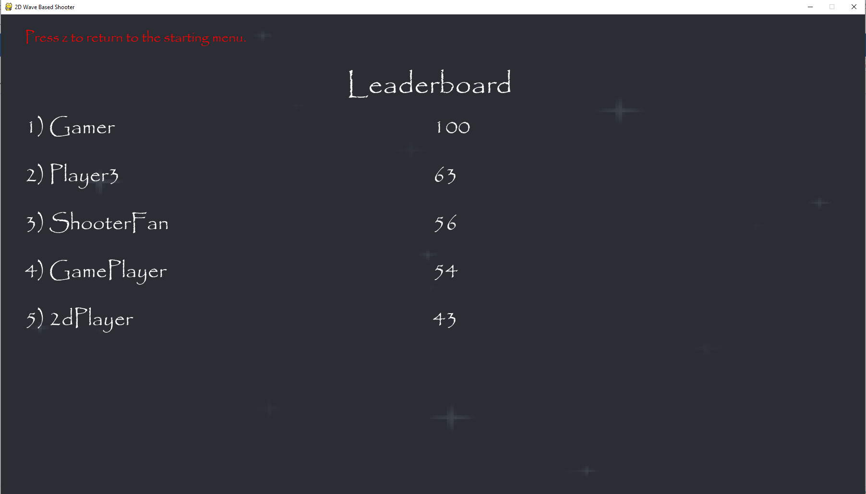  
The top five scores are now drawn on the leaderboard.

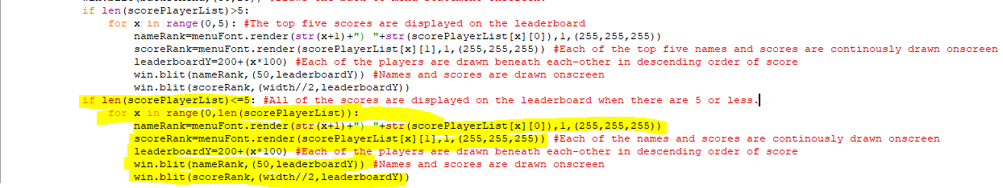The highlighted code displays all the players and scores onscreen if there are 5 or fewer elements in the 2D array (so if fewer than 5 names and scores have been saved in the files. It is identical to the other for loop except its range is from 0 to the length of the array, so if there are three items in the array, then three sets of names and scores are drawn onscreen.

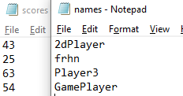  
I have temporarily removed several of the scores and names from their respective files to test out the highlighted code above.

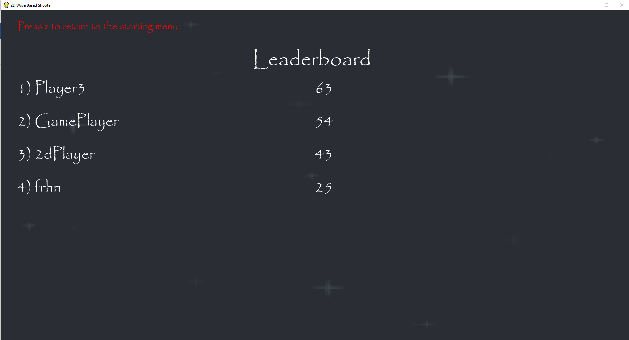  
This is successfully drawn onscreen with only four scores being displayed.

**The client has decided against recording the times that the player survived for in the leaderboard, since it isn’t ultimately a very useful well of knowing how good someone is at the game as much of the game is based on timed events anyway. Therefore, this won’t be implemented into the game even though it is on the success criteria.** 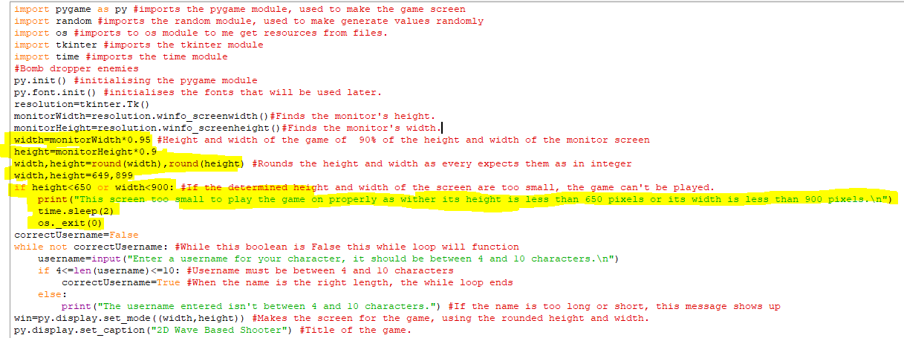I changed the way the height and width of the game screen are determined since now it isn’t chosen by the user but now the width of the game screen is 95% of the size of the of width monitor and the height is 90% of the height of the monitor. I did this because it didn’t make sense how the player could randomly make their screen bigger or smaller and it made the game artificially difficult. The precondition checking that the width and height of the game screen are big enough are still here and if the height is less than 650 pixels or the width is less than 900 pixels, the program will tell the player this and code in the shell will be terminated. I have included test widths and heights to make sure that they aren’t accepted when they are smaller than 900 or 650 pixels respectively.

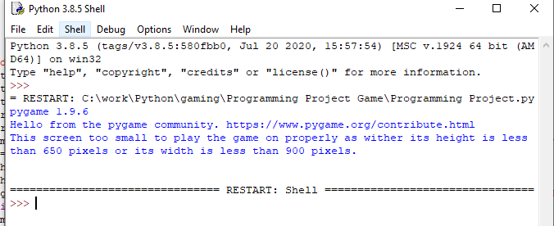When the height and width are 649 pixels and 899 pixels respectively, the program tells the player that their screen is too small to play the game on.

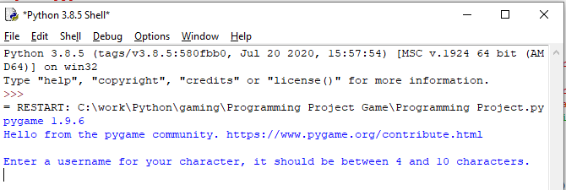When I remove the code changing the height and width to 649 and 899 and give it the values it originally had, then my game screen is big enough and the program asks for my player name and moves on.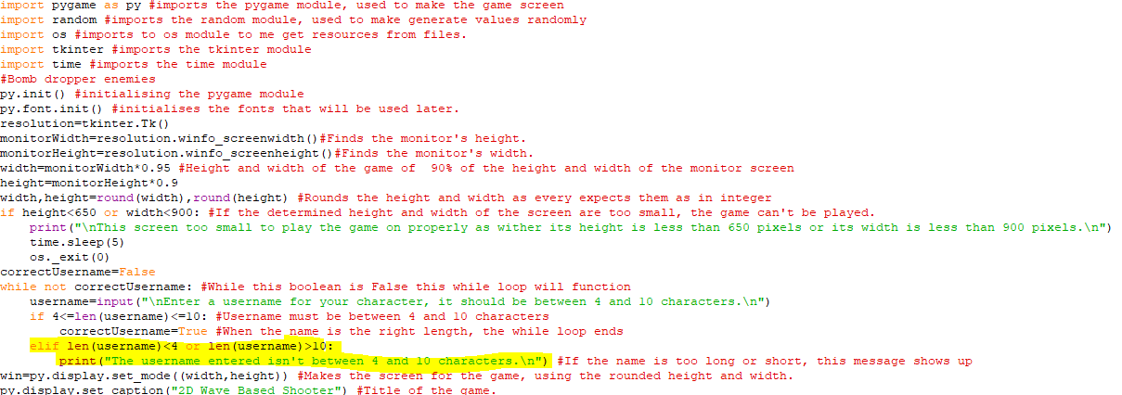I changed the code checking if the username entered was so that it would display the error message specifically if the length of the username was less than 4 characters or more than 10. This means that if nothing is entered then this error message is shown instead of the game crashing.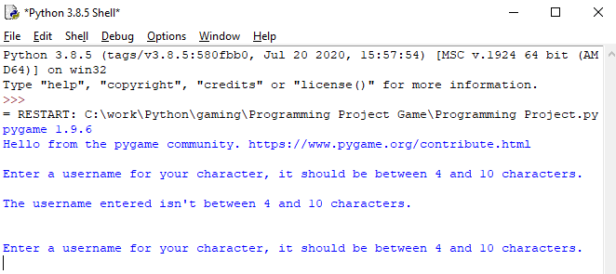When I enter nothing for a username, the program now tells me that the username entered wasn’t between 4 and 10 characters, rather than the program crashing. This means that the code works as a presence check and a length check for the username entered.

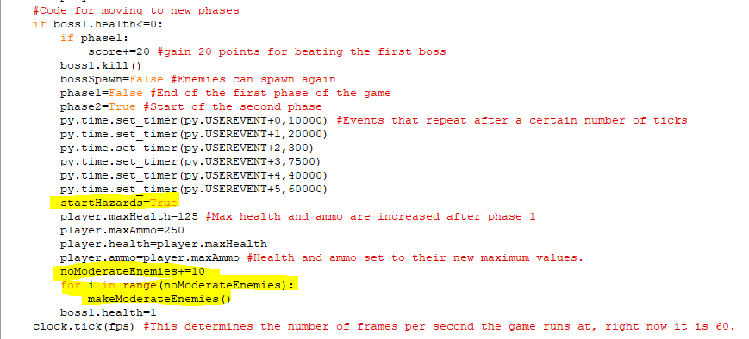I am now returning to developing more of the game itself. Here, after the first boss is defeated and the first phase is completed, I am immediately spawning in more of the moderate enemies, which will be the main enemies fought against in the second wave. There number will increment by ten between each wave rather than the five it was before. The variable startHazards, which triggered the spawning of meteors and laser beams is also set to True here because for some reasons it was being set to False after all the events were rest in the code right before it.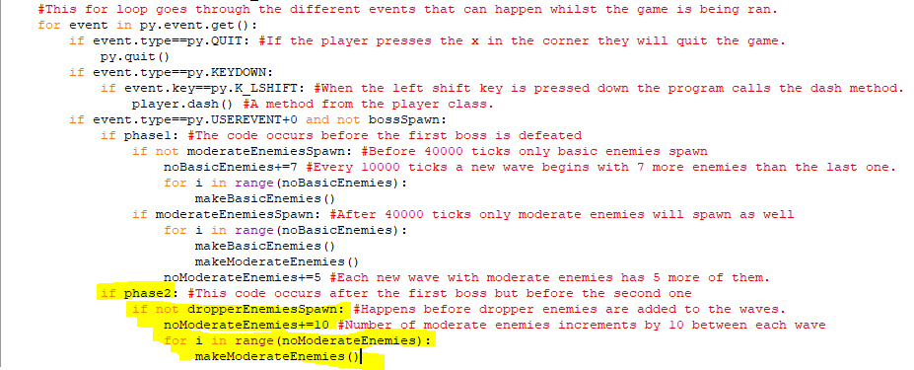When phase 2 of the game begins, every time the USEREVENT+0 is triggered (every 10000 ticks), the game will now only spawn moderate enemies, whose numbers will continue to increase from the previous phase. This section of code occurs if the boolean dropperEnemiesSpawn is False and when that becomes True a new type of enemy will spawn into the game.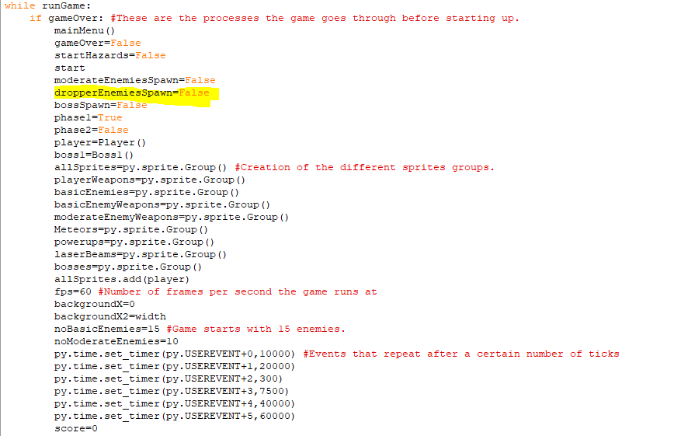When the game is running, after the main menu has been used, the dropperEnemiesSpawn boolean has been added and is set to False, also the verticalLaserBeam boolean has been added and is set False. When it becomes True later, a second laser beam will spawn vertically once I have written its code to match the horizontal one currently in the game.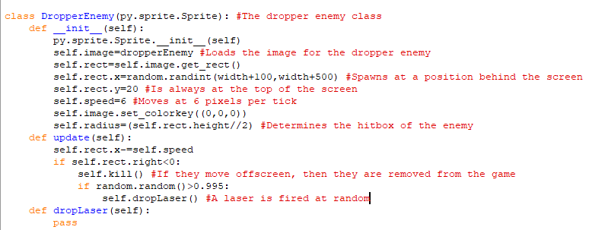This is the code for some of the dropper enemy class. It is a new enemy that will drop lasers on the player from the top of the screen as they quickly move across it. It holds many of the same attributes as the other enemy classes as its initial spawn is to the left of the screen itself and it moves across the screen rightwards. It is also removed from the program when it moves offscreen to the right and can call a method called dropLaser when a random value between 0 and 1 is more than 0.995. This method will be created in a short while. The dropper enemy is restricted to the top of the screen and only moves horizontally, not vertically.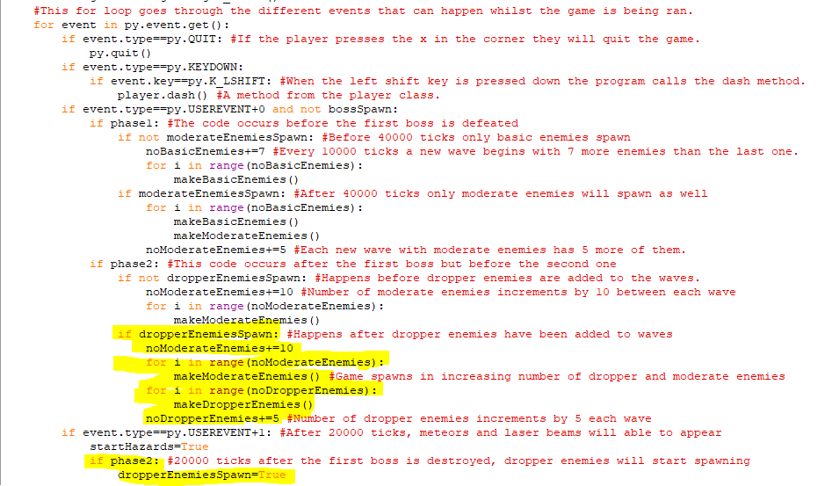The highlighted code at the bottom makes dropperEnemiesSpawn become True when 200 ticks have passed since the first boss is destroyed. After that point, every for subsequent 10000 ticks until another boss, the highlighted code above it will keep increasing the number of moderate enemies, but will also start making dropper enemies spawn into the game by calling the makeDropperEnemies subroutine. The number of dropper enemies drawn starts off at 20 but increases by 5 each wave.

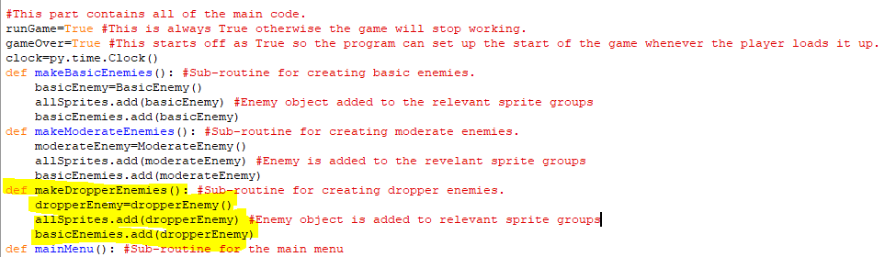The makeDropperEnemies subroutine is coded here and creates an object from the dropperEnemy class before adding that enemy to the allSprites sprite group so it is drawn in game. It is also added to the basicEnemies sprite group since its interactions with the player and player weapons are identical to the interactions by the basic and moderate enemies.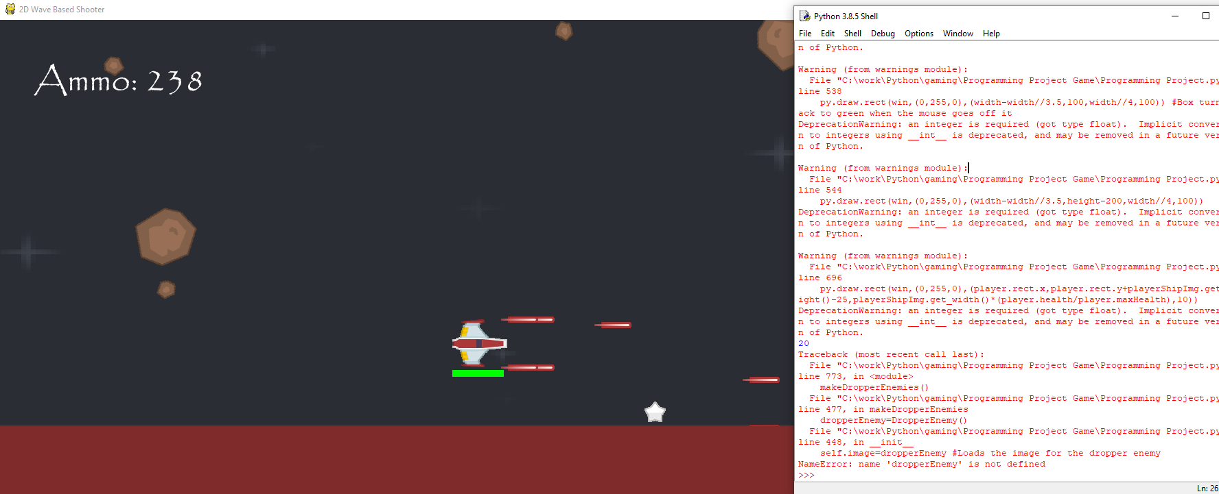When I tried to run the game, I got this error because I had given self.image in the dropper enemy class the wrong variable to find an image from. I gave dropperEnemy instead of dropperEnemyImg.

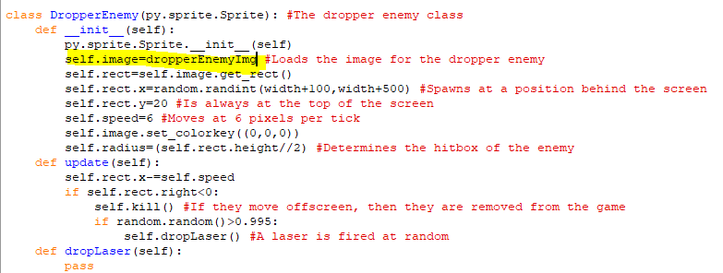I changed it to dropperEnemyImg

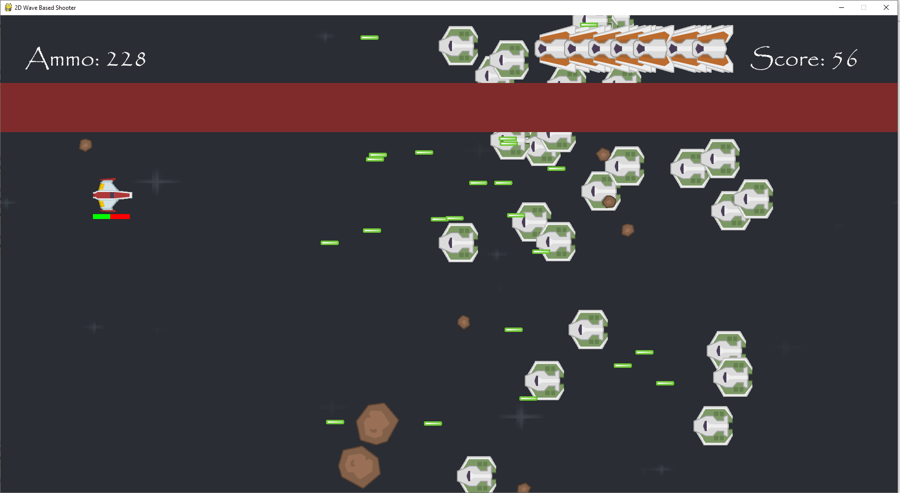  
The new enemies are appearing at the top of the screen and the only other enemy onscreen is the moderate enemies. The other hazards have also returned so laser beams and meteors are also onscreen. The dropper enemies are really close together so I will try to space them out more.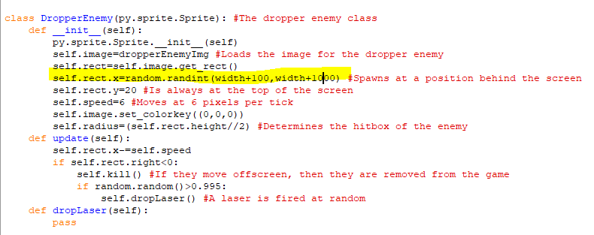I increased the range of the x-coordinates that the dropper enemies can spawn at.

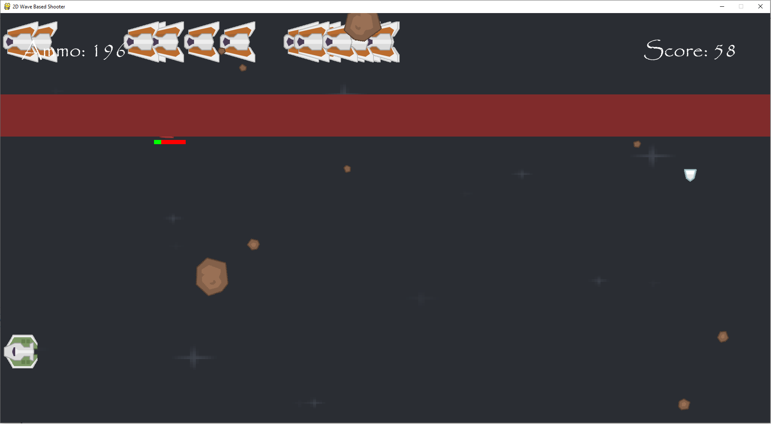  
The dropper enemies are now more spaced out.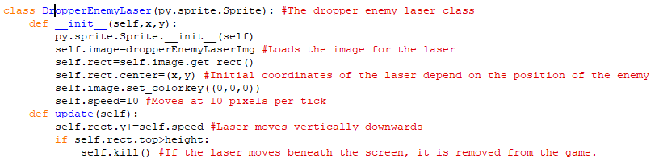  
This is the class for the laser that the dropper enemy fires downwards. It uses a new image for the laser and its x and y coordinates depend on the coordinates of the dropper enemy when it fires the laser. It moves at 10 pixels per tick and, in the update method, when it moves beneath the game screen it is removed from the game.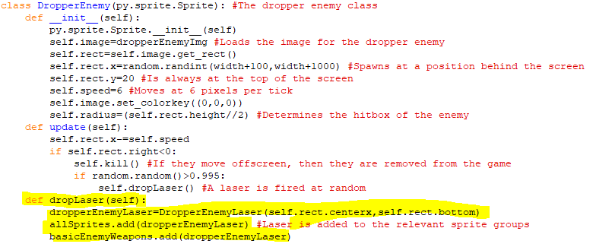When the dropLaser method is called, it now creates a dropper laser object and adds it to the revelant sprite groups. The dropper lasers are added to the basicEnemyWeapons sprite group so they will do 10 health points of damage if they collide with the player.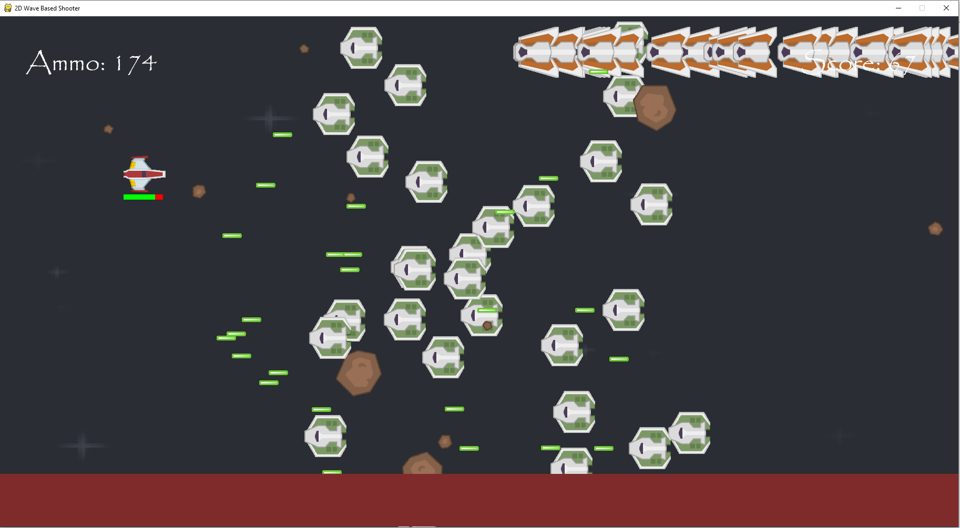  
The dropper enemies aren’t dropping any lasers when they move onscreen. But shooting at the sropper enemies removed them and colliding with the dropper enemies makes the player lose health so the dropper enemies themselves are functioning properly.

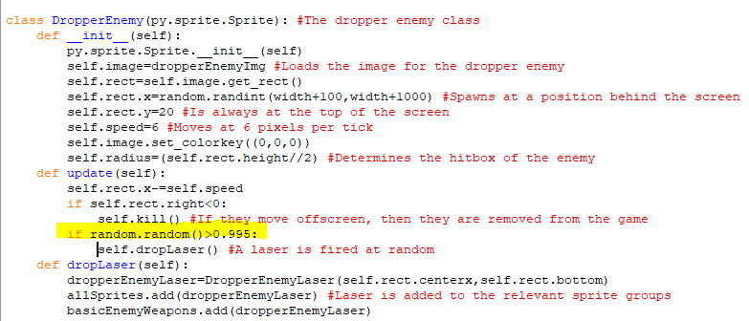This if statement was nested inside the if statement above it so, the enemies could only drop lasers when they had moved offscreen.

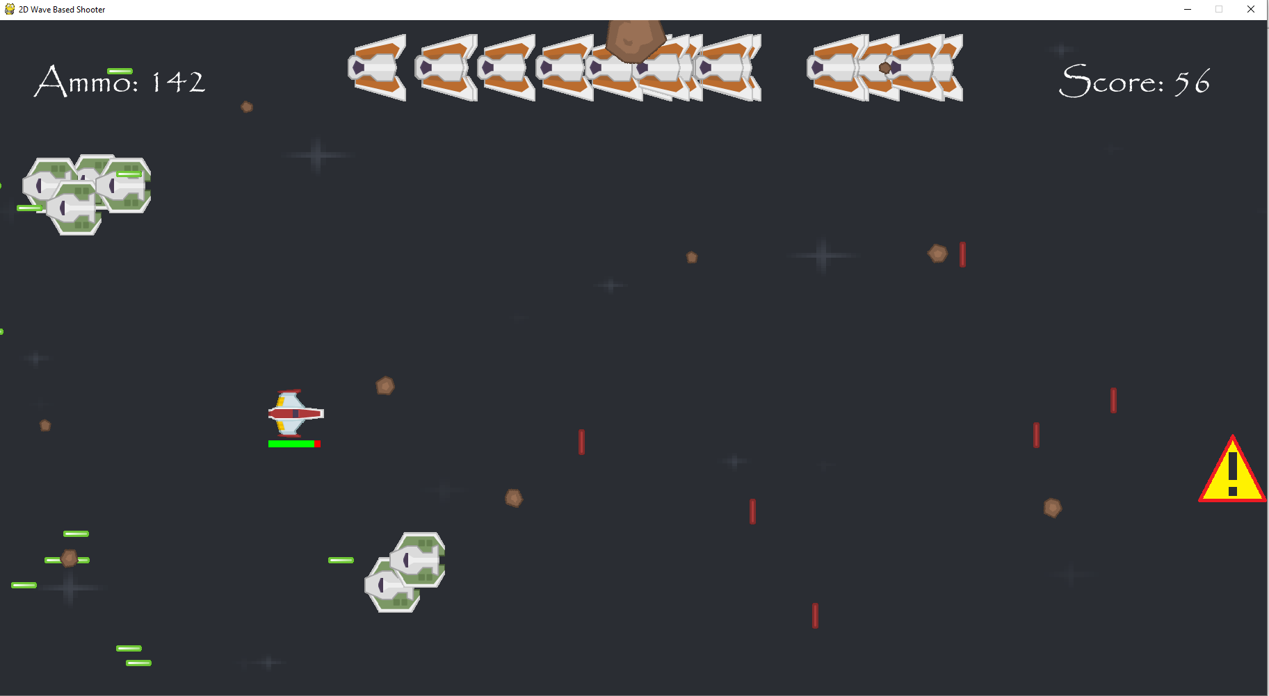The red lasers are the ones being shot by the dropper enemies and they are now appearing onscreen normally. Colliding with the lasers made me lose 10 health points. 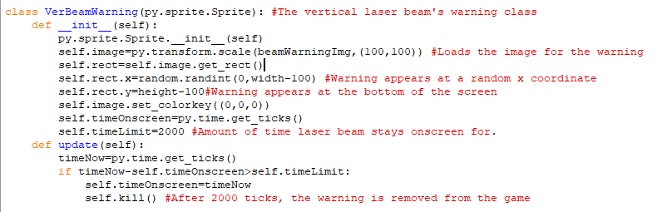This is the class for the warning sign for second laser beam that is going to be added to the game. It will appear in the second phase and will be shot vertically rather than horizontally. This warning will appear at the bottom of the screen will have a randomised x-coordinate at any point along the screen. The warning will appear on onscreen for 2000 ticks before it is removed from the game and soon I will make the update method create a laser beam at the position it was at after it is removed.

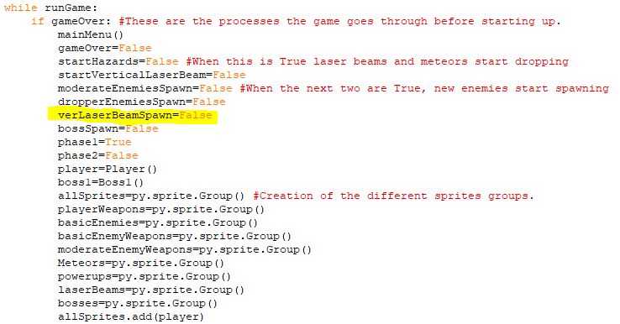I created a new variable called verLaserBeamSpawn and set it to False and whilst it is False vertical laser beams and their warnings won’t spawn into the game.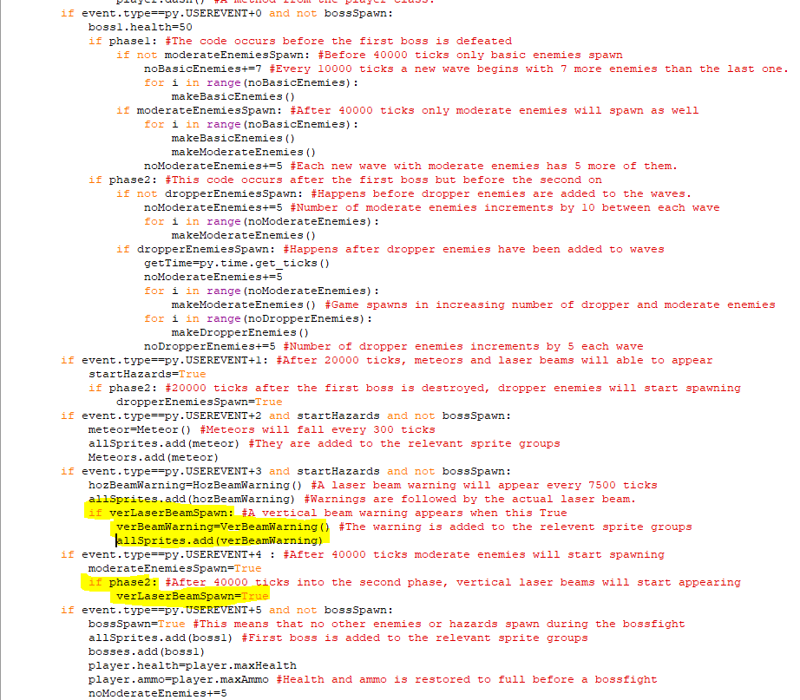The highlighted code at the bottom says that if the 40000 ticks have passed and phase2 is True then verLaserBeamSpawn is True. The code above it says that if it is True then when a warning for the horizontal laser beam has appear, a warning for the vertical beam will appear as well.

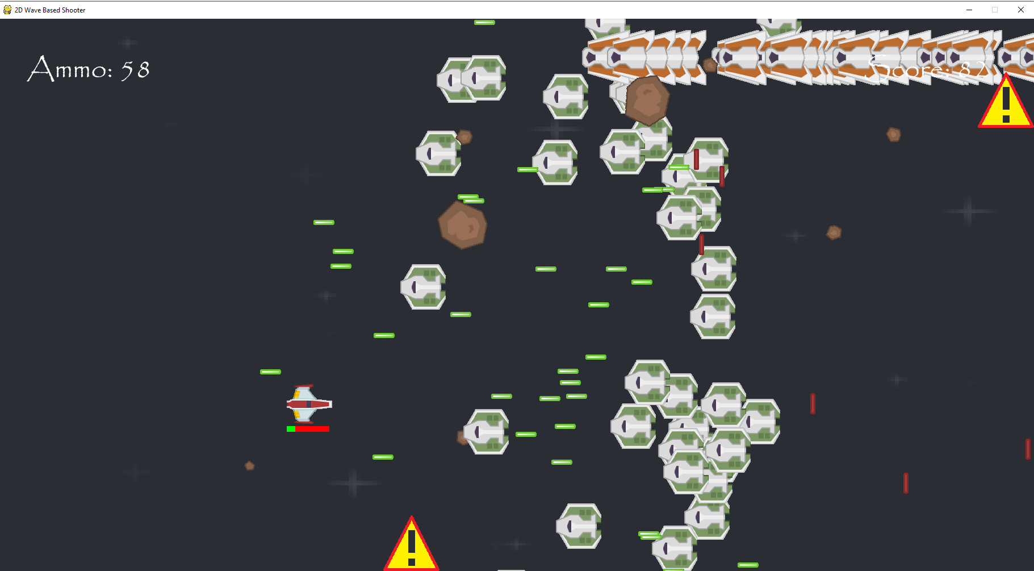A laser beam warning is now appearing at the bottom of the screen as well after 40000 ticks into the second phase.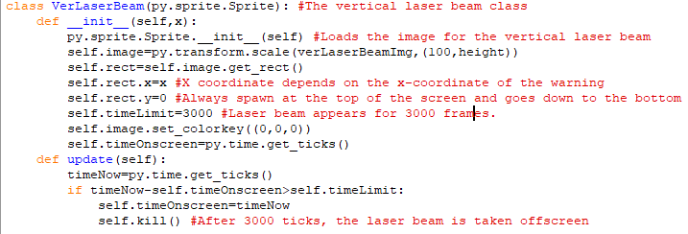This is the class for the vertical laser beams. Its image has been stretched to the length of the height of the screen and its y-coordinate is at the top of the screen so that it is stretched all the way down to the bottom. Its x-coordinate is dependent on the position of the warning image and once it is onscreen it will stay there for 3000 ticks. After that it is removed from the game. All of this means that new horizontal and vertical laser beams will appear onscreen simultaneously every 8000 ticks and will both disappear after 3000 ticks.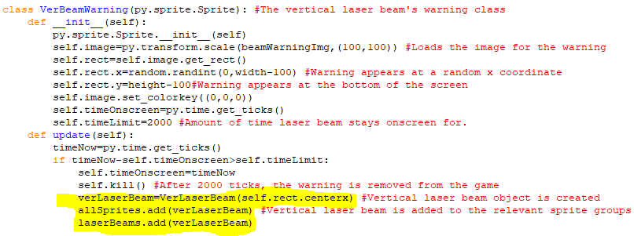This highlighted code makes the vertical laser beam warning class create a vertical beam object after being onscreen for 2000 ticks and adds it to the laser beam sprite group. This means the vertical laser beam will do the same amount of damage as the horizontal laser beam.

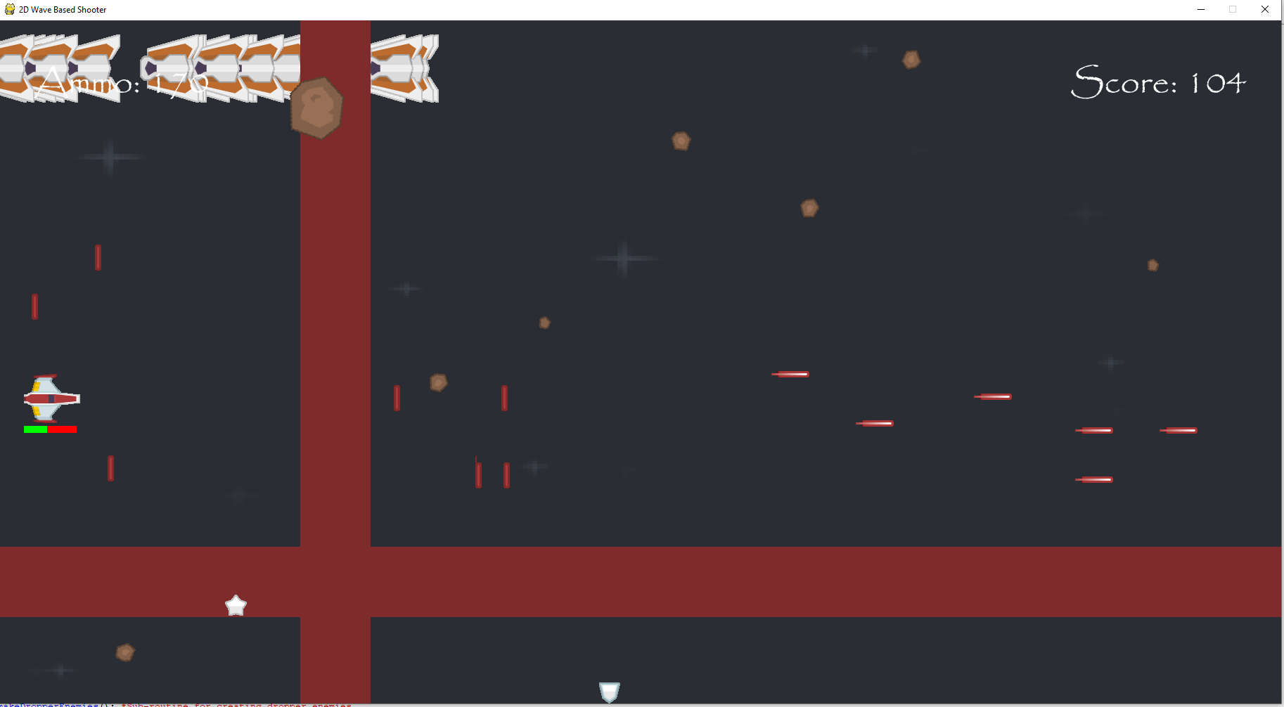  
Both laser beams are now appearing onscreen at once and you take damage when you collide with them.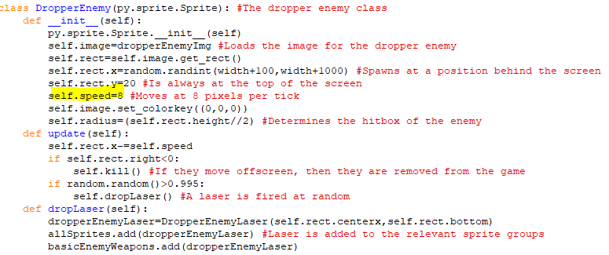I increased the speed of the dropper enemies so that they move across the screen more in line with the moderate enemies.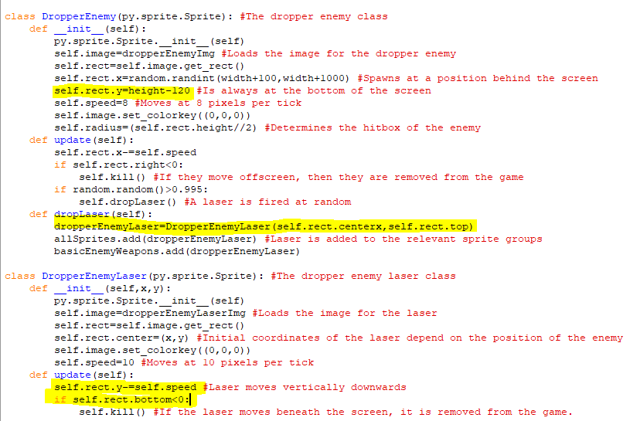I have decided to change the dropper enemies so that they appear from the bottom of the screen and shoot their lasers upwards instead. They will now spawn 120 pixels above the bottom of the screen, but their speed and the speed of the lasers are the same. The lasers will be removed from the program if the move above the screen, rather than below it. I made this change because it makes the enemies fairer since now their lasers can be neutralised by the player bombs. This means that the bombs also have more of a use now as they are more effective against dropper enemies that lasers.

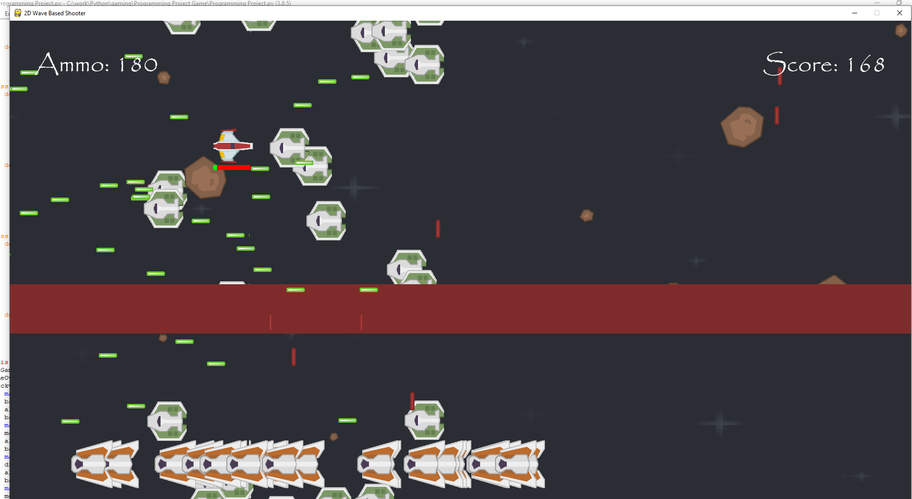  
The dropper enemies are now at the bottom of the screen and their lasers are travelling upwards. When they collide with the player, then the player loses health. Also, when the player bombs are dropped on a dropper laser, then both weapons disappear as they are removed from the game.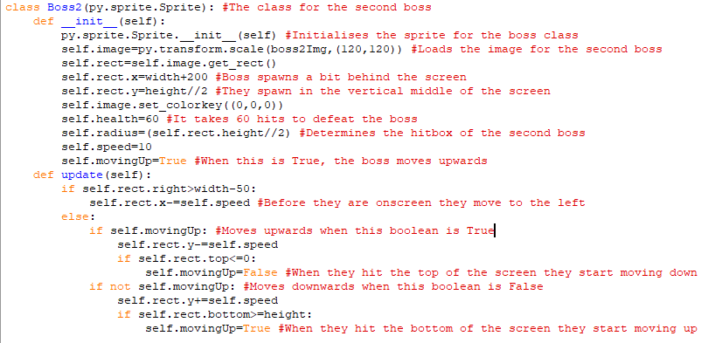This is the class for the second boss in the game. Many of its attributes are the same as those of the first boss’s class. But a new image is used for the second boss. and it also has ten more health points than the previous boss fight. Its spawn point is the same as the one for the previous boss as it spawns slightly behind the screen and then moves onto the screen by leftwards before moving up or down. When the second boss starts moving up and down they will always begin by moving up because self.movingUp is True and when it is True the boss moves up. When the top of the boss hits the top of the screen then self.movingUp becomes False so the boss moves downwards and when the bottom of the boss hits the bottom of the screen then self.movingUp becomes True again so the boss starts moving up again.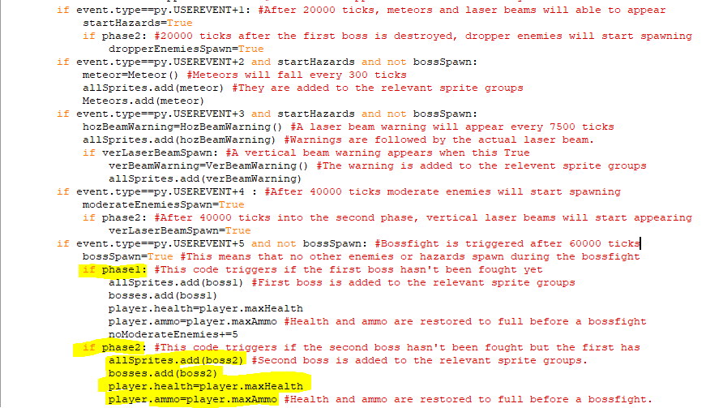The highlighted code splits the event for a boss spawning into whether it is the first or second phase. If it is the second phase, then the boss2 object will be added to the allSprites sprite group and the bosses sprite group so that it can interact with the player like the first boss. The player’s health and ammo will also be set to maximum value before the second boss fight. This all happens 60000 ticks after the second phase begins since all the timing events are reset after the first boss is defeated.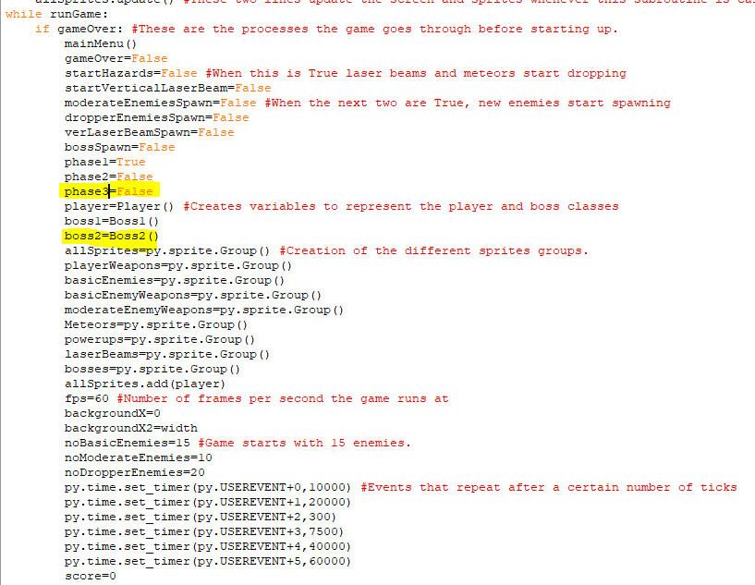Here is the assignment of a boss2 class to the variable boss2 that is used to make an object of the boss2 class in the code beforehand. I have also created a variable for phase3 that is currently False but once the second boss is defeated, it will become True and phase2 will become False.

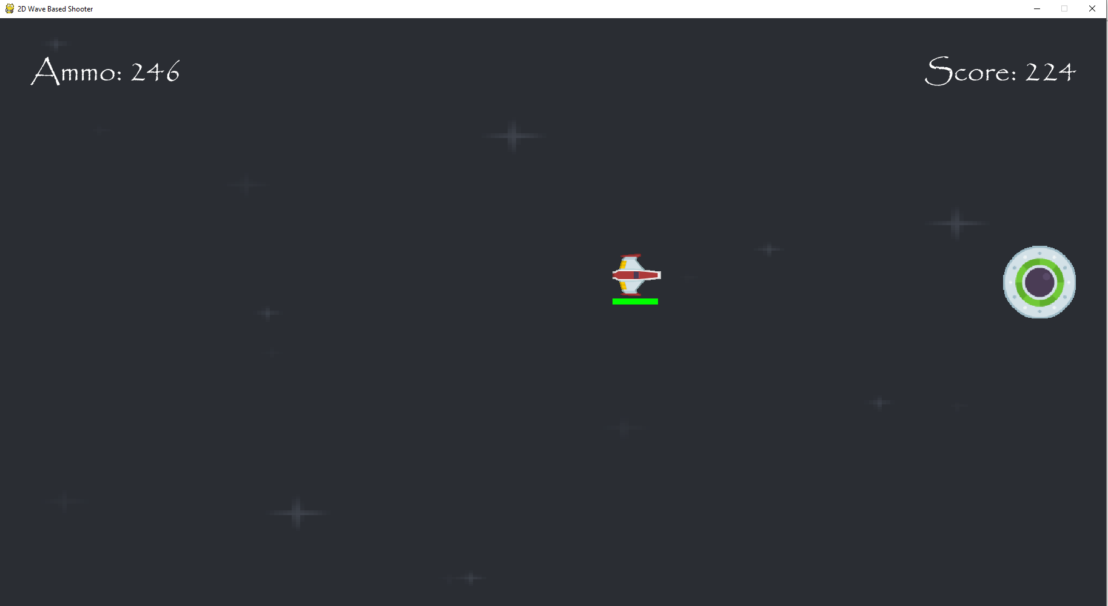  
The second boss is appearing onscreen, but currently it can only move up and down after moving forwards onto the screen.

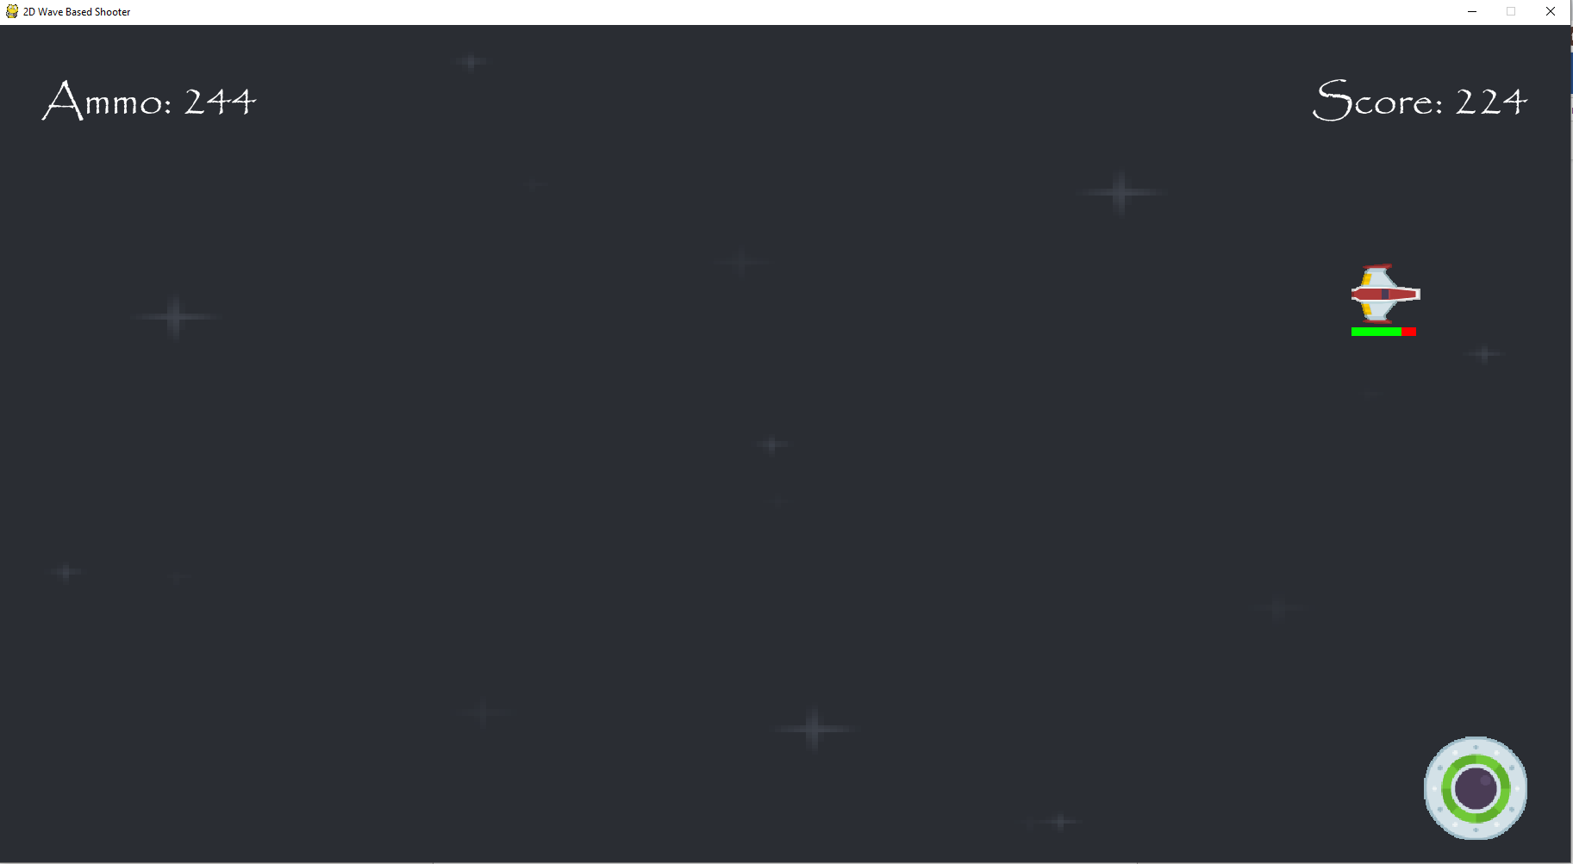  
Since the boss was added to the bosses sprite group when I collide with the boss, I take damage.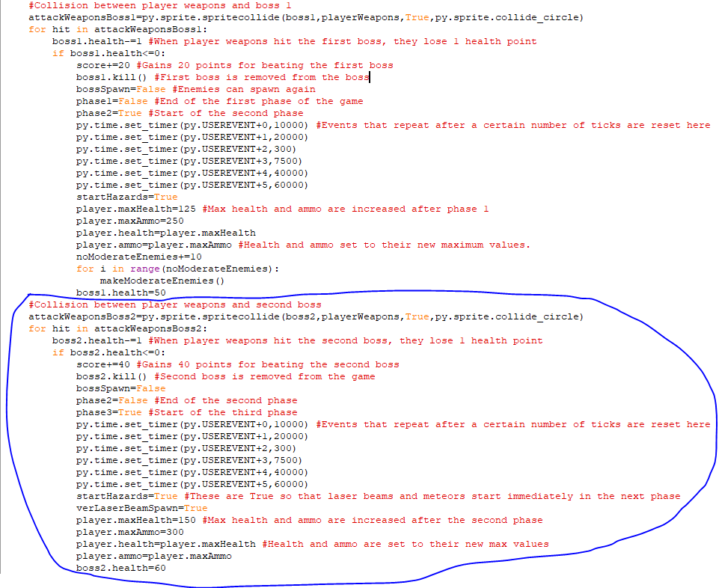The circled code is the code for the collision between player weapons and the second boss. When the boss loses all their health, the player’s score goes up by 40 points and bossSpawn becomes False so regular enemies can spawn again. The second boss is also removed from the game and all the timing events are reset and phase2 becomes False and phase3 becomes True. Currently, phase3 being True should mean that only the hazards of meteors and laser beams should appear onscreen when the second boss is defeated since the spawning of proper enemies is tied to a particular phase and there is no code for the third phase yet. After the second boss is defeated, the player’s maximum health and ammo also increase by 25 and 50 respectively and the player’s ammo and health are set to these new maximum values.

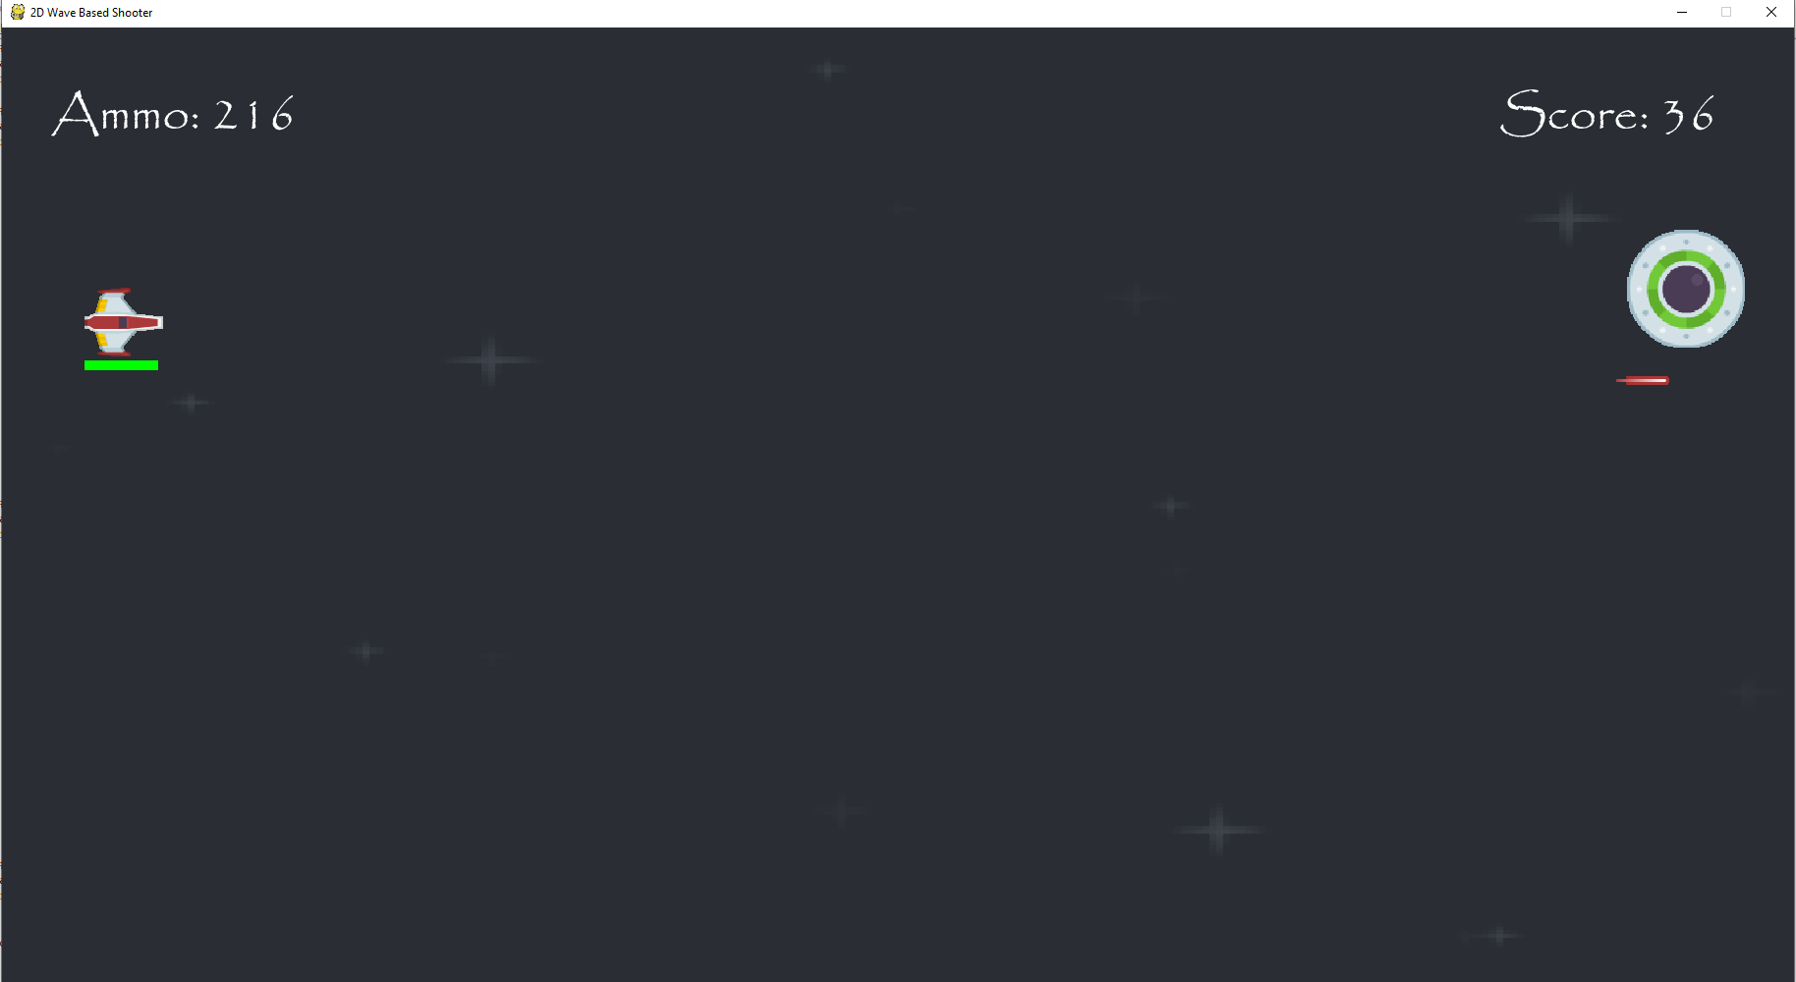  
When the lasers are shot now at the boss then they collide with the boss and causes it to take damage.

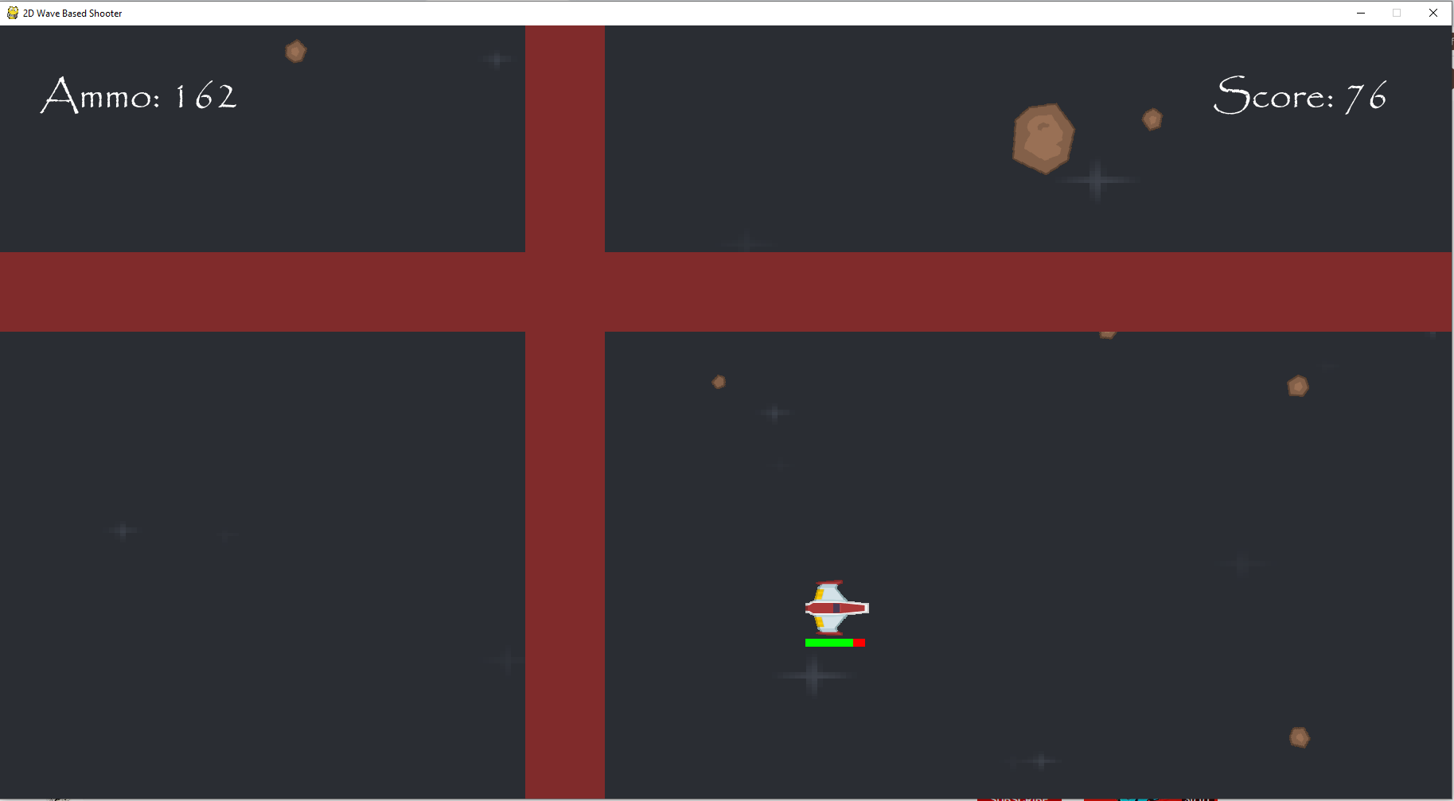  
After the second boss is defeated, only the laser beams and meteors start appearing onscreen again, which is what was expected.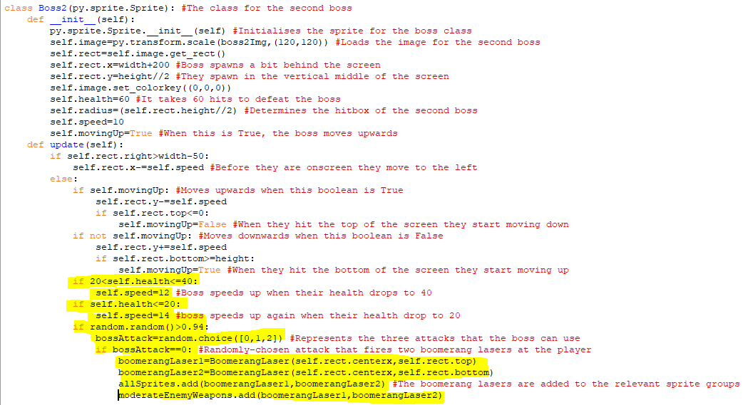The highlighted code makes the speed of the second boss go from 10 to 12 pixels per tick when the boss’s health falls between 21 and 40 and when their health drops to 20 or below then their speed increases to 14 pixels per tick. The code beneath that is the first attack for the second boss; when a random number between 0 and 1 is more than 0.94 and another random number from 0, 1 and 2 is 0 then the first attack will be triggered. This is the boomerang laser from the first boss fight but now two of them spawn in at the top and bottom of the boss which makes it tricker to avoid.

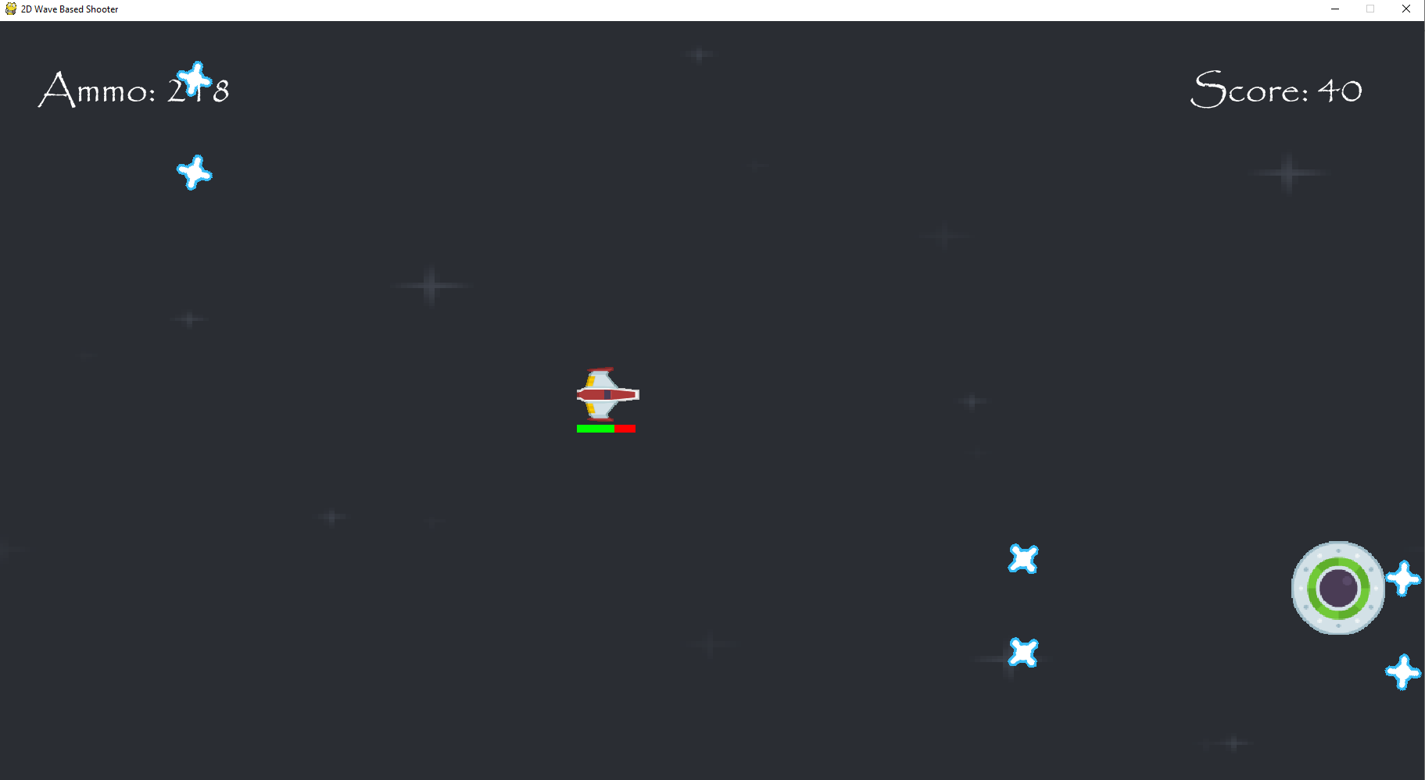Pairs of boomerang lasers are shot across the screen when the second bossfight comes onscreen and these do damage the player. Also, when the boss loses 20 health points it does speed up and it speeds up again after losing 40 health points.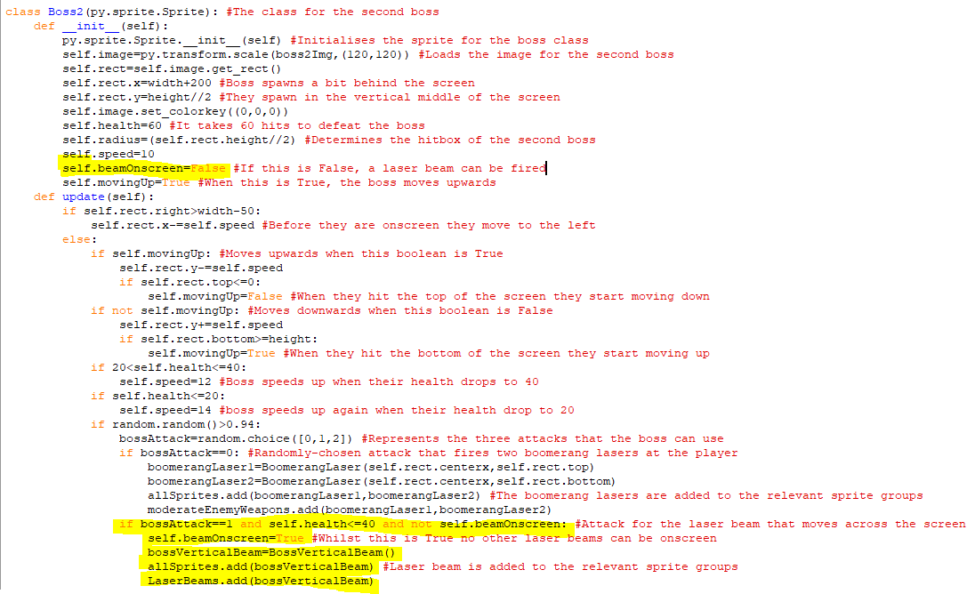The highlighted code is the code for the next attack which will be a laser beam that moves horizontally across the screen like one of the original hazards I had in my design section. It is called the bossVerticalBeam because it is pointed vertically. This is triggered when the boss’s health is 40 or less and the randomly selected value from 0,1 or 2 is 1. In addition, since only one laser beam can be onscreen at a time there is another attribute called self.beamOnscreen and when it is False a laser beam can be drawn, but when it is True it can’t be and as soon the highlighted if statement is called then it becomes True. An object of the laser beam is created and is added to the laser beams sprite group so it will be continuous damage to the player if they stay in it.

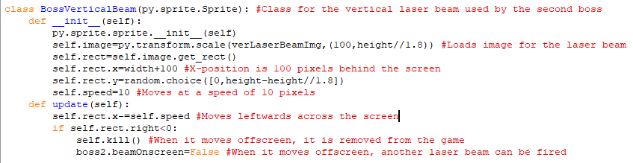  
This is the class for the vertical laser beam that moves horizontally. Its size is slightly larger than half of the screen’s height and will either be placed at the top or bottom of the screen and then move across the screen leftwards at a speed of 10 pixels per tick. It will start behind the screen on the right and will then move leftwards. After it goes off the left-hand side of the screen, it is removed from the game and the beamOnscreeen attribute becomes False so another laser beam can move across the screen.

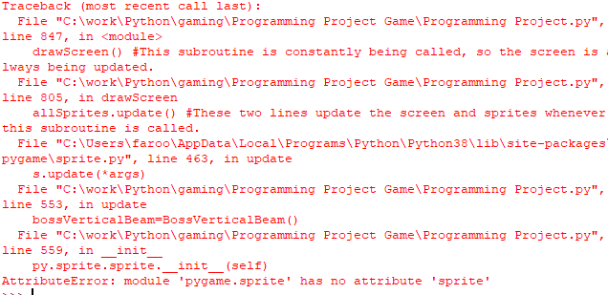When I tried to run the program, this error came up when the second attack for the second boss was called. It occurred because I wrote py. sprite. sprite. __init__(self) instead of py. Sprite. Sprite.__init__(self).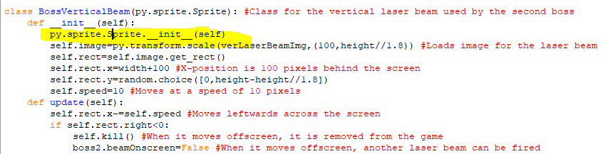I have now fixed the problem.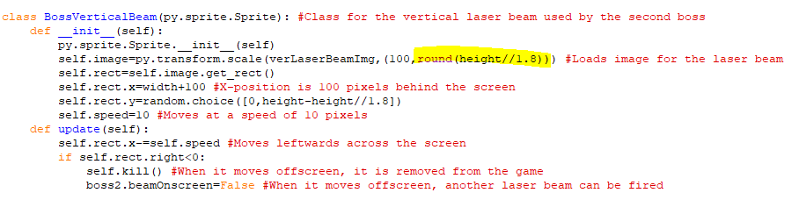I also rounded the value of the height of the laser beam so it the software could use it properly.

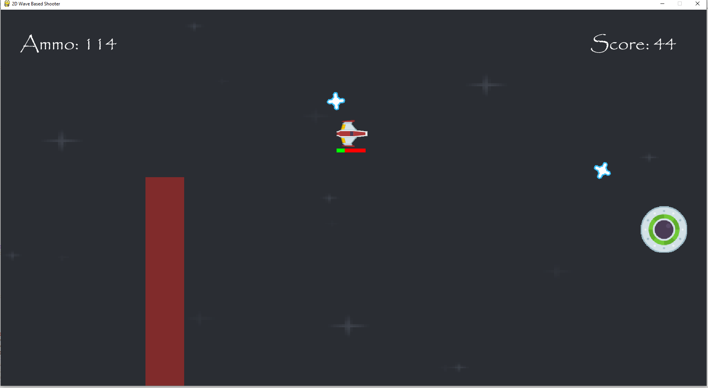  
The laser beams are now appearing onscreen after the boss has lost 20 health points and they damage the player like other laser beams do when they move into them.

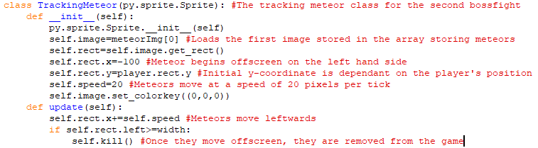This is the class for the third attack. IT uses the image for the smallest meteor in game which then moves across the screen at 20 pixels per tick. Its initial y-coordinate is whatever the player’s y-coordinate is at that time and its x-coordinate is behind the screen on the left by 100 pixels. The meteor will then move leftwards across the screen and if it moves off the screen to the right, then it is removed from the game.

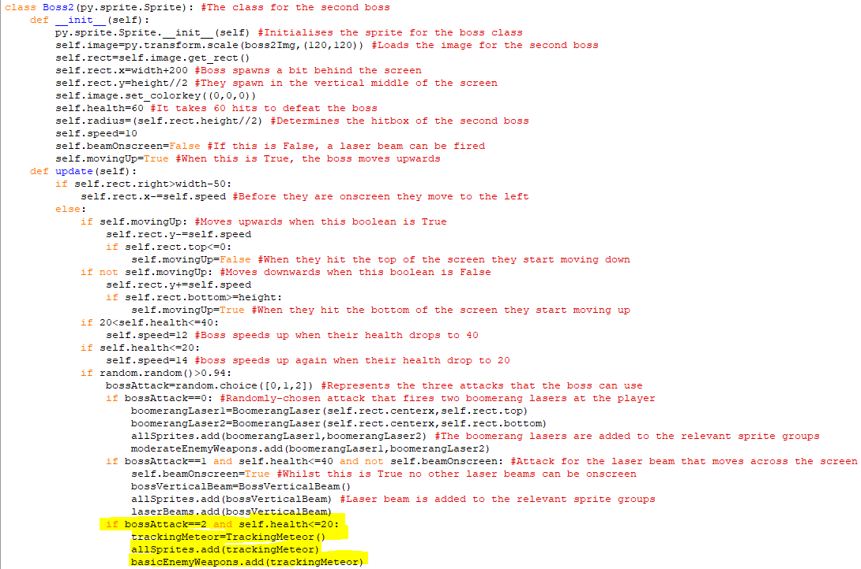The highlighted code means that when boss has lost 60 health points and 2 is randomly selected from 0,1 or 2, the tracking meteor object is created and is added to the allSprites sprite group and the basicEnemyWeapons sprite group which means that they will deal ten health points of damage to a player upon a collision.

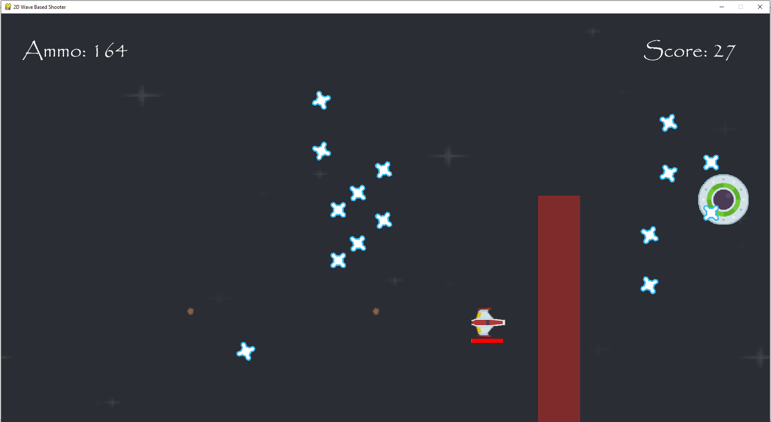  
You can see the meteors appearing from the lefthand side of the screen. When they collide with my character, I do lose health. However, they are very small, so they are hard to notice so I will use a larger meteor for this attack instead.

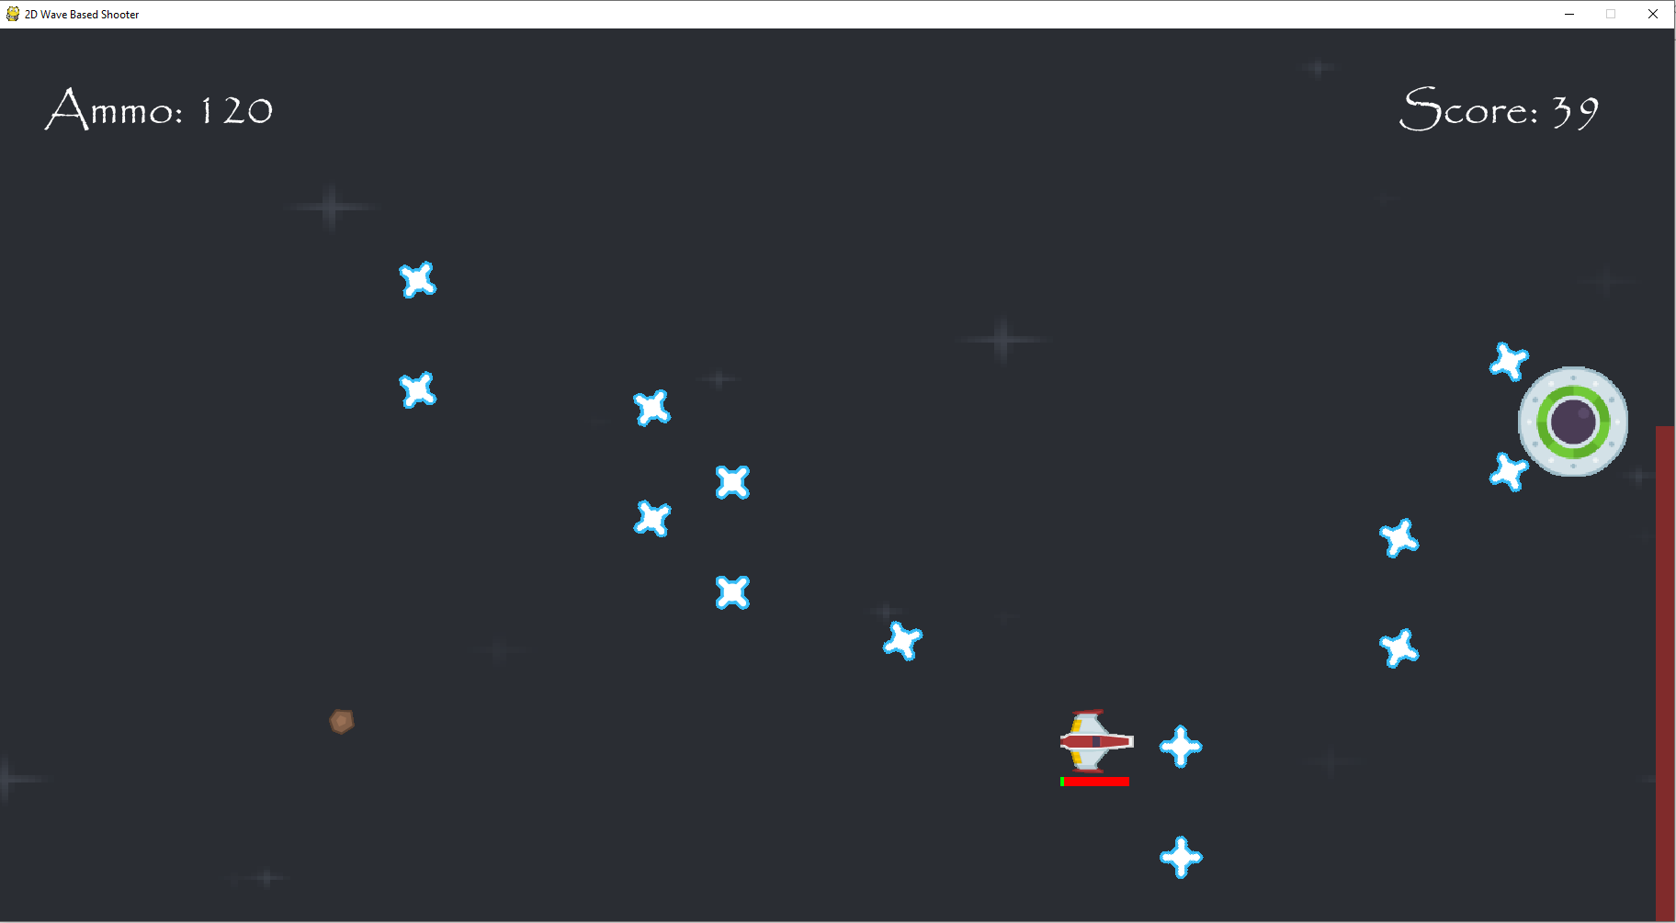  
The meteors being used now are more noticeable.

Stage 6 Review

I this stage, I have managed to make a functioning leaderboard which present the top five scores of all time on that computer, or if five scores haven’t been saved then it presents all the scores in descending order. I have also implemented a second phase to the game which occurs after the first boss is defeated this phase has more of the moderate enemies spawn in the waves and introduces a new enemy in the dropper enemy. There is also a second hazard in the form of a vertical laser beam, and I added a second boss at the end of the second phase as well.

For the success criteria, I have now recorded the player score in a permanent manner as it is stored in a separate text file and the game now also stores the highest scores achieved in the game and displays them on the leaderboard. I have also expanded on the enemies as there is a new enemy and boss in the game now that are brought into the second phase. The new enemy is also quite different from the previous ones, so it helps make the game continue to feel unique.

Client Feedback:

Adding new enemies after each boss keeps making the harder reducing repetitivity the dropper enemies shoot upwards which adds another dimension the player must analyse to dodge and the new boss has several interesting attacks to avoid.

Stage 7- Implementing a Third Phase and a Better Way of Entering a Username

**In this stage, the parts of the success criteria I am going to achieve are:**

* **Introducing new enemy types and bosses.**
* **Expanding the interactive UI.**

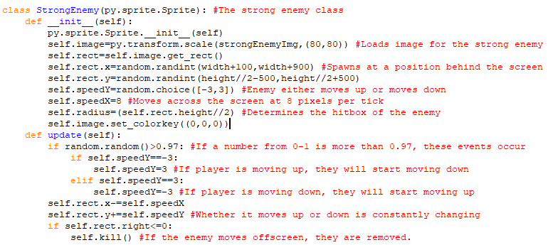This is the code for the class for the new enemy, the strong enemy. This strong enemy will spawn at a random position from 100 to 900 pixels behind the screen and starts from any position 500 pixels or below the centre of the screen. This enemy will move either upwards or downwards at will also move leftwards by 8 pixels per tick. But, in the update method, if the enemy is moving upwards and a random number between 0 and 1 is more than 0.97 then the enemy will start moving downwards and vice versa. This means that the enemy will change its vertical motion whilst moving across the screen which makes them more difficult to hit than other enemies and since this is the final unique phase, these enemies should be harder than all other enemies. Like the other enemies, if the enemy moves offscreen then they will be removed from the program. 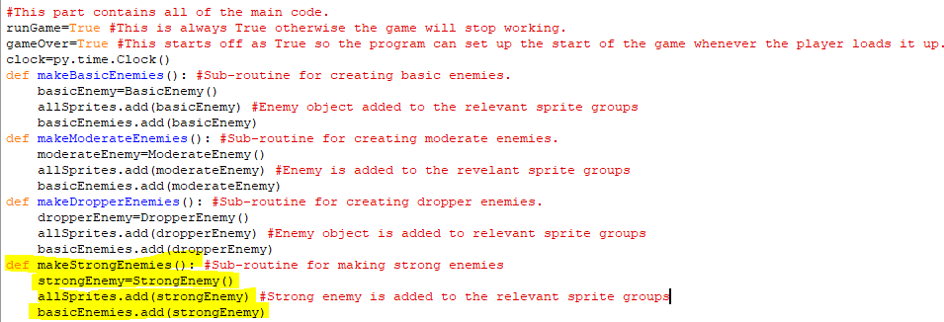This is the subroutine for making strong enemies. It creates an enemy object, and this object is added to the allSprites and basicEnemies sprite group which means that it will do ten health points of damage upon a collision. 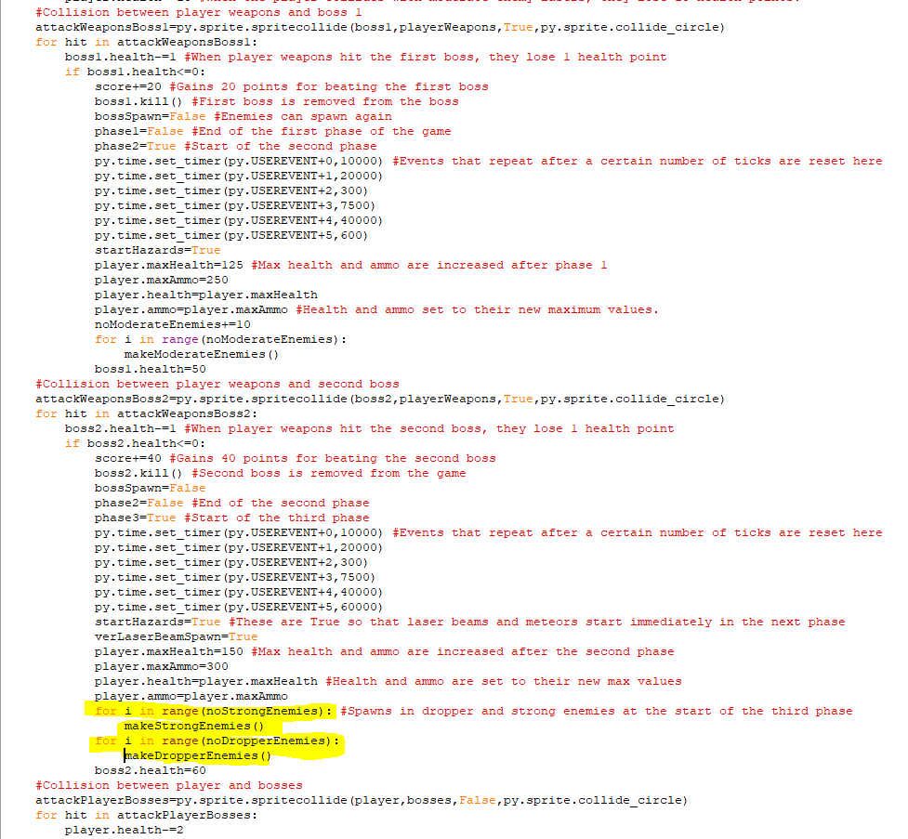After the second boss is beaten, the highlighted code makes a wave of strong enemies and dropper enemies with the number of them depending on the values of noStrongEnemies and noDropperEnemies. 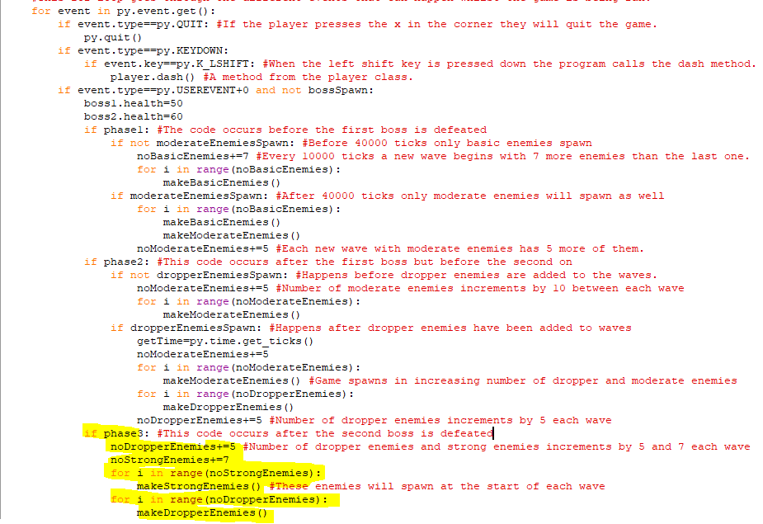Every 10000 ticks after the second boss is beaten, the number of dropper and strong enemies incremented by 5 and 7 respectively. For loops are then used to create objects from the dropper and strong enemy classes for the number of times that is equivalent to the number of enemies of each type that should spawn in, which is given by noStrongEnemies and noDropperEnemies. 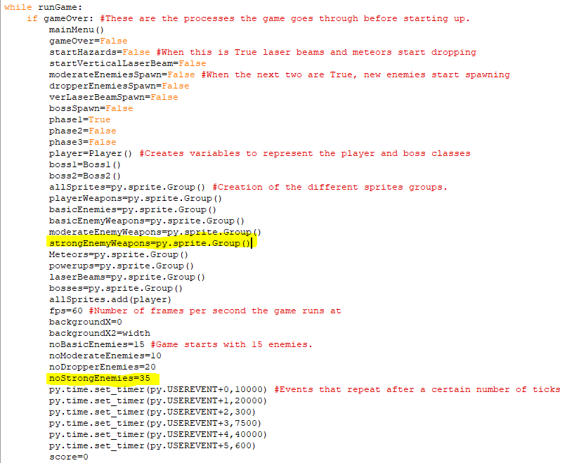When the game first begins, the number of strong enemies will be 35, so that’s the number of them that will be faced in the first wave after the second boss. In addition, I have created a strongEnemyWeapons sprite group for the strong enemies’ lasers later.

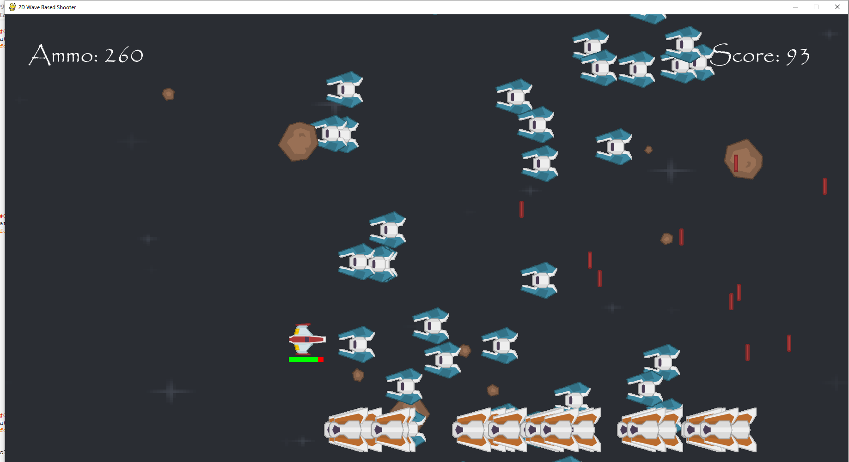The new enemies are appearing onscreen and they do alternate between moving up and down. Colliding with them makes the player lose health but I feel they move up and down too quick.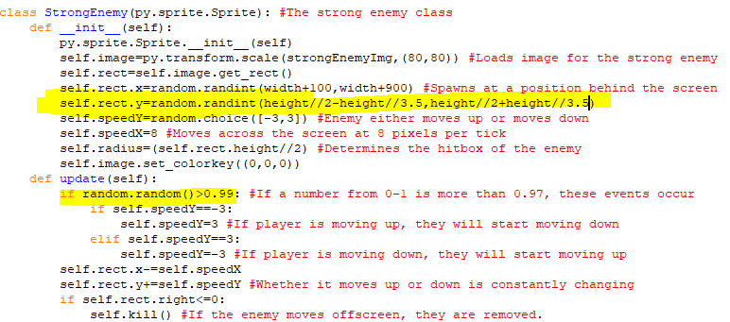I bumped up the chance of the change in direction to being if the number was more than 0.99 and changed the maximum and minimum spawn heights for the enemies so that they were dependent on the height of the screen so that enemies couldn’t spawn above or below the screen.

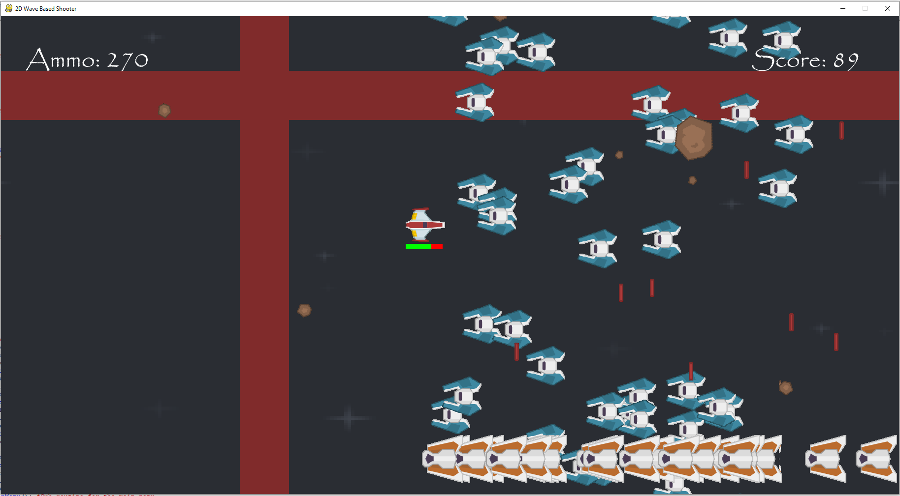  
The enemies now move in one direction on the vertical axis for longer.

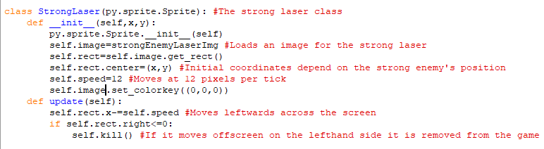This is the class for the strong laser for the strong enemy. It moves faster than the moderate laser with a speed of 12 pixels per tick. Its initial spawn will be dependent on the position of the strong enemy at that time and it will move leftwards across the screen as seen in the update method. When it moves offscreen on the left it is removed from the game.

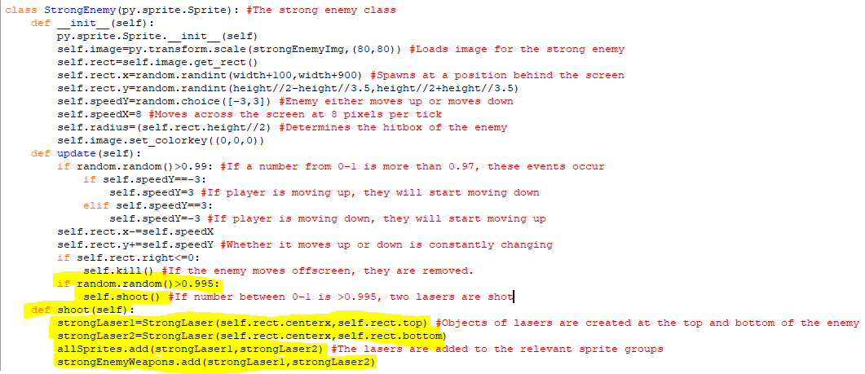In the strongEnemy class, when a random number between 0 and 1 is more than 0.995 then the shoot method is called. This method creates two strong laser objects and puts them at the top and bottom of the strong enemy. These lasers are then added to the allSprites sprite group, so they are drawn onscreen and the strongEnemyWeapons group made earlier as they will deal more damage than the other lasers. 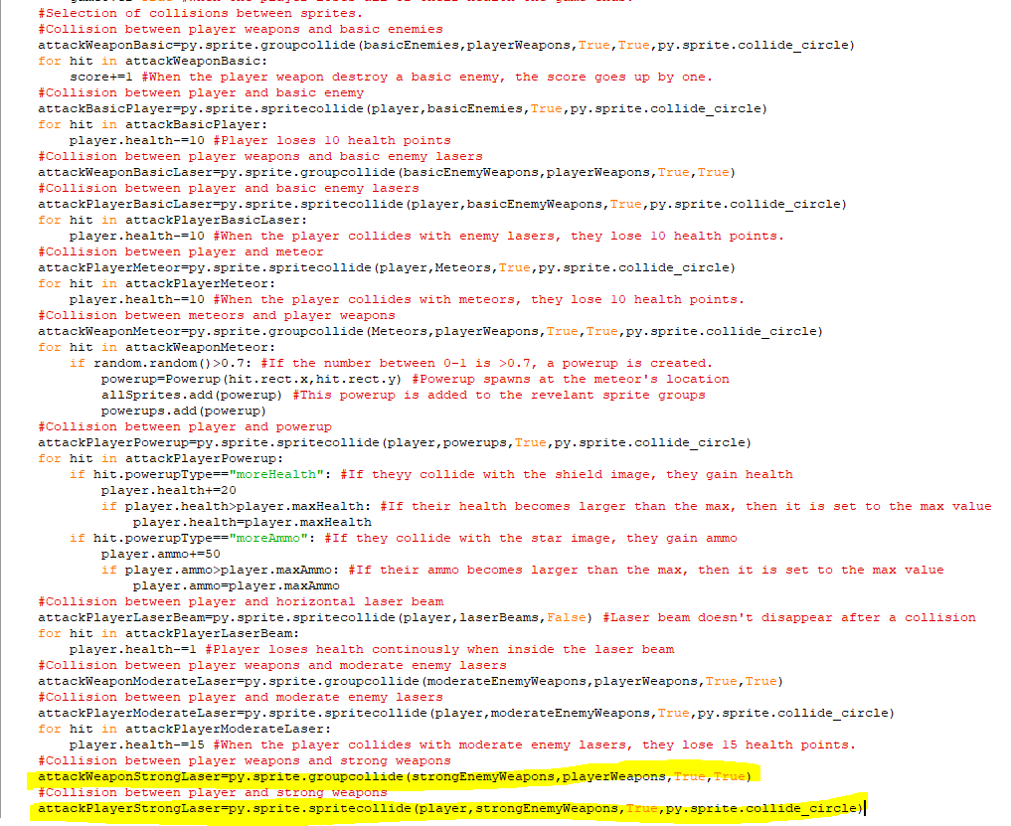The highlighted code is the code for the collision between the player weapons and strong weapons and the collision for the player and strong weapons. When the player weapons and strong weapons collide, they are both removed from the game and disappear and when a player and enemy weapons collide the strong weapons are removed.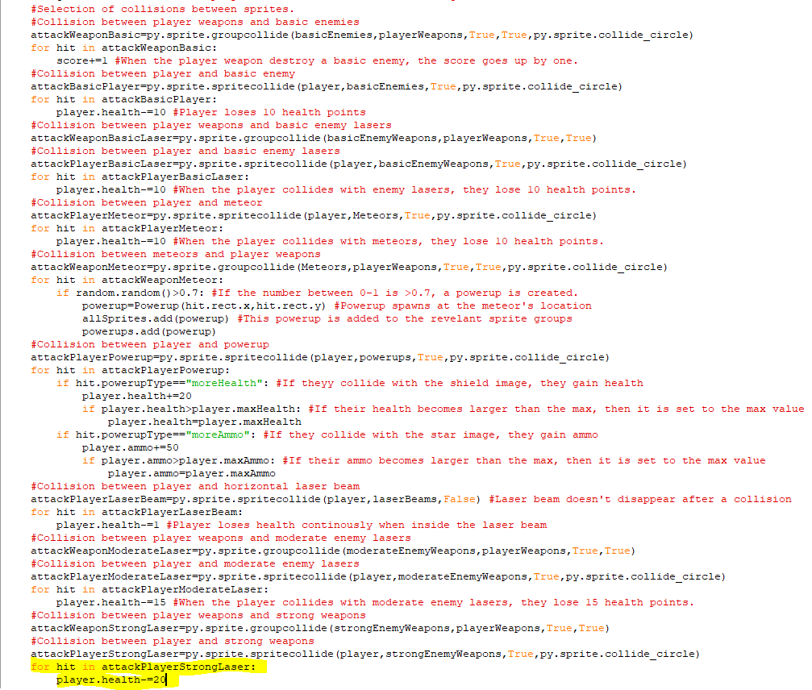I forgot to add the code for the enemy weapons dealing damage to the player. When the player collides with an strong laser, they lose 20 health points.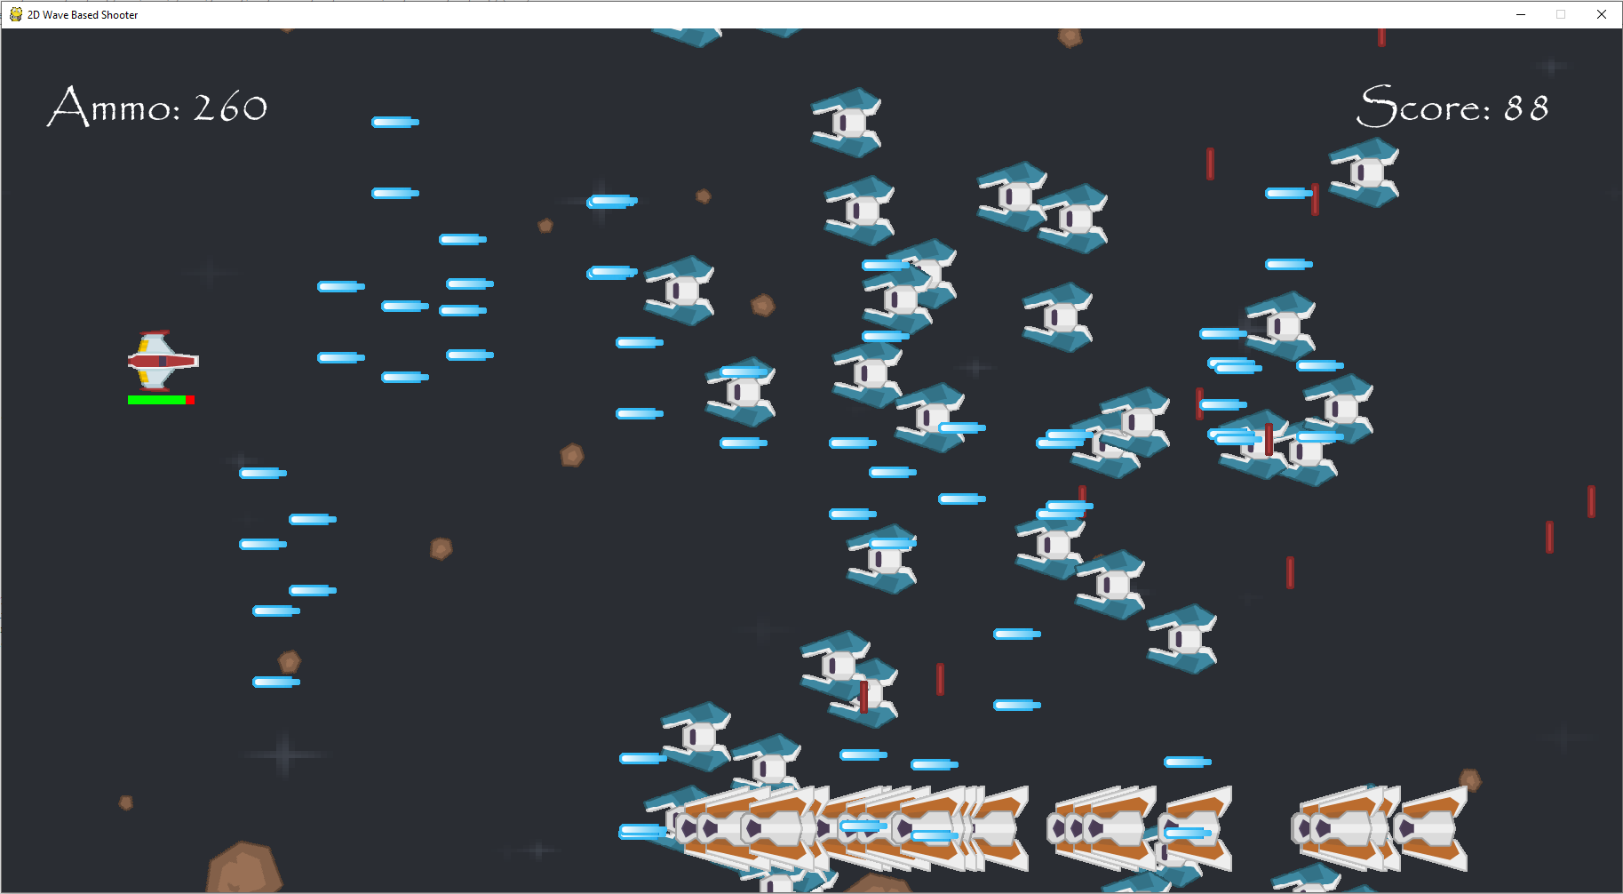The strong enemies are now shooting their strong lasers that spawn at the top and bottom of them in pairs. These can be neutralised by player lasers and add deal 20 points of damage upon a collision.

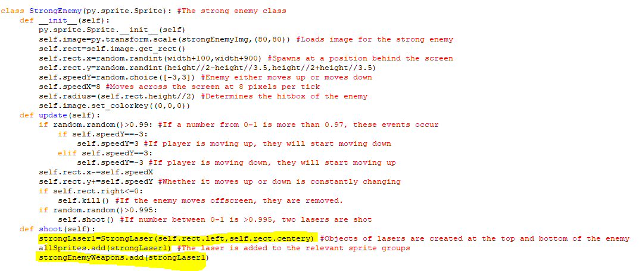I found that it was very hard and even unfair to dodge the pairs of lasers that were fired at me so I have cut it down to only firing one laser.

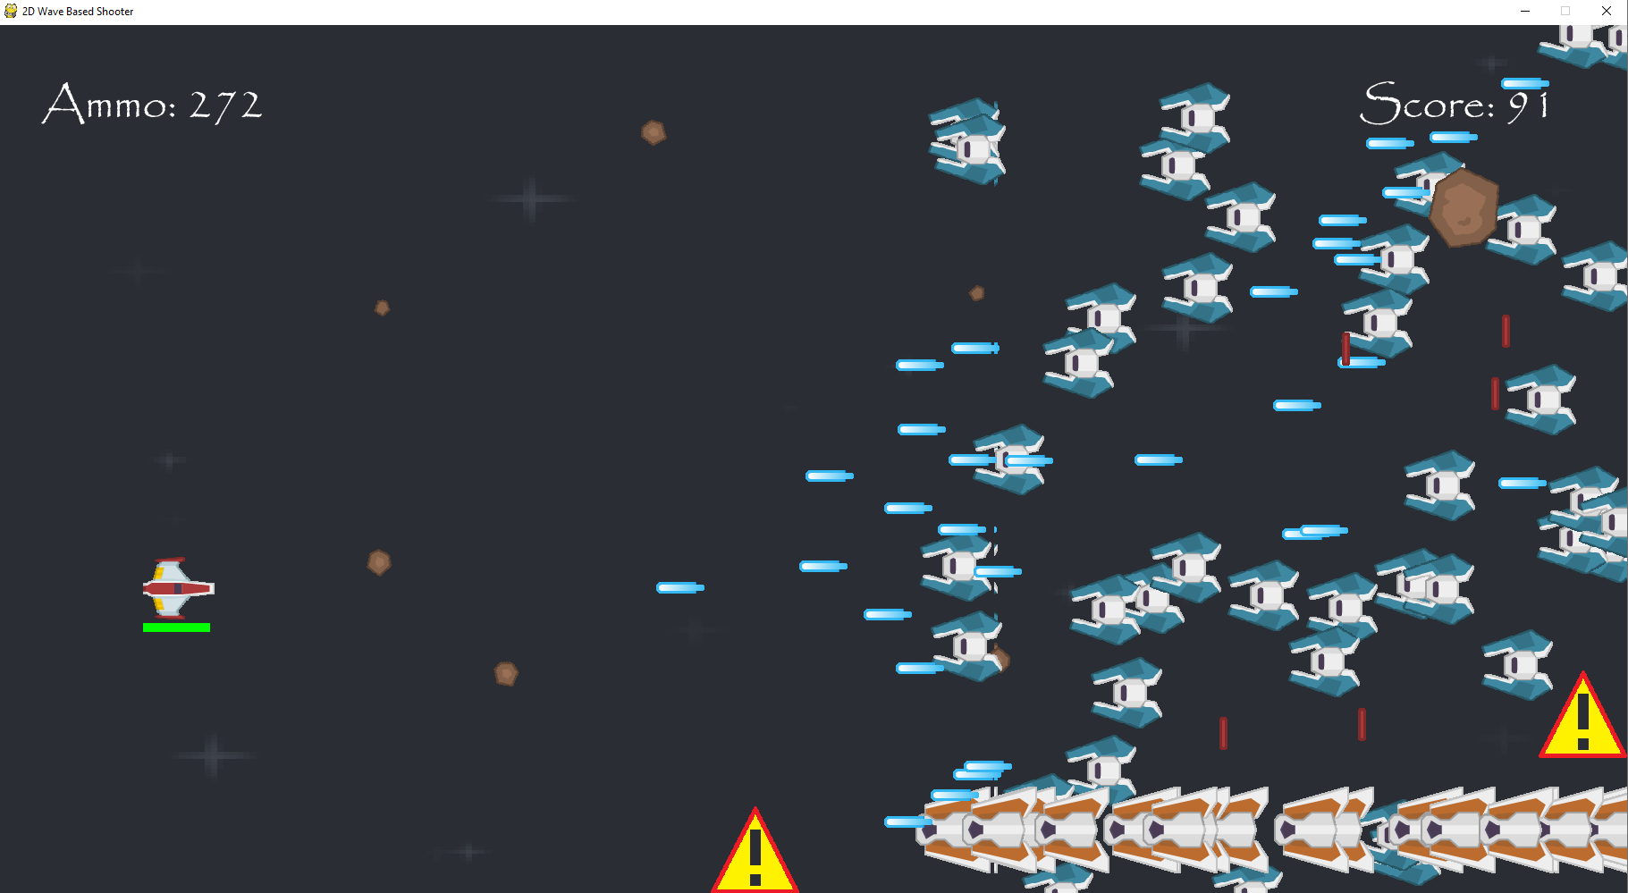Only one laser is being fired from each strong enemy at a time now.

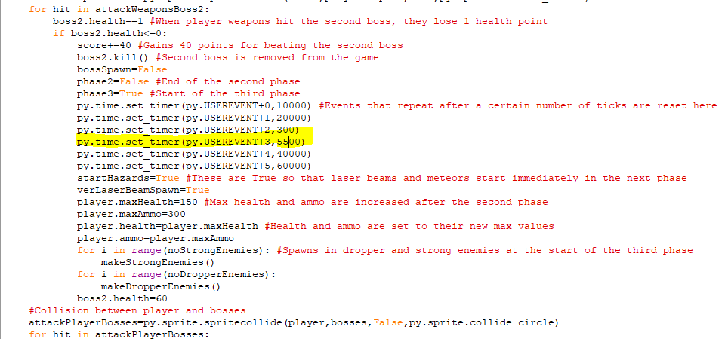In the third phase the time between laser beams appear onscreen has reduced from 7500 ticks to 5500 ticks so they will appear much more frequently now.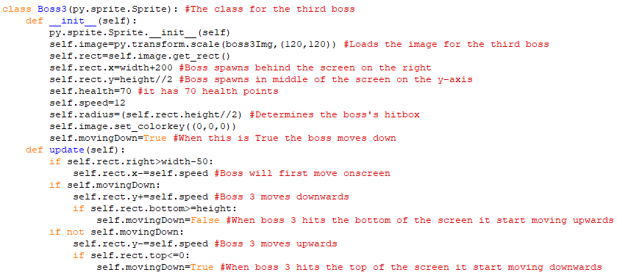This the is class for the third boss. It uses a new image that will be another ufo as its image and like the other bosses it spawns 200 pixels behind the screen on the right-hand side and in the middle of the screen on the y-axis. This boss has 10 more health points than the previous boss fight and starts at a speed of 12 pixels per tick. The update method is used to initially move the boss leftwards so that it is fully onscreen and after this has happened then when movingDown is True then the boss will move down and when they collide with the bottom of the screen, movingDown becomes False and the boss starts moving upwards. When the boss collides with the top of the screen than movingDown becomes True again.  
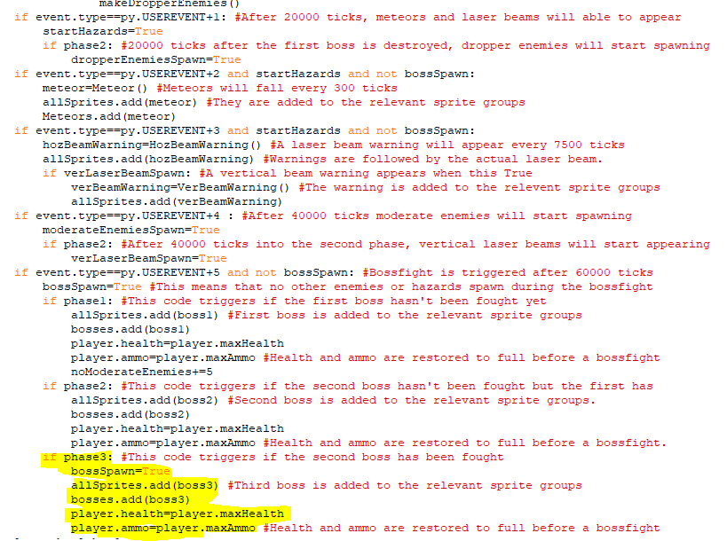The highlighted code creates adds an instance of the third boss to the allSprites sprite group as well as the bosses sprite group. Adding it to the bosses one allows it to collide with the player like the other bosses. The player’s health and ammo are also set to full at this point.

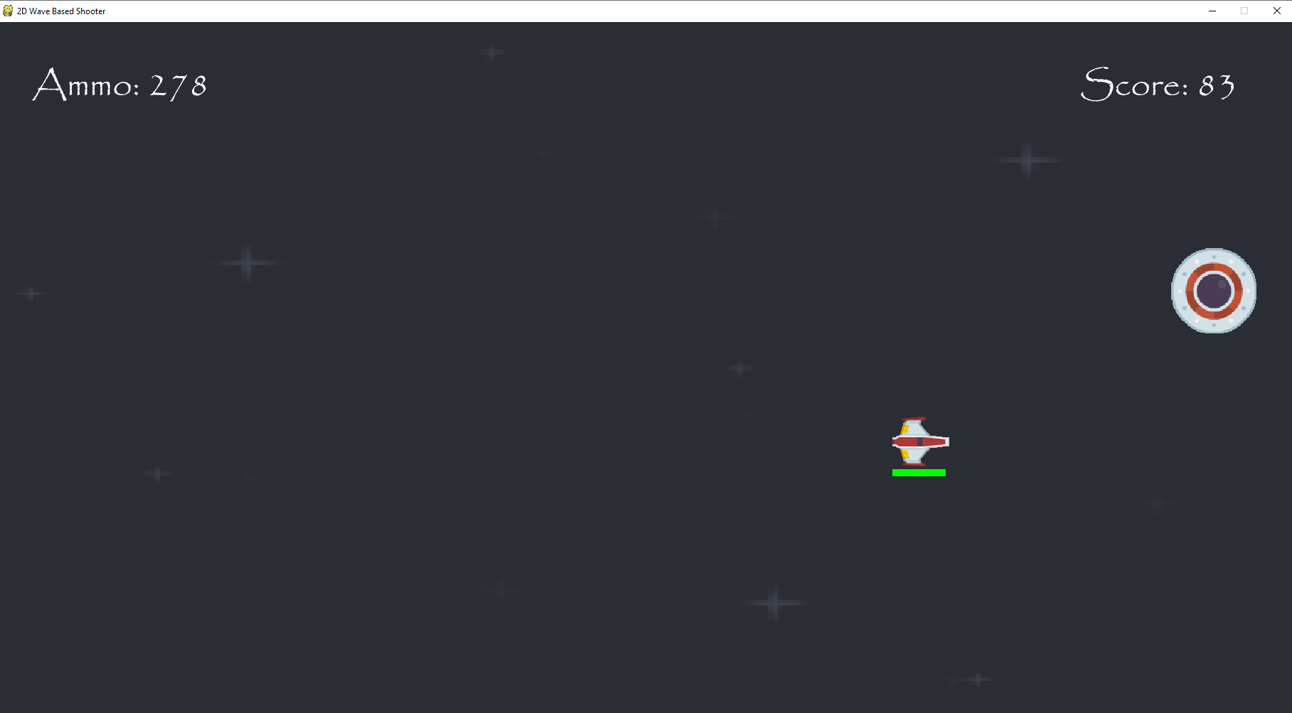  
The boss is appearing onscreen and after moving leftwards to be fully visible it moved down until it hit the bottom, at which point it started moving upwards until it hit the top of the screen and started moving downwards again. This is all working fine. 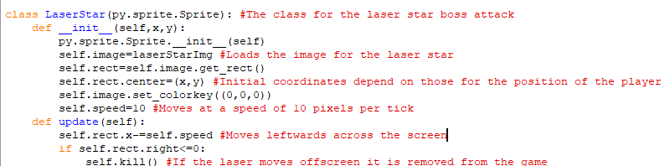The is the class for the laser star which is an attack used by the boss which is a laser shaped like a star that is fired but after moving a random amount of distance, it will disappear and four more lasers in all four directions will be shot out instead. Its starting coordinates will depend on the current position of the third boss and it will move at a speed of 10 pixels per tick leftwards across the screen. When it moves off the left-hand side of the screen, it is removed from the game. The additional lasers will be implemented soon.

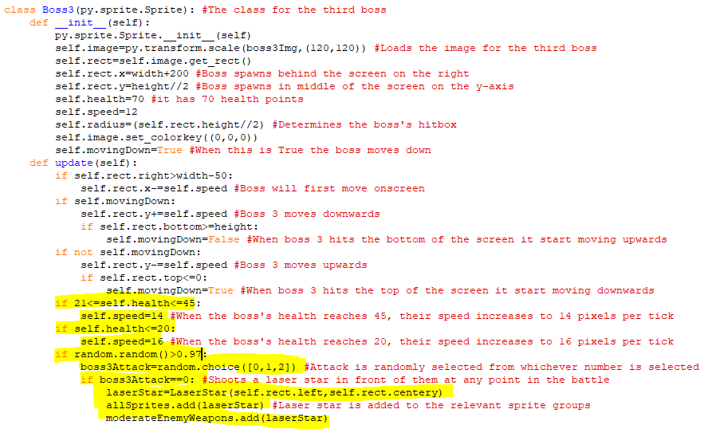The highlighted code is code added to the Boss3 class which means that if a random number between 0 and 1 is more than 0.97 and 0 is chosen from 0,1 and 2, then an object of the laser star is created and is added to the moderateEnemyWeapons and allSprites sprite group. This means it does 15 health points of health upon a collision with the player. The highlighted code above it makes the boss’s speed increase to 14 pixels per tick when their health reaches 45 and 16 pixels per tick when their health reaches 20. 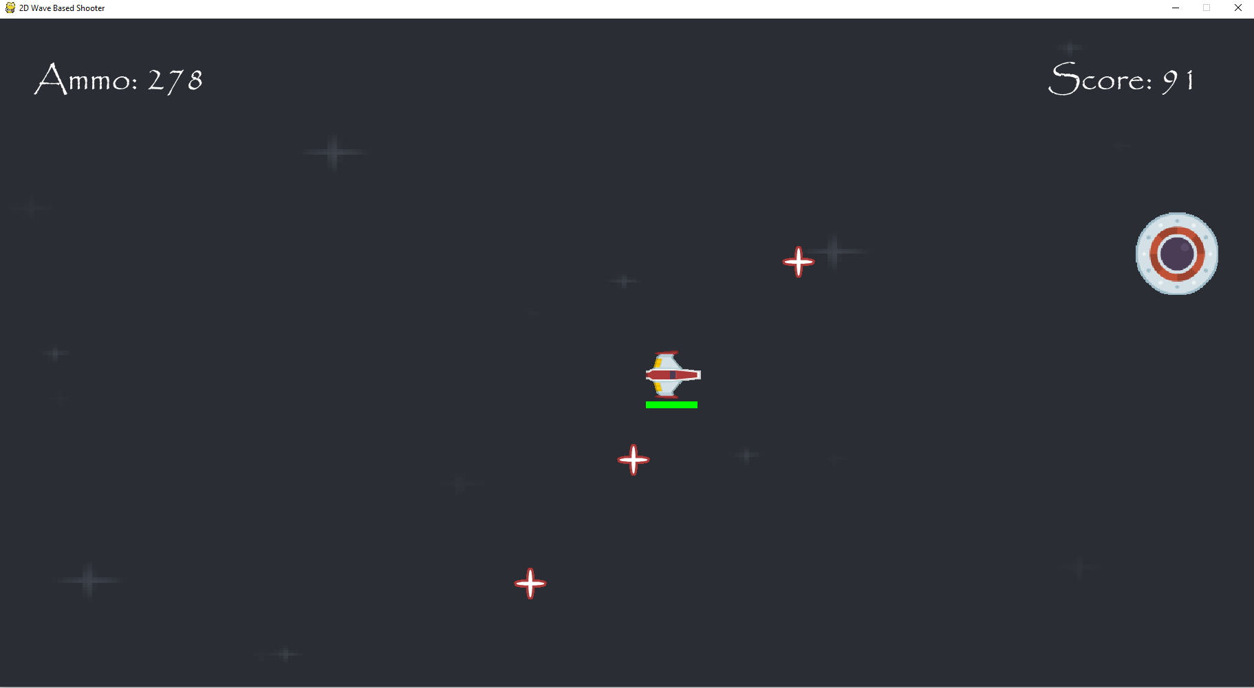  
The boss is firing the laser stars which can collide with the player to deal damage to them.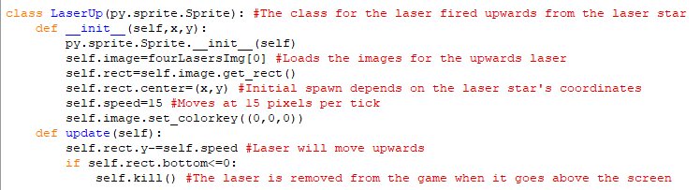This is the class for one of the lasers fired from the laser start when it disappears. It uses an image of a red laser pointing upwards and its initial coordinates depend on those of the laser star when it disappears. The update method makes it move upwards at 15 pixels per tick and when it moves above the screen, it is removed from the game.

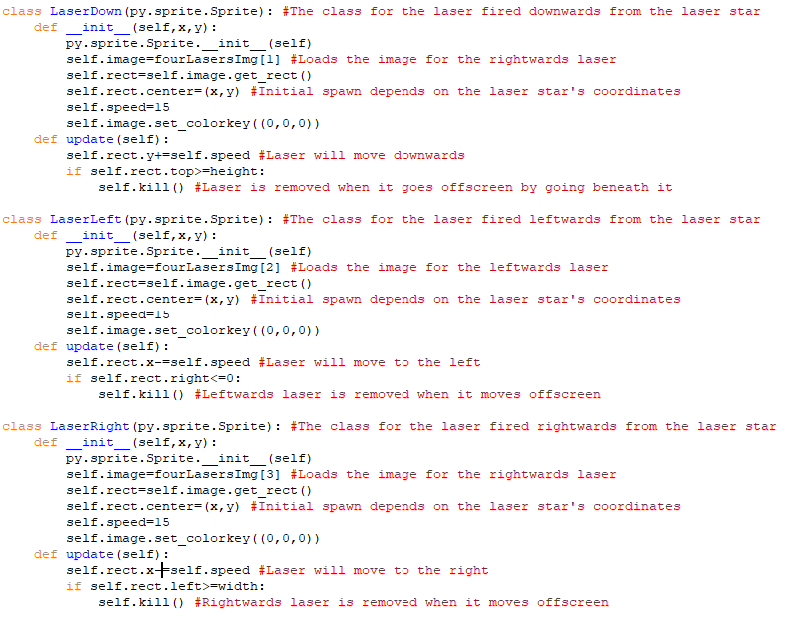These are the classes for the other lasers that are spawned when the laser star disappears. They will use images for the image points downwards, left and right and will all move in those directions at 15 pixels per tick just like the other laser. They are all removed from the program when they go offscreen in the direction they were travelling.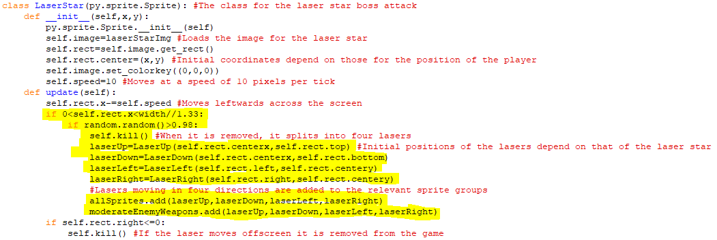The highlighted code in the update method means that when the laser star has moved more than a third of the way across the screen, then if a random value between 0 and 1 is more than 0.98 during any tick, then the laser star is removed from the game and objects for the four new lasers moving up, down, left and right. These objects are then added to the allSprites sprite group and the moderateEnemyWeapons sprite group so that they deal 15 health points of damage to the player during a collision

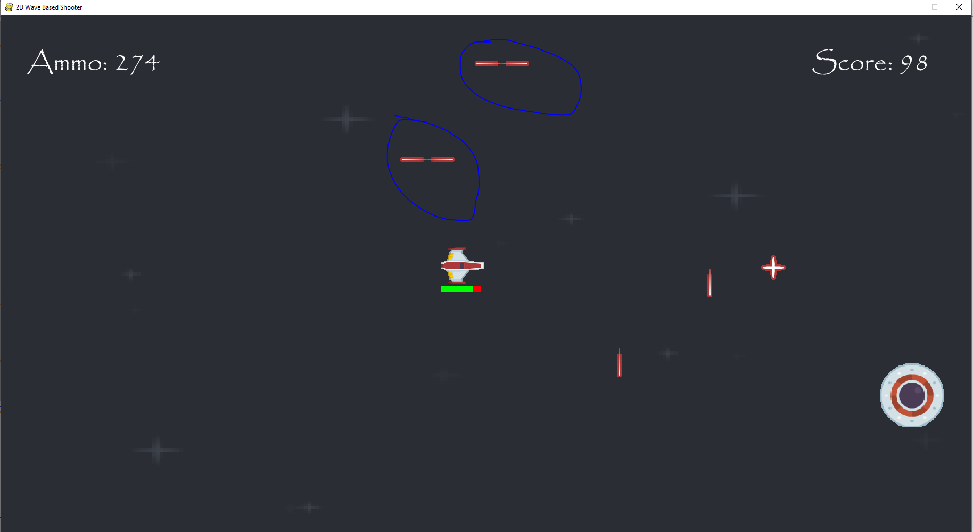  
The lasers are being spawned from the laser star when it is removed, but for some reason, two of the lasers were being spawned are both moving to the left as can be seen in the image with the circled lasers coming from two separate laser stars.

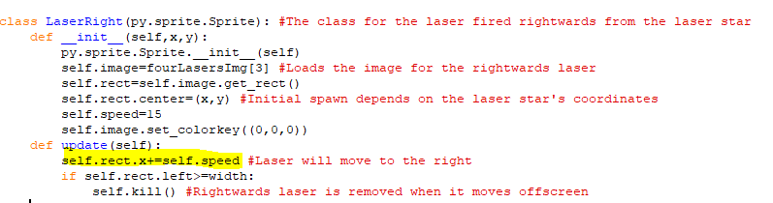The issue was that the laserRight class’s method was making the laser move to the left instead of the right.

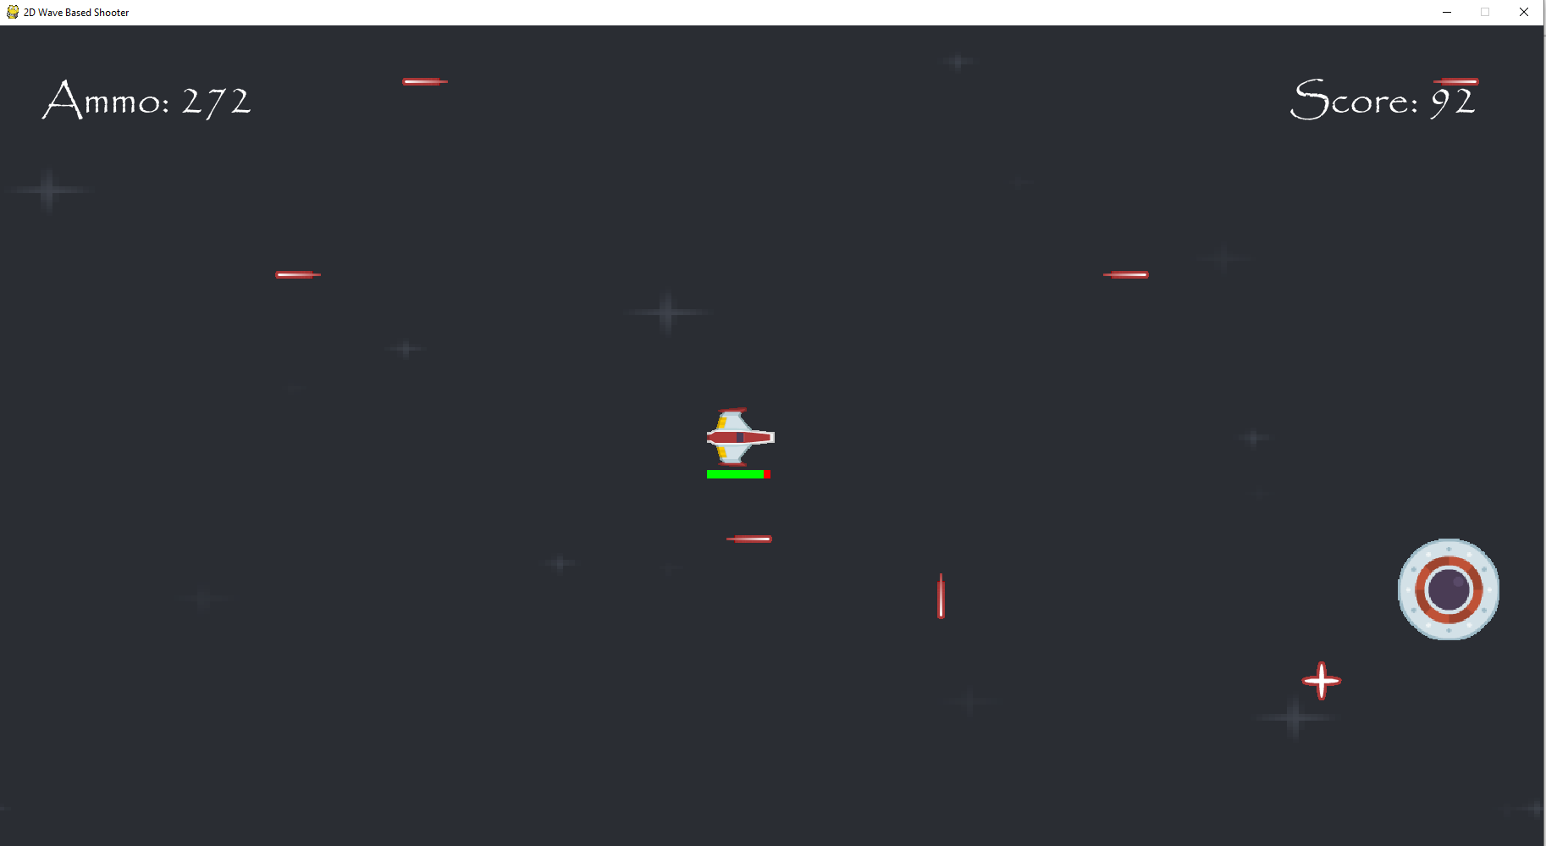  
All the lasers are now moving in the right directions.

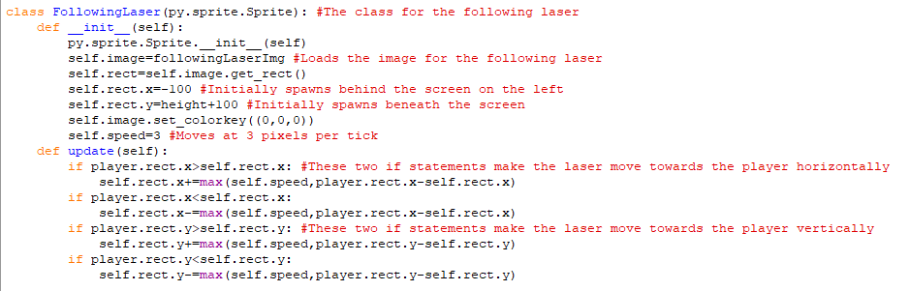This is the class for the following laser which is a laser that will move in the direction of the player. It spawns beneath the screen and behind it and moves and has a base speed of 3 pixels per tick. The update method means that when the laser approaches the player x or y coordinate, it will slow down in that axis and will never move past the player. The method checks if the laser’s x and y coordinates are more or less than those of the player and moves the laser differently depending on that.

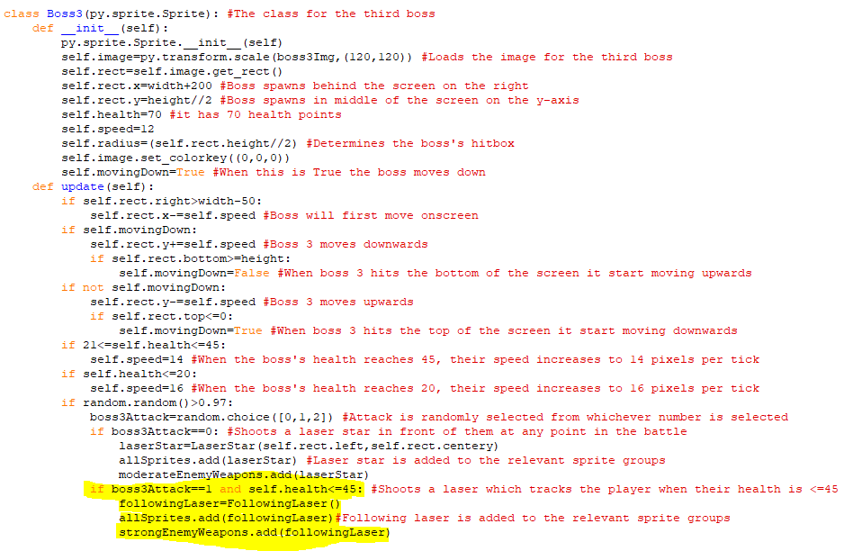The highlighted code means that when the random number selected from 0,1 and 2 is 1 and the boss health is less than or equal to 45, then an instance of the following laser is created, and this is added to the strong enemy weapons, so it deals 20 health points of damage upon a collision.

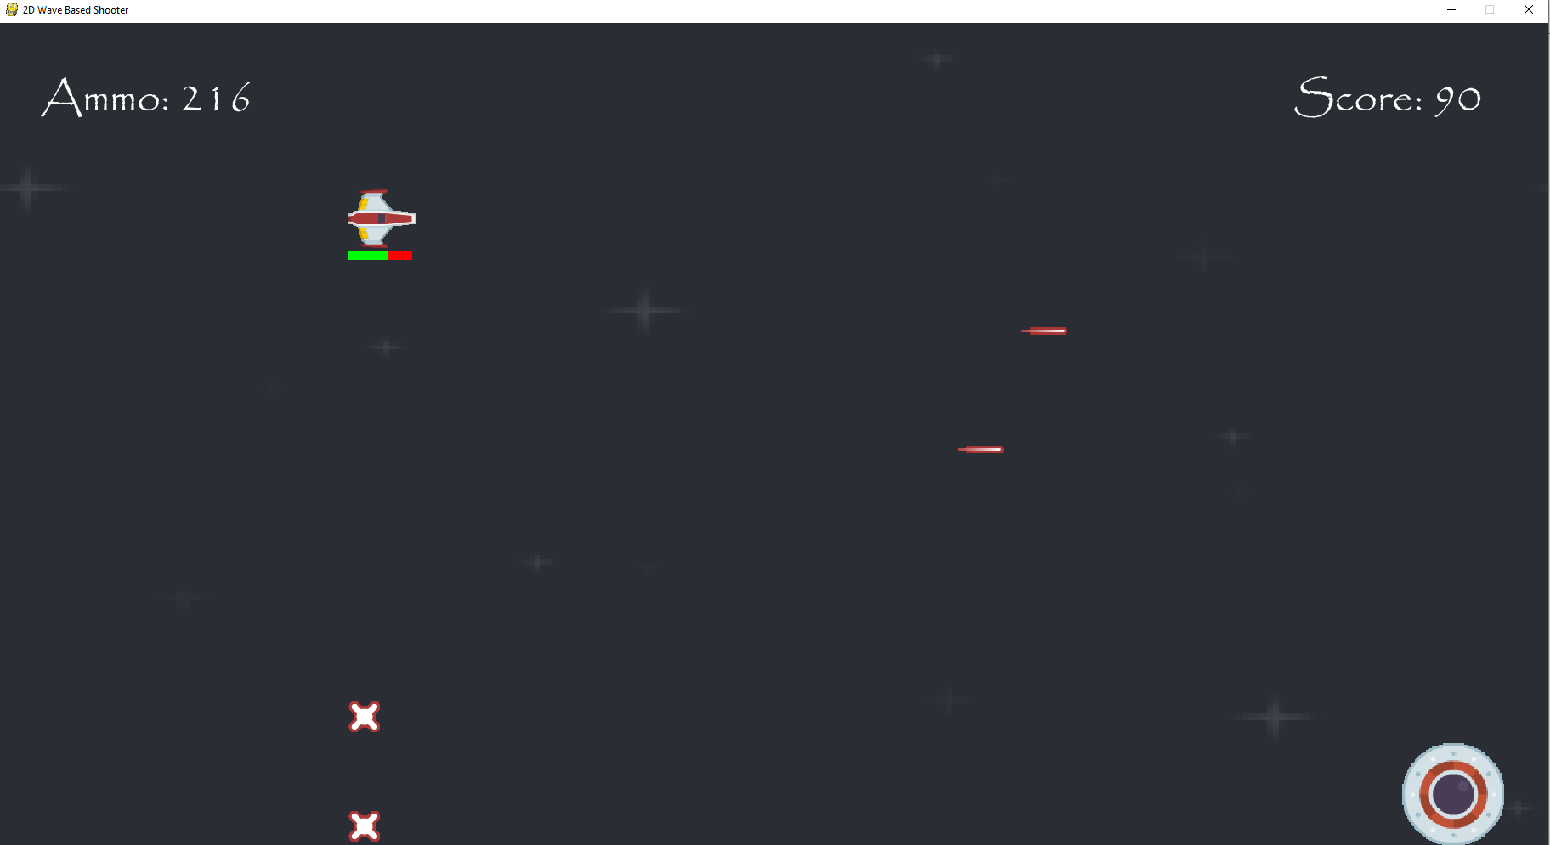  
The following lasers directly beneath the player are moving upwards to it and when I moved left or right, they moved left or right as well. They quickly move directly beneath the player after spawning in. 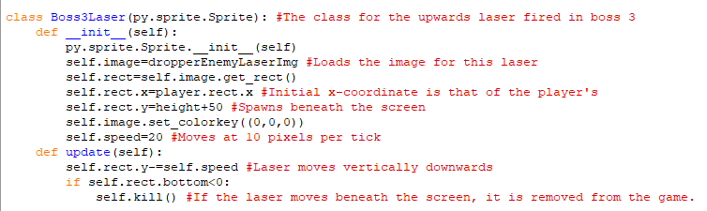The is the class for the boss’s third attack, which is just a laser that is fired upwards from the bottom of the screen. It is like the attack for the dropper enemy, except its initial x-coordinate is the same as that of the player ship at that moment, so the player must be constantly moving to avoid them. They move upwards at 20 pixels per tick and when they move above the screen, they are removed from the game.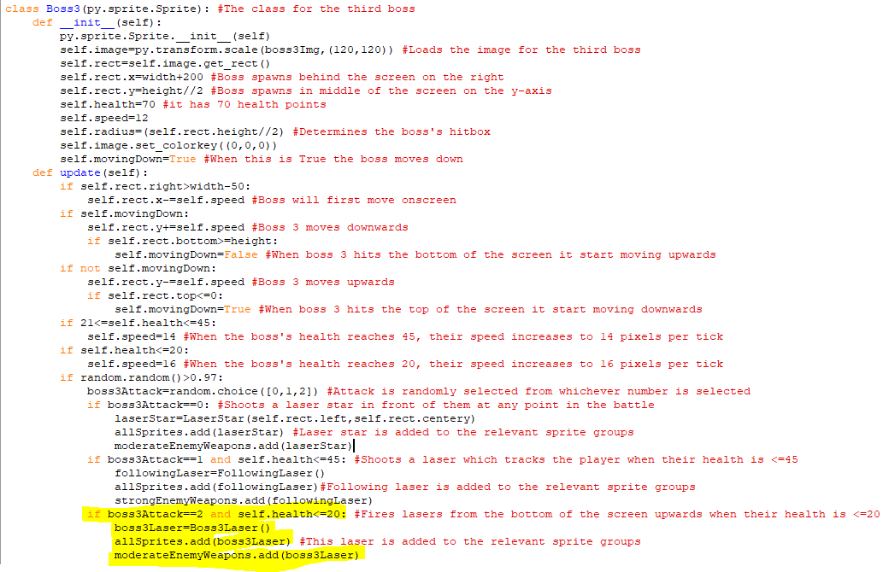The highlighted code creates an instance of the boss3laser class whenever the random number between 0 and 2 is 2 and the boss has 20m health points or less. This object is then added to the allSprites sprite group and moderateEnemyWeapons one.

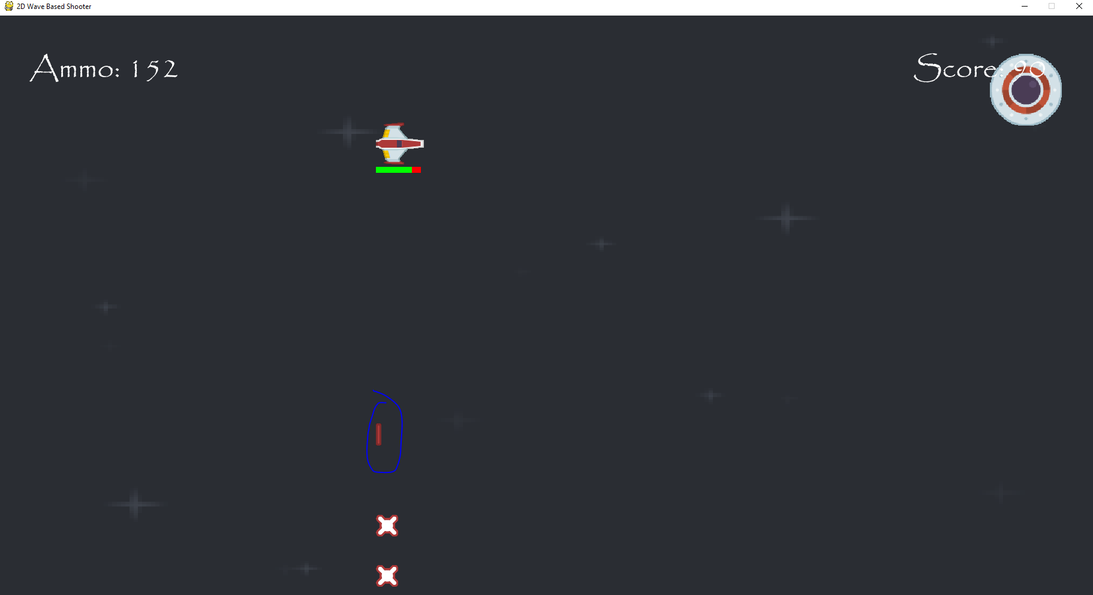The upwards lasers are being fired as expected, only appearing after the boss has lost fifty health points and they deal damage to the player upon a collision with them.

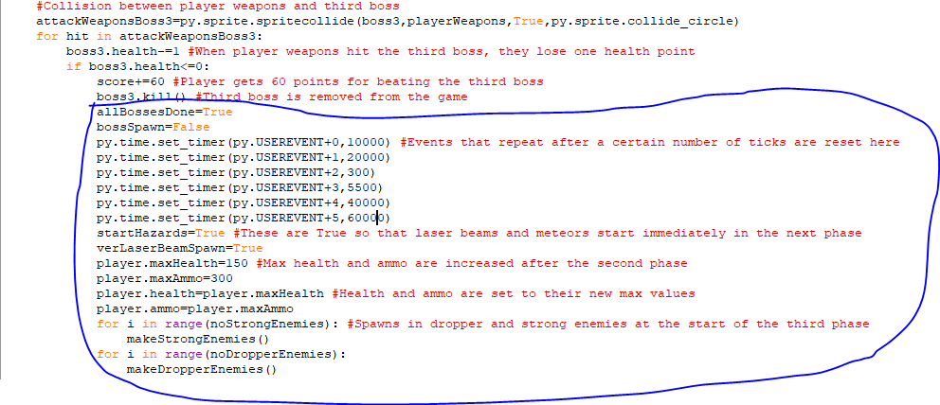I have added code to the event when the third boss loses all their health. When this happens, a new variable called allBossesDone becomes True and when it is True bosses won’t spawn in anymore and only regular enemies will be fought. The events are all reset but since the game will now always be in phase 3 until the player dies, they will continue fighting strong enemies and dropper enemies. Some of the variables are also set to True to allow for laser beams and meteors to spawn in immediately and the player is given their maximum ammo and health again. Then more strong enemies and dropper enemies will be drawn onscreen right after the boss is defeated.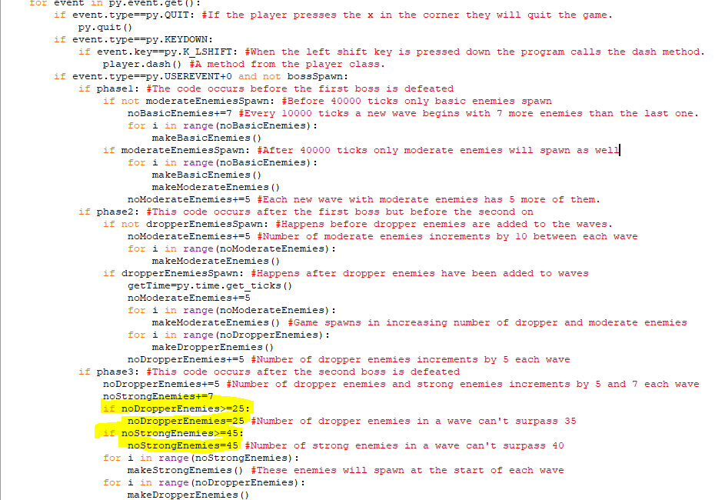The highlighted code limits the number of dropper enemies in a wave to 25 and the number of strong enemies to 45, this means that the player won’t be too overwhelmed by the number of enemies in the waves after the third boss.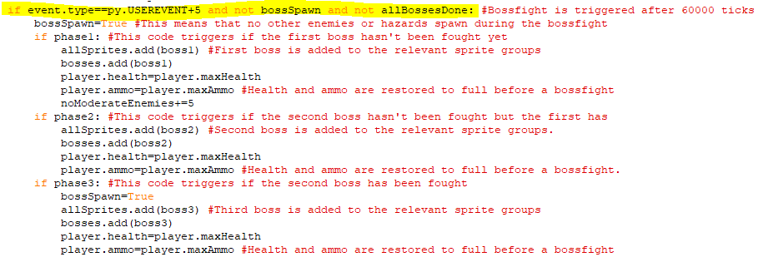I have added another condition to the event for the boss fight so that it doesn’t trigger if allBossesDone is True. This means that after the third boss another boss won’t spawn in.

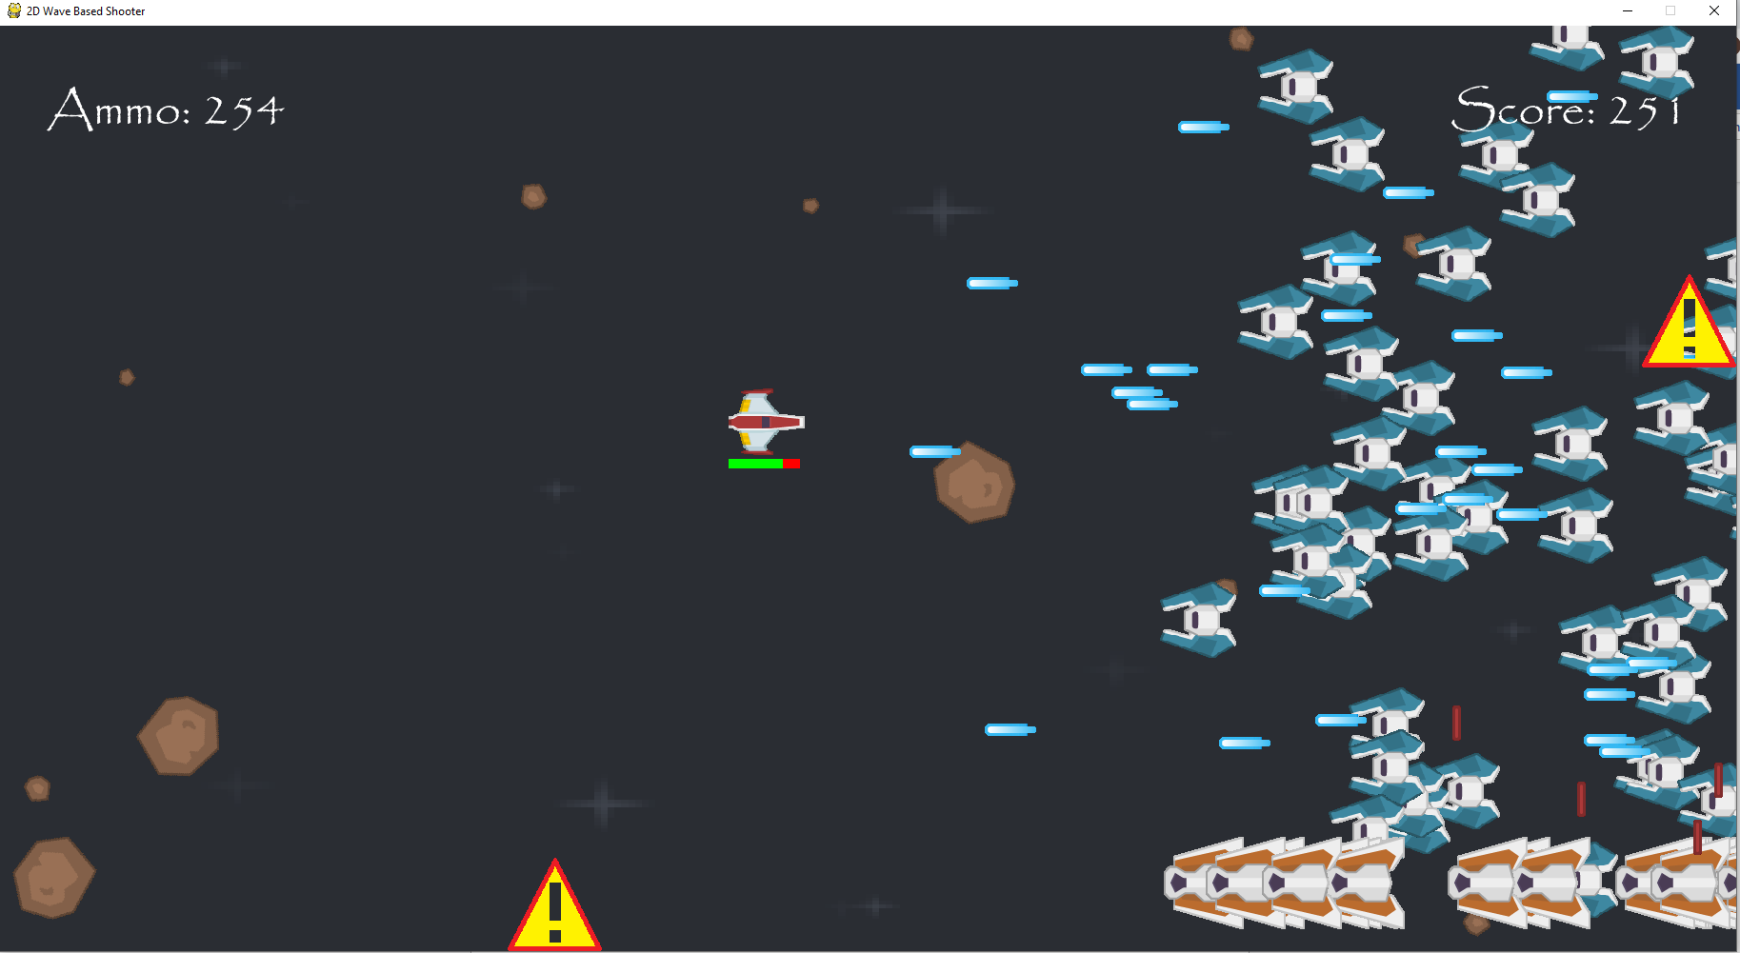This is a wave after the final boss, the enemies are still spawning, and it has been more than 60000 ticks and another boss fight hasn’t occurred, so the code is functioning properly.

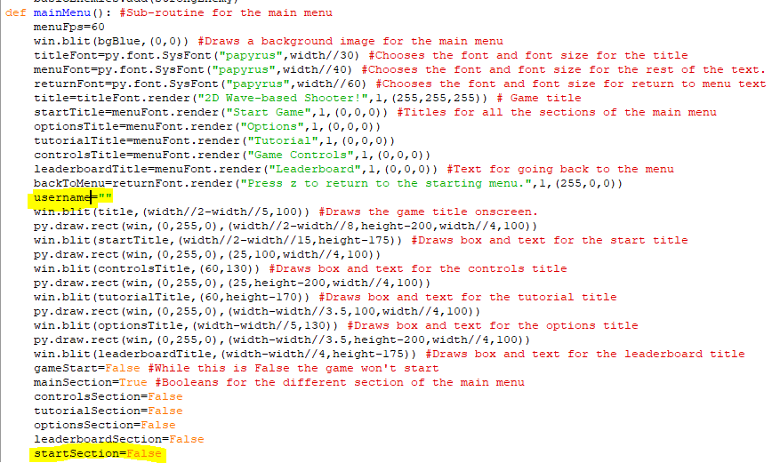I am implementing a better way for entering a player name so that it can be changed when the player dies, rather than only when they first load up the game. For this, I have a new username variable in the mainMenu sub-routine and have created a variable that becomes True when the player presses start.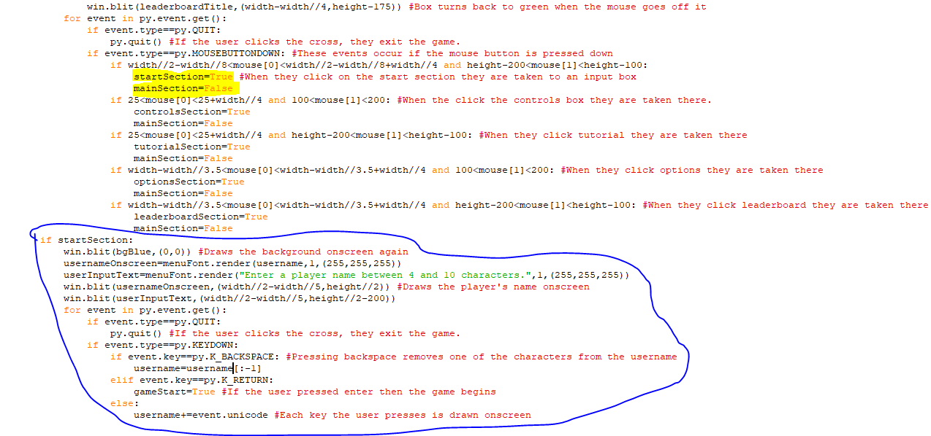The highlighted code means that when the player clicks on the start game box in the game, startSection becomes True. The circled code is code just added that determines what happens when startSection becomes True. When this happens, a new background is drawn over the screen and some text telling the player to enter a player name between four and ten characters long appears. When the player presses a key, it a drawn onscreen and added to the username. This is unless the key is a backspace, in which case the previous character entered is removed, or the enter key, in which case the game begins.

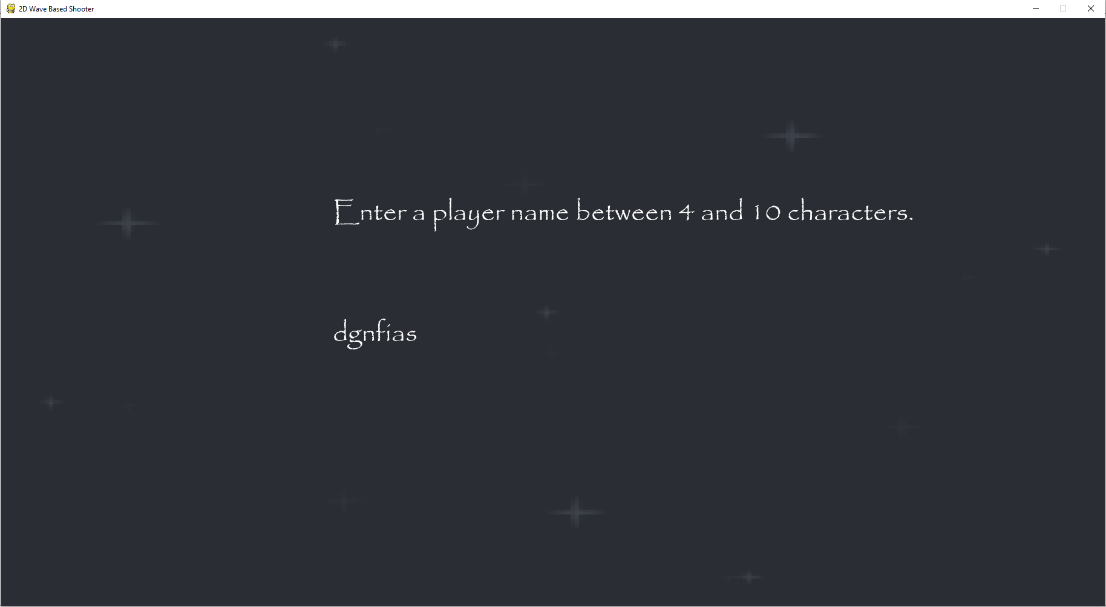  
Adding letters onscreen as a part of the username works fine, but the text above it will have to be better centred.

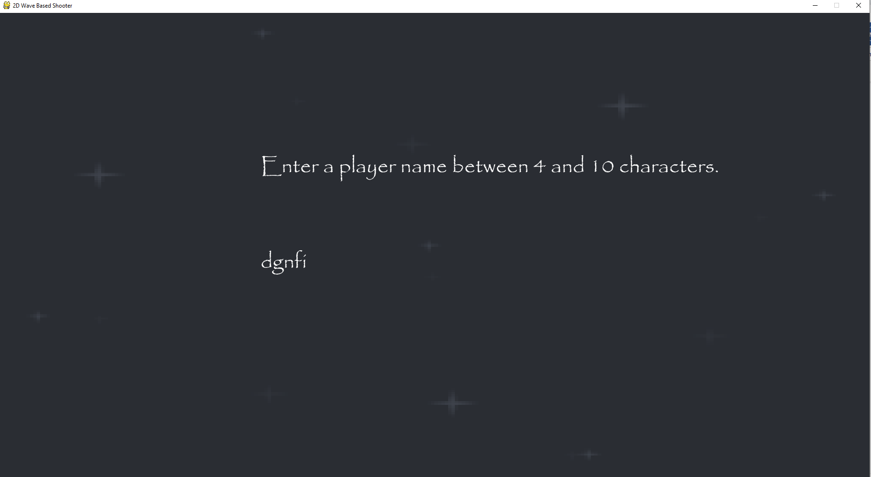  
Removing characters from the username also works fine as dgnfias has had the as taken off it.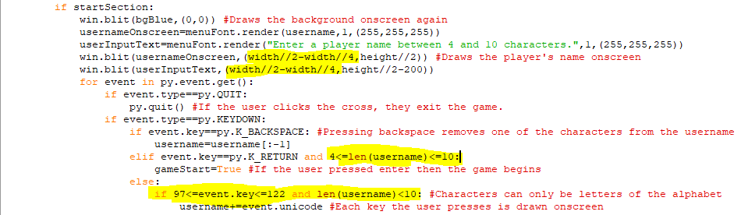The highlighted lines of code move the start of the text onscreen the left more so that it is more centred. The third highlighted line makes sure that the username will only be accepted if it is between 4 and 10 characters and the fourth line makes sure that only a-z characters are accepted into the username by checking the unicode value of the keys pressed and makes sure that no more characters can be entered when the username is 10 characters long.

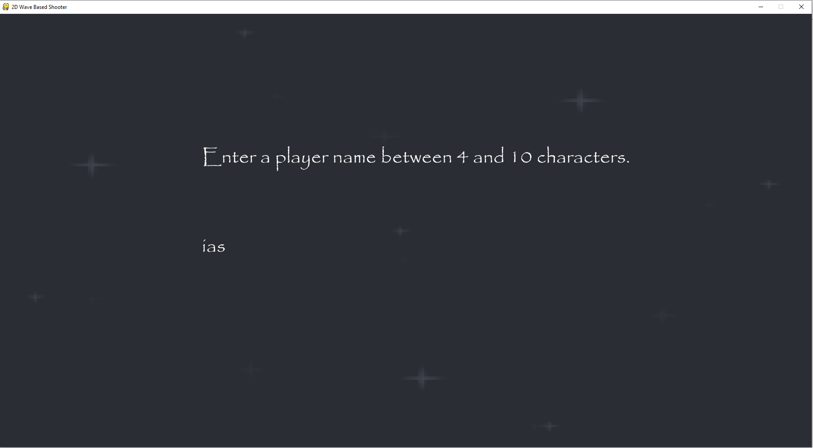  
When the name is 3 characters long, nothing happens since it isn’t long enough to be a username. The text is also a lot more centred now.

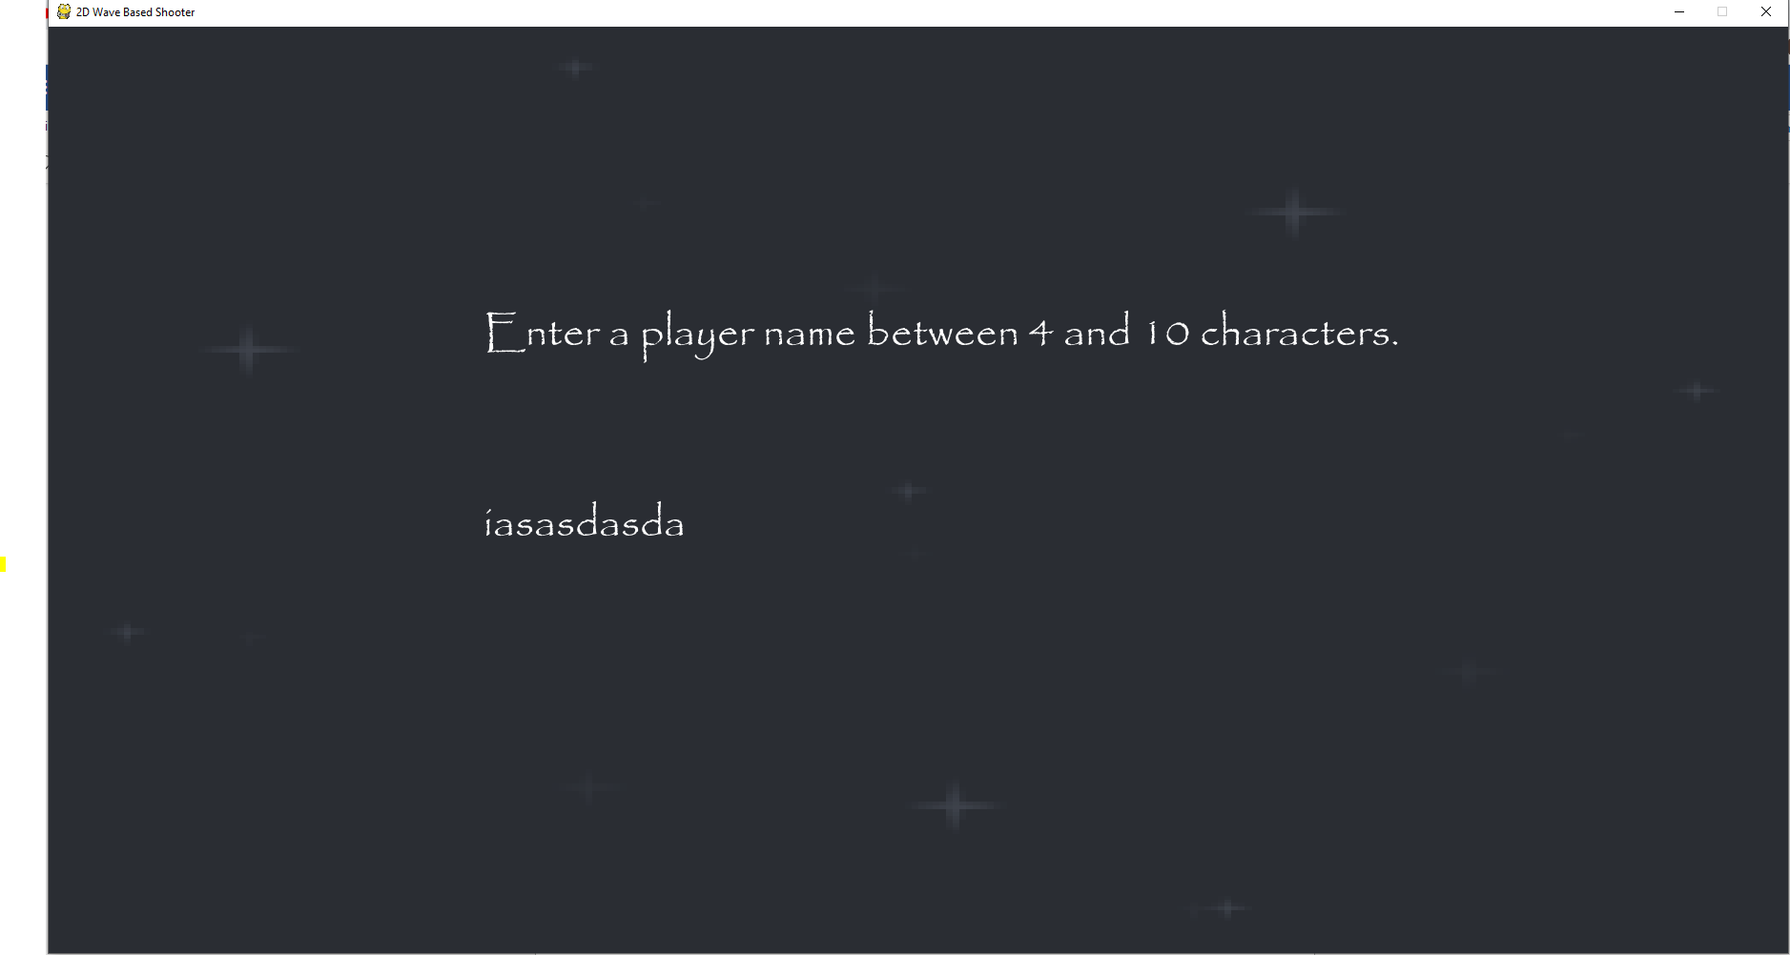  
The username can’t be more than 10 characters long, more than 10 characters physically can’t be entered as the username.

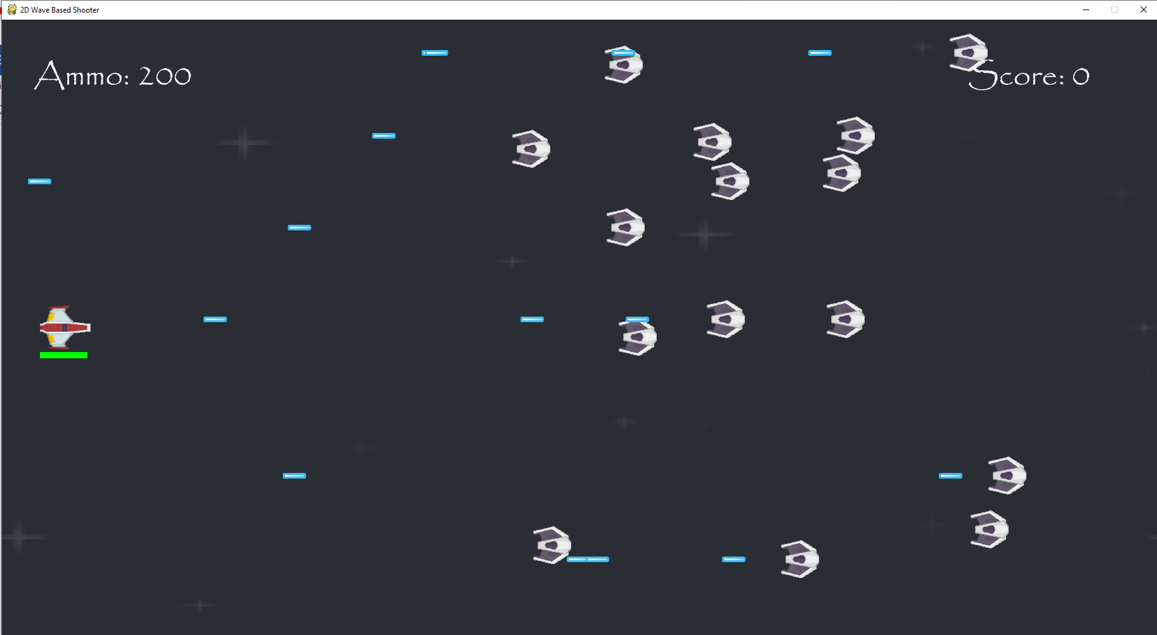  
When I hit the enter button, the game began as the number of characters in the username was between 4 and 10.

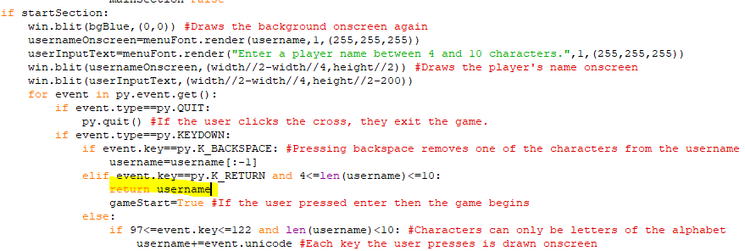The username is returned to the main program and this will be written to the names file when the player is defeated.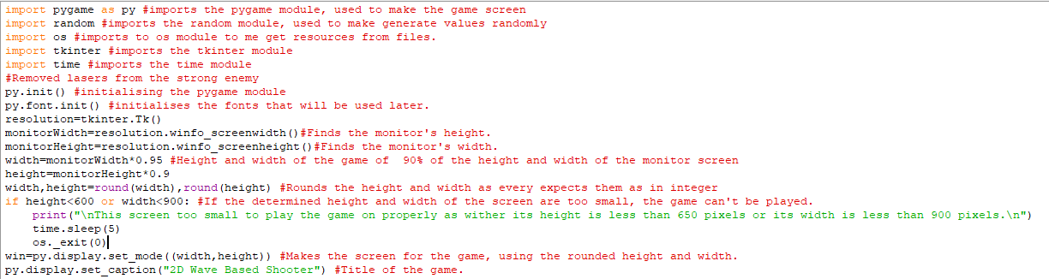I have removed the code from the start of the game where you entered the username from the python shell as this new method has been implemented of entering the username in game.

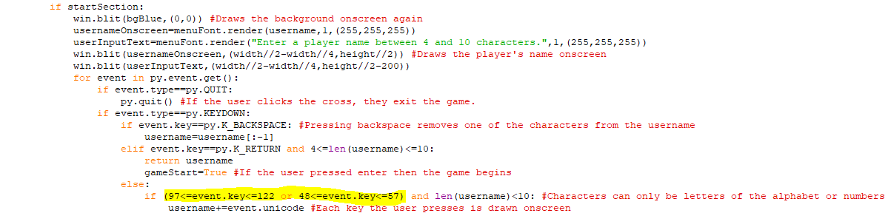I added in unicode values for numbers into the if statement determining whether a character should be a part of the username. This means that numbers can now be used in the player name.

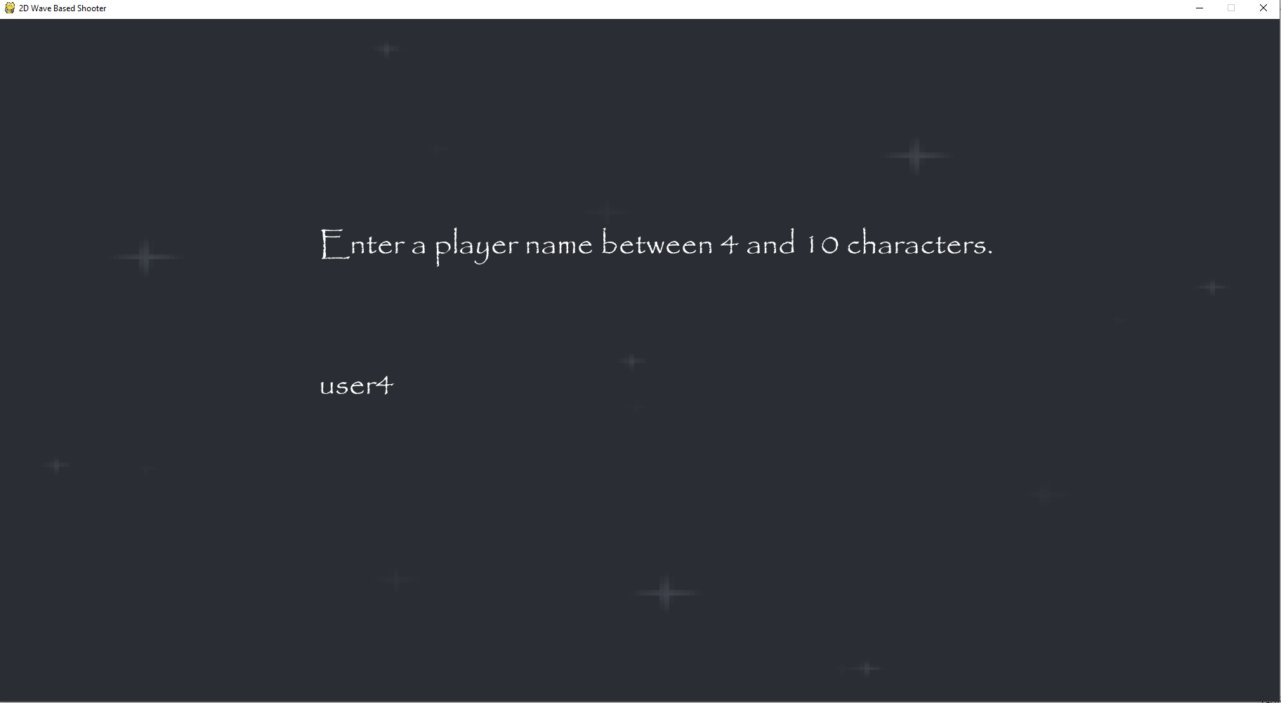  
This is the username I am going to test with to see if it and the corresponding score are added to the relevant files upon player defeat. This also shows that numbers are now able to be entered in game for the player name.

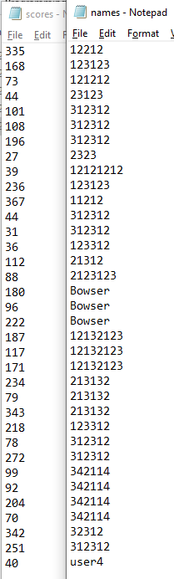  
When I died, user4 was saved to the names file, and my score of 40 was saved to the scores file.

Stage 7 Review

In this stage, I have implemented the third phase of the game, which has a new, tougher enemy to increase the game’s difficulty. The number of the strong enemy and dropper enemy increases in each wave so they become progressively harder and after six waves there is a final boss who has three new moves, as well as moving faster than the previous bosses and having more health. I also made the username entered through the pygame window itself when you click start game instead of it being done in the shell. This makes the game look nicer and makes it more usable and universal since everything is now done in the game window.

For the success criteria, the interactive UI has been improved since the username is now entered directly through it and the design and layout has been kept the same as the same background and font are used here. More enemy types and bosses have been added to the game as well to make the game more difficult over time and this requirement has been completed now as I have finished developing the different waves of the game. After the third boss, the game continues with the strong enemies and dropper enemies until the player loses all of their health.

Client Feedback:

The new enemy is essentially a faster, stronger version of the original enemy making the attacks faster as well helping the game from becoming too easy. The new boss is also tougher than the other bosses and has more health as well.

Stage 8- Implementing Multiplayer and using inheritance

**In this stage, the parts of the success criteria I am going to achieve are:**

* **Making the game playable with two players.**
* **Fitting two sets of controls on the same keyboard.**

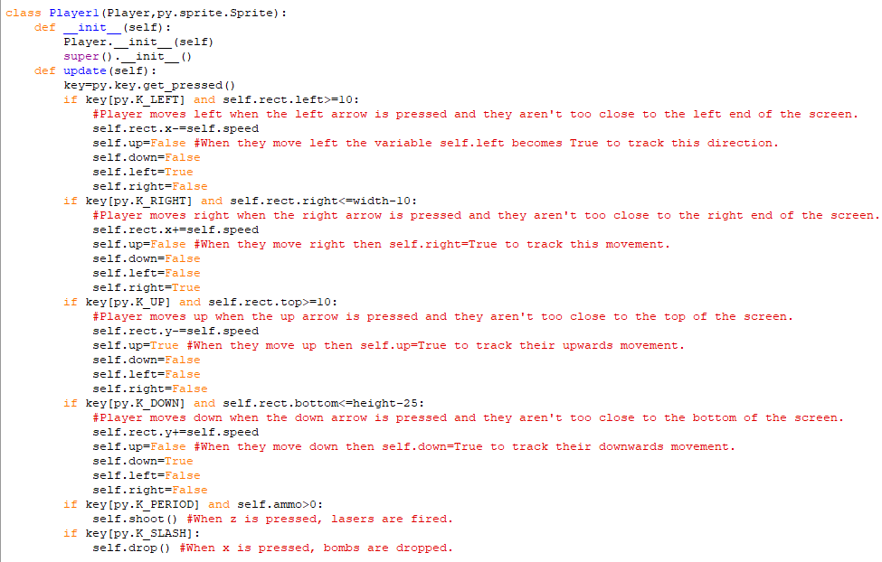This is the class for one of the player spaceships when you are in multiplayer mode. It is a subclass of the Player class and the super() command makes it inherit all the methods and attributes from the Player class. However, I have overriden the update method since different keys will have to be used to move and shoot when there are two players so that there is enough space on the keyboard for both players. For the first player up, down, left and right are still used to move in those directions, but now the full stop and slash on the keyboard are used to shoot lasers and drop bombs.

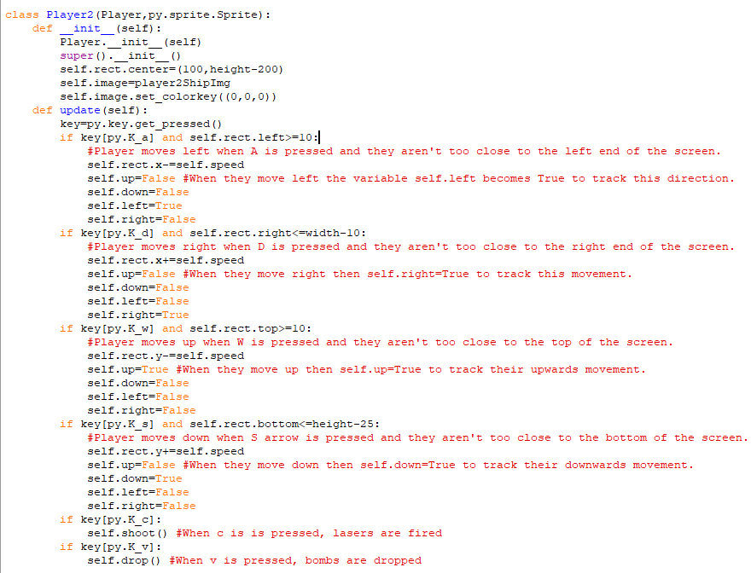This is the class for the second player. It also inherits all the methods and attributes from the Player class, and it uses W, A, S and D to move up, left, down and right respectively. It then uses c and v to shoot lasers and drop bombs respectively.

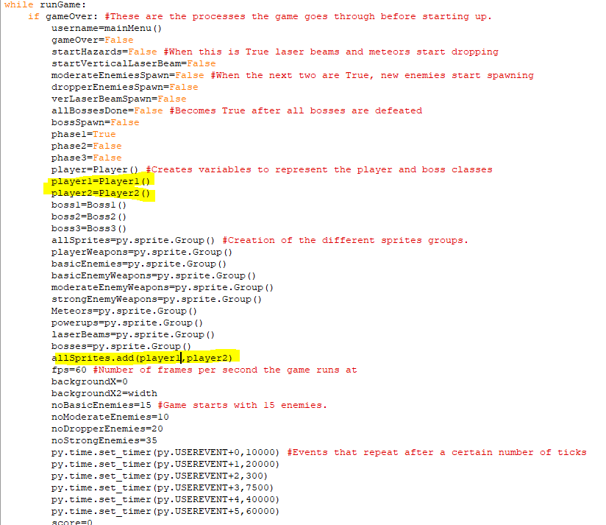I have created objects for player 1 and player 2 from their respective classes and, for now, the program will always add them to the allSprites sprite group at the start of the game rather than just one player. This is until I implement a way to choose between single player and multiplayer.

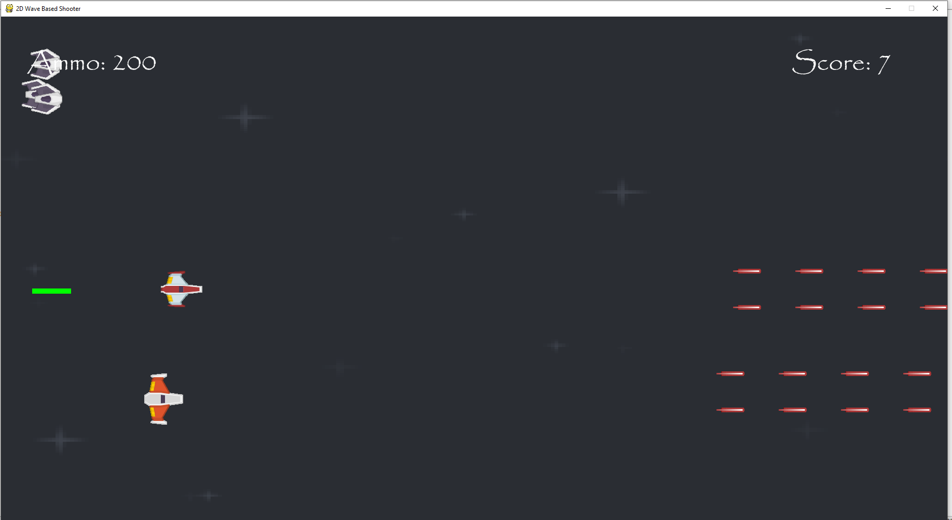  
The two new players do appear onscreen they both move in the right directions when I press the corresponding keys, and both can’t move off the screen due to the preconditions in the code. They both also look different and can fire lasers and drop bombs that damage enemies. However, the player health bar is still showing up because it is still onscreen.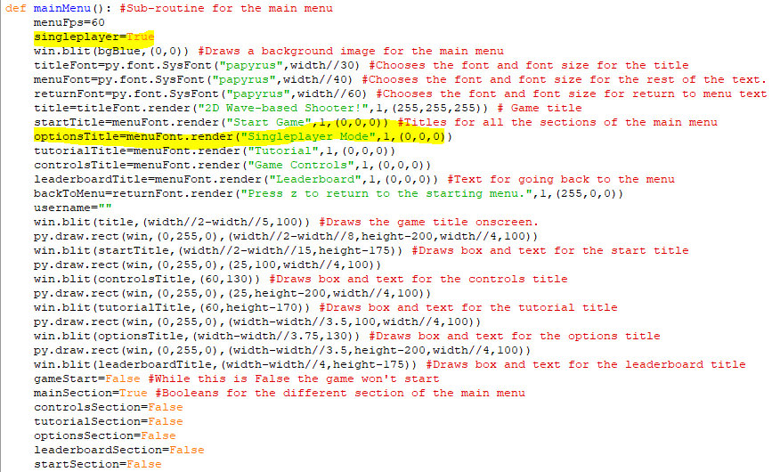This is a new variable in the mainMenu subroutine called single player and I am changing the options section box so that it is instead a way to toggle between single player and multiplayer. When you click on the options menu box, then singleplayer becomes False. When singleplayer is True the box will now read ”singleplayer mode” and when it is False the box will read ”multiplayer mode”.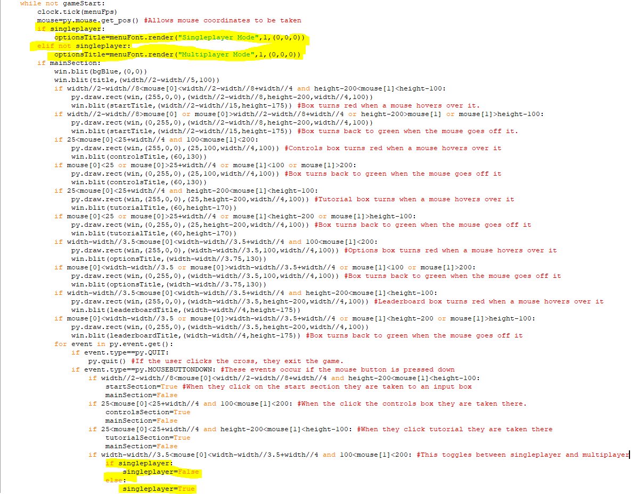The highlighted code at the top means that when singleplayer is True the text inside the box says ”singleplayer mode” and when it is False, the text inside the box says ”multiplayer mode”. The highlighted code at the bottom means that when the options box is clicked and singleplayer is True then it becomes False and when it is clicked when singleplayer is False then it becomes False.

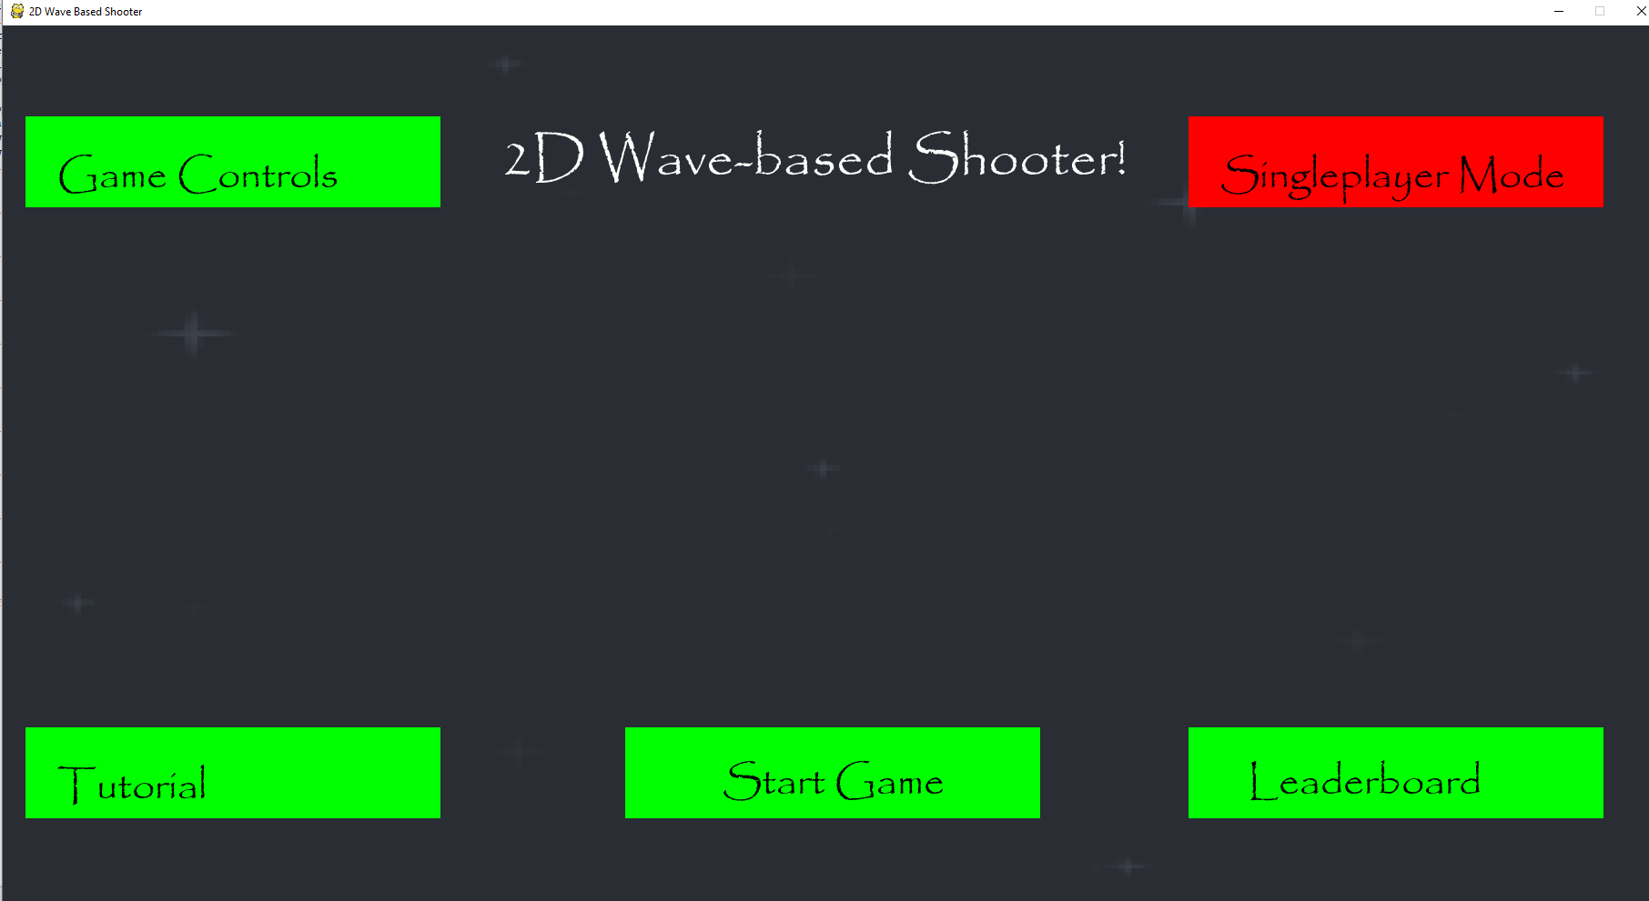  
The text in the options box now says singleplayer mode and turns red when you hover over it.

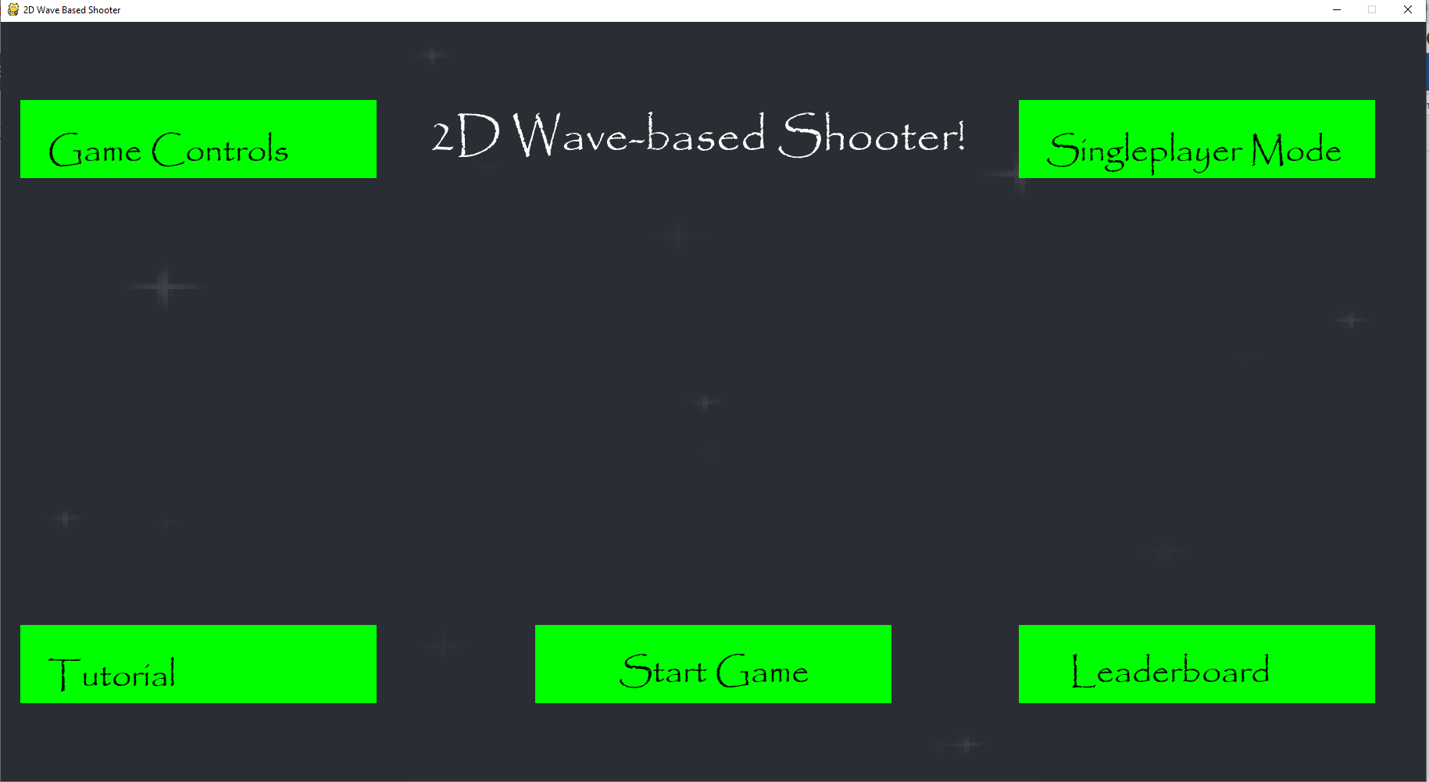  
The box becomes green again when the mouse cursor goes off it.

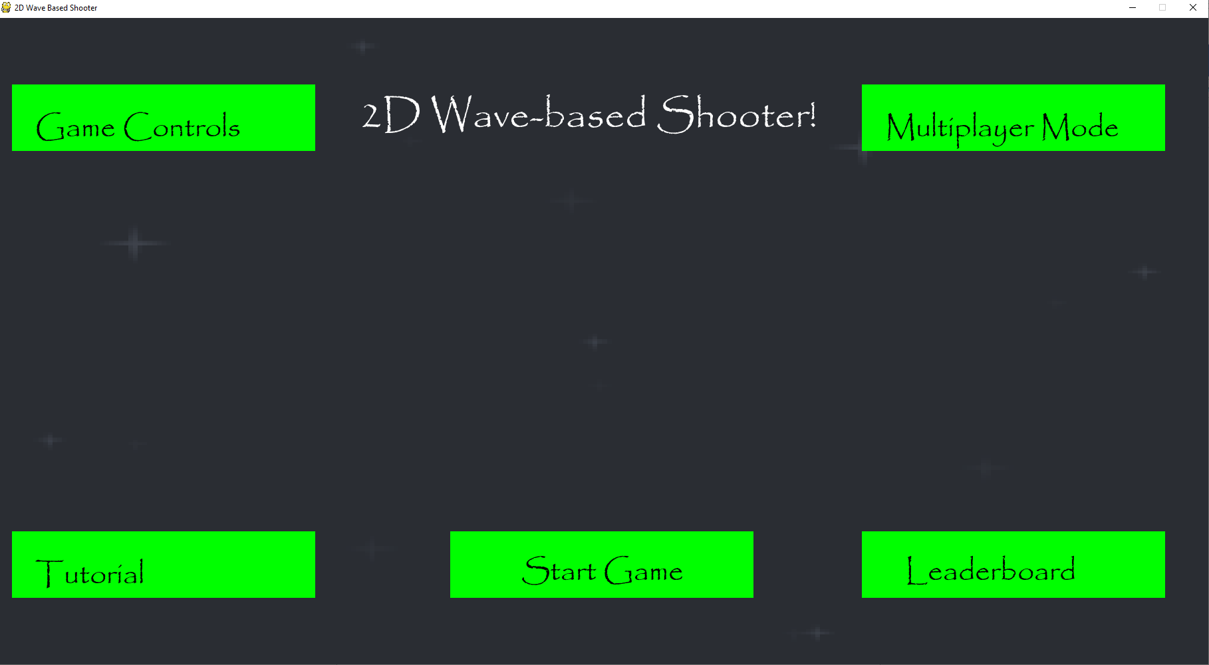  
When you click on the box, the text changes to multiplayer mode.

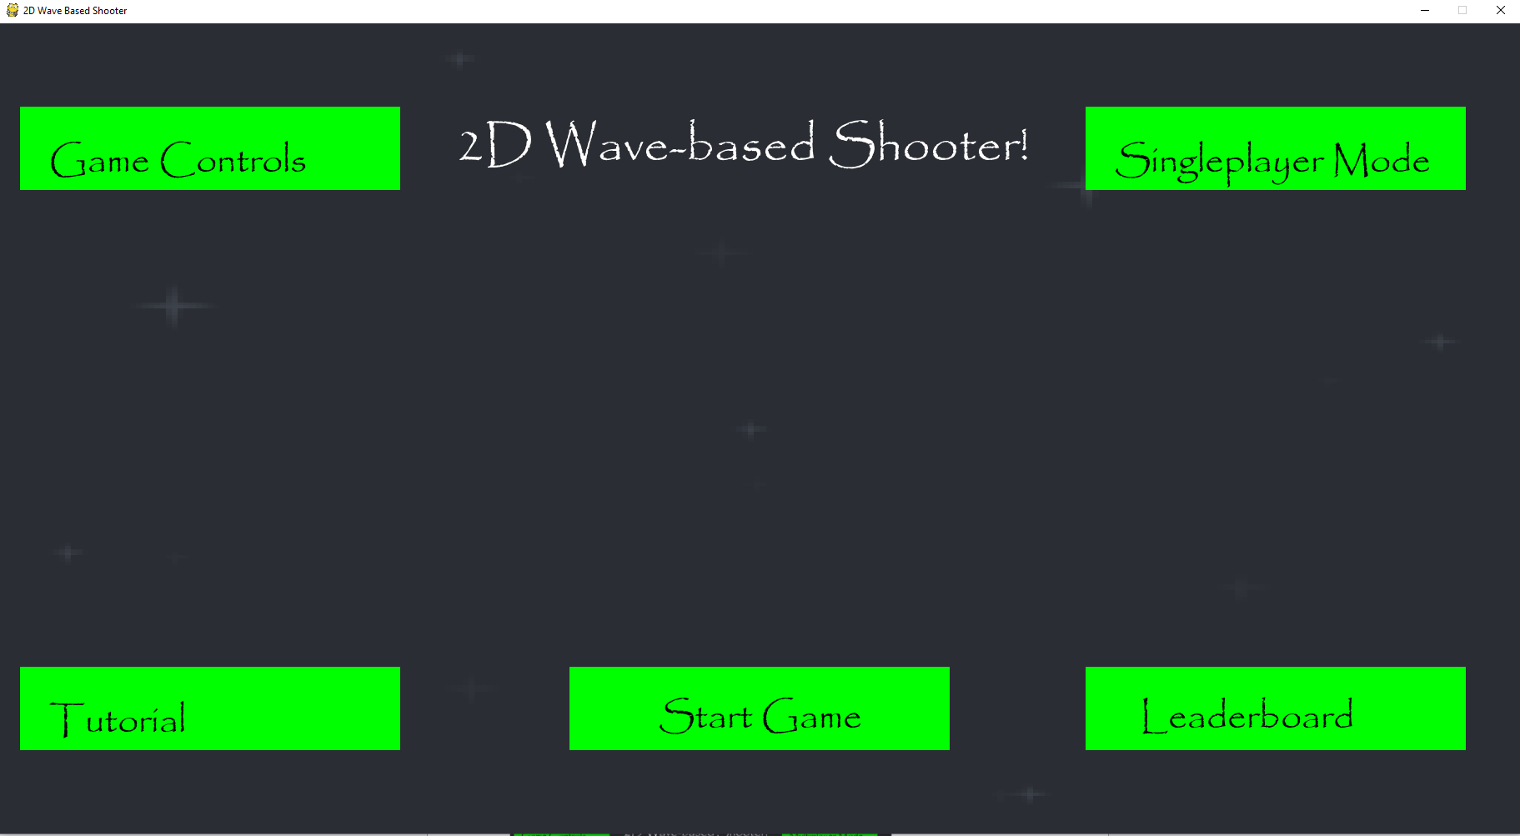  
When I clicked on the box again, the text changed back to singleplayer mode

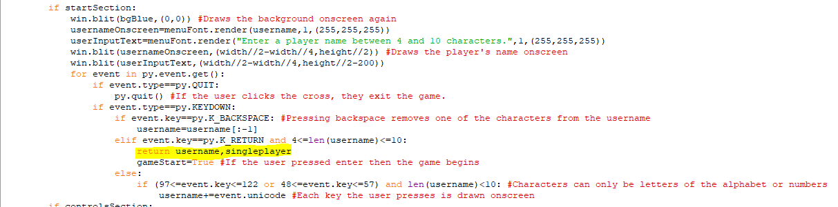The singleplayer boolean is returned to the main program after the player has entered a player name.

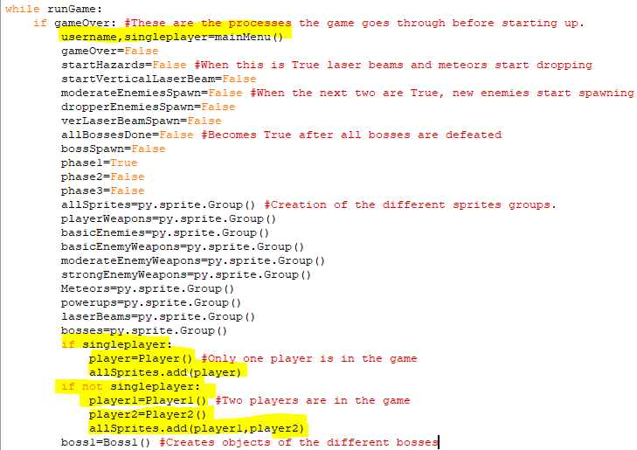When the player leaves the main menu, then if singleplayer is True, only an object of the original player class is created. If it isn’t True, then two objects for the two players are created instead. In either case, the resulting objects are added to the allSprites sprite group.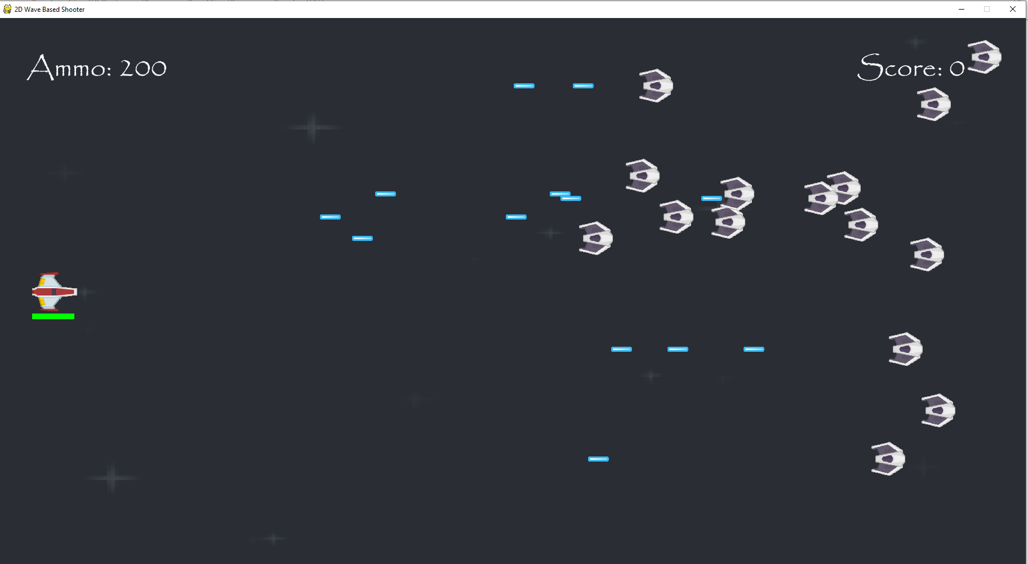  
When the game is in singleplayer mode, it will function like normal. With waves of enemies still spawning in.

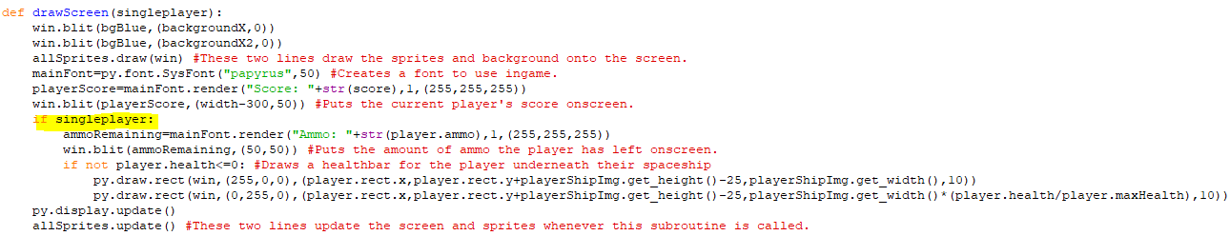

This is the subroutine for drawing the objects onscreen, but it has been changed so that the ammo and health for the player are only drawn onscreen when singleplayer is True, because when it isn’t the player object doesn’t exist.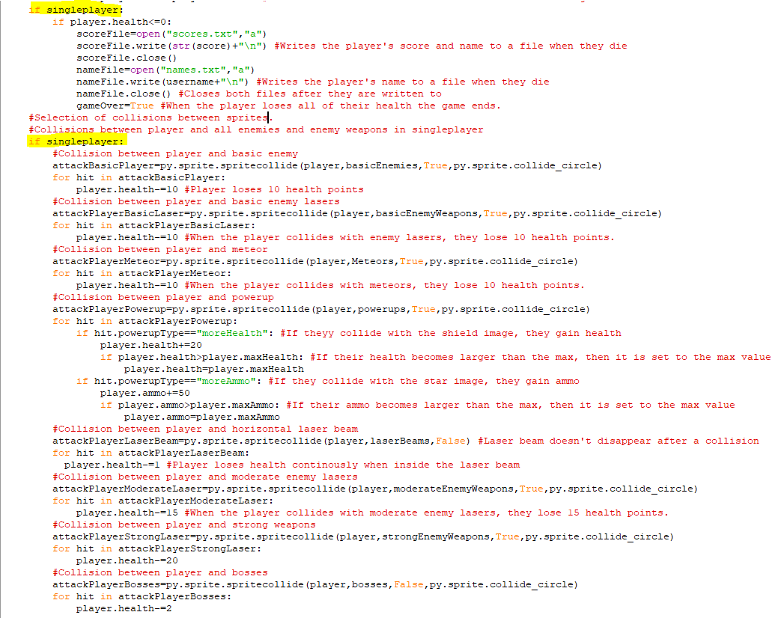Similarly, all the collisions between the player object and any other hazard are put inside of an if statement, so they will only happen if singleplayer is True since otherwise, the player object is non-existent.

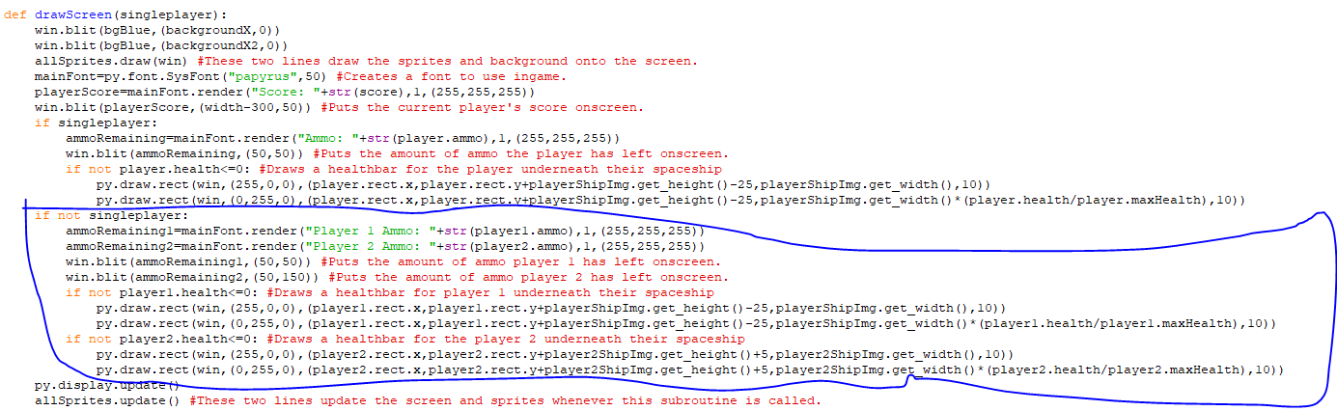The circled code draws the amount of ammo that each of the players has left onscreen when the game is in multiplayer. Both ammo amounts are drawn in the top left-hand corner. When singleplayer is False, the game will also draw health bars for the two players that are beneath their spaceships. They will become gradually redder as the player takes damage.

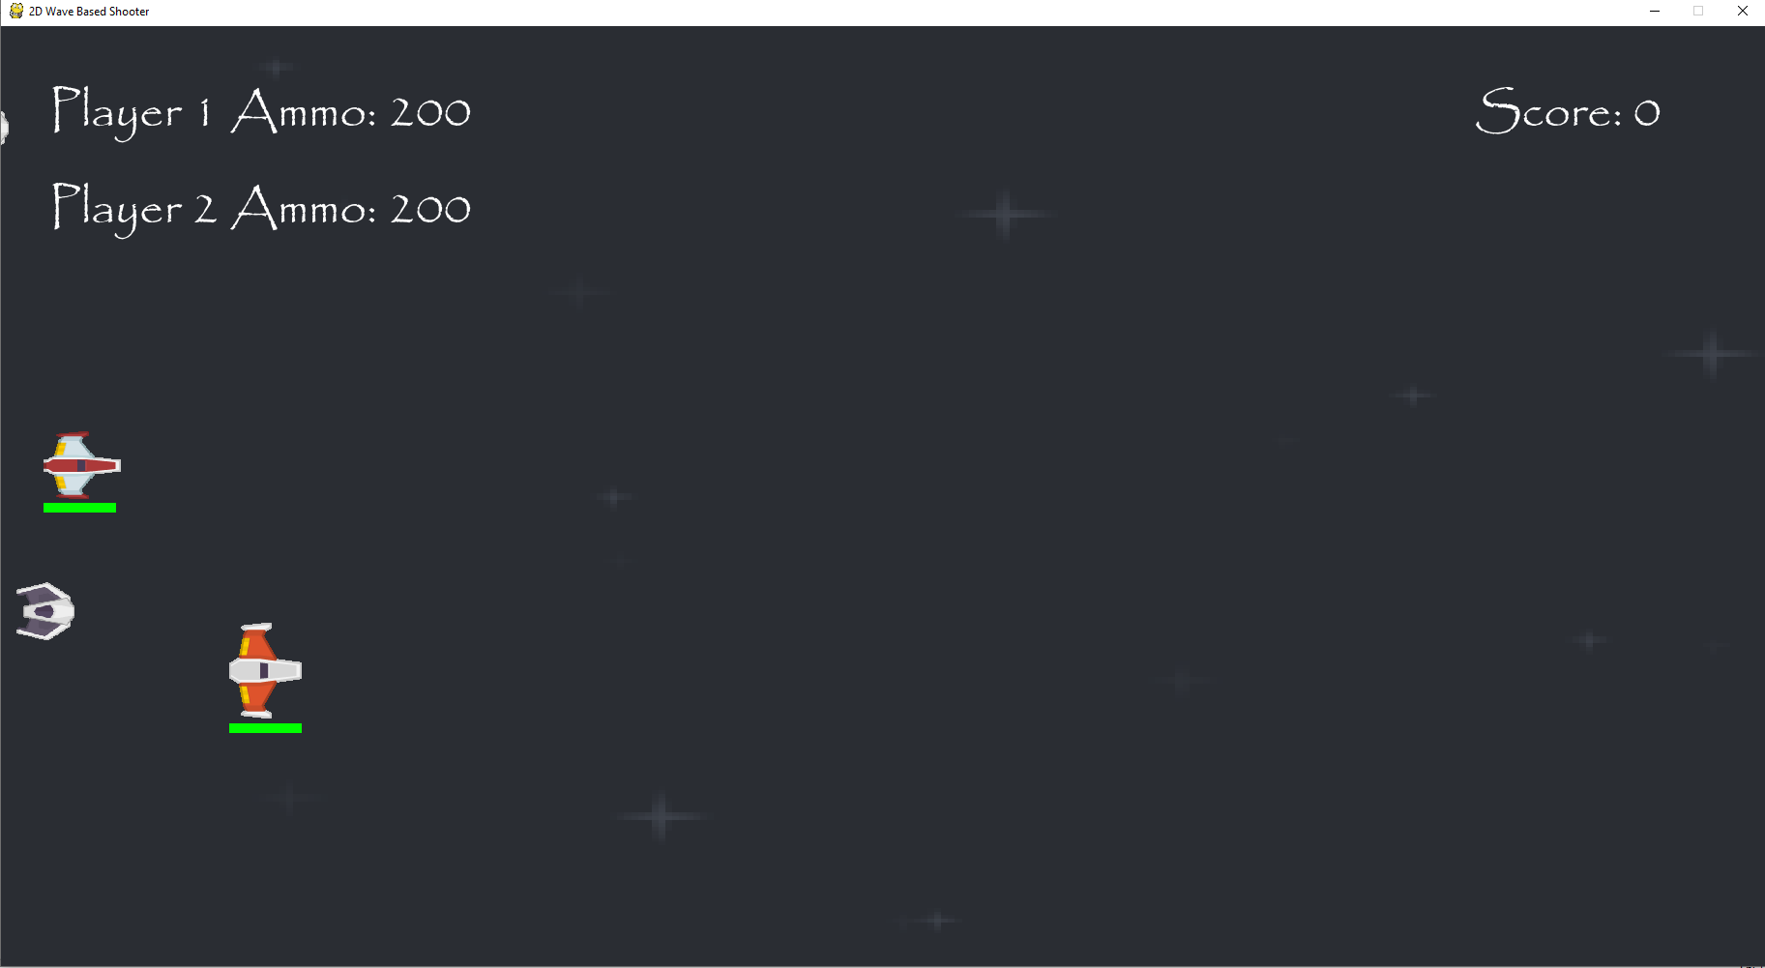  
Here are the two players, both of whom have the health bar beneath their spaceship.

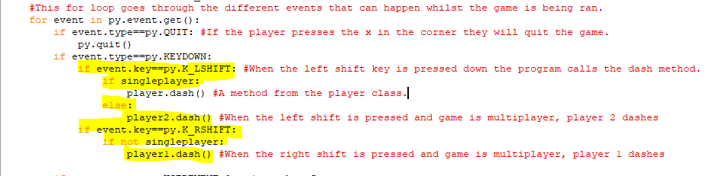The event for dealing with a player dashing has been changed so that when left shift is pressed then if the game is in singleplayer then the player onscreen will dash and if it is in multiplayer then pressing it makes the second player dash. Also, if the game is in multiplayer and right shift if pressed then the first player will dash instead.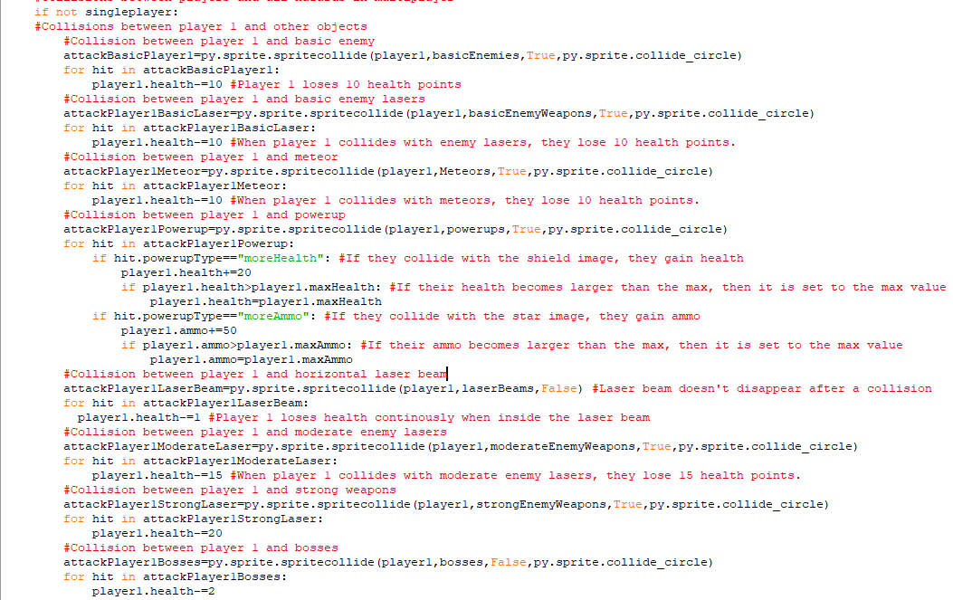All of this code determines the collisions between player 1 and the different sprite groups when singleplayer is False. These collisions are identical to those for the player and other objects when in singleplayer so I have already explained what collisions cause to happen previously. The same amount of damage is done by the strong, moderate and basic weapons and also by laser beams and meteors and player 1 can also pick up powerups in the same way and they have the same effect. All of the collisions will now occur with the player1 project rather than the player object.

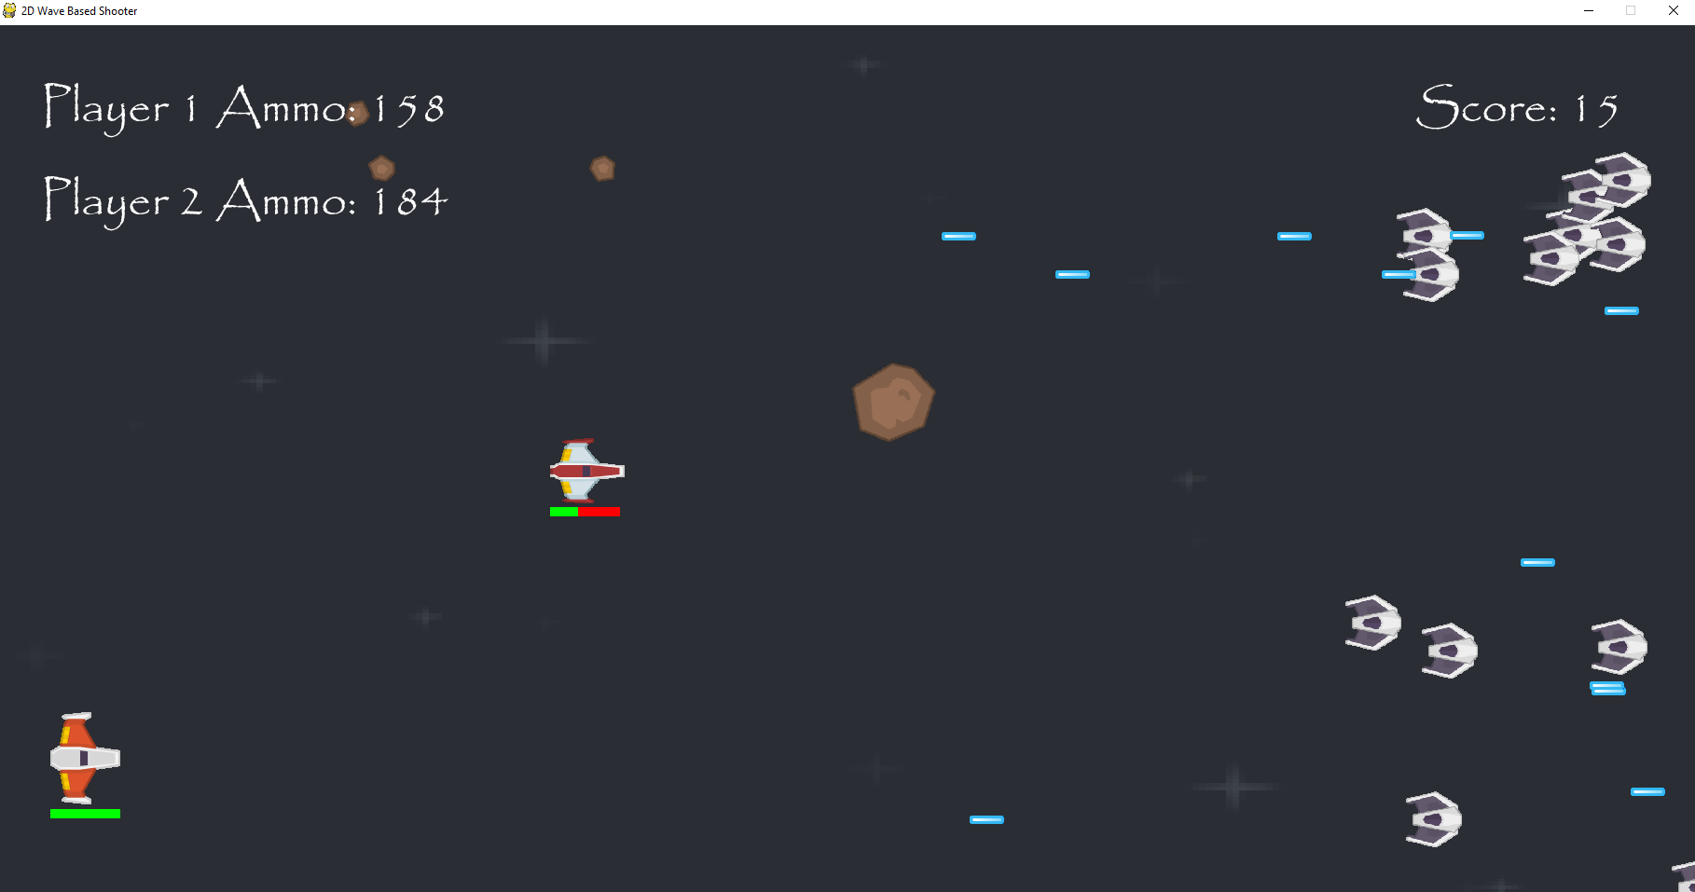  
Player 1 will now lose health when they collide with meteors basic enemies and basic lasers.

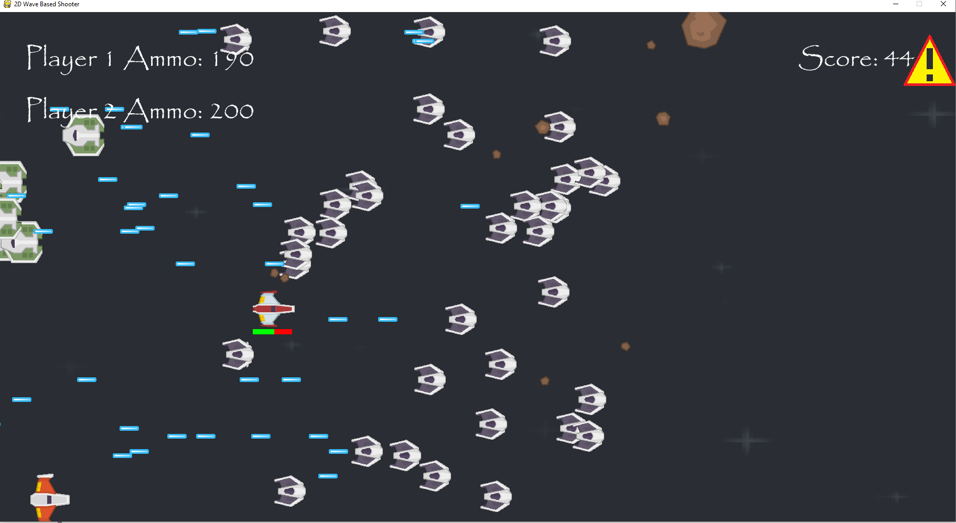  
Player 1 is also damaged by laser beams and moderate lasers. With the beams doing continuous damage and the moderate lasers doing or more than the basic ones. Also, taking powerups from meteors give player 1 the expected effect of having more health or ammo. However, player 2 is shown here to have their health bar goes beneath the screen.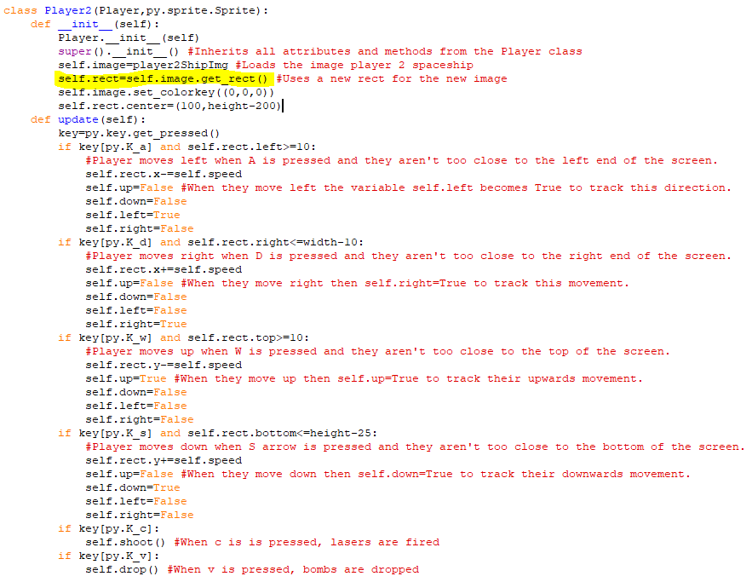The problem with the health bar was that the rectangle being drawn around the image as a hitbox hadn’t been updated to fit around the new image that was being used, so the hitbox was smaller than it should have been so the ship could move beneath the screen.

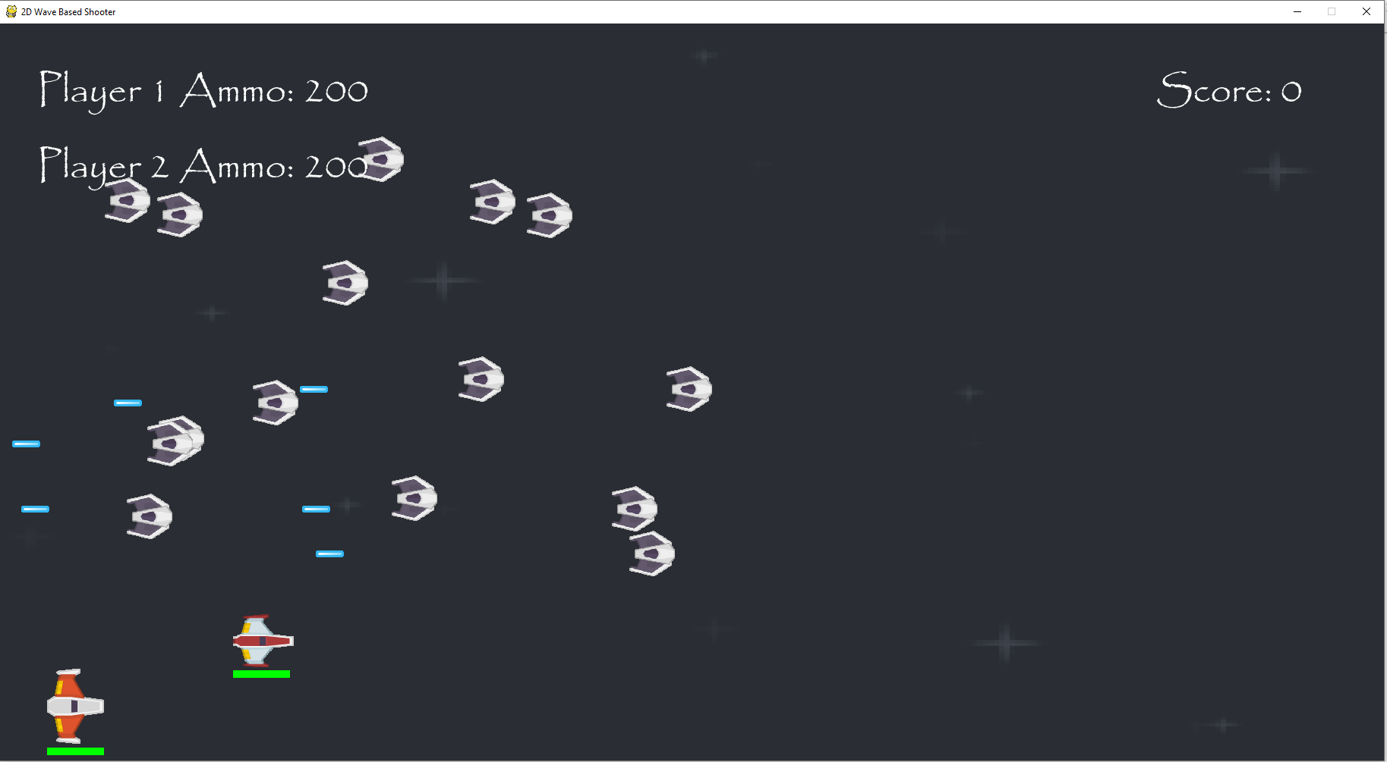  
Player 2’s spaceship now can’t move beneath the screen.

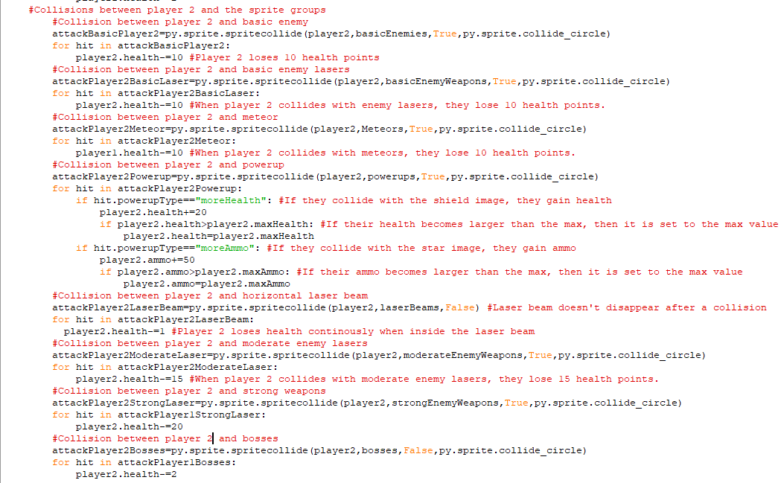This manages collisions between player 2 and the different sprite groups. It is identical to the previous code, except the collisions are now between the player 2 object and the sprite groups, rather than the player 1 object.

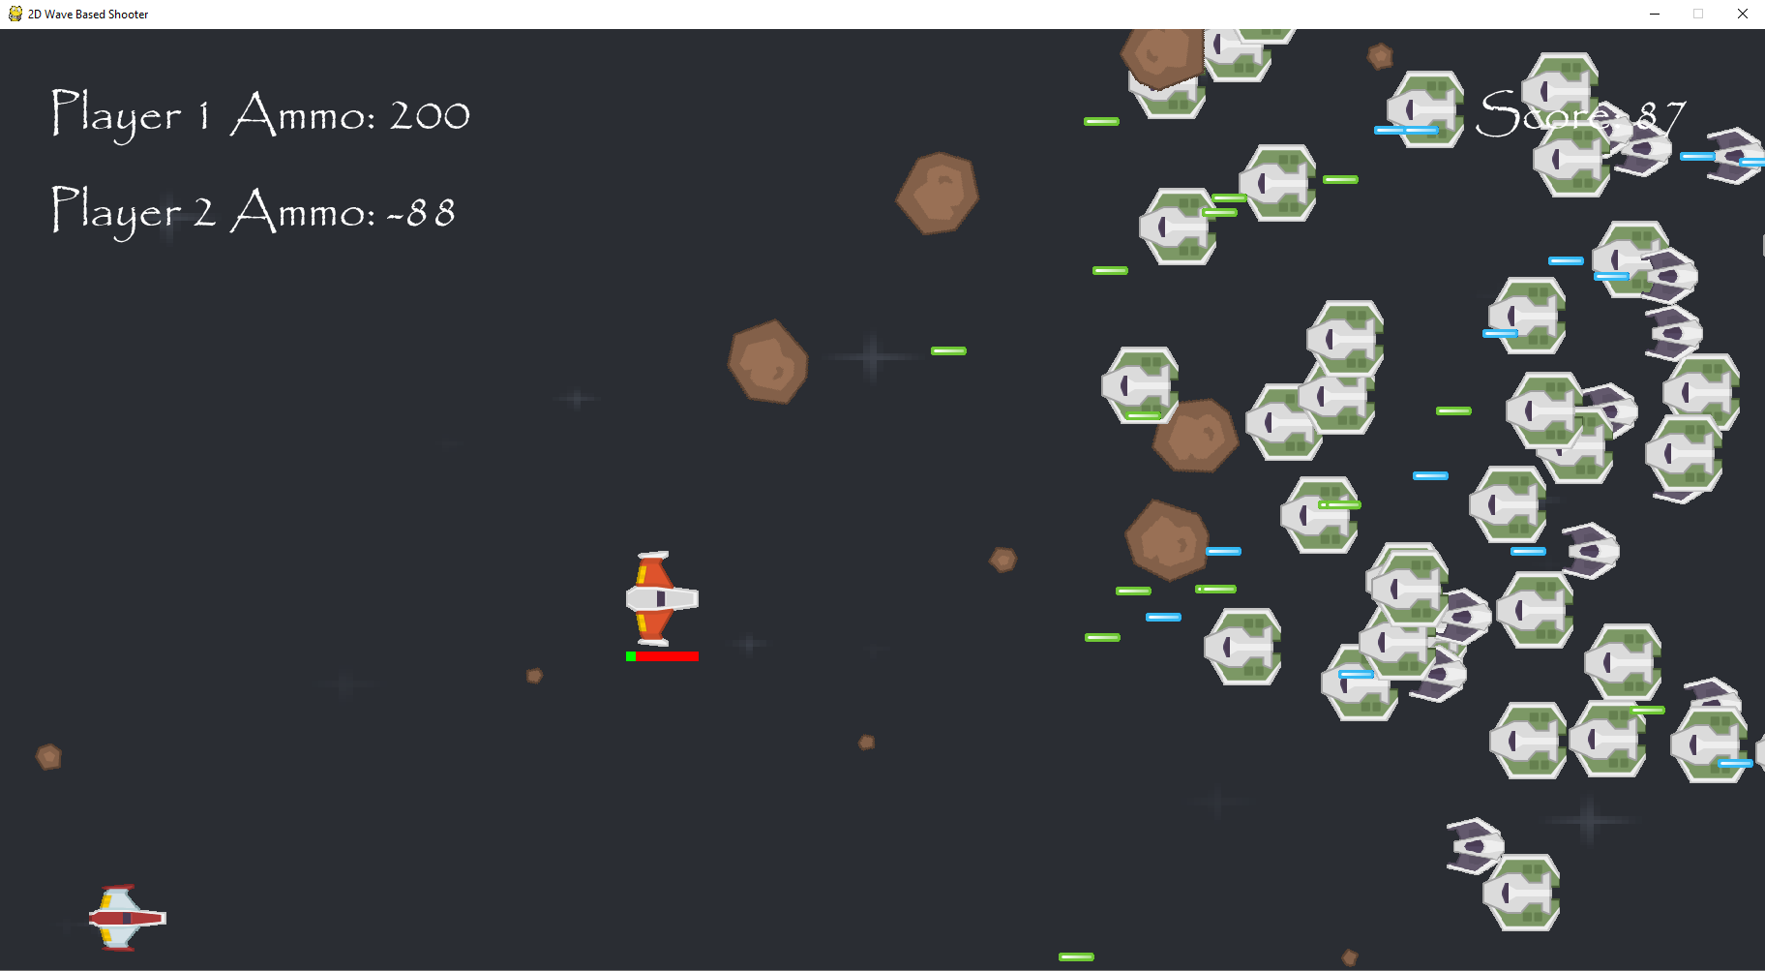  
The player 2 spaceship now takes the correct amount of damage from the meteors, laser beams, basic lasers and moderate weapons and can pick up powerups to regain health and ammo. Sprites in the basicWeapons sprite group will deal 10 health points of damage, those in the moderateWeapons group deal 15 and the those in the laserBeams group will deal a continous amount of damage.

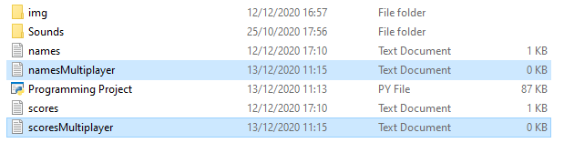I am making new files for the names and scores in multiplayer. This is because the client has asked me to implement a different scoring system for multiplayer games where their scores are collectively owned by both players.

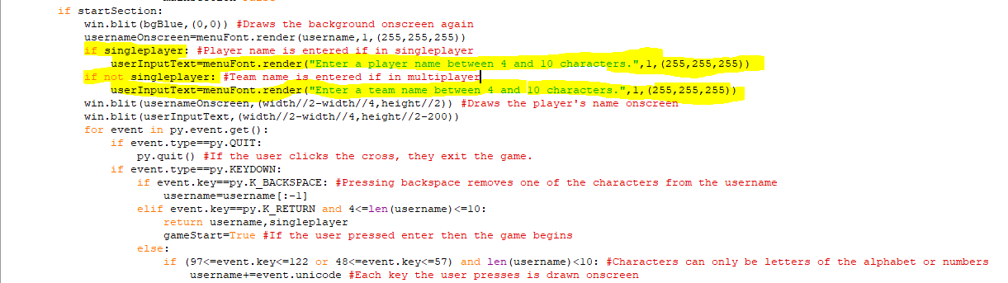When the game is in multiplayer, the program will ask the user to enter a team name rather than a player one as this username before starting the game as this name is going to be added to the nameMultiplayer file when the game ends.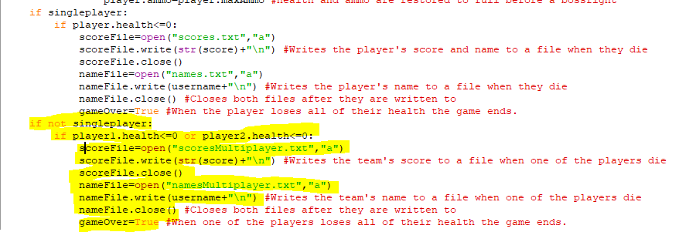When singleplayer is False, the team name entered and the collective score are both added to the scoresMultiplayer text file and the namesMultiplayer text file respectively. These names and scores will be drawn onscreen on the leaderboard when the game is in multiplayer mode. This occurs when either one of the players loses all of their health and after this happens, gameOver becomes True so the players are taken back to the main menu.

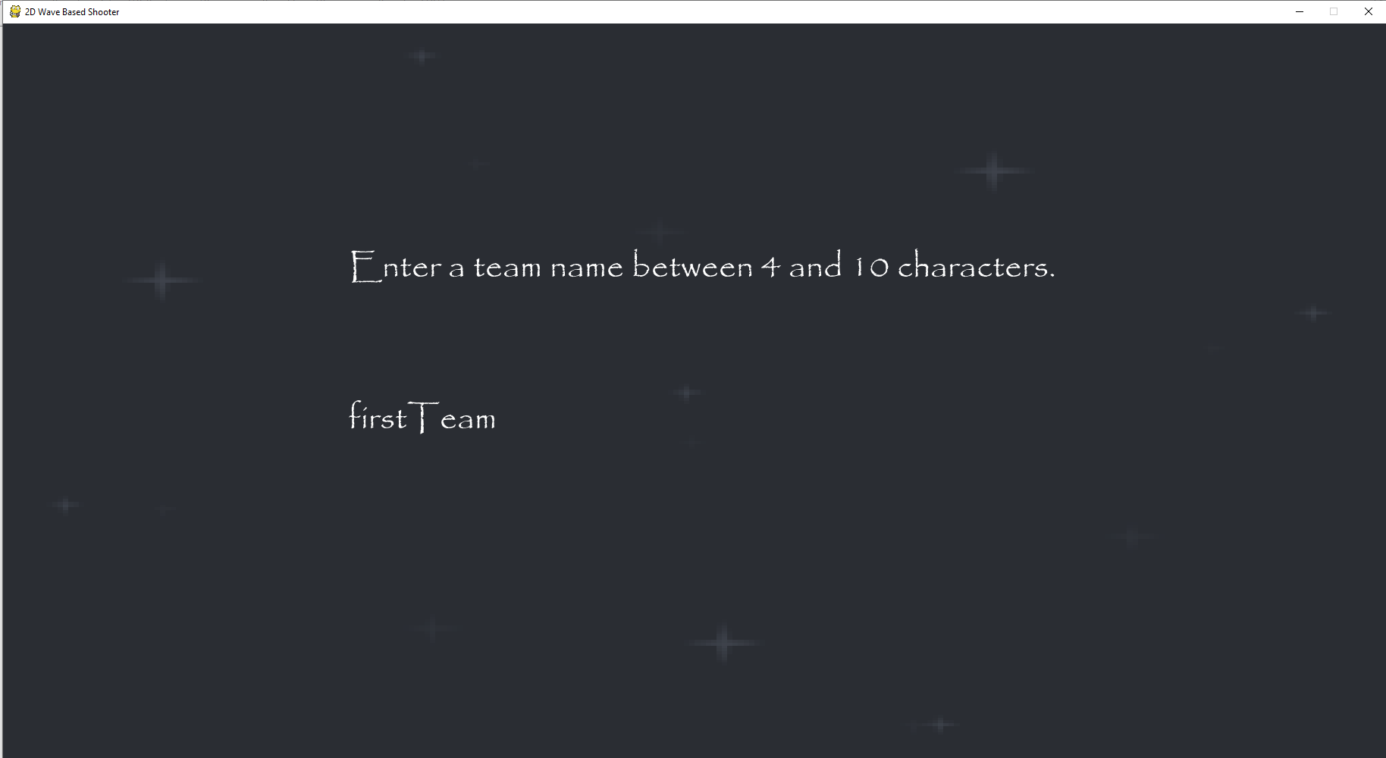  
The name I will test with for the multiplayer mode is firstTeam.

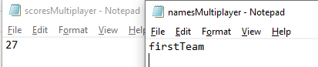  
The team name and score are saved to the relevant files correctly when one of the player die.

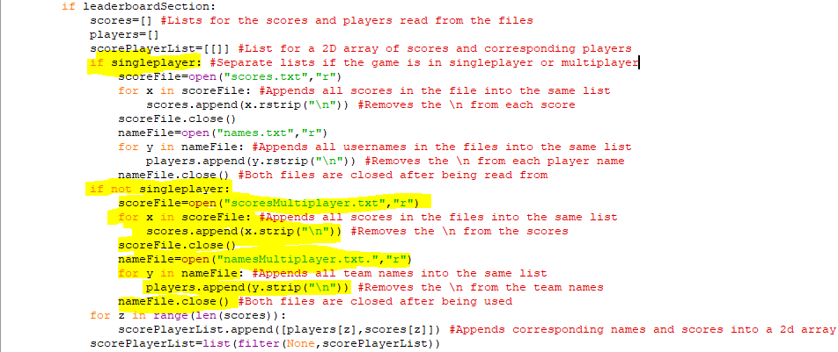When singleplayer is False, the game will take the scores and names from the namesMultiplayer and scoresMultiplayer files and appends them to the scores and players lists. The top five scores and teams will then be presented on the leaderboard if you are in multiplayer mode unless there are less than 5 in which case the top scores and team names are presented.

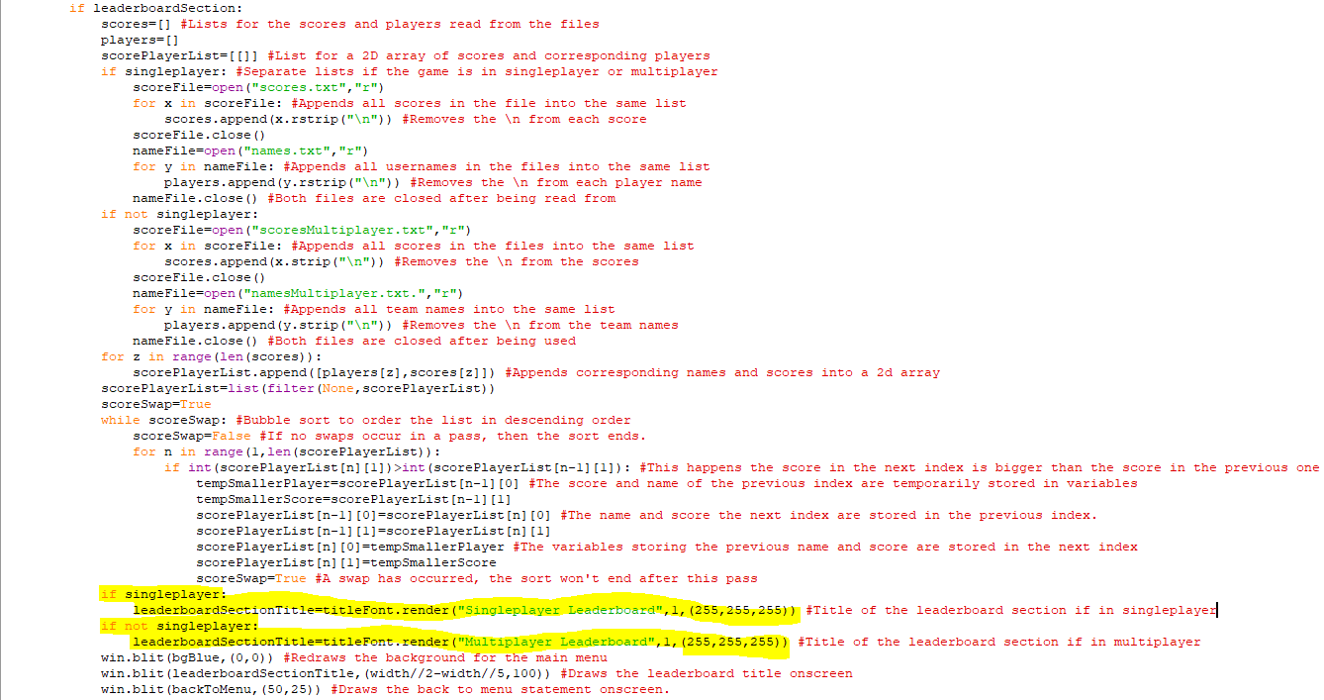If the game is in singleplayer, then the title of the leaderboard section reads ”Singleplayer Leaderboard”, if it isn’t then it will read ”Multiplayer Leaderboard”

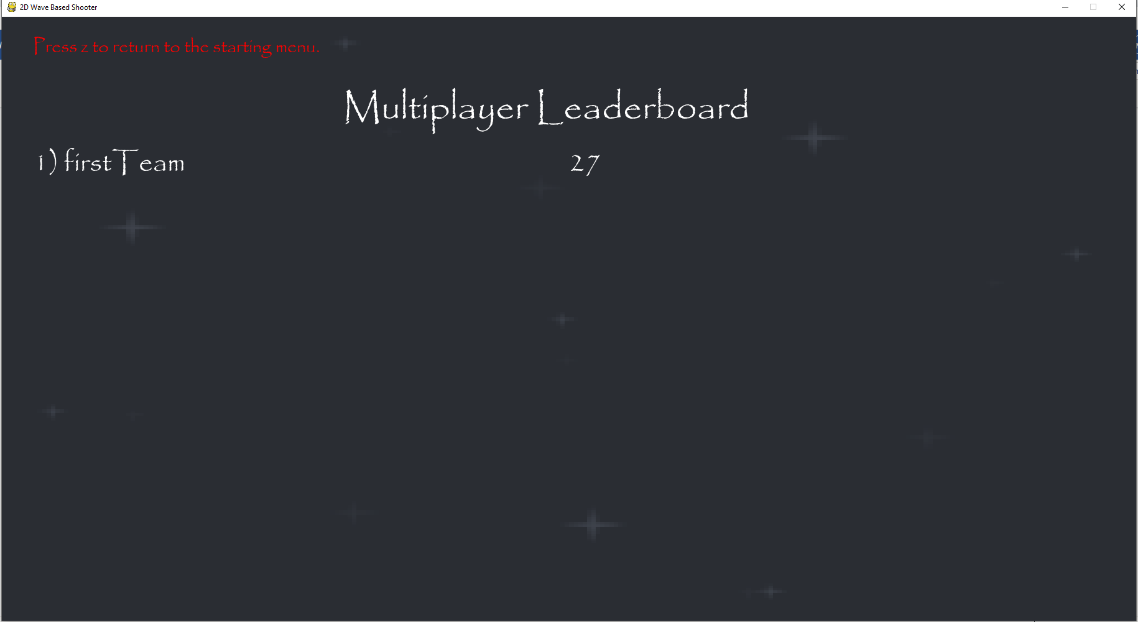  
When I click on the leaderboard section after setting the game to multiplayer, the next at the top is now Multiplayer Leaderboard and only one team name and score is presented on there,

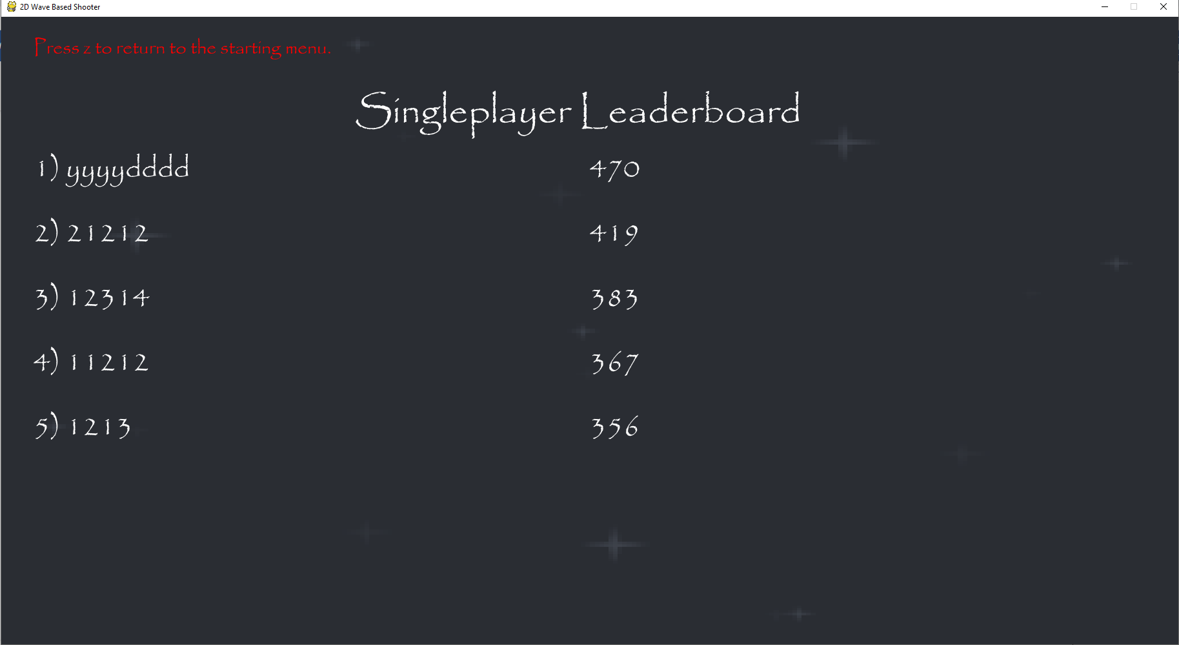  
When I go back to the singleplayer mode, the text at the top says singleplayer leaderboard and the names and scores display are the top ones achieved in singleplayer.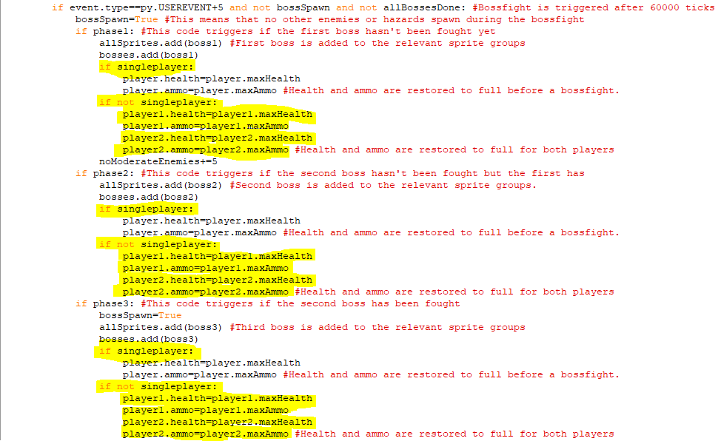The highlighted code adds in events for setting the players’ health and ammo to their maximum values when singleplayer is False. This is the code before each of the boss fights so when the game is in multiplayer it will give both players full health and ammo rather than just a single player. This occurs for all of the bosses when the game is in the particular phase in which they spawn. 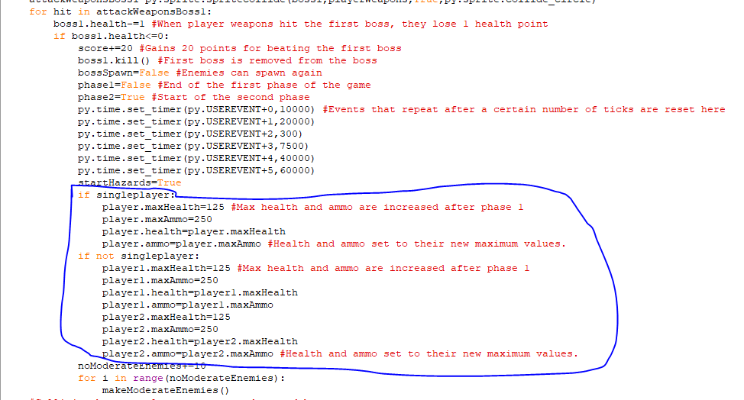The circled code is code added to the if statement for if the first boss has lost all of their health. When this happens, if singleplayer is True, then only one player will get an increase to their maximum health and ammo but if singleplayer is False, then both players will get this increase, so their health and ammo go from 100 and 200 to 125 and 250 respectively.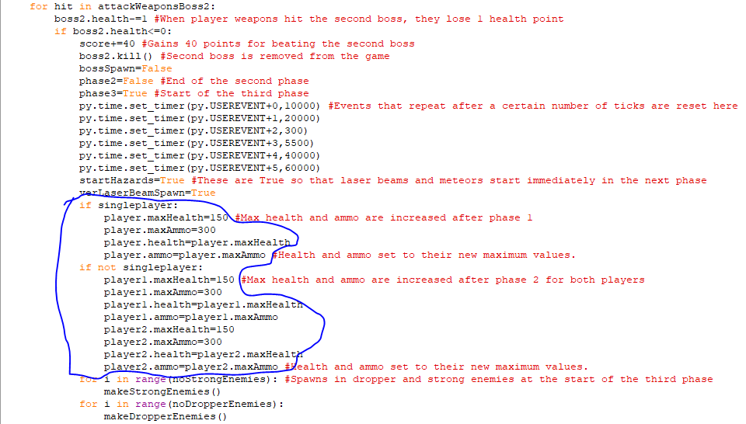This circled code does the same as the previous code, except it is for the second boss. Once they have lost all of their health, the player’s maximum health and ammo will increase again from 125 and 250 to 150 and 300 respectively and this increase occurs for both players if singleplayer is False. 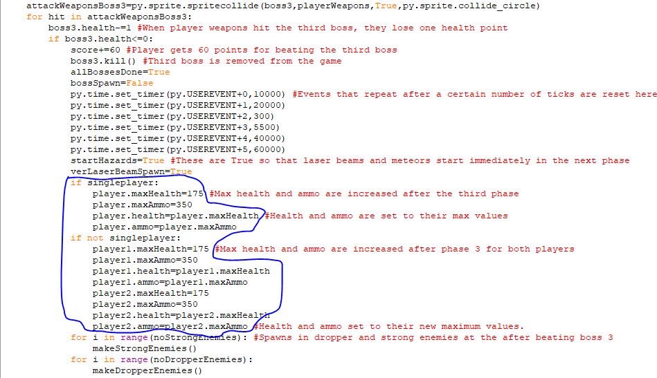This circled code increases the player’s maximum health and ammo to 175 and 300 once the third boss has been defeated and if singleplayer is False then this increase occurs for both players.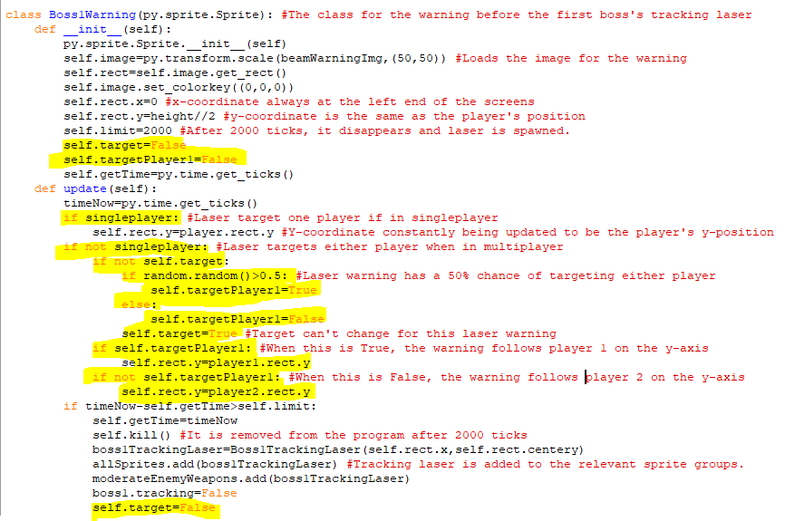I have changed the warning before the tracking laser for the first boss fight because before it tracked the y coordinate for the player object. However, in a multiplayer game there is no player object so instead when singleplayer is False then if a random number between 0 and 1 is more than 0.5 then self.targetPlayer1 will become True which means that the warning will have the same y coordinate as the player 1 object. If it is False, then the warning will instead track player 2 and have its y-coordinate. When this is decided, then self.target becomes True so the player the laser is targeting won’t change.

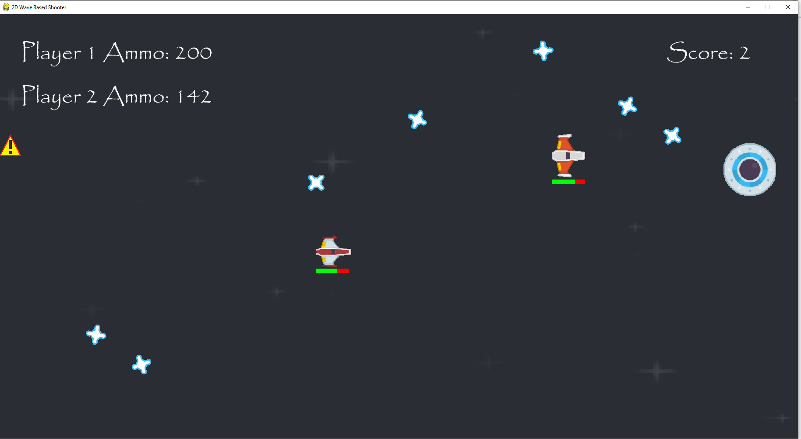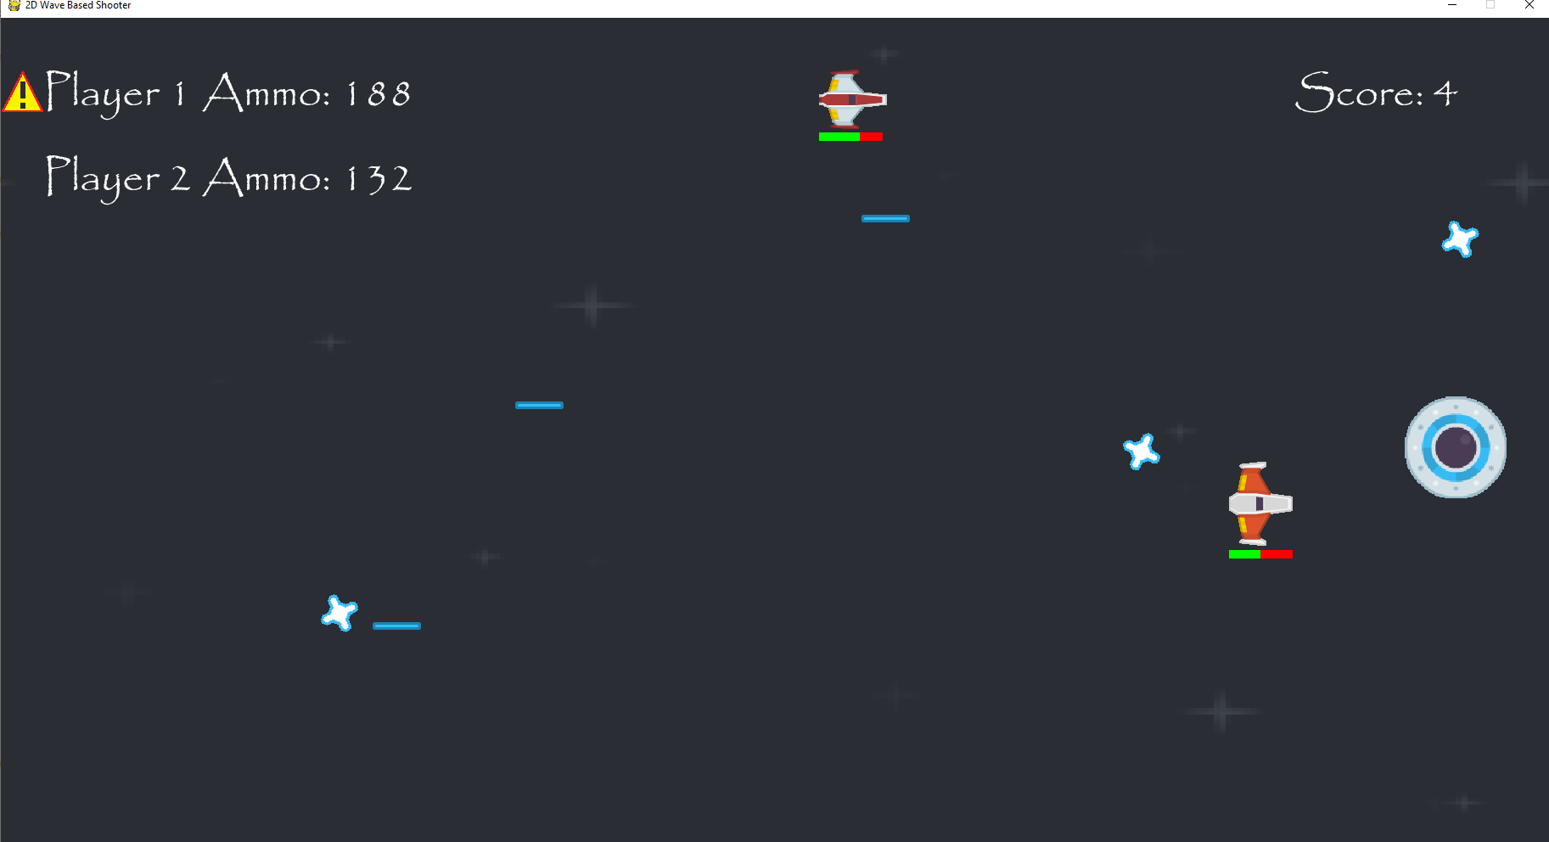  
The laser warnings are randomly selecting a player to track in the boss fight and when they disappear, a laser is shot from that y-coordinate. The laser warning is functioning properly with two players.

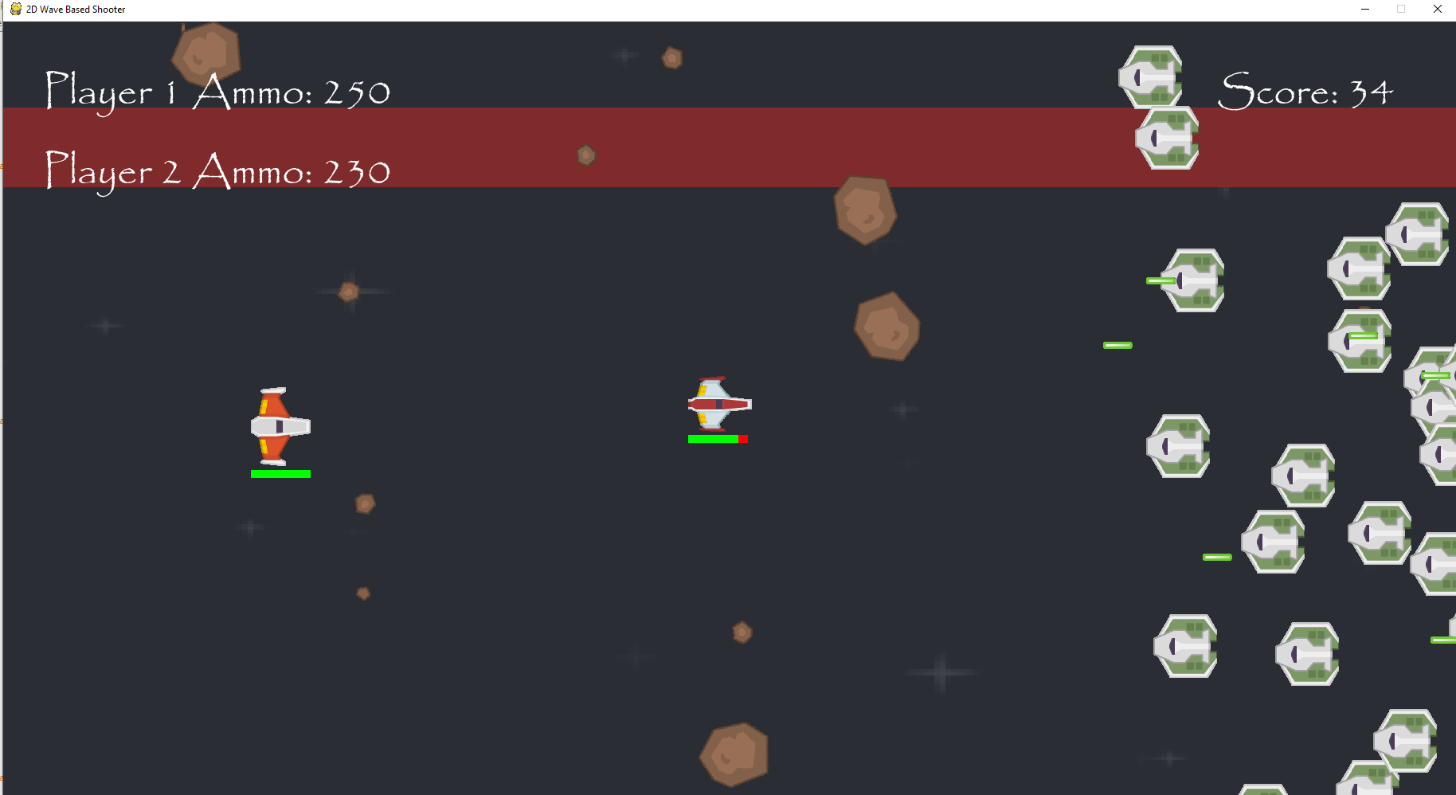After the first boss, the game continues as normal in multiplayer, so the game is functioning properly.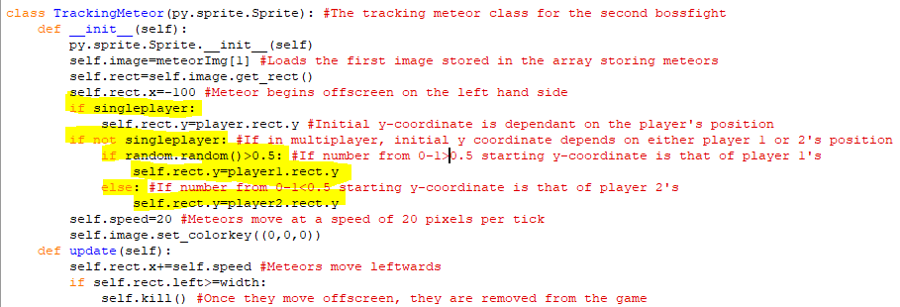This is the class for the tracking meteor attack that the second boss does in the game. Its initial y-coordinate was dependent the position of the player object. However, since that doesn’t exist in multiplayer, then when singleplayer is False, then there is a fifty percent chance of a meteor having the starting y coordinate of the player 1 object and a 50% chance of it having the starting y-coordinate of the player 2 object.

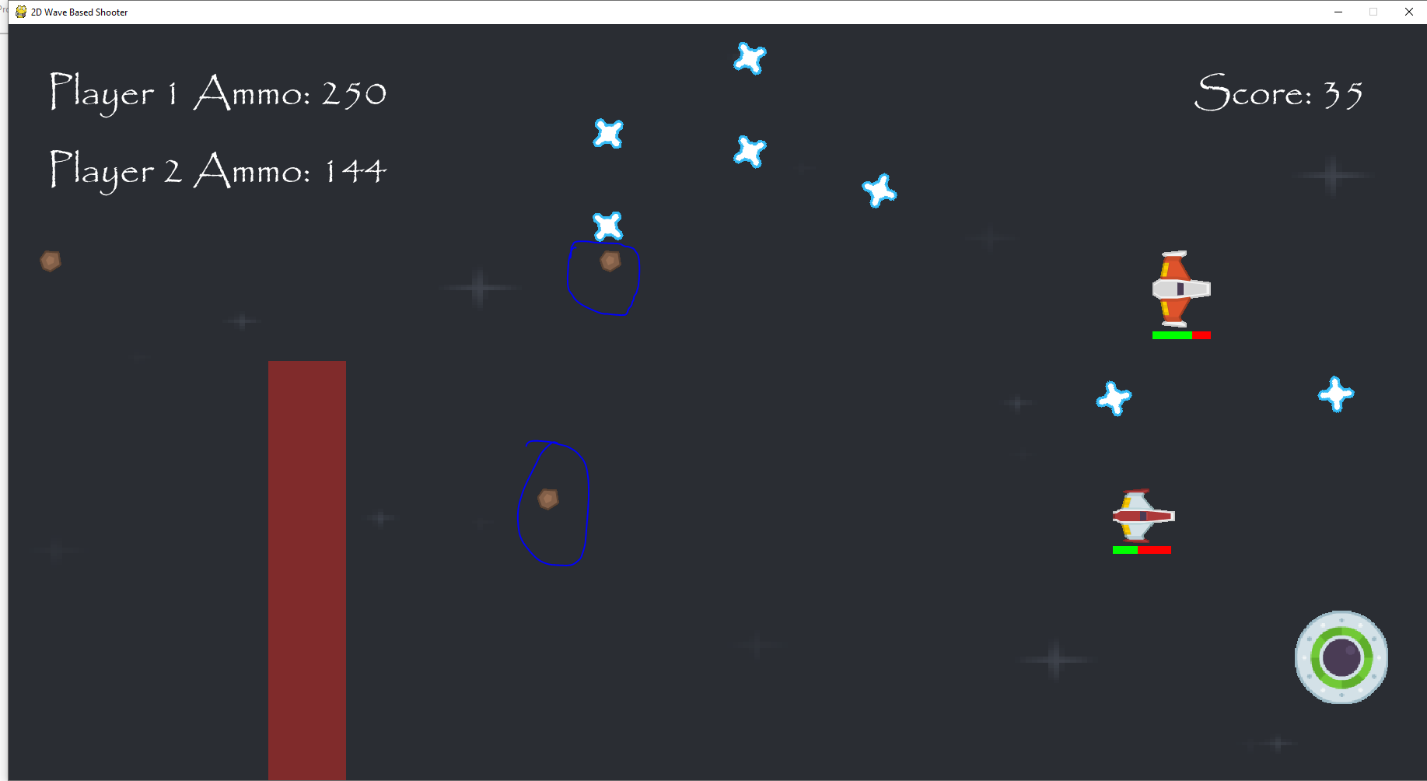  
The tracking meteors in the second boss are using the y-coordinates of both players when they move across the screen.

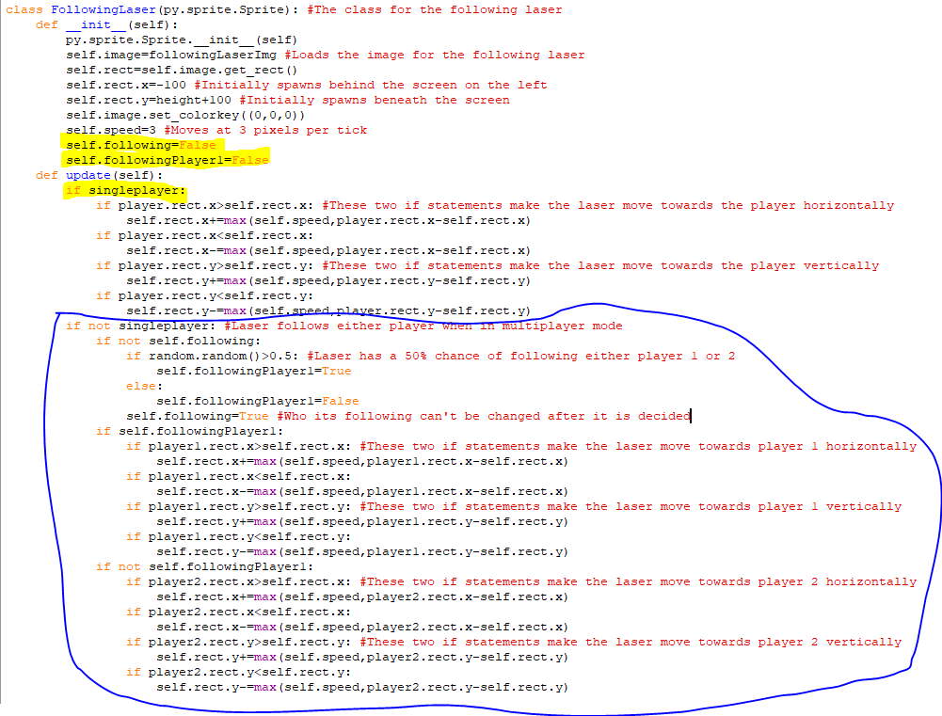This is the class for the following laser attack in the third boss fight. This laser will follow the player and move closer and closer to their position, but when singleplayer is False, in the update method, each laser object will instead have a 50% chance of following either player 1 or player 2. When a random value between 0 and 1 is more than 0.5, then self.FollowingPlayer1 is True and the laser is move towards player 1 in the same way as it would if the game was in single player, but if it is less than 0.5 then self.FollowingPlayer1 is False and the laser would instead follow player 2.

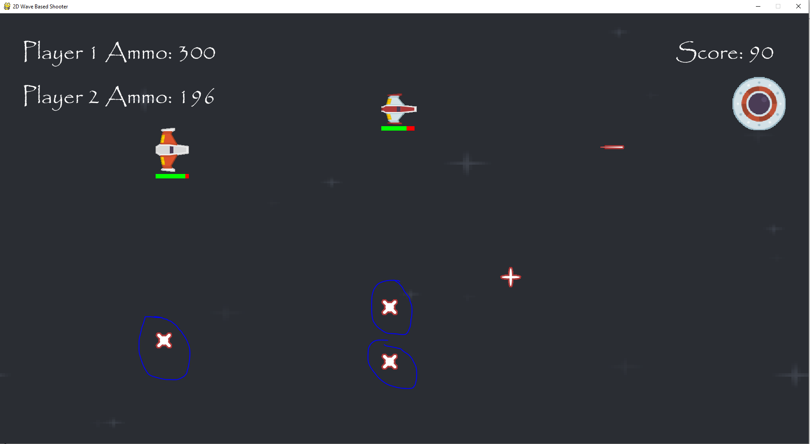

The following lasers will now randomly either follow player 1 or player 2 as can be seen with the following lasers that are currently between both players. The following lasers also damage the player on impact and will disappear when the player weapons collide with them. 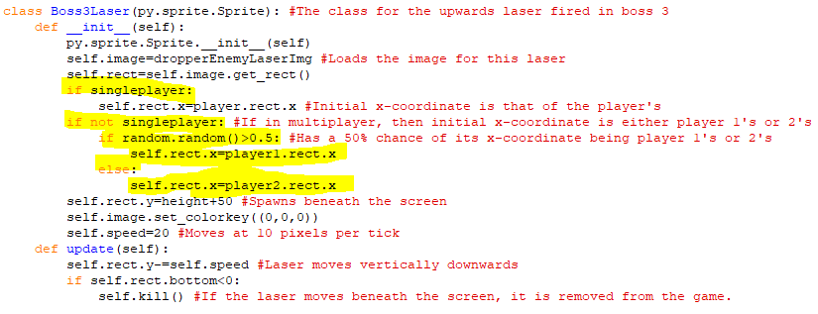This is the class for the upwards laser attack for the third boss fight. When singleplayer is False, its x-coordinate has a fifty 50% chance of being the same of player 1’s at that time, and a 50% chance of being the same of player 2’s at that time.

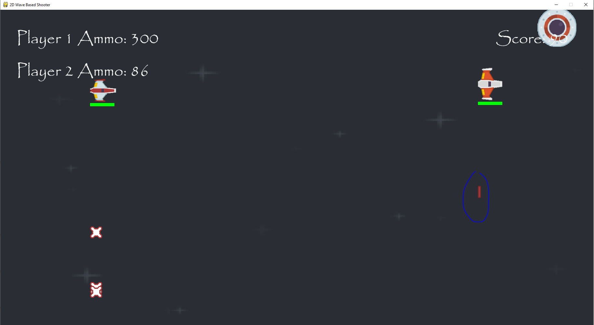  
Here, we can see the upwards laser having the x-coordinate of player 2 when it moves up the screen. A collision with the player does cause damage and these lasers can be neutralised using player weapons.

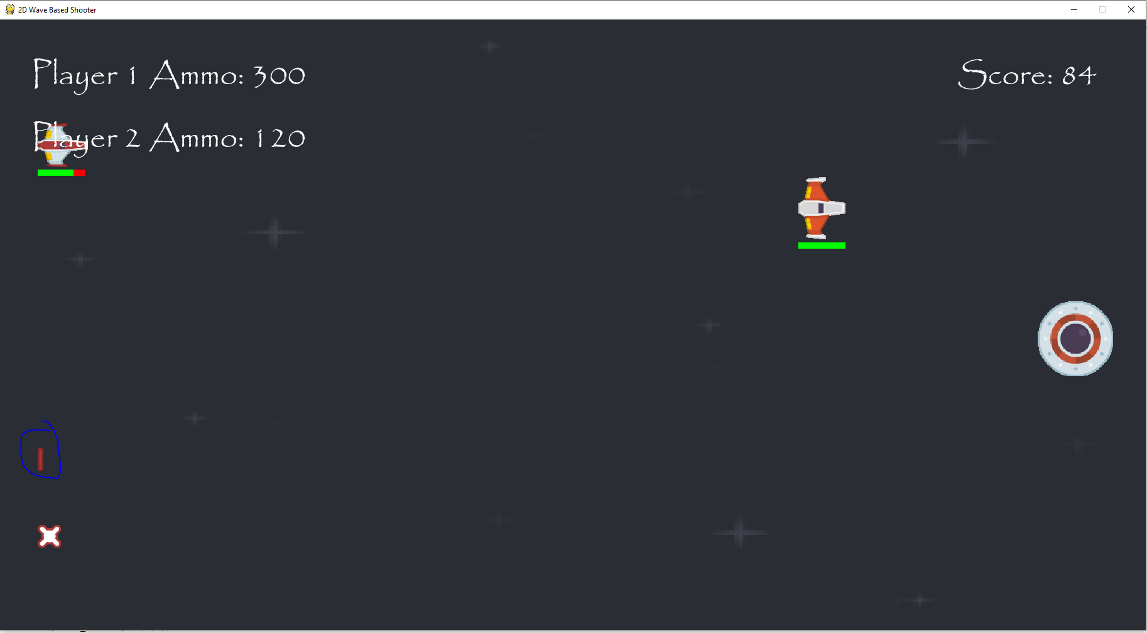

Here we can see the upwards laser having the x-coordinate of player 1 when it moves up the screen.

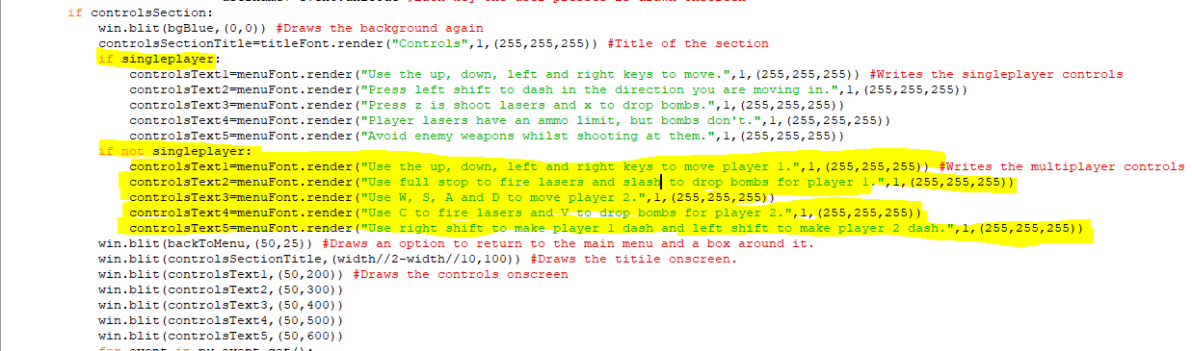This code is part of the controls section on the main menu and I have added in code that makes this section display different text when singleplayer is False. When it is False, the game gives the controls for both player 1 and player 2 and by telling each player how to move, use weapons and dash.

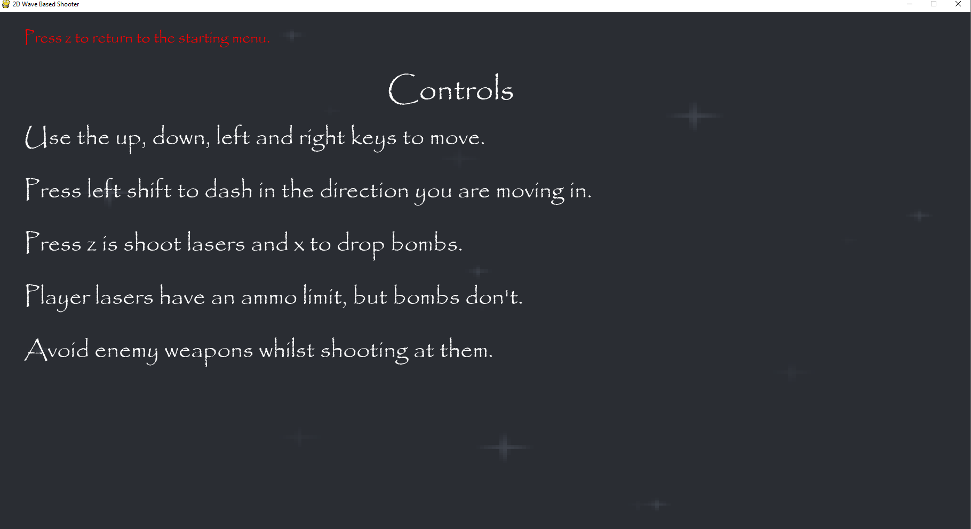  
This text appears in the controls section when singleplayer is True. This is the same as the controls that appeared beforehand.

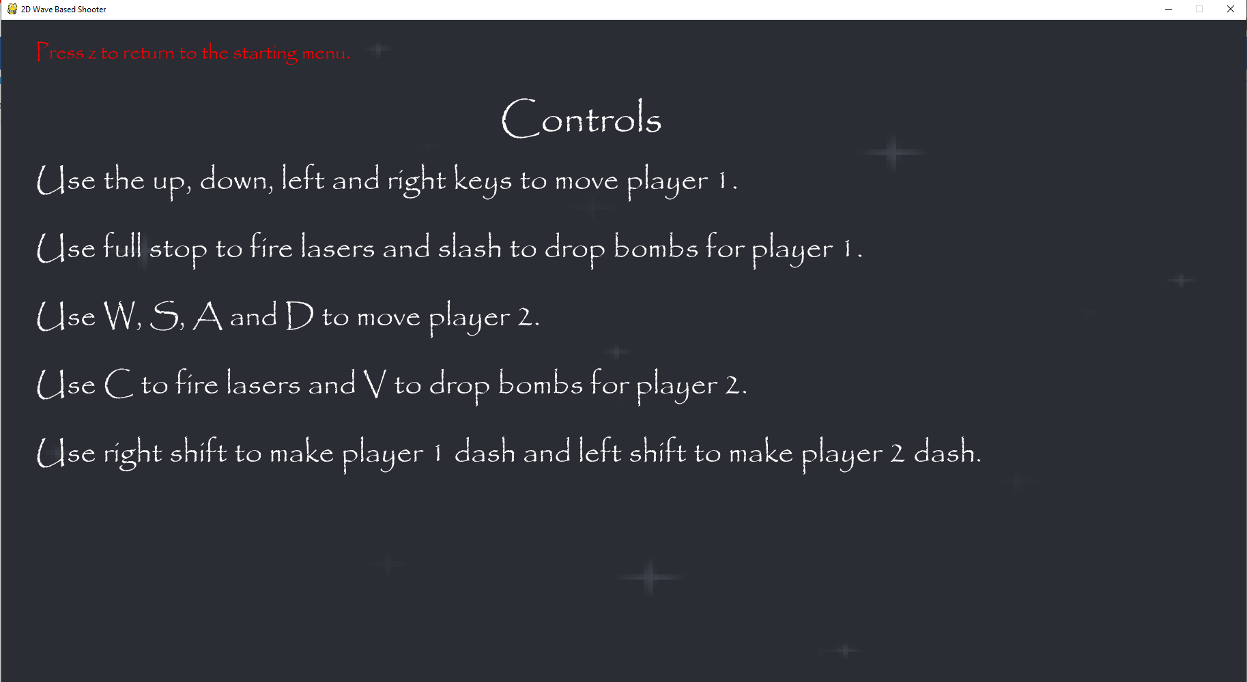

This text appears in the controls section when singleplayer is False. It displays the controls for each player in a clear manner soncreen.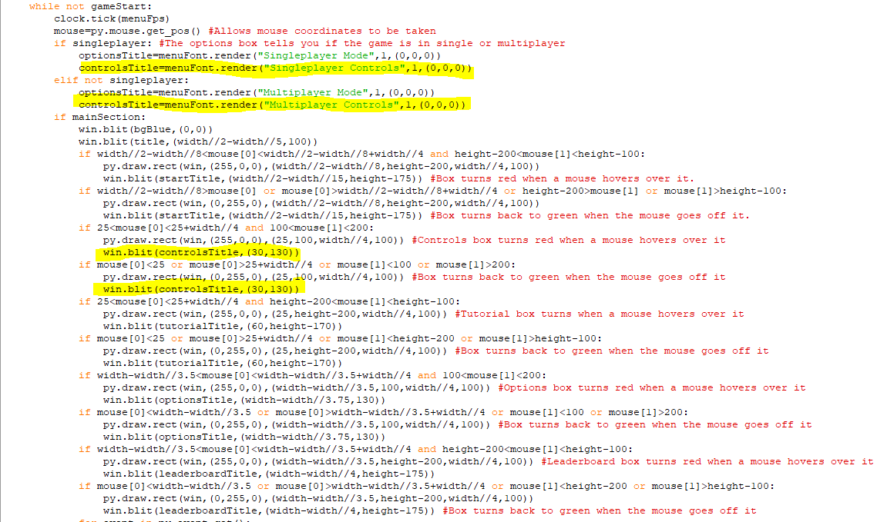I have added to main section of the main menu. The highlighted code makes the title for the control section ”Singleplayer Controls” when singleplayer is True and when singleplayer is False it makes the title ”Multiplayer Controls”. The text has also been moved leftwards so that all of it can fit in the box for the controls section.

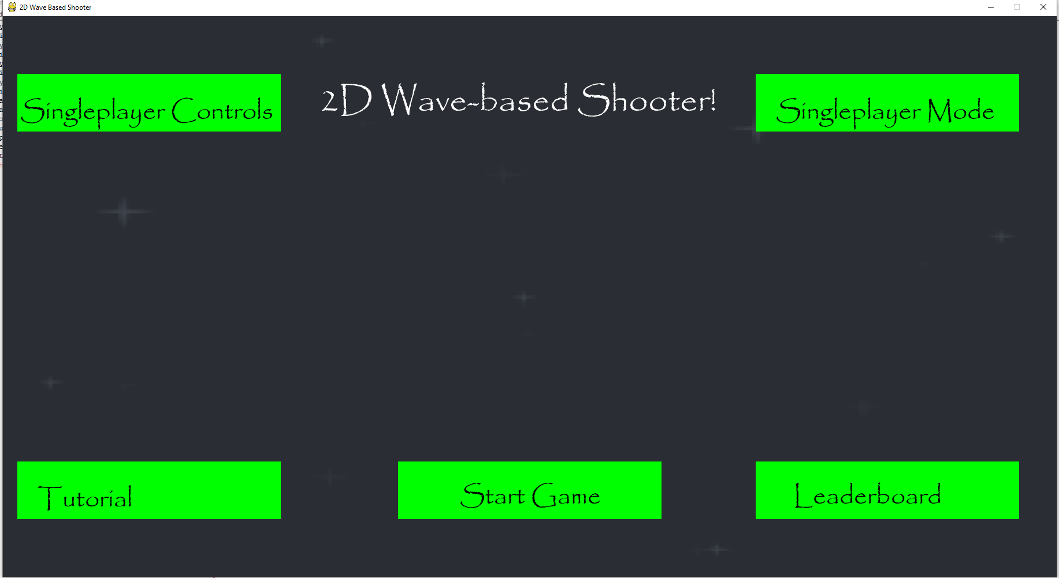

This is what is displayed onscreen when the game is first launched.

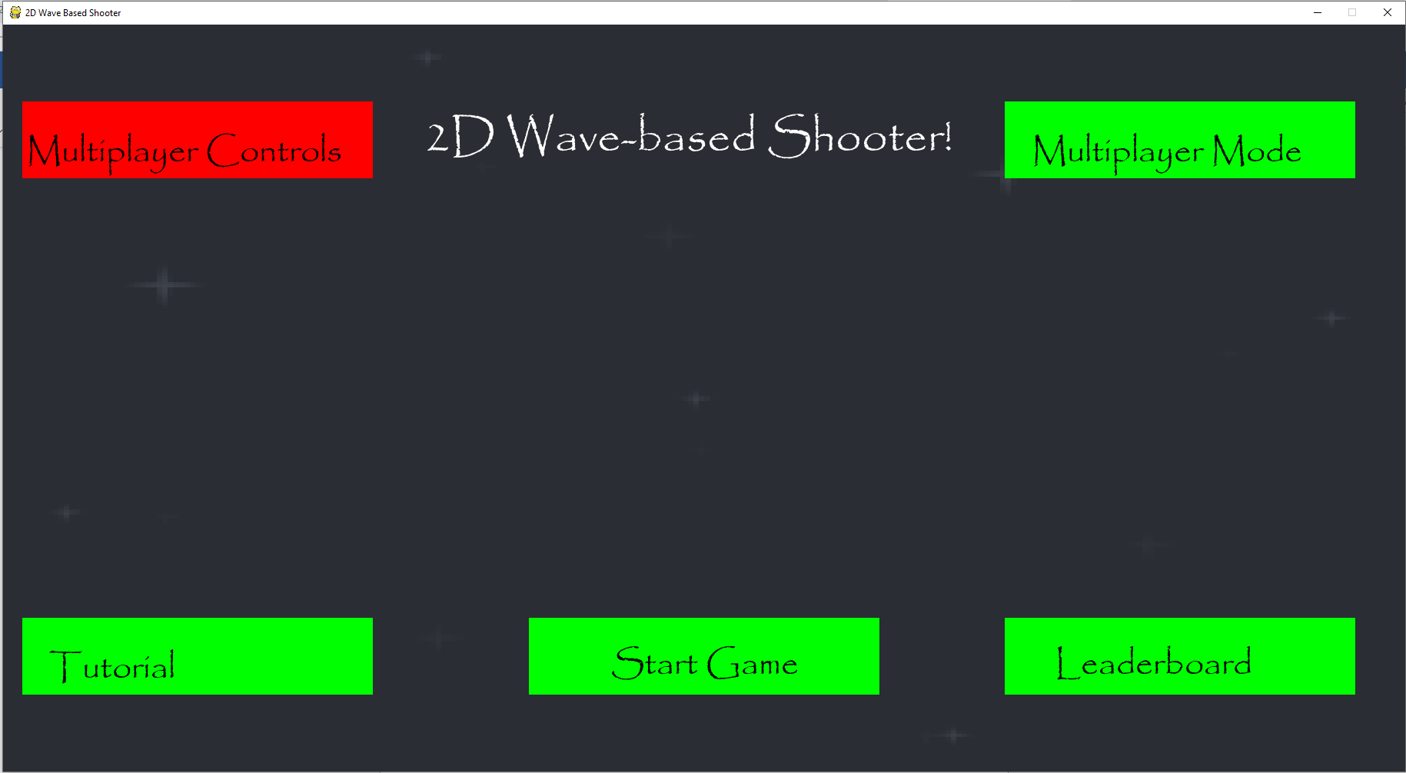

When I clicked on the options box, the text in there changed to multiplayer mode and the text of “Singleplayer Controls” is replaced by “Multiplayer Controls”.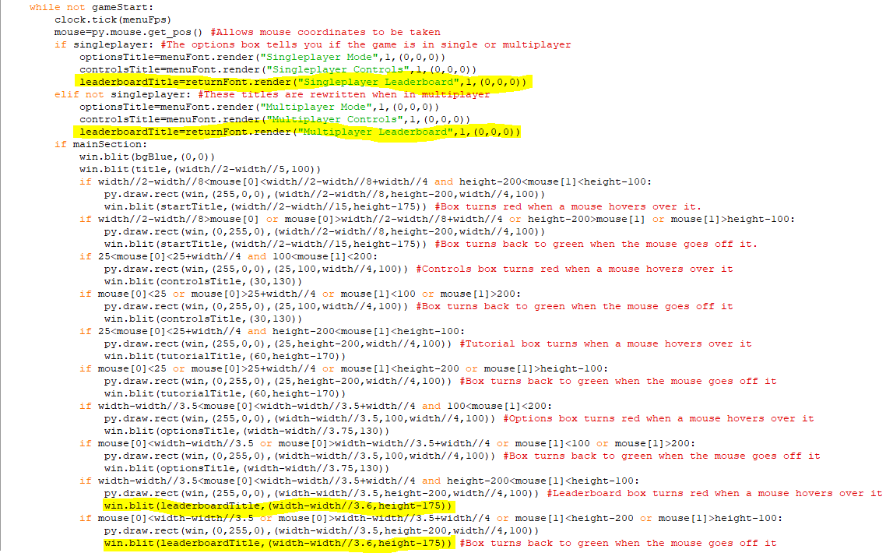The first two highlighted lines make leaderboard box say ”Singleplayer Leaderboard” when singleplayer is True and then make it say ”Multiplayer Leaderboard” when it is False. I used the returnFont here as it is smaller so all of the text will fit in the box. The last two highlighted lines move this text leftwards so that it can also fit in the box.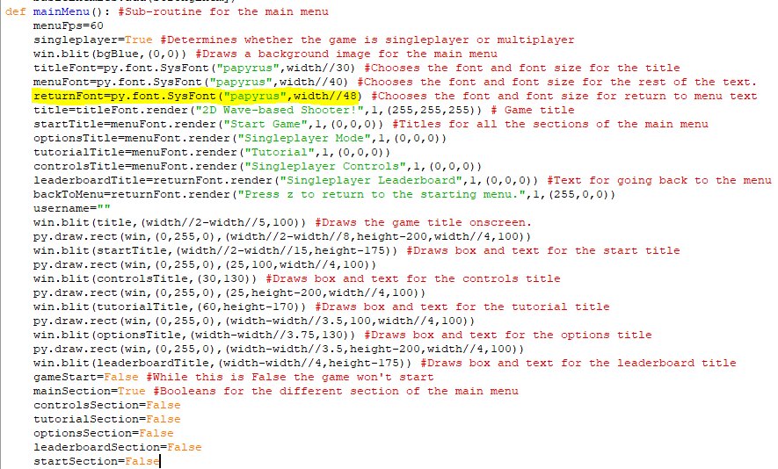The returnFont’s font size was increased from being 60 times smaller than the width of the screen, to being 48 times smaller so that the leaderboard text would better fit in the box.

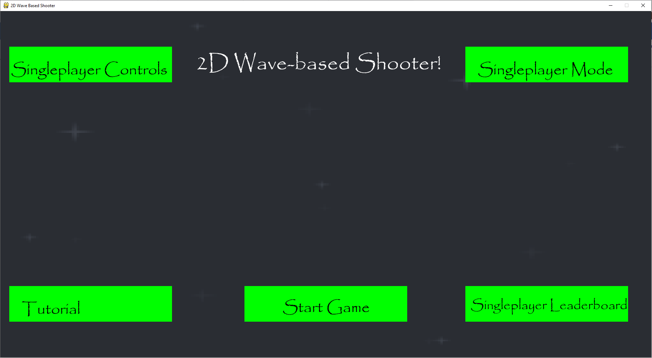

The text in the leaderboard box now reads “Singleplayer Leaderboard” when the game is in single player mode.

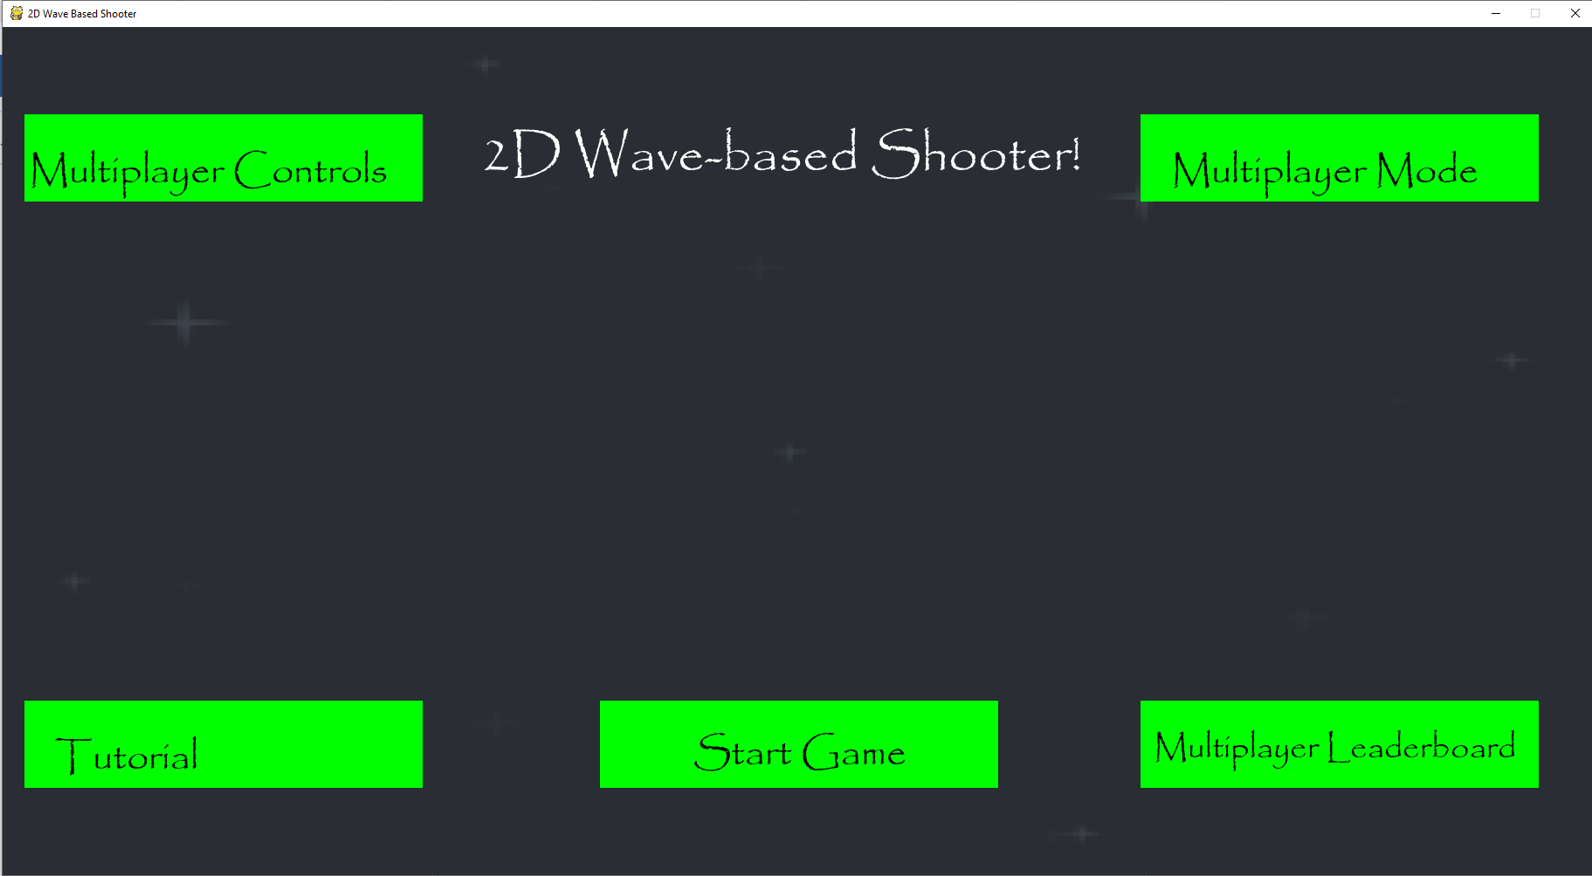  
The text in the leaderboard box now reads ”Multiplayer Leaderboard” when the game is in multiplayer mode.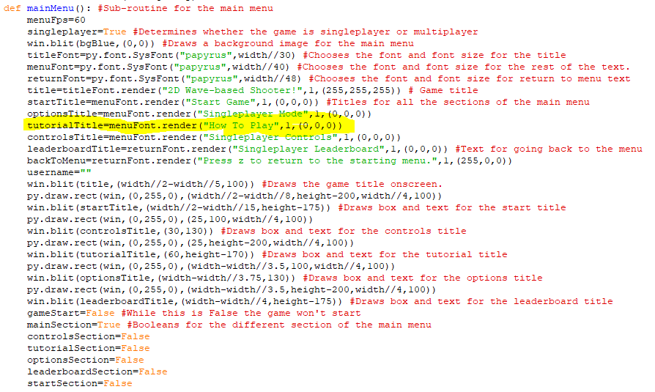I changed the text in the tutorial box to say ”How to Play” instead because I thought that was a more accurate depiction of what it contained.

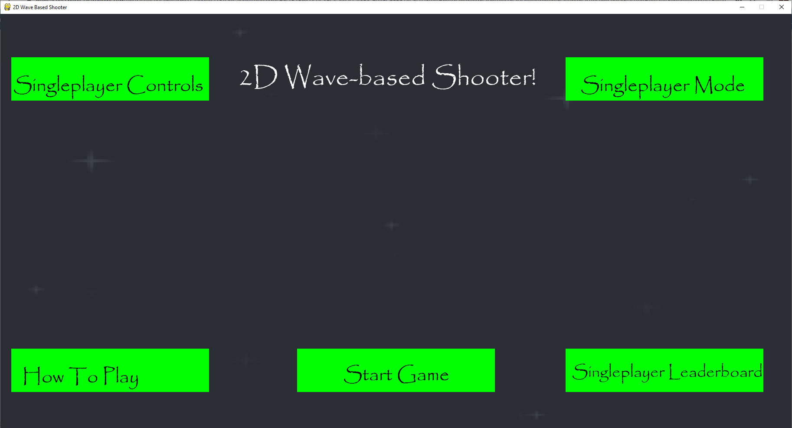Here is the main menu with ”How to Play” written in place of ”Tutorial”.

Stage 8 Review

I have now implemented a fully functioning multiplayer component into my game with both players able to be onscreen at once and able to move, shoot and dash like how it would be in singleplayer. I have made changes to several aspects of the game to account for the two players such as implementing collisions between these players and enemies and changing boss attacks when in two-player mode.

For the success criteria, I have implemented the multiplayer component and have made the controls distant from each-other so that people’s hands will not collide as much when playing. However, I didn’t make them compete against each-other with their scores since I was asked by the client to implement a separate scoring system for teams instead. There are now also different sets of the controls for players in singleplayer and multiplayer which are given in the multiplayer controls section of the game that is easily accessible by going into multiplayer mode and clicking multiplayer controls.

Client Feedback:

Adding multiplayer means that you can play with your friends, and in the menus, there are new controls for the second player and a multiplayer scoreboard and the new controls are designed so two people can easily use the same keyboard. The combined scoring system is also better to differentiate the singleplayer and multiplayer leaderboards.

**All the necessary requirements of the success criteria have been fulfilled at this point, so the main aspect of the game is done now. The rest of the code I am going to write will be to implement some of the non-functional requirements into the game to improve it.**

Stage 9- Implementing some Non-functional Requirements

**In this stage, the parts of the success criteria I am going to achieve are:**

* **Enable controller support for the game.**
* **Adding sound effects to the game**
* **Having the background of the game change over time.**

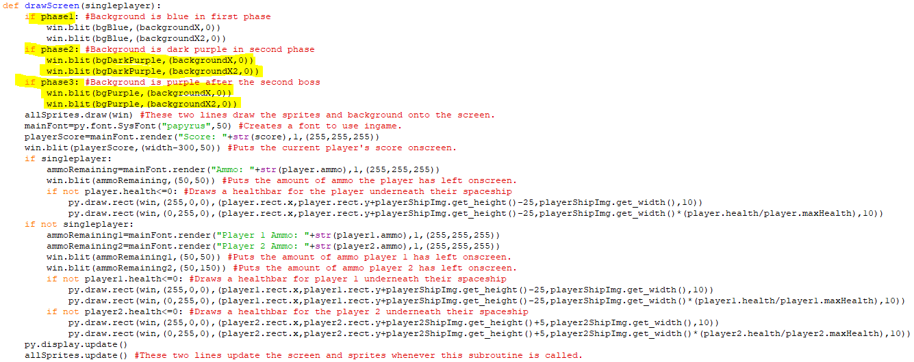The highlighted code that has been added replaces the current background with a background that is almost completely identical except it is dark purple when the first boss has been beaten and phase2 becomes True. When the second boss is beaten, this background is replaced with a completely purple background after phase3 becomes True. Since these backgrounds use the same variables for their x and y coordinates, the background should still move across the screen like normal, even when it changes colour.

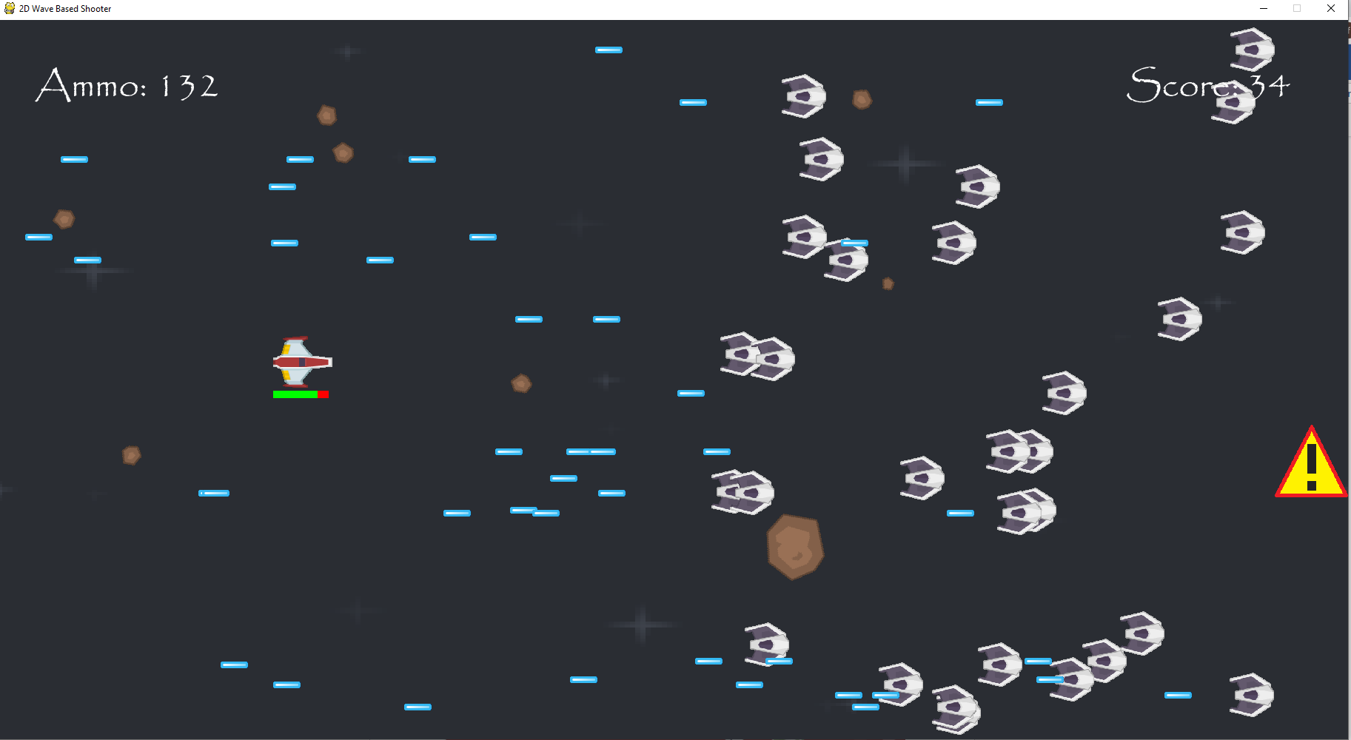  
This is the background in the first phase, it has the original colour and moves across the screen like normal.

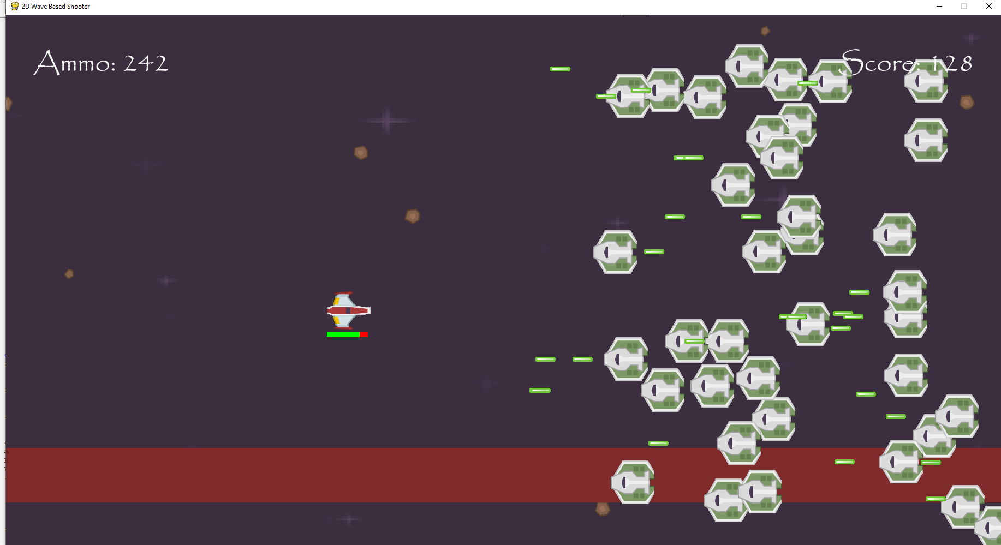

This is the background in the second phase, it is now dark purple and continues to move across the screen like normal.

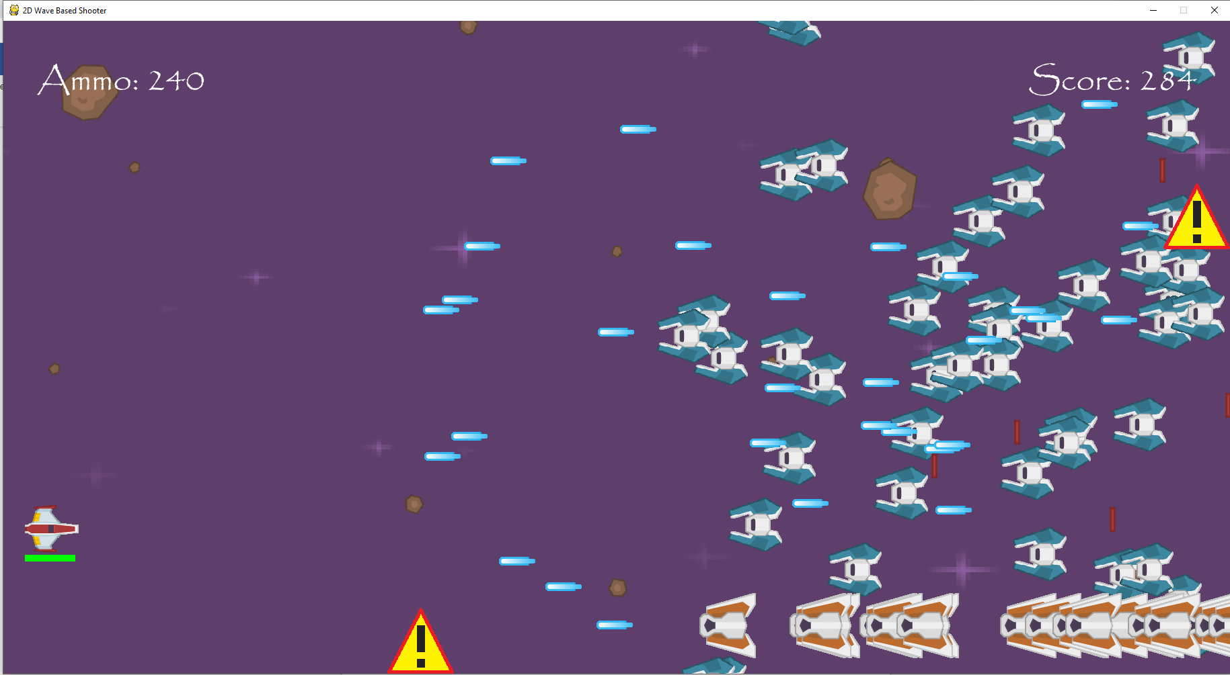

This is the background in the third phase, it is now fully purple and continues to move across the screen like normal.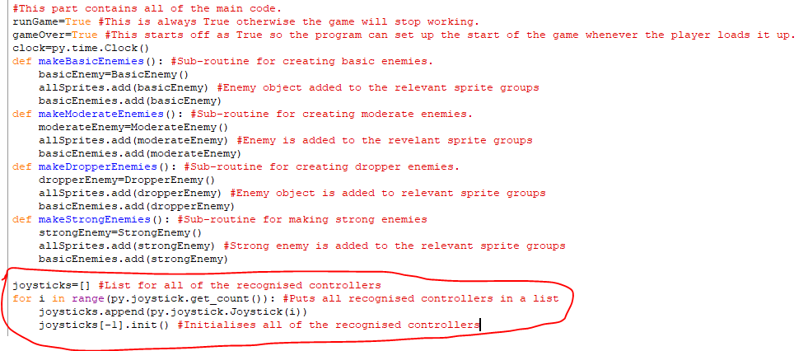The circled code is code for initialising any controllers to be used in the game. It first creates a list and then find all the recognised controllers and puts them in the list. It then initialising all of the controllers in that list.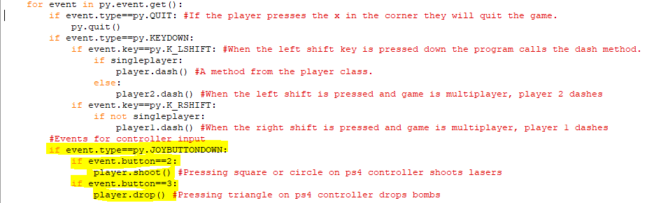I have added in an event for detecting controller input. When the button is 2 (square or circle on a ps4 controller) the player shoot method is called and when the button pressed is 3 (triangle), the player method for dropping bombs is called instead.

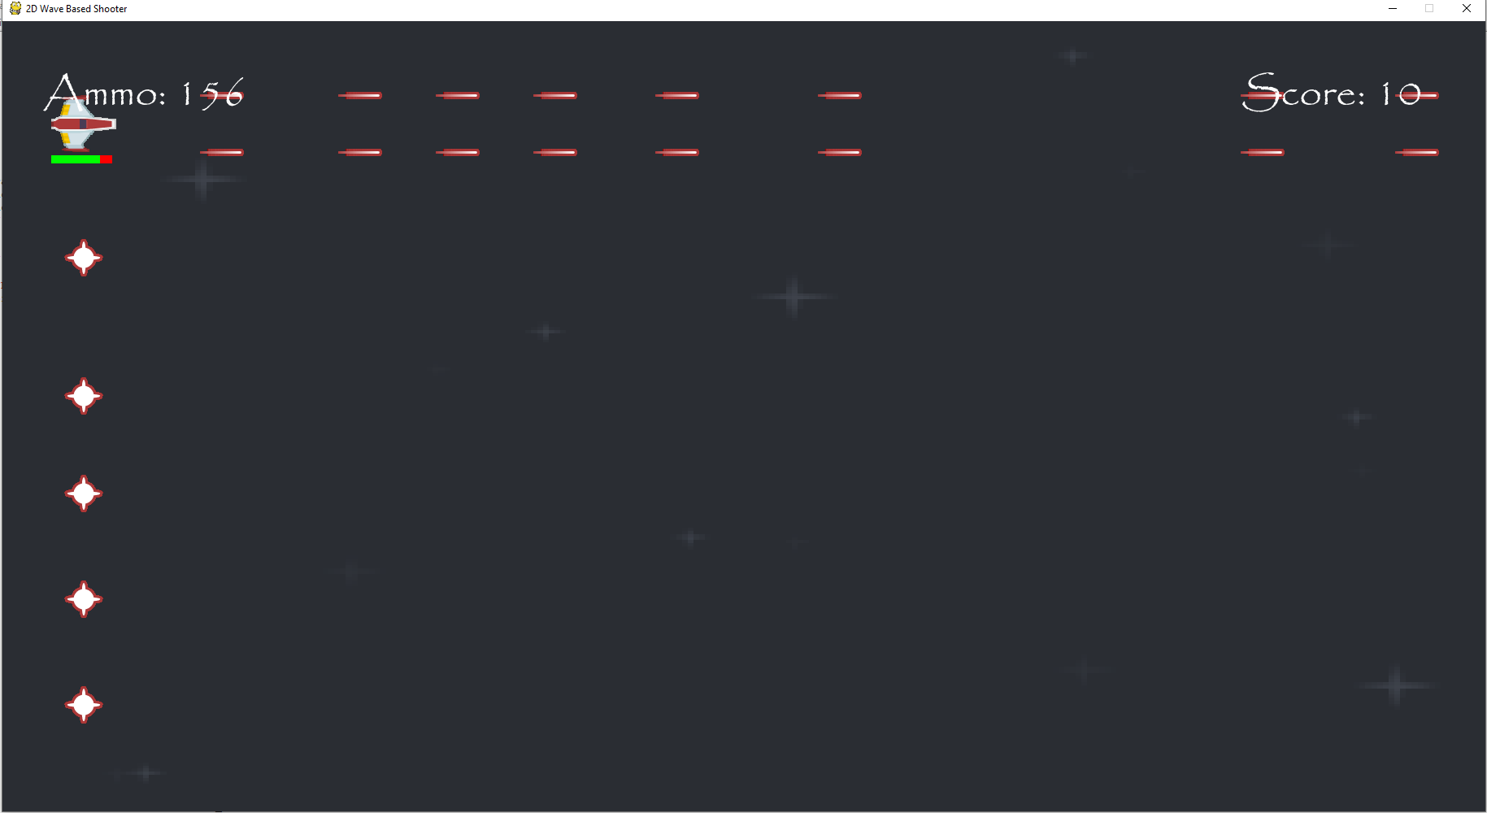  
Both lasers and bombs can be used when pressing those buttons on the controller, however, holding down these buttons won’t cause a continuous stream of bombs and lasers to be fired.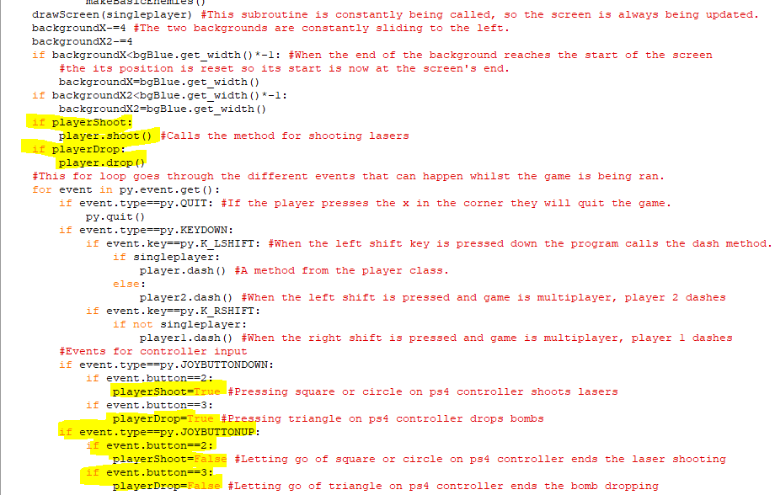When the player presses down on square or circle, playerShoot will become True and whilst it is True lasers are constantly shot from the player. When they let go of sqaure or circle then it becomes False and lasers are no longer shot. Similarly, when they press down triangle playerDrop becomes True so bombs will constantly be dropped from the player but when they let go of it then playerDrop becomes False, so bombs are no longer dropped.

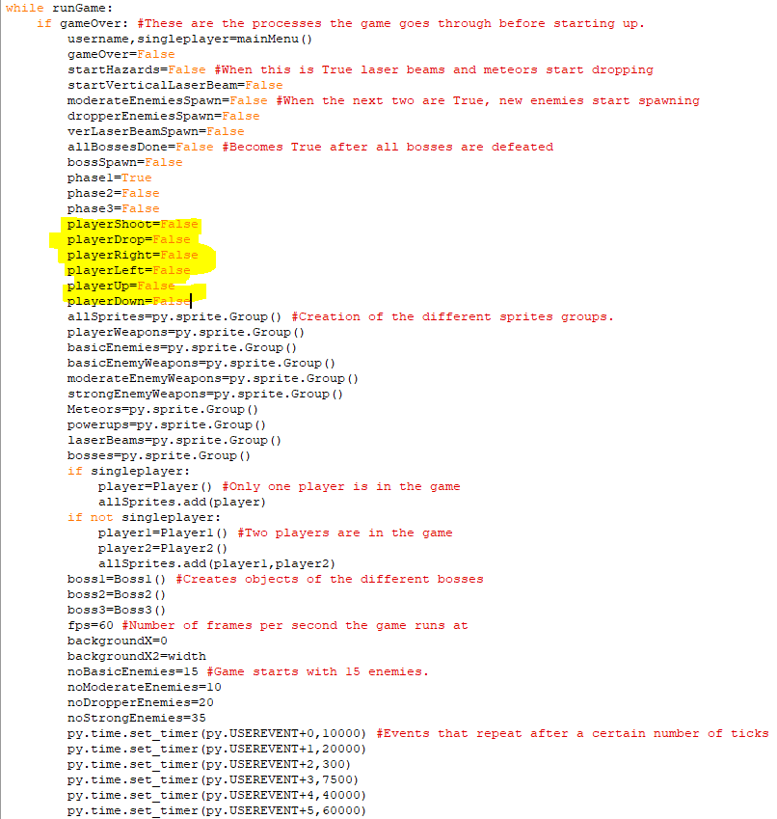This is where the variables controlling whether lasers and bombs are fired were initialised. I have also created variables for controlling the direction the player is moving in when the button is held down.

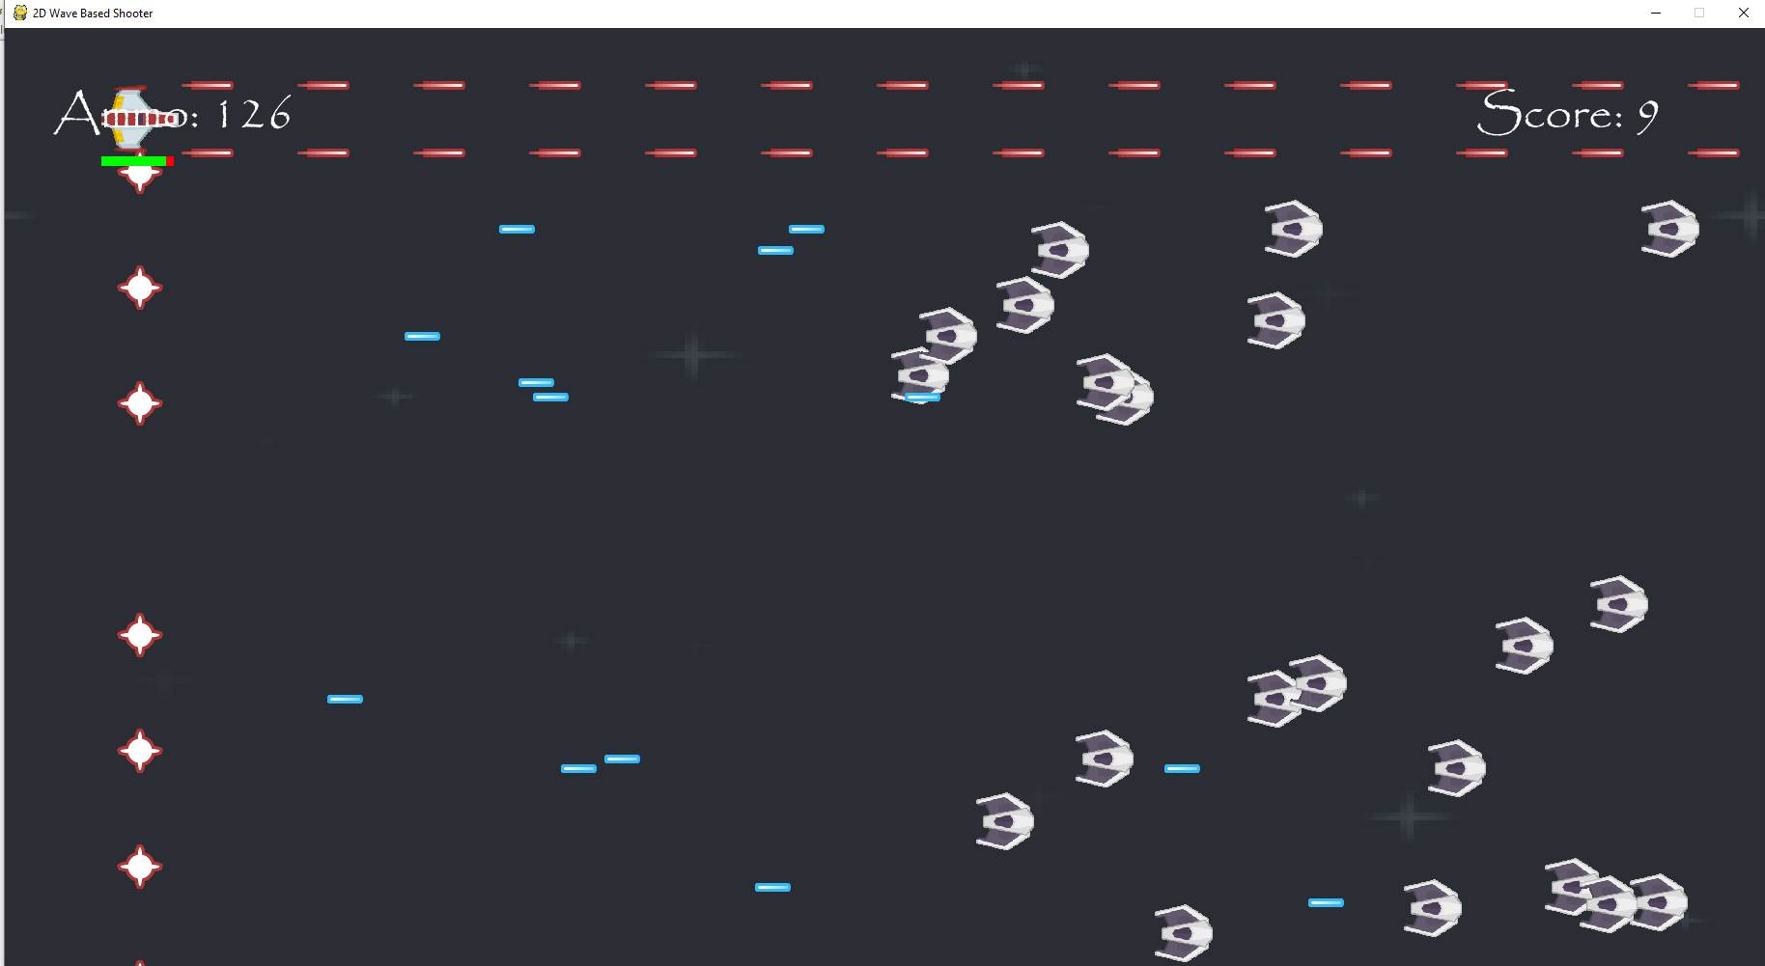  
Bombs and lasers are now continuously fired when the relevant buttons are held down.

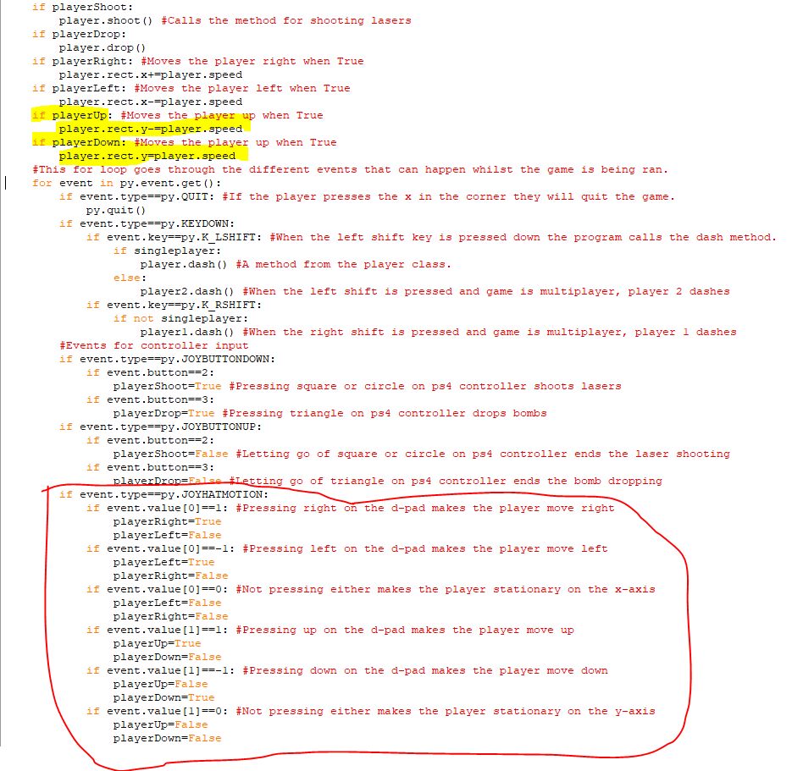The circled code is a series of if statements which determine the direction the player moves in when they press a button on the d-pad. When the left button is pressed, then playerLeft becomes True and playerRight becomes False and the same happens vice versa. Whilst neither button is pressed both playerLeft and playerRight are False. When the up button is pressed then playerUp becomes True and playerDown becomes False and vice versa and when neither up nor down is pressed then both playerUp and playerDown are False. The code at the top makes the player ship move left when playerLeft is True, move right when playerRight is True and so on. 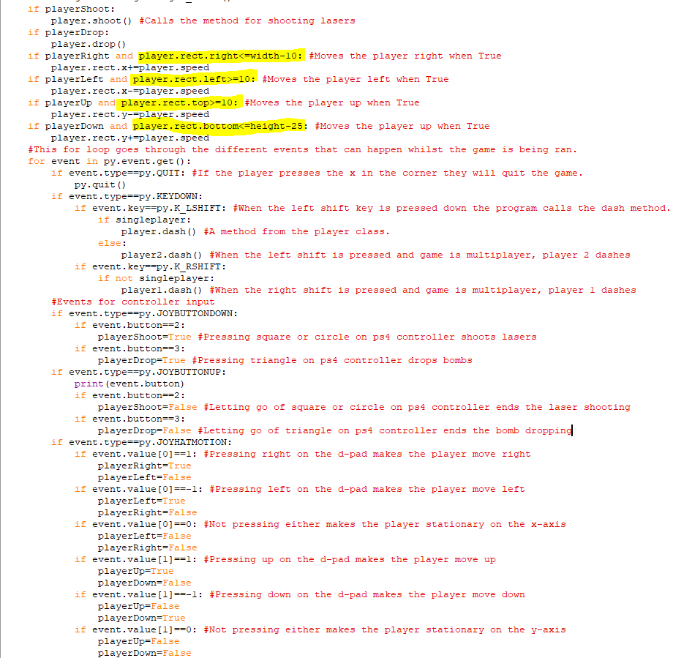I added conditions for when the player can move up, down, left and right. These conditions make sure that the player can’t move offscreen when they move in a particular direction when they are using a controller by only changing their x or y coordinate when changing it won’t move the player outside of the established parameters which are 10 pixels below the top of the screen, 25 pixels above the bottom of the screen, and 10 pixels from the left or right of the screen.

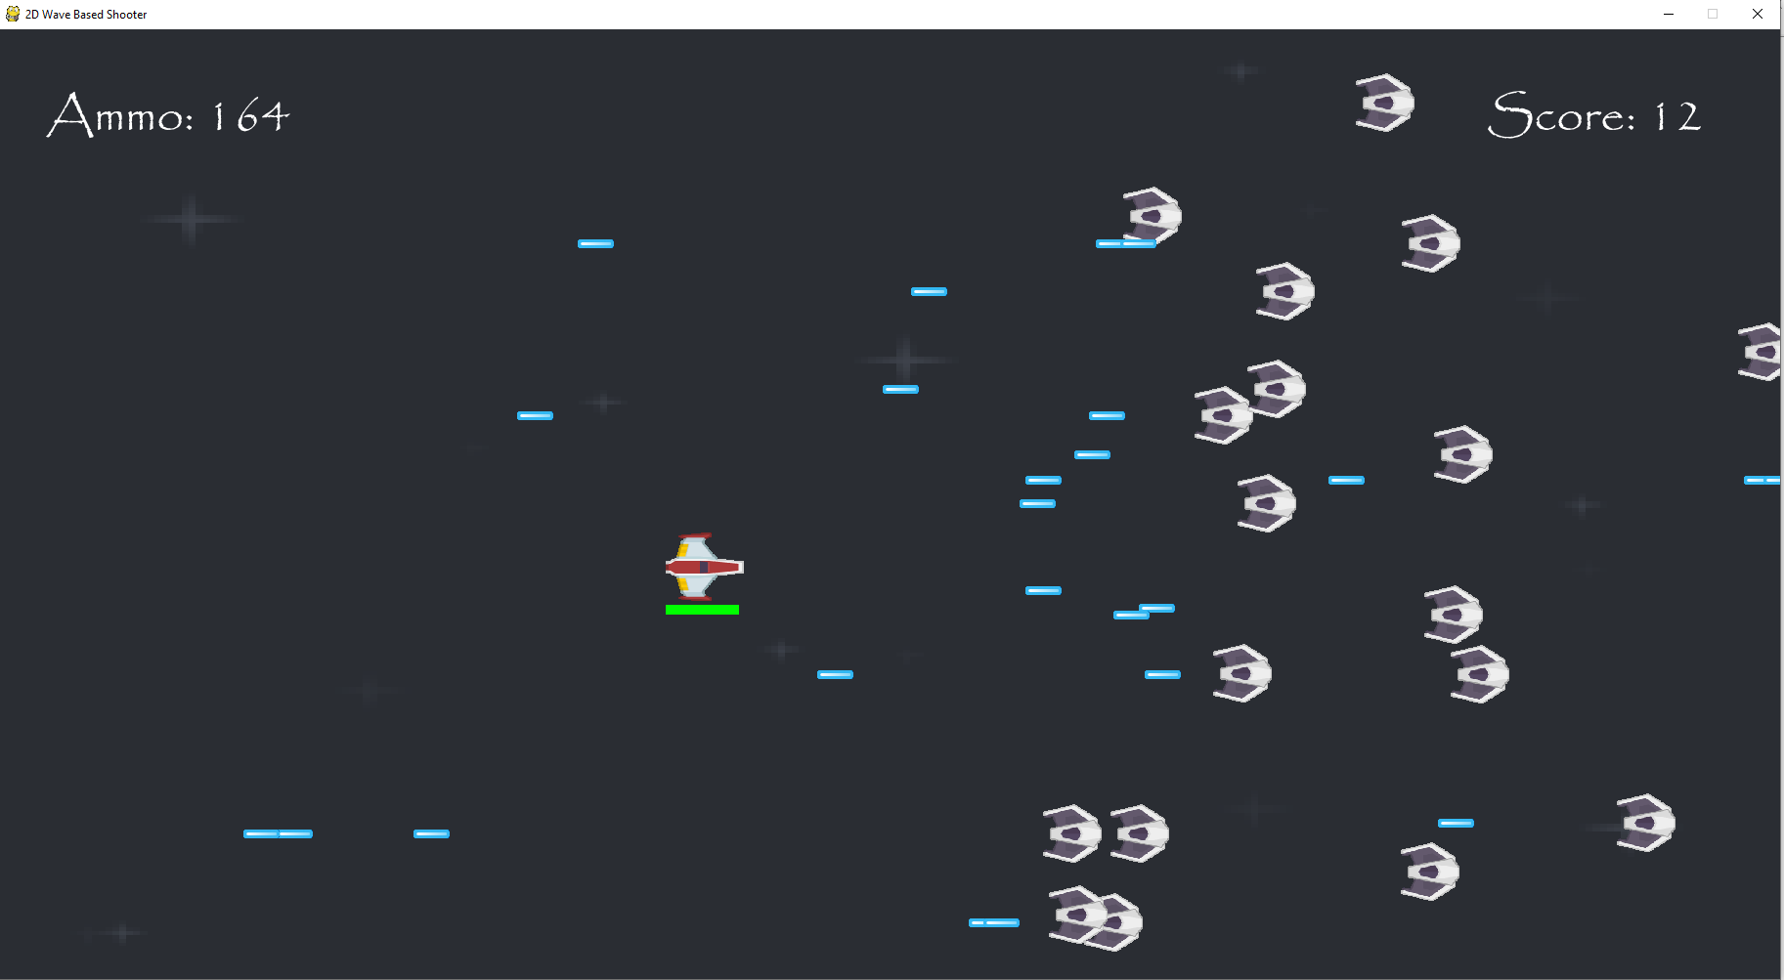  
I can move around just fine when I use the d-pad on the controller in all the required directions. Also, I can’t move offscreen when moving my player around, so everything about movement using a keyboard is functioning properly. 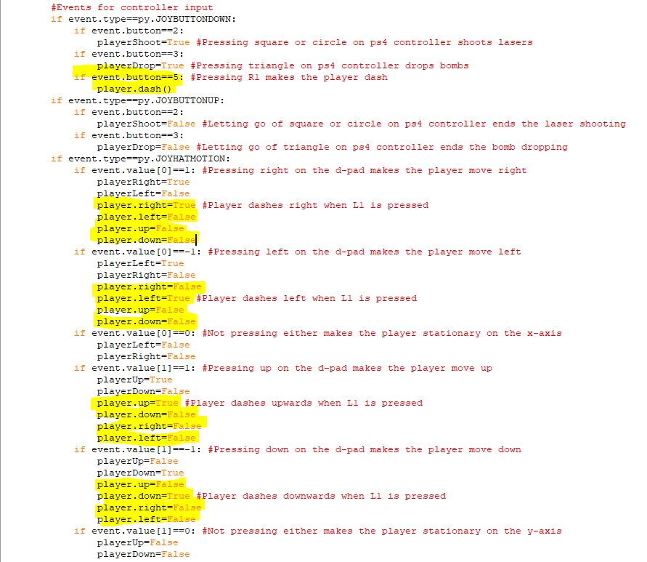I have added in the attributes that track the player’s direction from the player class. When the player presses up on the d-pad, then player.up becomes True and the other attributes become False, when down is pressed on the d-pad, then player.down becomes True and the rest become False and same occurs for the other two directions. This means that when the player dash method is used to make the spaceship dash, then they will dash in the direction they are moving. These attributes couldn’t be used to move the character because the way that movement works with keys on the keybaord is different to how it works with controller input.

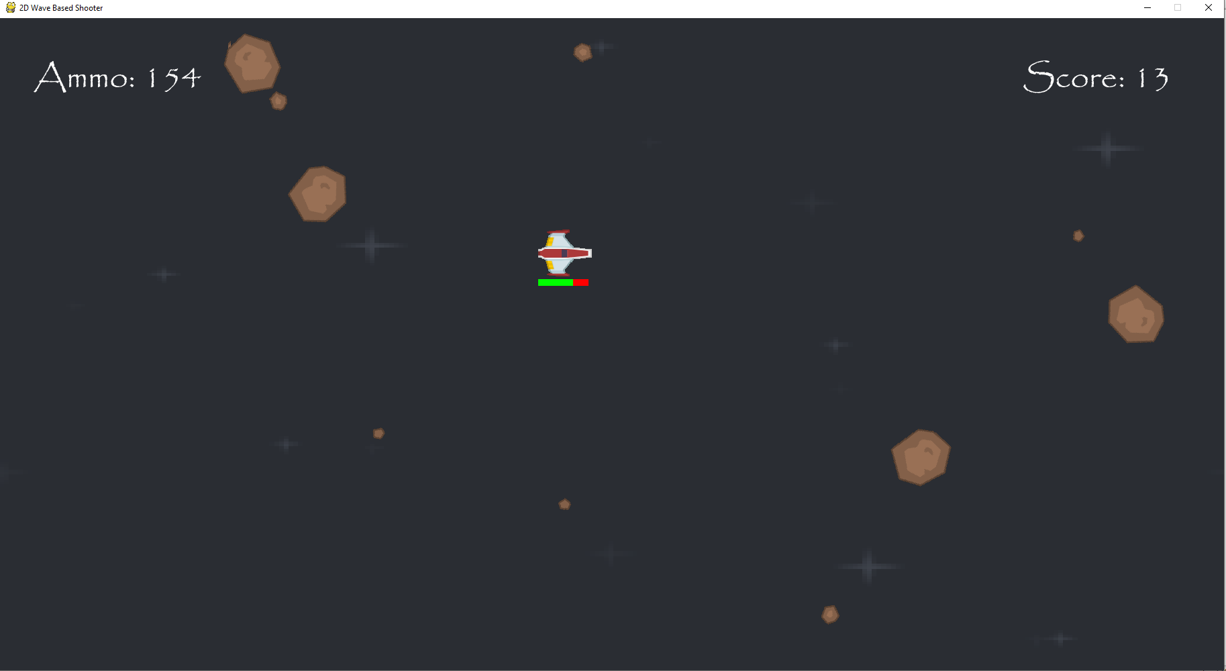When I press L1 on the controller, the spaceship dashes in the direction it is currently moving in. The spaceship also won’t dash offscreen when I dash close to an edge, as that is part of the dash method.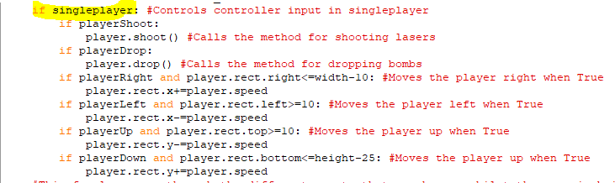The if highlighted if statement means that all of this code for player movement and using weapons for the Player object can only occur when game is in singleplayer. This is so the program doesn’t stop work when the player tries to use a controller in multiplayer.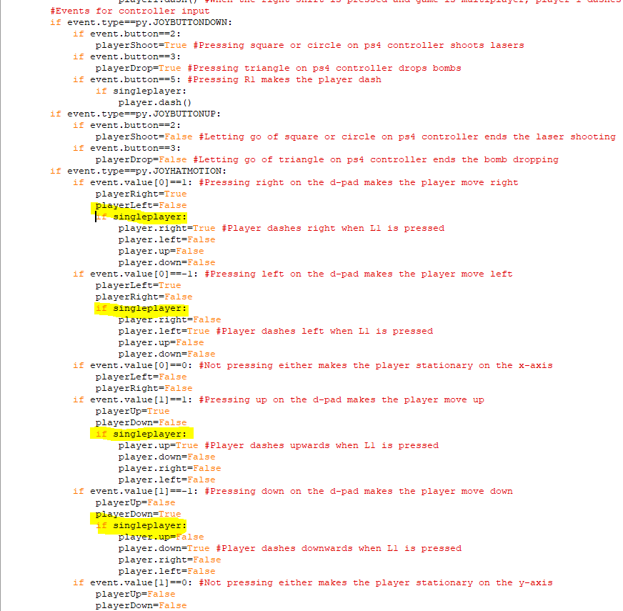All the attributes tracking the Player object’s direction are also only changed when singleplayer is True for the same reason.

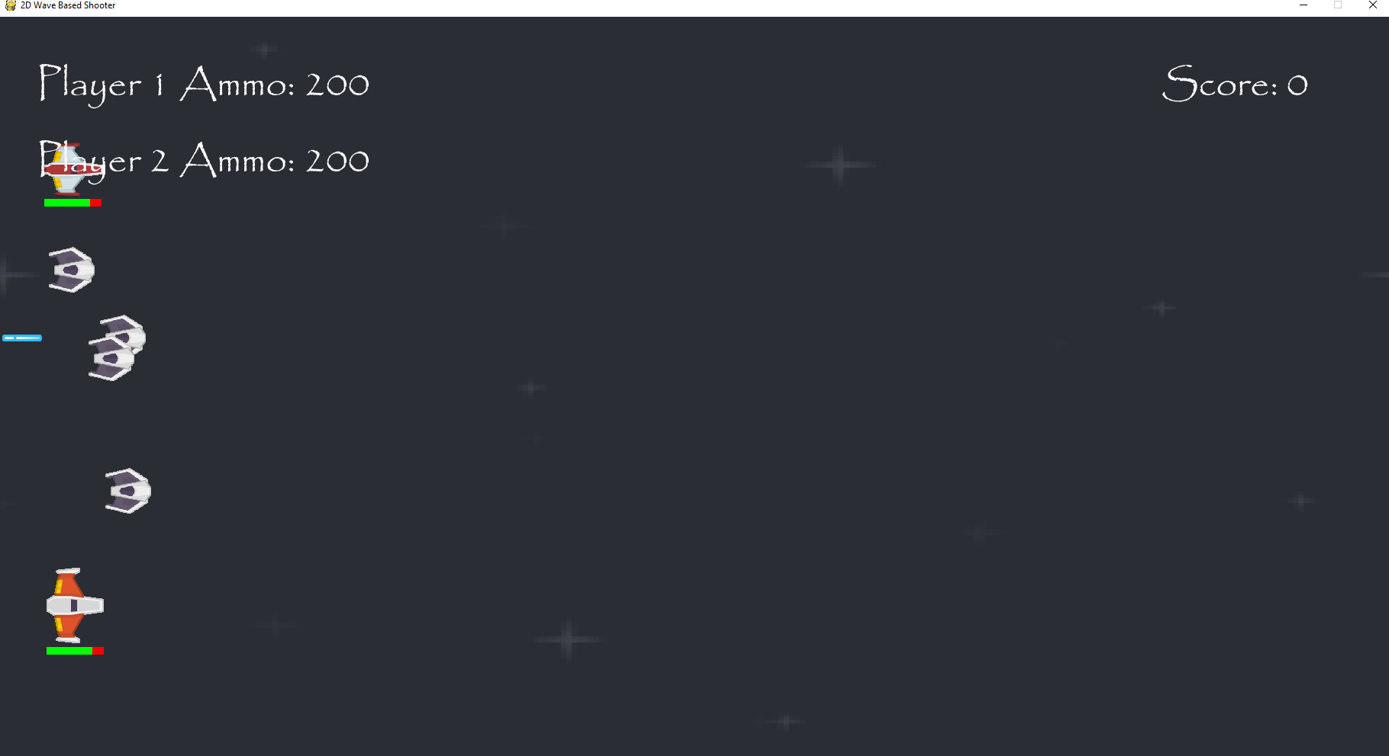  
The controller doesn’t control the players at all when the game is in multiplayer and pressing it doesn’t break the game.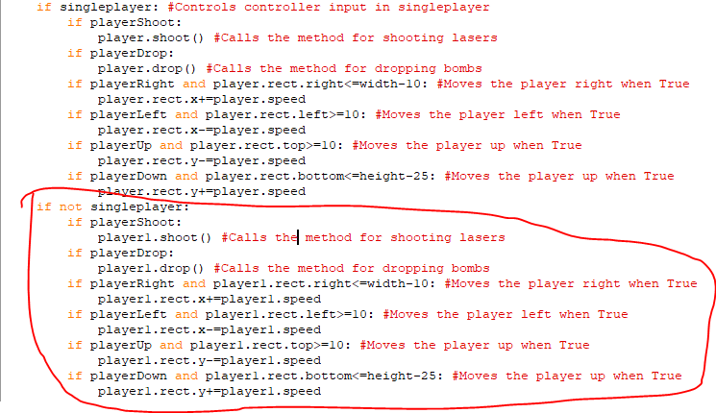The circled code implements the movement and shooting options when the game is in multiplayer. Using all the same buttons on the keyboard leads to player 1 instead moving around and shooting lasers and dropping bombs as that object is used instead of the player object.

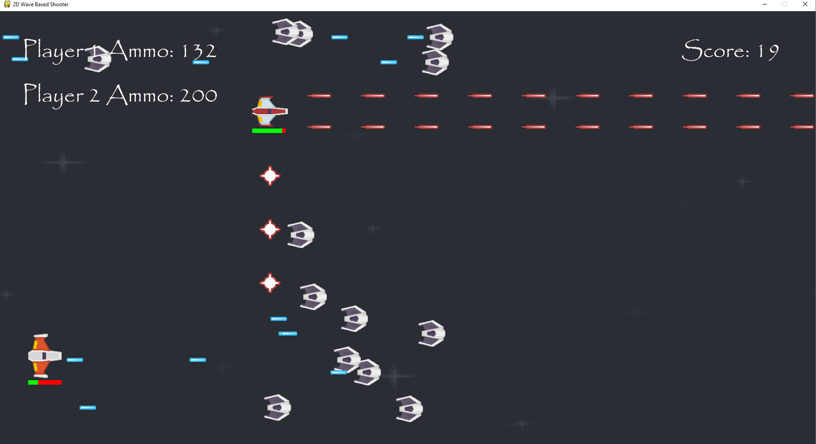  
The controller successfully moves around player 1 and pressing triangle and circle will make the player drop bombs and fire lasers respectively. Also, player 1 can’t move offscreen as all the preconditions around where you can move have remained.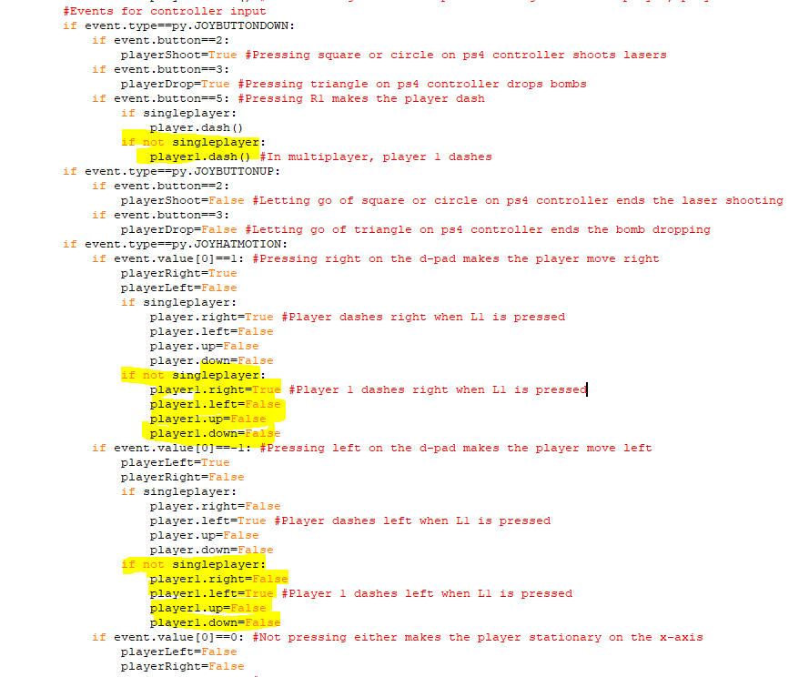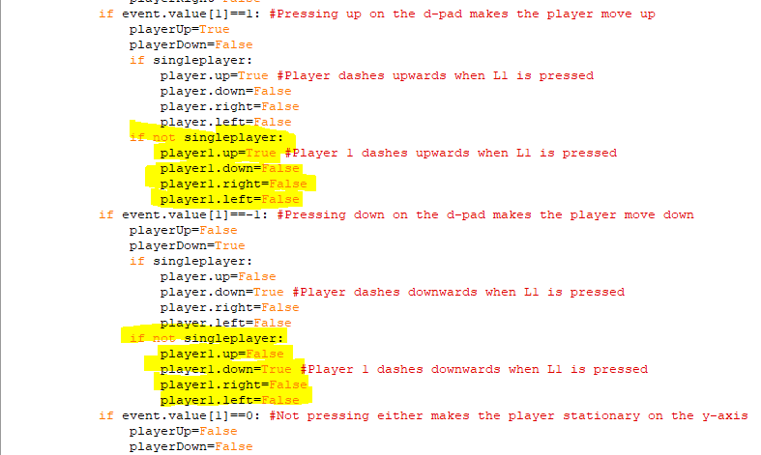These two images of code implement the ability for player 1 to dash when L1 is pressed on a controller and the game is in multiplayer. When singleplayer is False and L1 is pressed on the controller, the program calls the dash method for player 1 instead of the player object and when singleplayer is False, the program will change the up, down, left and right attributes for the player 1 object to track the player’s direction. This means that player 1 will dash in the direction that they are currently moving.

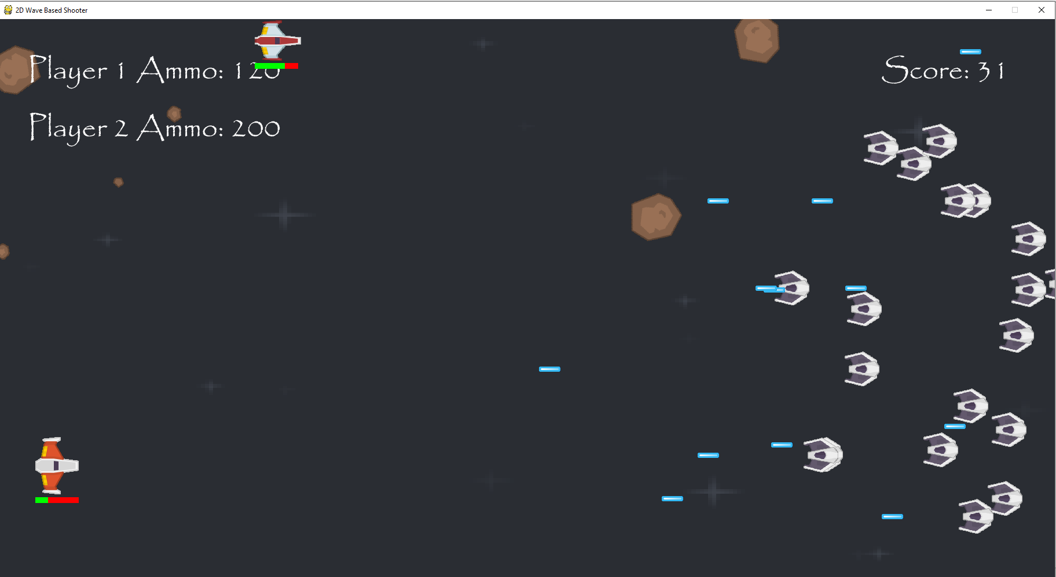  
When L1 is pressed and the game is in multiplayer, then player 1 does dash in the direction they are currently moving, and they also can’t dash offscreen no matter where they move to.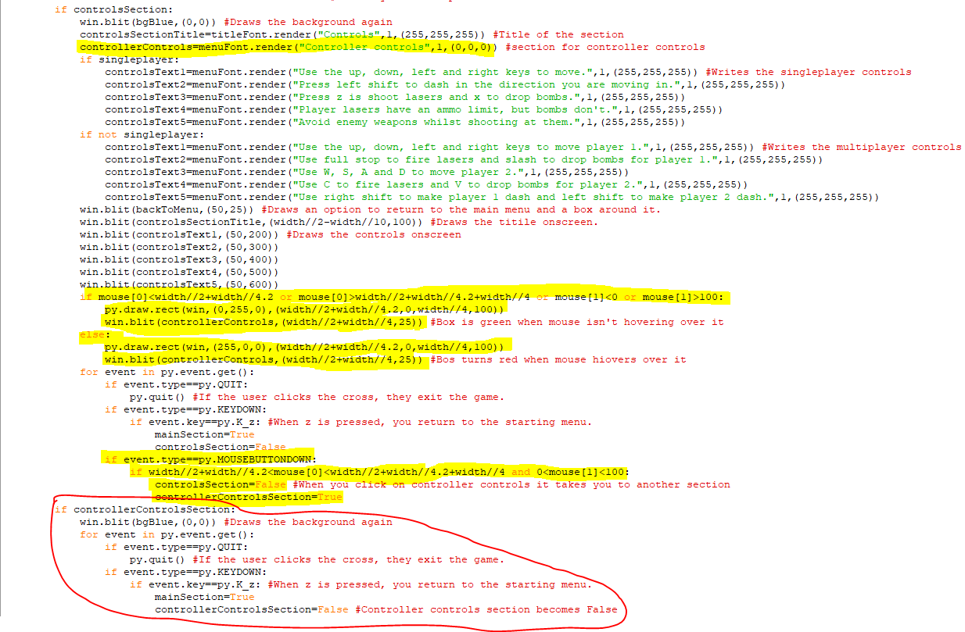The highlighted code is the code for drawing a box onscreen to let the player access the controller controls when in the controls section. This box will have the text ”Controller Controls” in it and when mouse is on the relevant coordinates, the box will turn red but at all other times, the box is green. When the player clicks on the box, controlsSection becomes False and controllerControlsSection becomes True. The circled code is what happens when this is True but currently all this does it draw a new background with nothing else, and it lets the player return to the main screen when they press z.

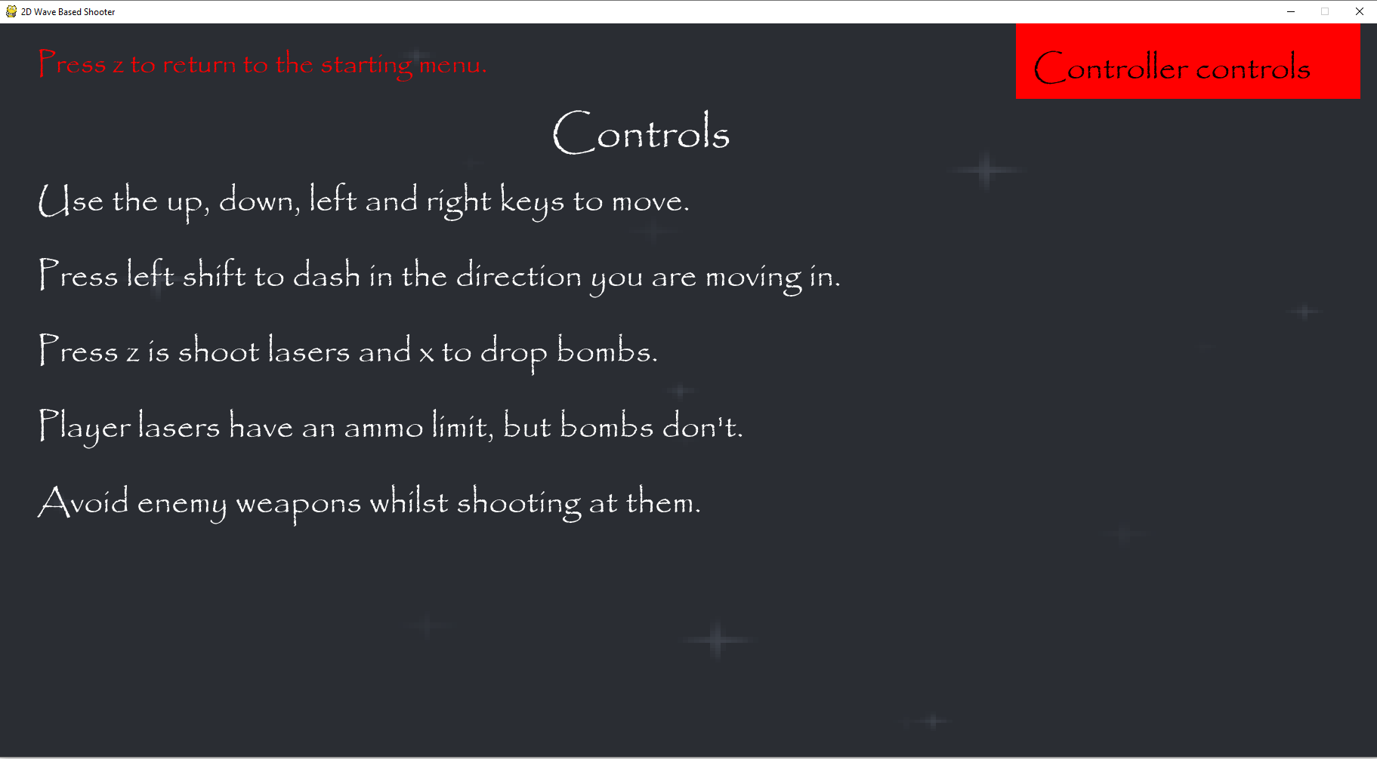  
The controller controls box appears onscreen and turns red when the mouse hovers over it.

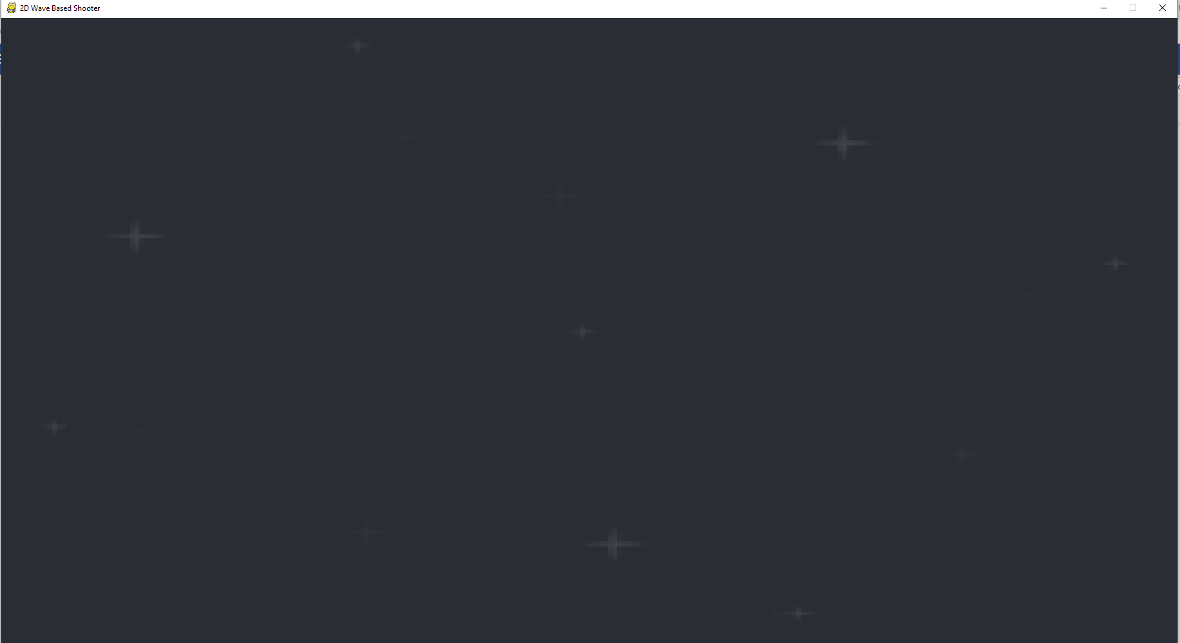  
When I clicked on the box it took me to this blank screen.

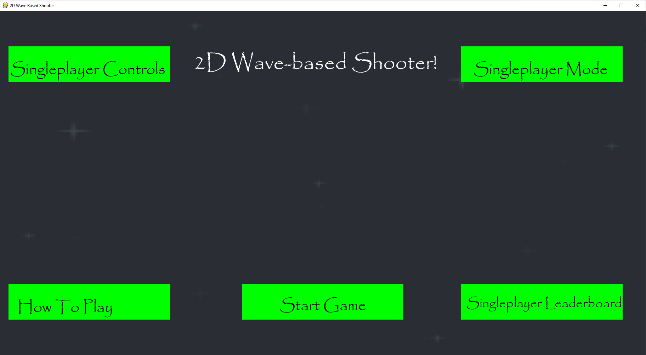  
Pressing z when on this blank screen took me back to the starting menu.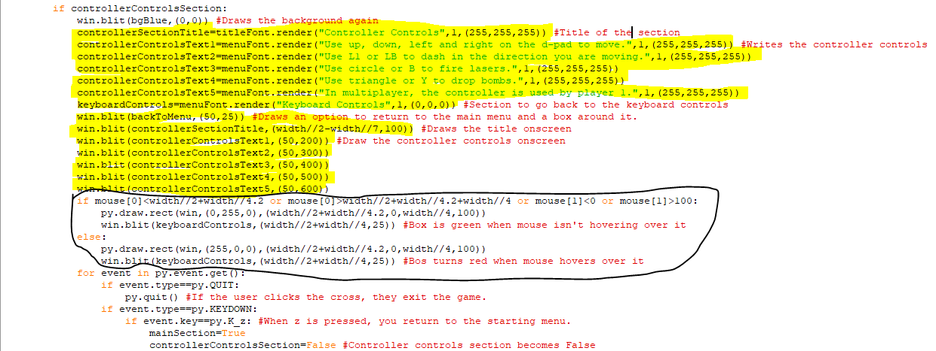The highlighted code writes the title for the controller controls section and also writes all of the controls for the controller. It then draws the title and controls onscreen as well as the back to Menu text to let them know they can return back to the starting menu by pressing z. The circled code draws a box for going back to the keyboard controls and this box turns red when the mouse goes over it but returns to green after the mouse goes off it.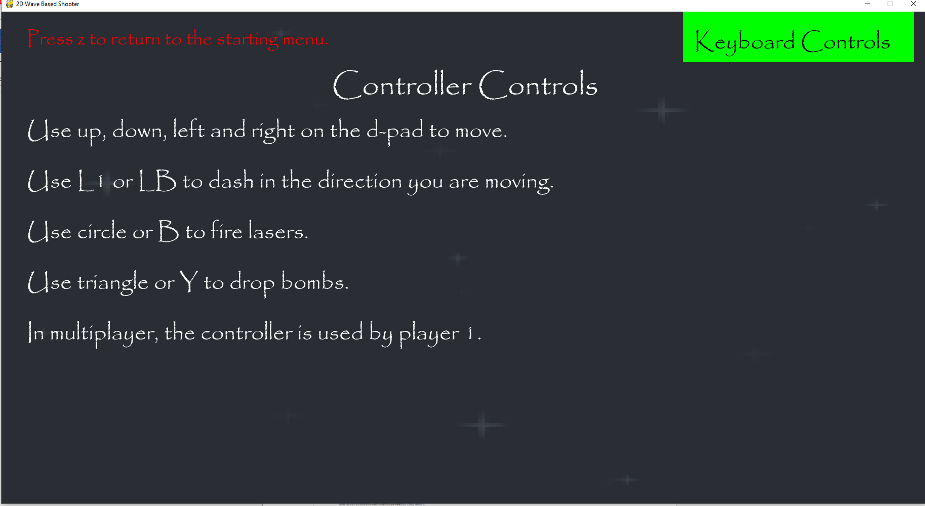  
The controller controls are displayed onscreen in the controller section, along with the title, the return to menu text and a box for keyboard controls in the top-right corner of the screen. This turns red when a mouse hovers it.

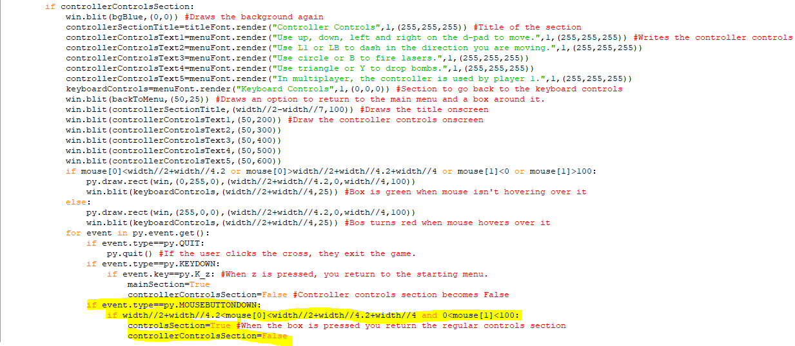When a mouse is pressed down within the area of the box, controllerControlsSection will become False and controlsSection becomes True so the player will return to the keyboard controls section.

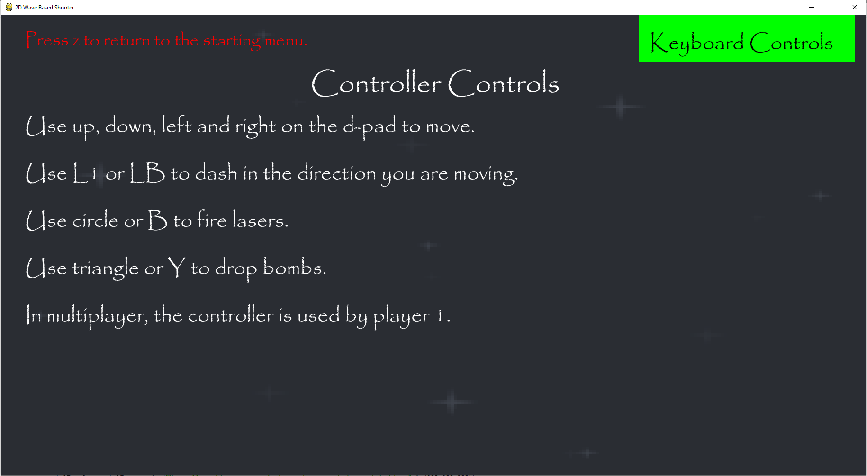  
Here is the controller section for controls.

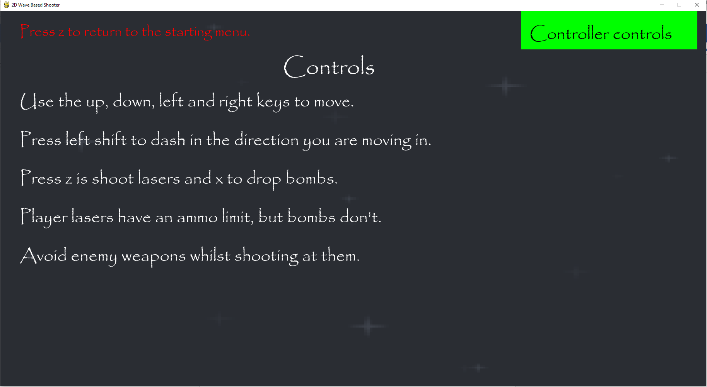  
When I clicked on the box in the top right of the screen, I returned to the controls section. So, this is functioning properly.

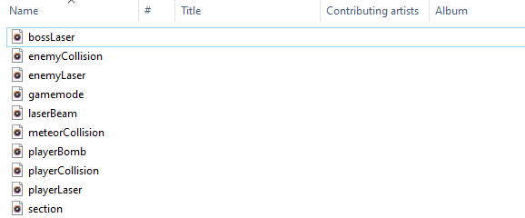

Here are the sound files for the different sound effects I will use in the game. These are files for player and enemy weapons, collisions and for navigating menus.

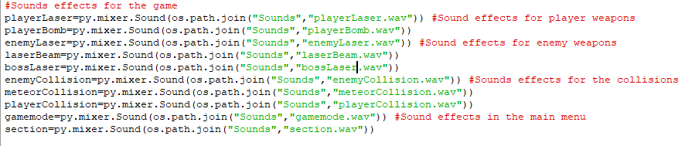This is the code that adds in the different sound files as sound effects. They are all one or two seconds long and will be triggered when their corresponding action occurs. The first two are for player weapons, the next three are for enemy attacks and hazards, the next three are for collisions and the last two are used in the main menu.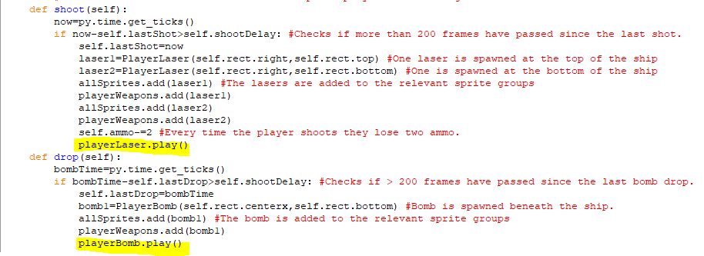This code is the shoot and drop methods in the parent Player class and I have added code to make the shoot method play the playerLaser sound effect and the drop method to playthe playerBomb sound effect. Since these are added to the base class, they should work with players in both single and multiplayer.

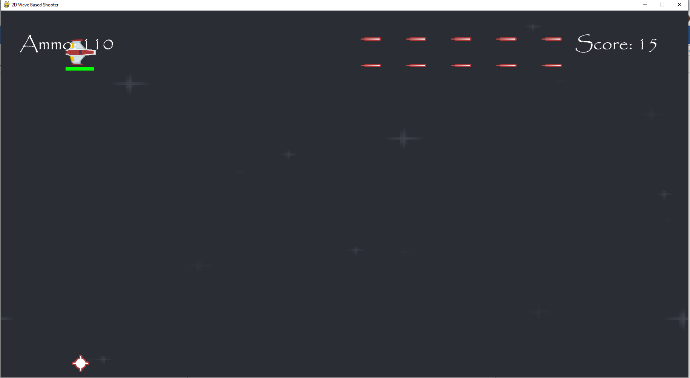  
There are different sound effects that play when I am shooting lasers or dropping bombs.

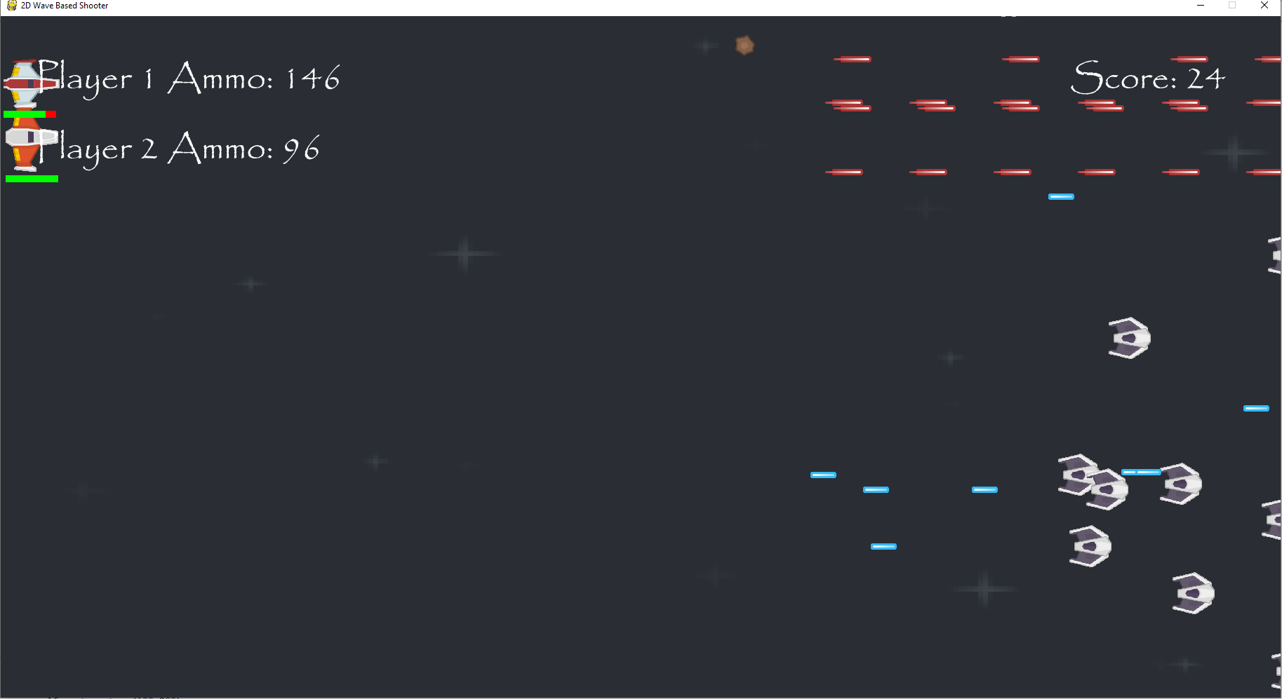  
Both players have the same sound effects for when they drop bombs and the same ones when they shoot lasers.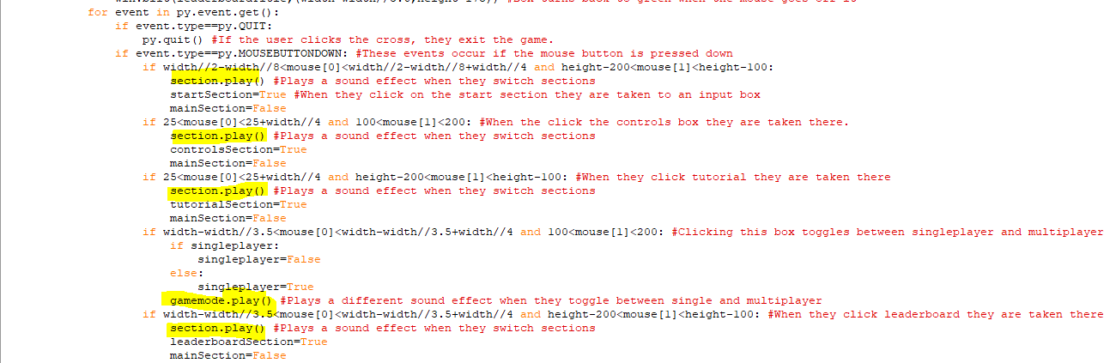This is code in the mainMenu function which determines what area of the screen you click on to move to another section of the menu. When you click on each of the sections it now plays a laser sound effect, but when you change game modes, there is a different sound effect that plays which signifies this change.

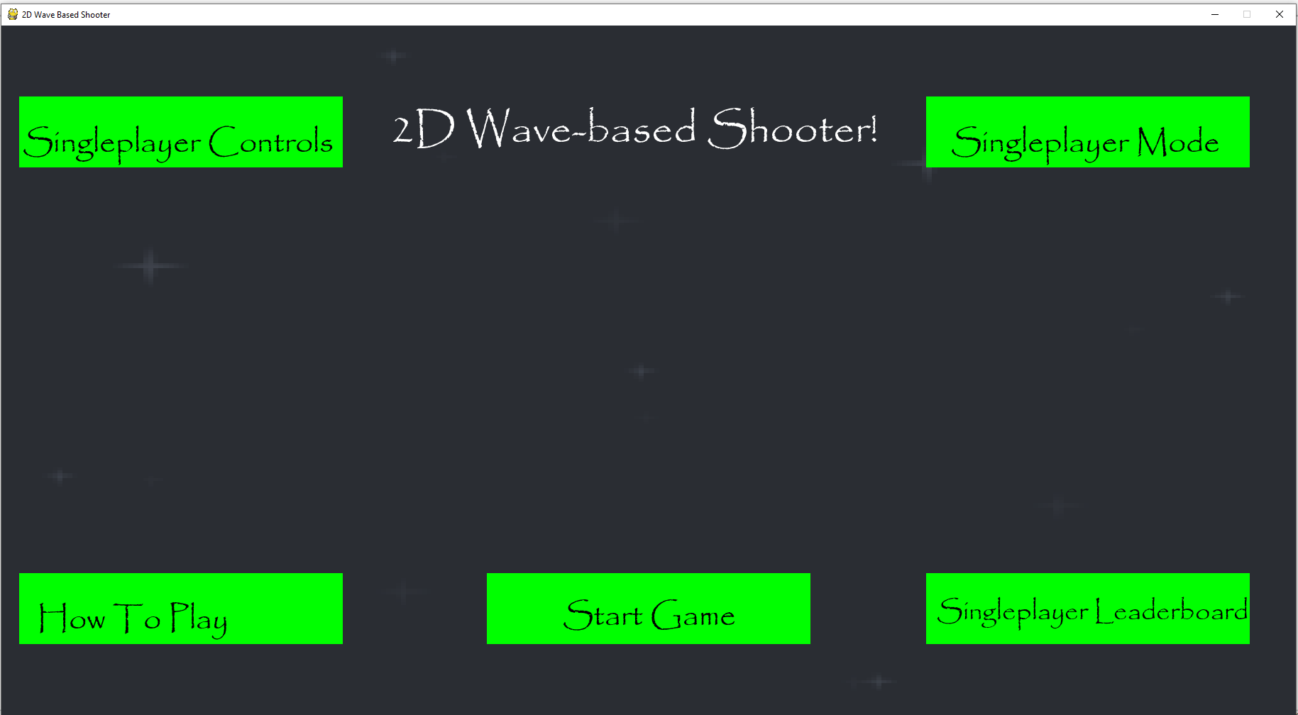  
I have clicked on all of the boxes and the same sound effects is played, except when I clicked on the singleplayer/multiplayer box where a different sound effect was played.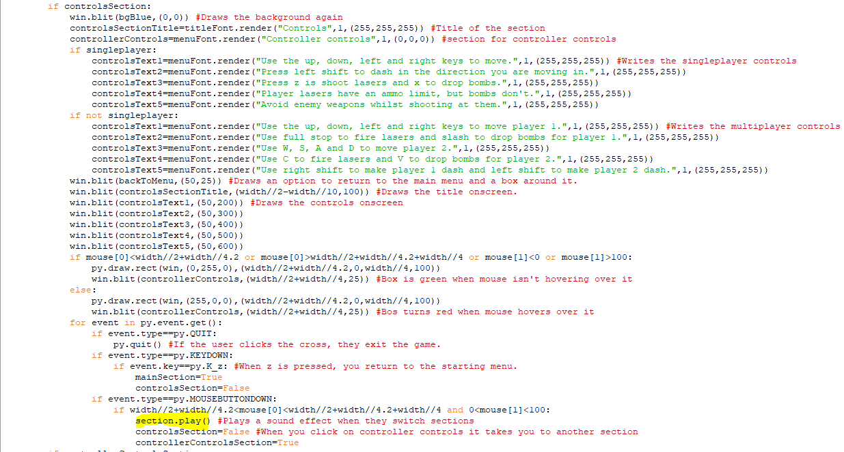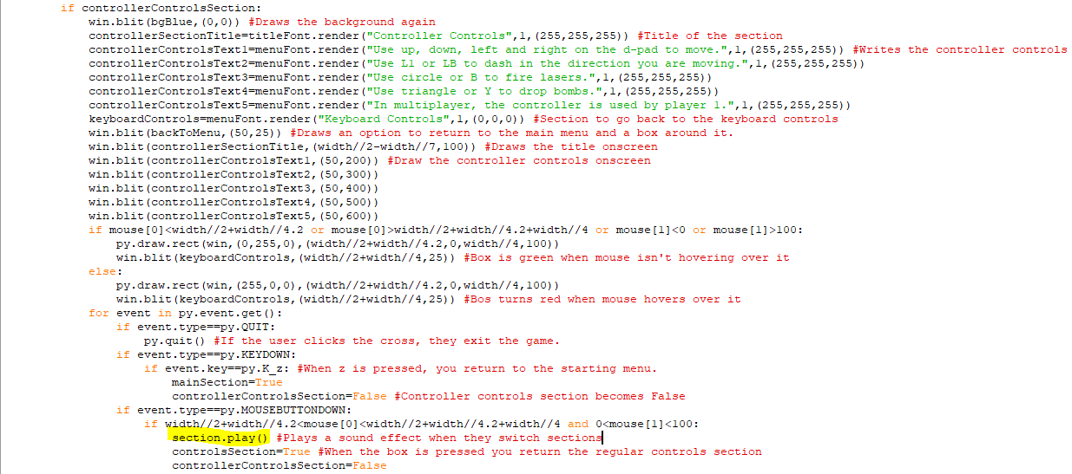When the player clicks on the box in the controls section to switch between keyboard and controller controls, the game will now play the sound effect for the other sections.

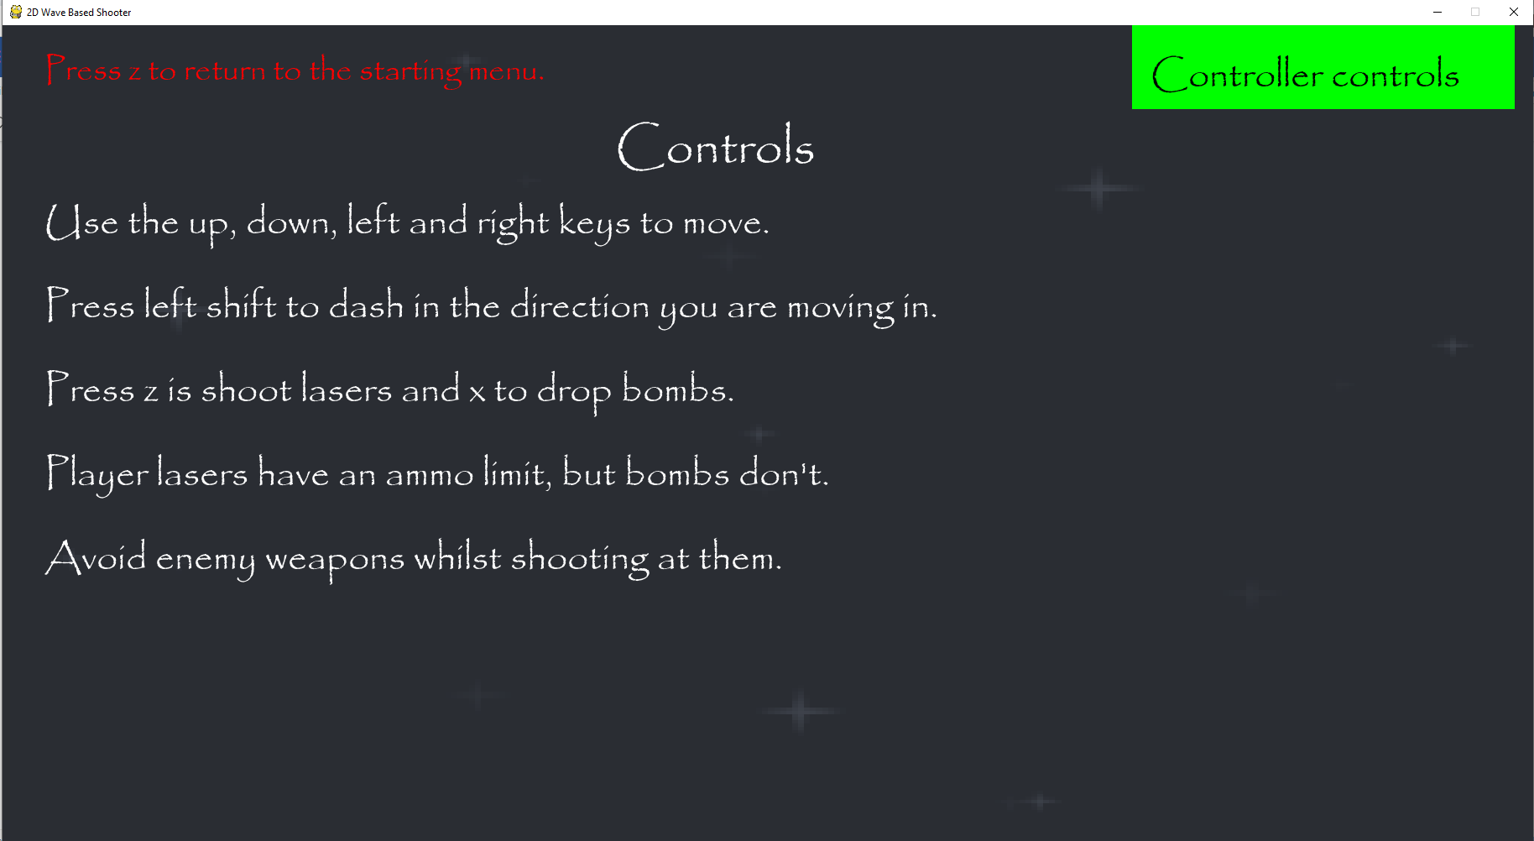  
I clicked on the controller controls and then went back to the keyboard controls section and the correct sound effect played when I clicked on the box.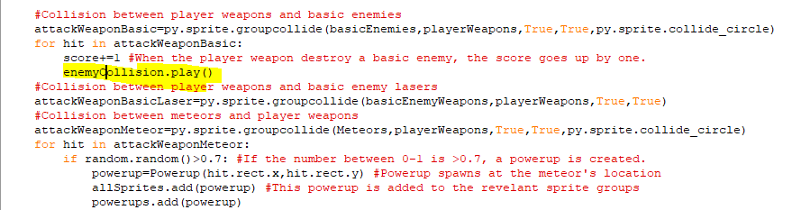The top section of the code is the for the collision between the player weapons and the basicEnemies sprite group which contains every enemy group except bosses. I have added the sound effect to be played when the enemy collide with the player weapons and this will work for all enemies in the basicEnemies sprite group.

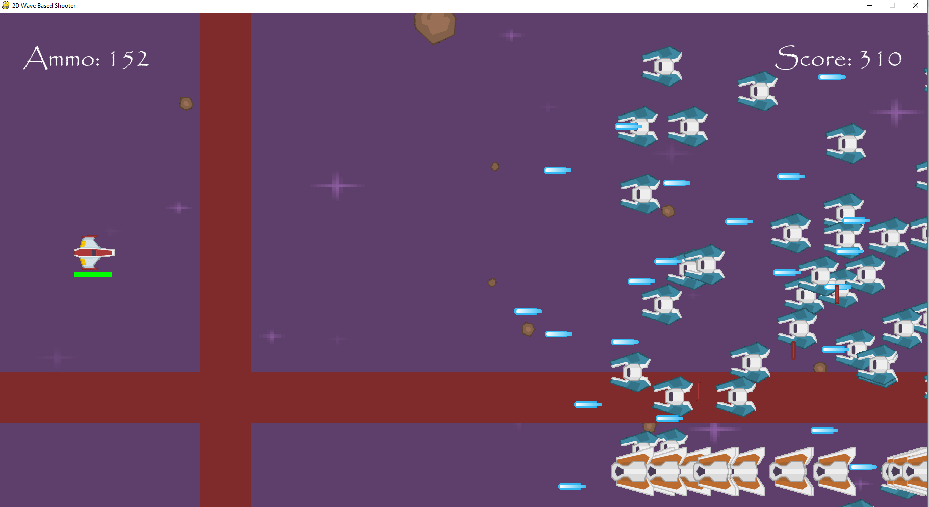I have tested all four enemy types and they all trigger the same sound effect when they collide with the player weapon.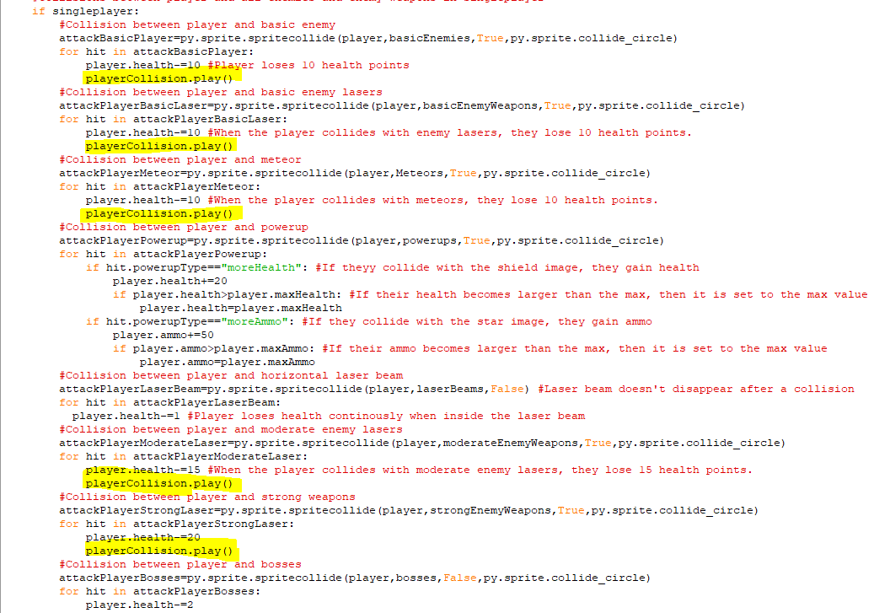The highlighted code makes the same explosion sound effect play whenever the player collides with the sprite groups that contain enemy weapons or other hazards, except when the damage is dealt continuously, like colliding with bosses or with laser beams. These sprite groups are basicEnemies, basicEnemyWeapons, moderateEnemyWeapons, strongEnemyWeapons, and meteors. 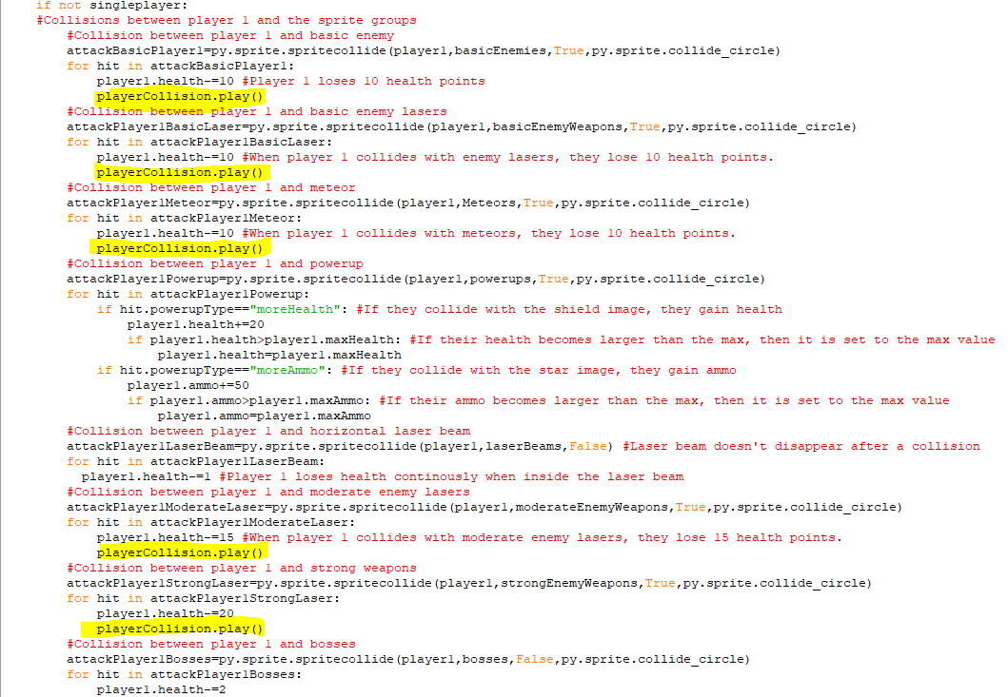The highlighted code here is the same except it plays the explosion when player 1 collides with the weapons or hazards in multiplayer.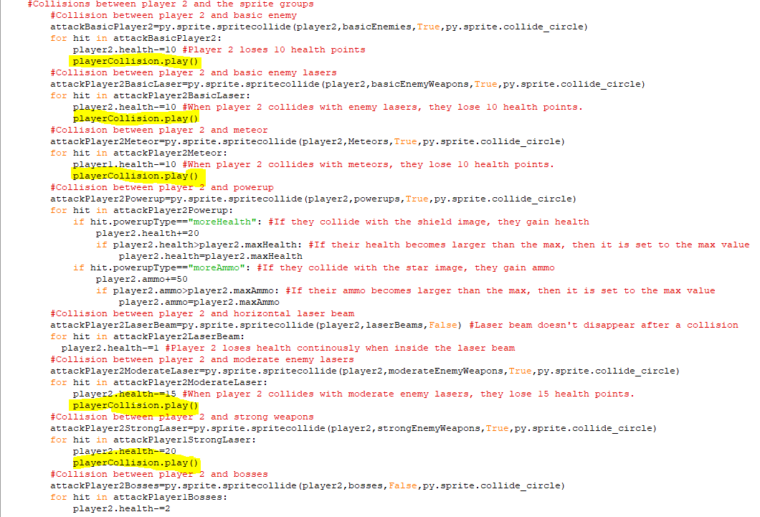The highlighted code here is the same except it is for the collisions with player 2.

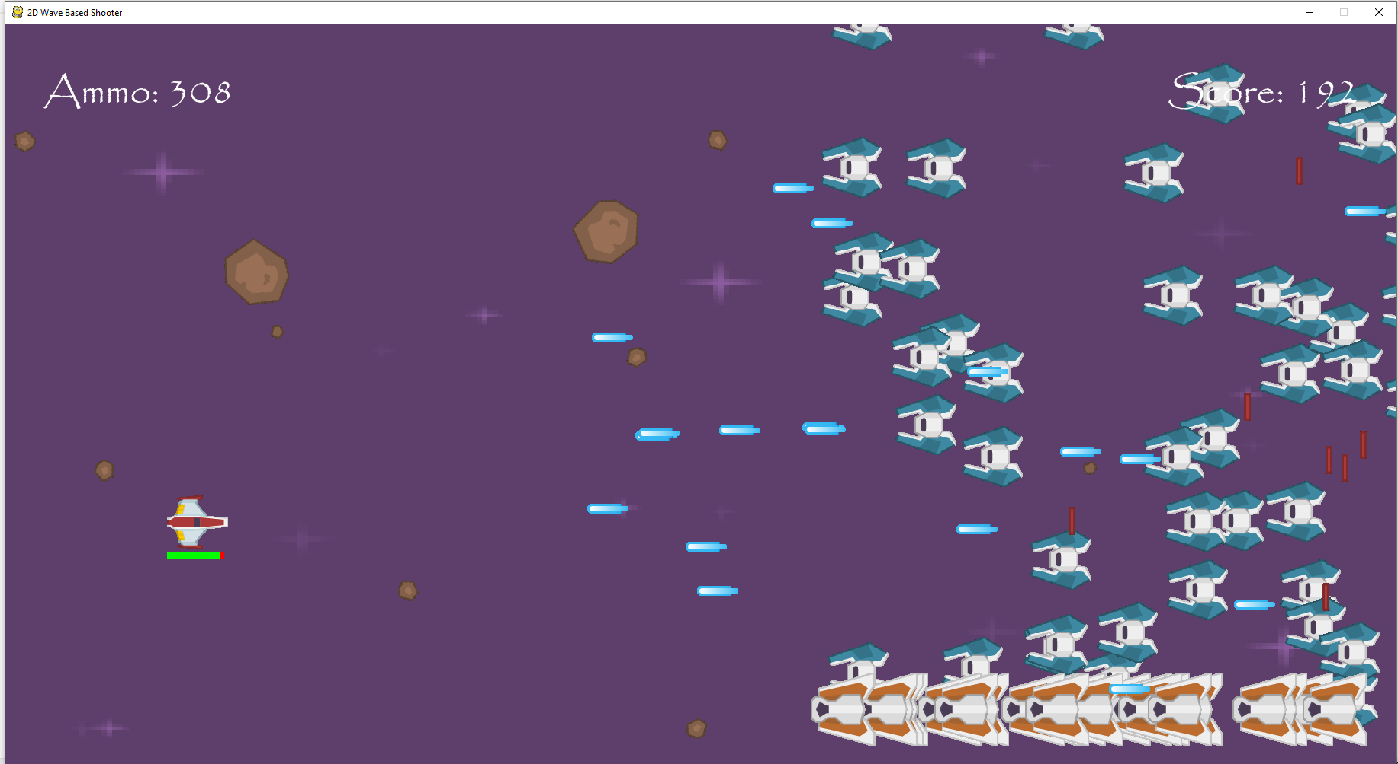  
I have made the player collide with each of the different sprite groups that should trigger an explosion sound effect and when the collision happened with an object from each of them, the correct sound effect always played.

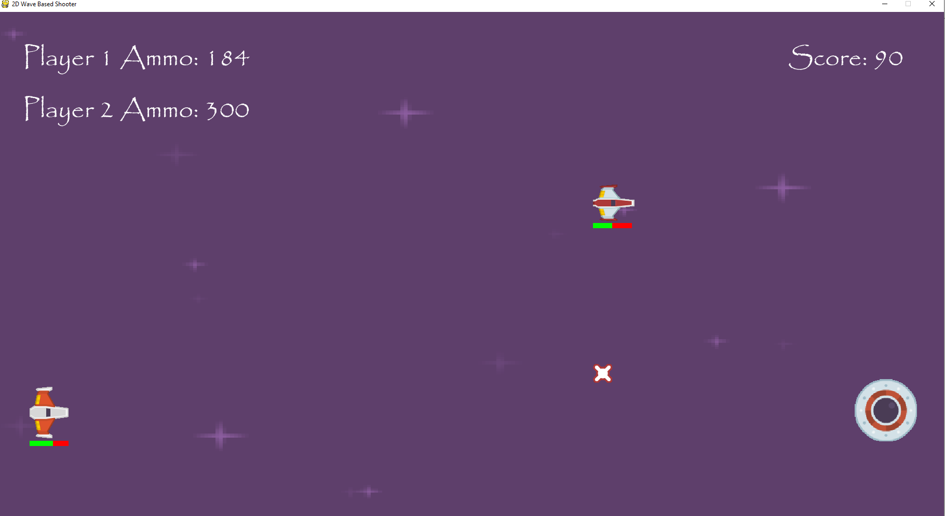  
I have now made both players collide with objects of each of the relevant sprite groups, and whenever either of them collided with these groups, the correct explosion sound effect was played.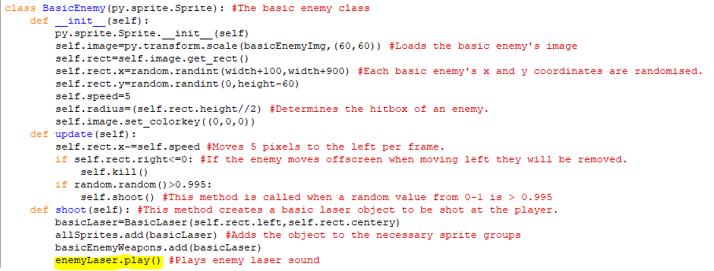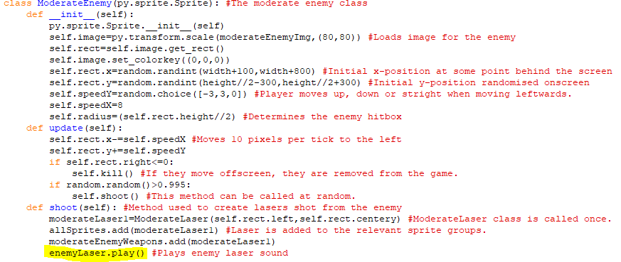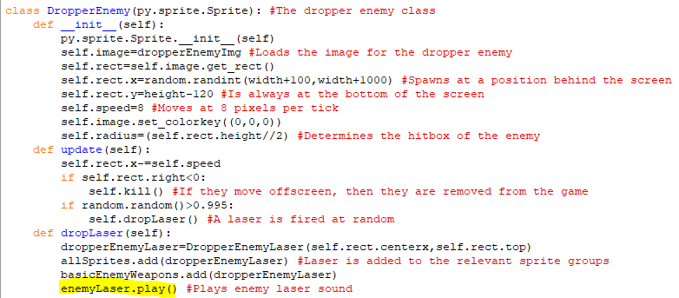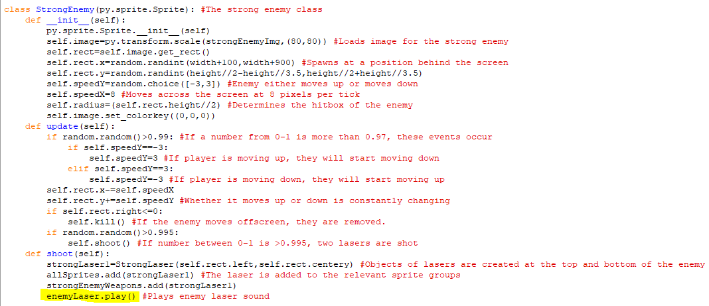The highlighted line of code added to each of the enemy classes makes them play an enemyLaser sound effect when they call whatever method they use to shoot lasers, the sound effect is the same for each of the enemies.

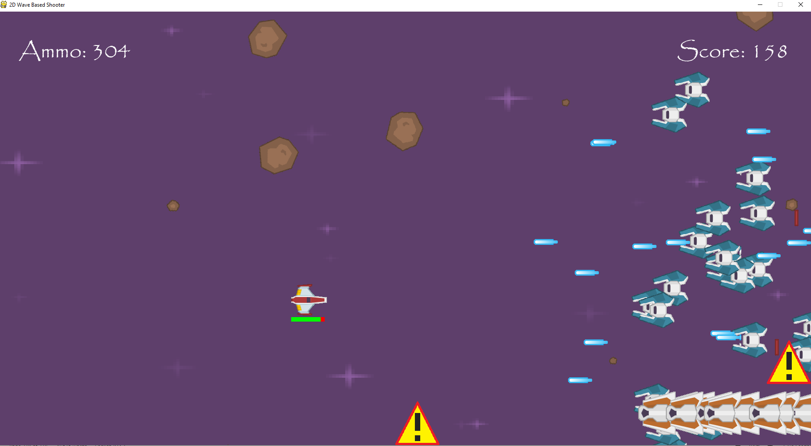  
Each of the four different enemies play that sound effect when they fire a laser. so thisis working properly.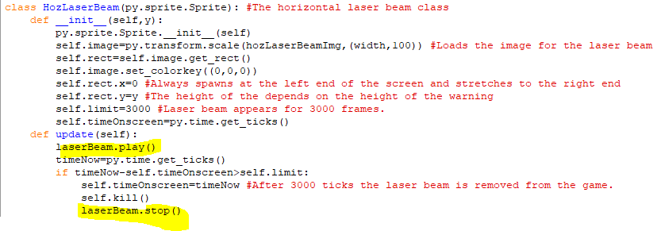The highlighted code to the laserBeam class makes it continuously repeat the laser beam sound effect whilst it is onscreen, but once it is removed it immediately stops. It is repeated since it stays onscreen for longer than the sound effect lasts. Also,wince the horizontal and vertical laser beam always appear at the same time, the vertical one won’t need its own sound effect.

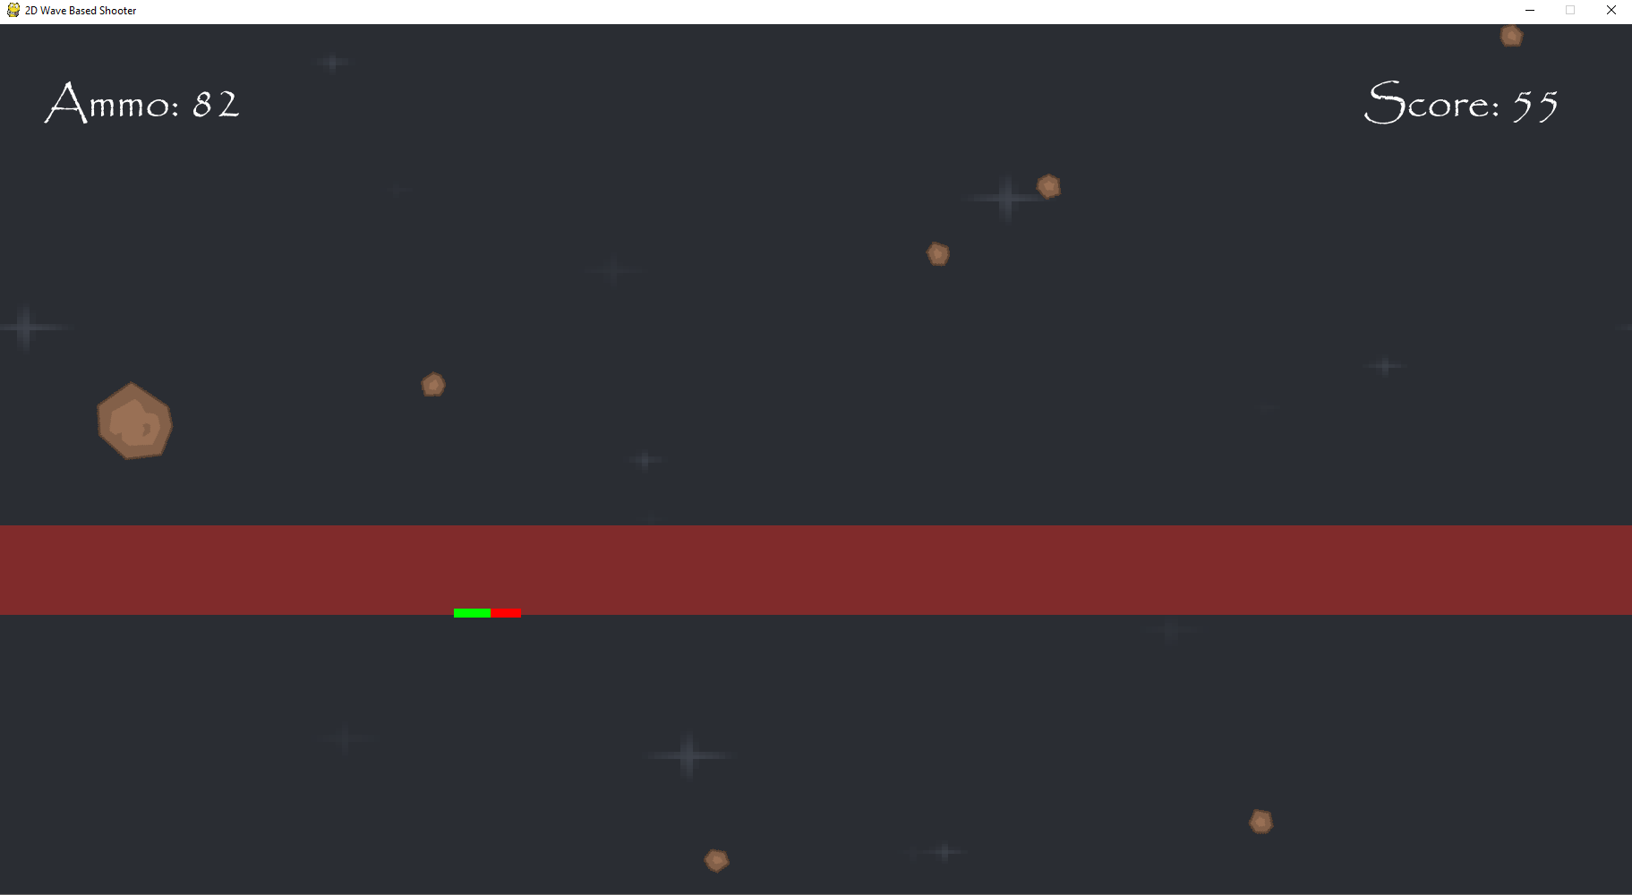  
The correct laser beam sound effect plays when the laser beam appears onscreen and immediately stops when it goes offscreen.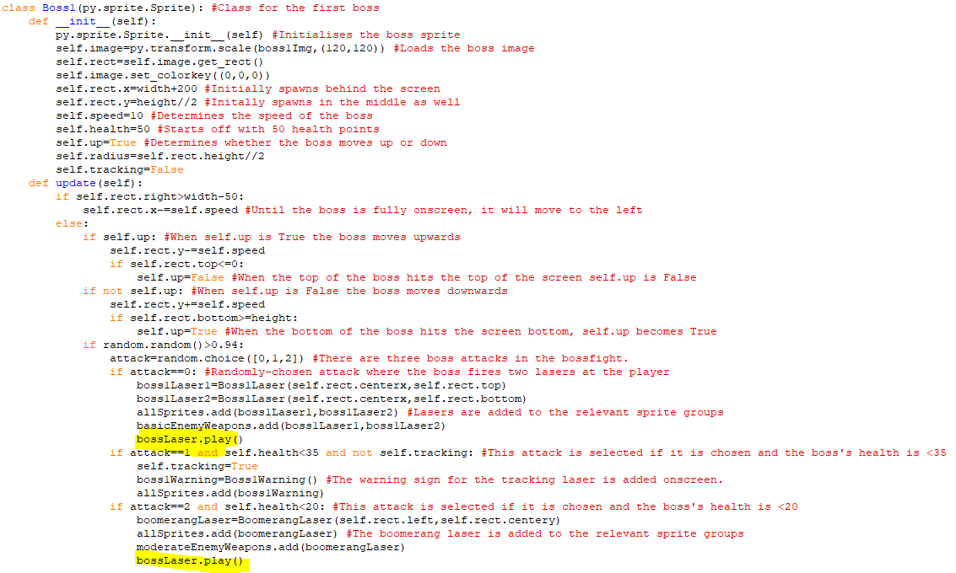Two of the laser attacks created as objects in the boss 1 class have the bossLaser sound effect play immediately after they are added to a sprite group and drawn onscreen. 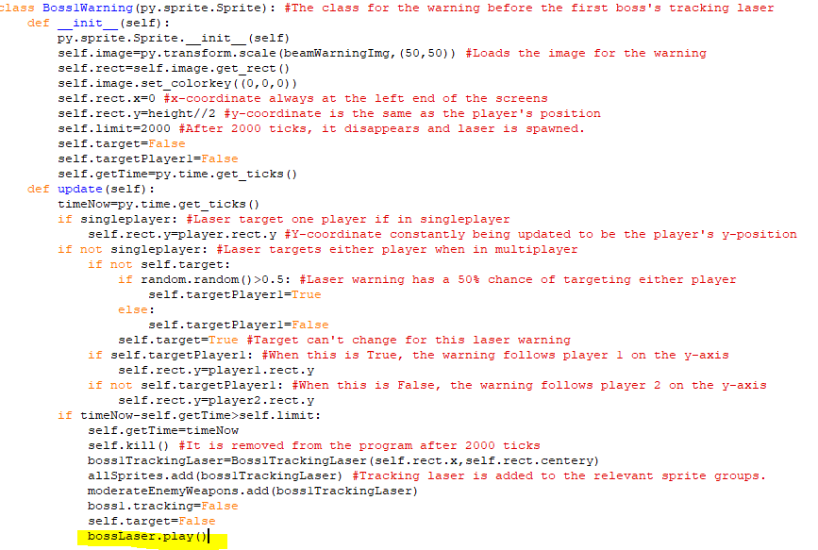The class for the tracking laser warning in the first boss also plays this sound effect once it is removed and the tracking laser is drawn onscreen.

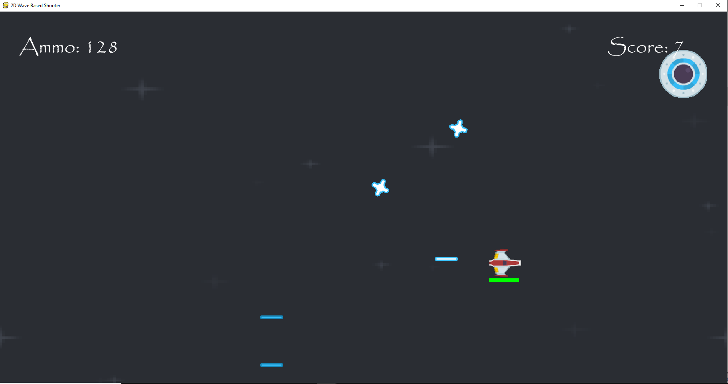  
The bossLaser sound effect is played after the boomerang laser and regular lasers are shot from the boss and plays when the tracking laser is shot from the other side of the screen, so it is always playing when it is needed.

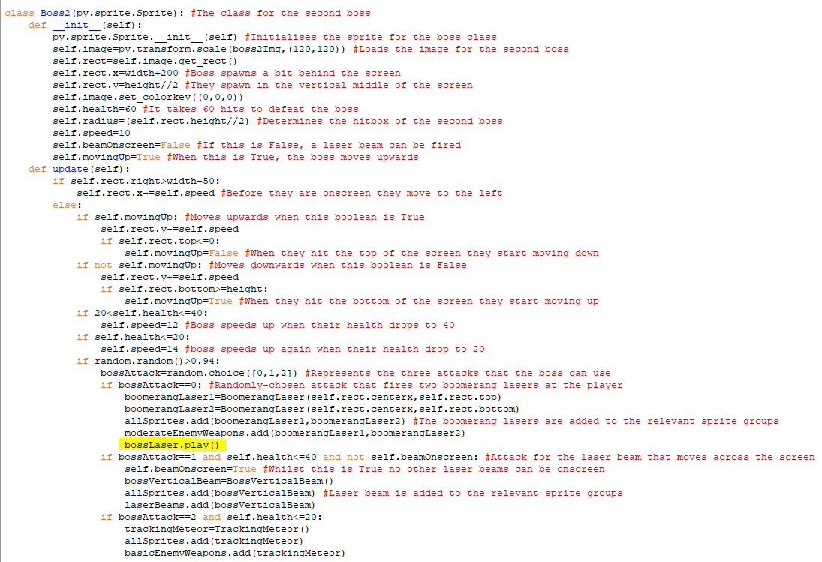In the boss 2 class, the bossLaser sound effect will only play after the dual boomerang attack and not during any other attacks since those aren’t stricktly laser attacks so it wouldn’t fit.

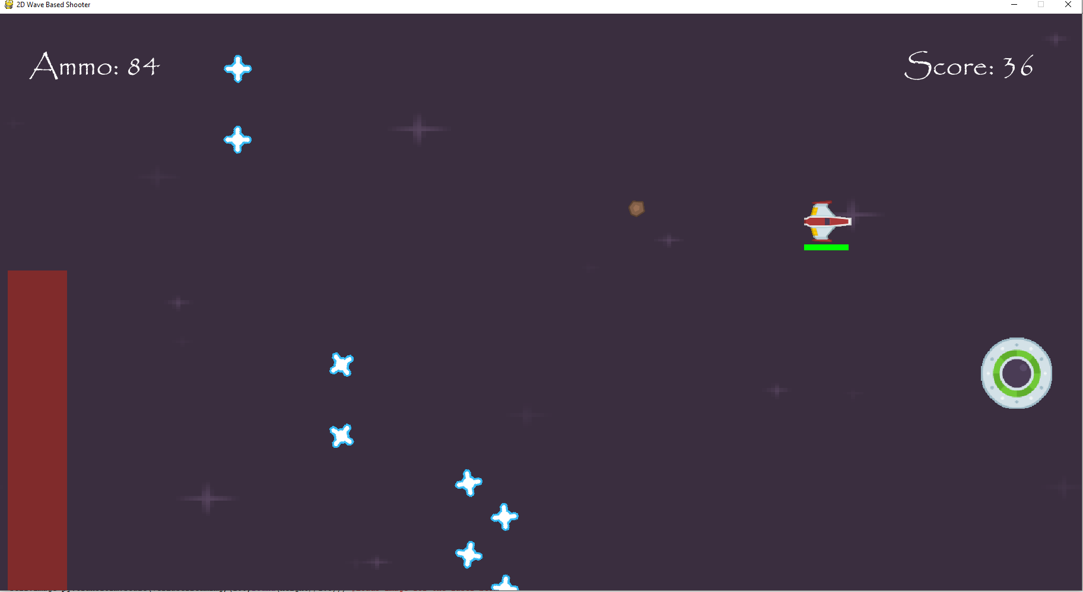The bossLaser sound effect only plays when the boomerang lasers are shot during the second boss fight.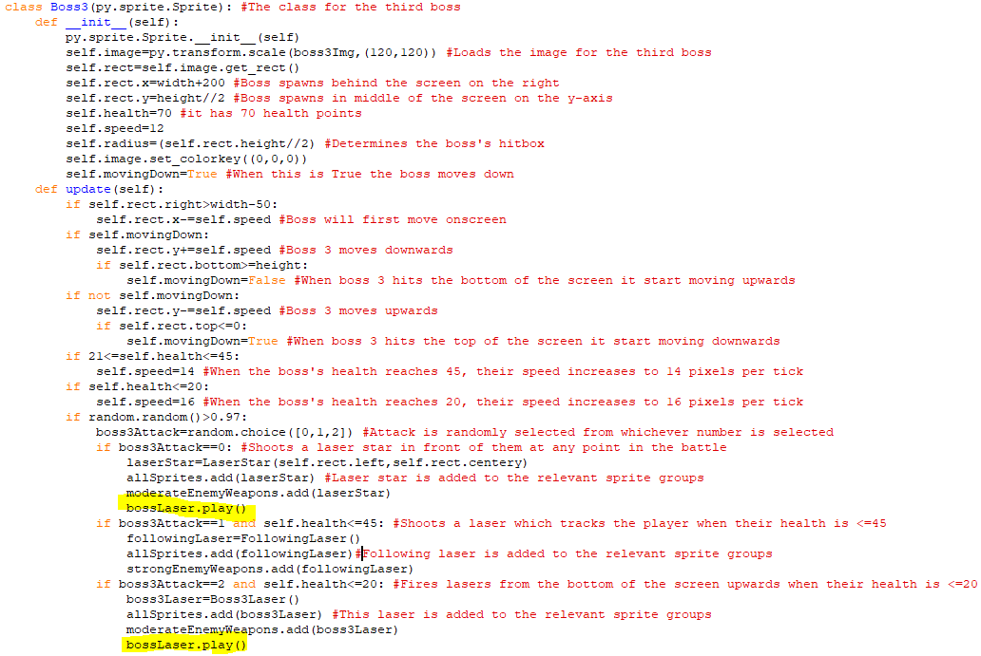Int he third boss fight, the bossLaser sound effect plays after the laser star is shot from the boss or when the upwards lasers are shot. It won’t play when the following laser comes osncreen since that moves very slowly so the sound effect wouldn’t fit there.

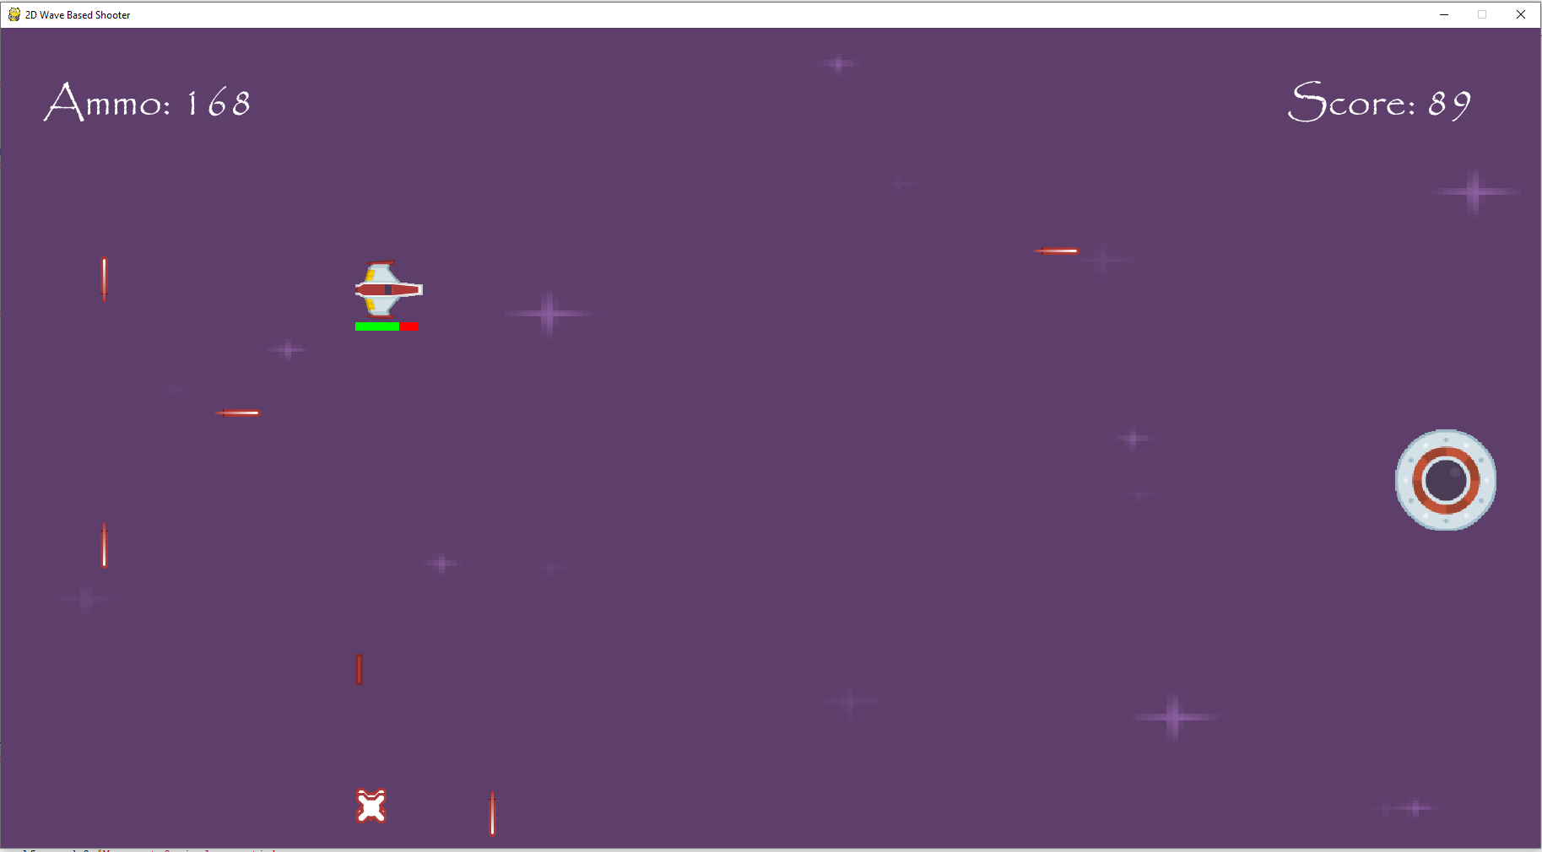  
The bossLaser sound effect doesn’t play when a following laser is shot but it does play when the other two attacks are shot so the boss laser sound effect is played only when it is needed during the third boss fight.

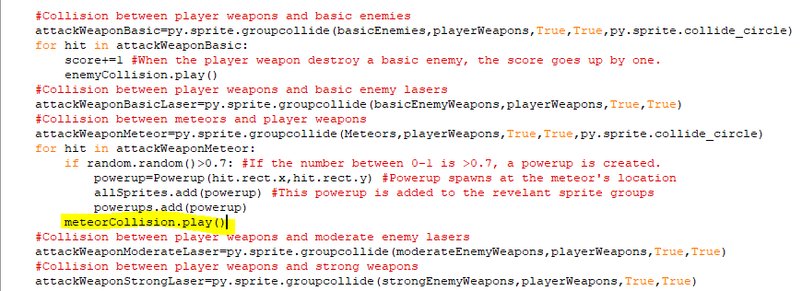When the player weapons collide with the meteor then a sound effect called meteorCollision will play and it is another explosion.

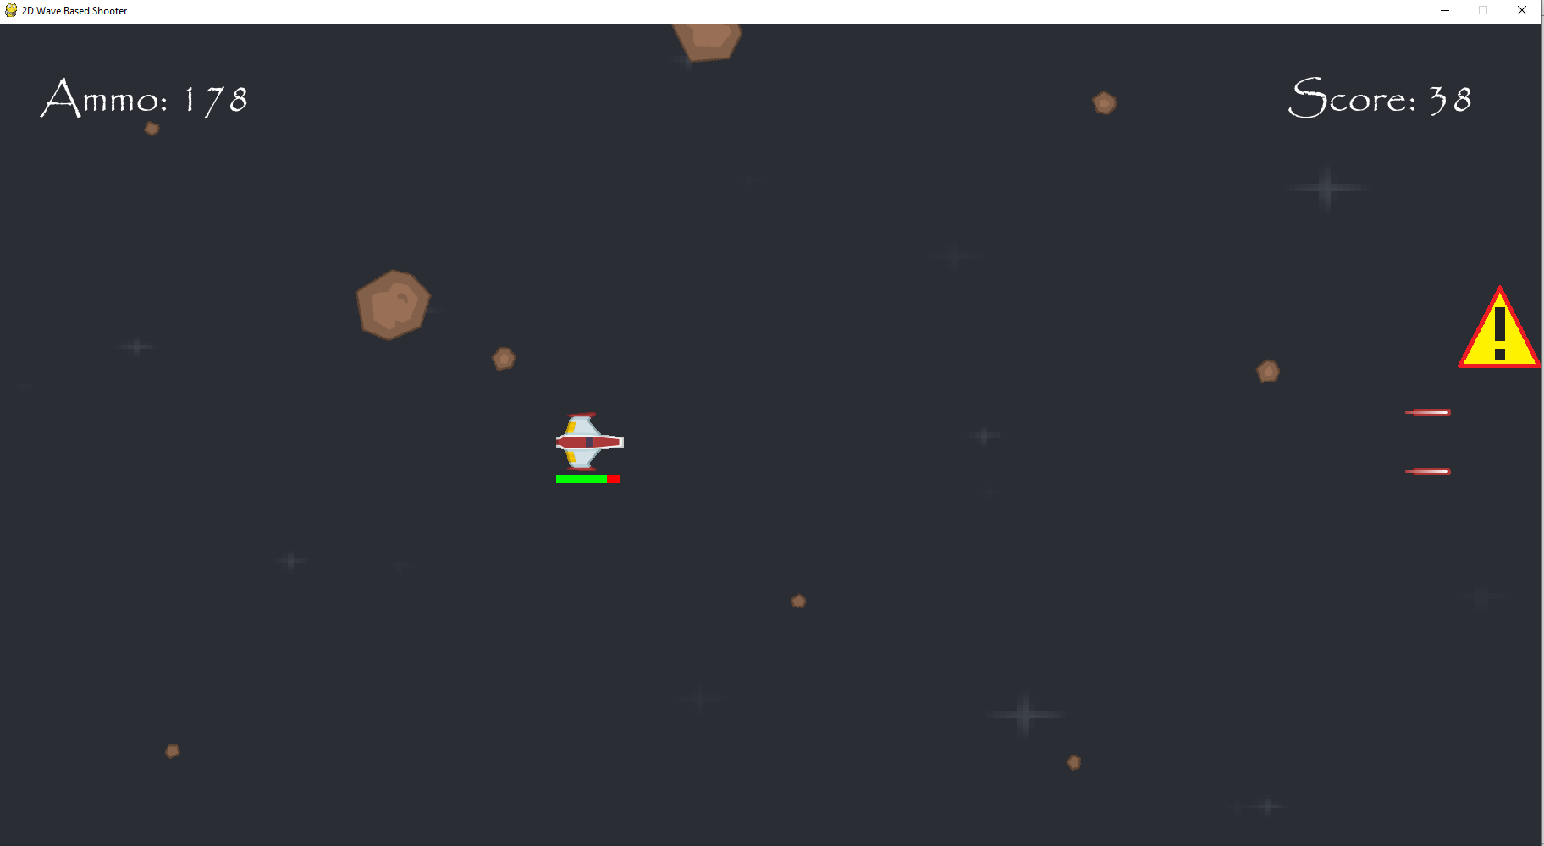When the player weapons collide with the meteor, there is a new explosion sound effect so meteorCollision is being played.

Stage 9 Review

In this stage I have managed to get functioning controller support for the game, so someone can now play using the controller in both singleplayer and multiplayer mode. The controls for the controller have been added to the controls section on the main menu as well. I have also made the background change colours after each new phase and have added sound effects to the attacks, collisions and menus of the game.

For the success criteria, I have accomplished the secondary objective of adding controller support as all of the different moves and attacks that can be done in singleplayer can also be done in multiplayer as well. In addition, there are different sound effects for different attacks and collisions and I have also made the background of the game change over time since when a boss is defeated the background changes colour until you reach the third boss.

Client Feedback:

Controller support means that the game can be played your preferred way for controllers. Changing backgrounds keeps the game fresh and makes each phase feel unique and the use of sound effects makes the game feel more engaging and responsive.

**I won’t be doing any more coding for the game. This is because the remaining two secondary objectives, adding online play and adding an AI player, would have very difficult to do and would require learning whole new chunks of code or even other programming languages. It would also be very time-consuming, and I don’t have enough time to code in a method of playing online or a functioning AI player. Moreover, I have already achieved all the primary objectives, so adding in these extra features aren’t necessary for me or the client.**

*Finally, I would like to thank Kenney Vleugels (www.kenney.nl) for the images used in the game. Almost all the images used were made by them.*